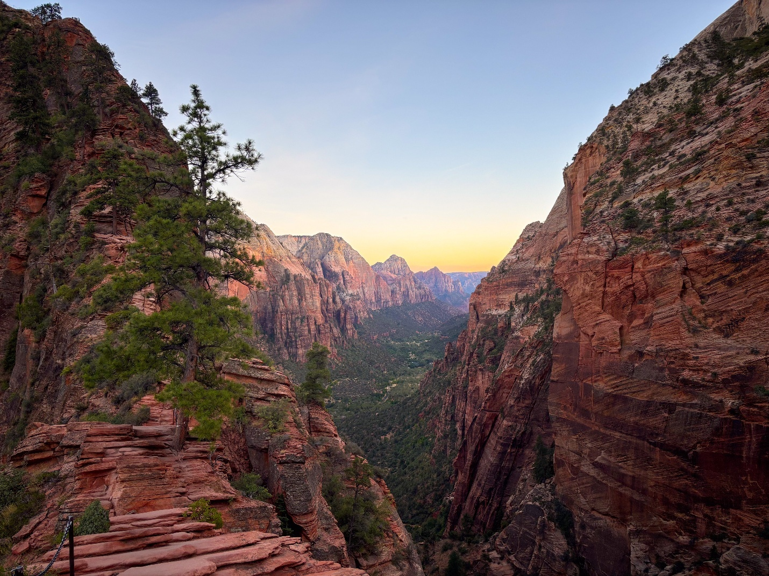
Figure 1: Zion Canyon's outstanding scenery is especially beautiful around sunrise and sunset.

ZION NATIONAL PARK

Park Profile 2026
Facts and figures from Fiscal Year 2025 (FY25) unless otherwise noted.

Table of Contents
Contents
Overview 4
Mission Statement 4
Establishment 5
History and Development 6
Natural Resources 7
Geographic Features 7
Hydrology 8
Zion Canyon 8
Cultural Resources 10
Museum Collection: 10
Archeological Resources 10
National Register of Historic Places 11
Selected Detail of Historic Structures/Buildings 11
Biological Resources 12
Flora 12
Fauna 12
Species of Special Concern 13
Threatened or Endangered Species 13
On-Going Projects 14
Front-country Facilities and Development 15
Campgrounds 15
Other Facilities and Development 15
Visitor Services 16
Visitation (CY 2025) 16
Visitor Protection (CY 2025) 17
Fire Management (CY 2025) 17
Zion Wilderness Use (CY 2025) 18
Interpretation and Education 19
Programming (CY 2025) 19
Volunteers-in-Parks and Youth Programming 21
Angels Landing Pilot Program (CY 2025) 20
Administration 22
Approximate Number of Employees 22
Service Contractors 23
Zion Transportation Shuttle System 23
Concession Operators 24
Xanterra Parks and Resorts, Inc. 24
Canyon Trail Rides, Inc. 24
Commercial Use Authorizations (CUA) and Special Park Uses (SPU) 24
Zion Forever Project 25

Overview
Located in Washington, Iron, and Kane Counties in Southwestern Utah, Zion National Park encompasses some of the most scenic canyon country in the United States.
The park is characterized by high plateaus, a maze of narrow, deep sandstone canyons, and striking rock towers and mesas. Zion Canyon is the largest and most visited canyon in the park. The North Fork of the Virgin River has carved a spectacular gorge here, with canyon walls in most places rising 2,000-3,000 feet above the canyon floor. The southern part of the park is lower desert area, with colorful mesas bordered by rocky canyons and washes. The northern sections of the park are higher plateaus covered by forests.

Mission Statement
The Zion National Park mission is to preserve the dynamic natural process of canyon formation as an extraordinary example of canyon erosion and to protect and preserve the valuable cultural, geologic, and biological resources while providing safe, sustainable, and cost-efficient access for visitors’ experiences and enjoyment. In addition, the park aims to educate both visitors and the general public about this exceptional environment.

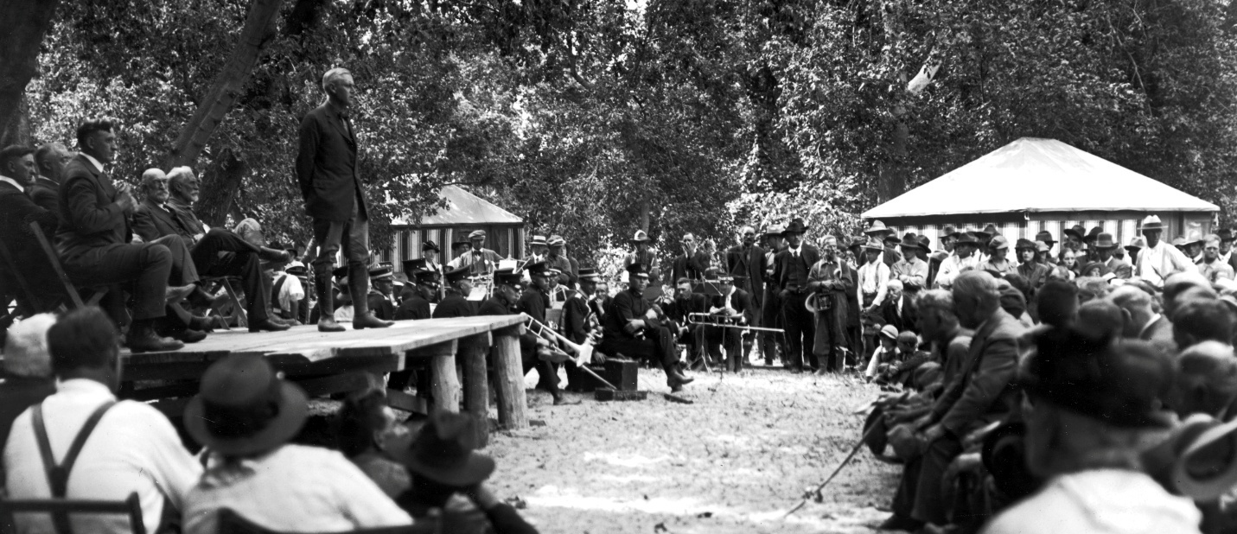
Figure 2: The area received National Park status in November of 1919.

Establishment
Zion National Park was originally protected by Presidential Proclamation on July 31, 1909 as Mukuntuweap National Monument by President William Howard Taft. Mukuntuweap, a Southern Paiute term, was suggested as the name for the monument by John Wesley Powell who believed that to be the Paiute name for the canyon. On March 18, 1918, the monument was enlarged and the name changed to Zion National Monument.
Zion, a Hebrew word interpreted by early members of the Church of Jesus Christ of Latter-day Saints to mean a place of safety or refuge, was given to the canyon by pioneers in the 1860s. The larger boundary allowed for the protection of, “unusual archeological, geologic and geographic interest…,” and provided opportunities for visitor enjoyment of its grandeur and scenic features.
The area received National Park status by the provisions of the Act of November 19, 1919. The subsequent Presidential Proclamation of January 22, 1937 by Franklin Delano Roosevelt established Zion National Monument adjacent to the then existing park, an area known today as Kolob Canyons. The park and monument were combined in 1956 by an act of Congress.

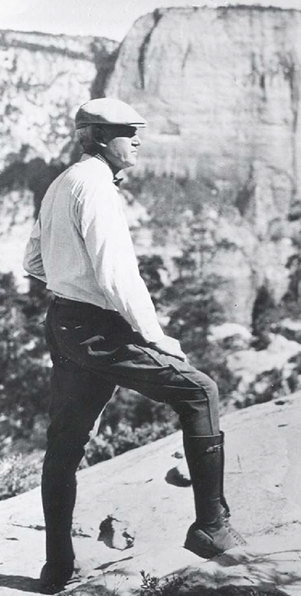
Figure 3: Stephen Mather, the first director of the National Park Service, was photographed on the West Rim Trail in 1919.

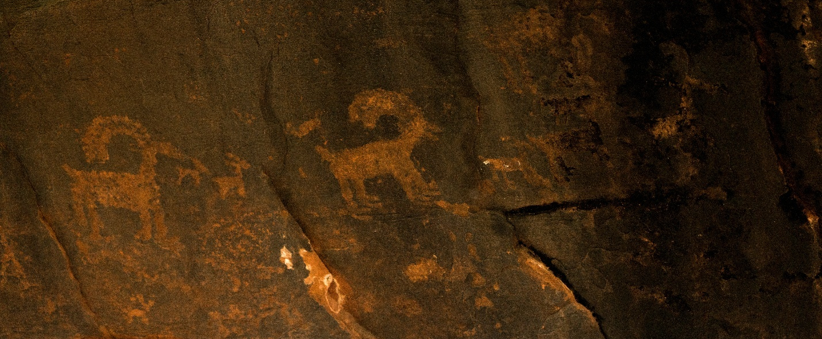
Figure 4: Even today, Zion National Park bears marks from thousands of years of human history.

History and Development
Zion National Park is the ancestral homelands of many indigenous tribes including the Paiute, Ute, Goshute, Hopi, Navajo, Zuni, and Pueblo tribes. The significance of the land to indigenous people and their history in the area is demonstrated through a rich tradition of oral history and knowledge passed between generations.
Today, tribal nations remain deeply connected to the land, as they have since time immemorial. Indigenous people refer to the canyon formed by the north fork of the Virgin River by several names. The Virgin River and its tributaries, as well as the wildlife and plants, are sacred. Zion National Park strives to learn from and collaborate with our tribal partners as we seek to co-steward this special place.
Zion’s archeological record provides evidence of at least 8,000 years of human occupation by indigenous people and European settlers. Scientific survey in the park has identified sites and artifacts attributed to the Archaic Adaptive Strategy, Basketmaker, Puebloan or Formative time period, Post-Puebloan time period, and European settlement.
During the National Park Service’s administration of the park, there are several periods of significance for the construction of roads, trails, structures, facilities and infrastructure. A large portion of public facilities in upper Zion Canyon were developed by the National Park Service between 1909-1933. New Deal-era Park Development continued to expand facilities utilizing the NPS Rustic and Naturalistic Design by Civilian Conservation Corps labor from 1933-1942, and the Mission 66 and Park Service Modern Design funding period expanded visitor services and facilities in lower Zion Canyon from 1945-1967.

Natural Resources

Geographic Features

Size
Total Acreage: 148,732 acres (232 square miles)
Designated Wilderness: 125,078 acres (84.1% of total area)
Private Land Inholdings: 3,310 acres

Elevation
Highest Point: Horse Ranch Mountain – 8,726 ft (2,660 m)
Lowest Point: Coalpits Wash – 3,642 ft (1,128 m)

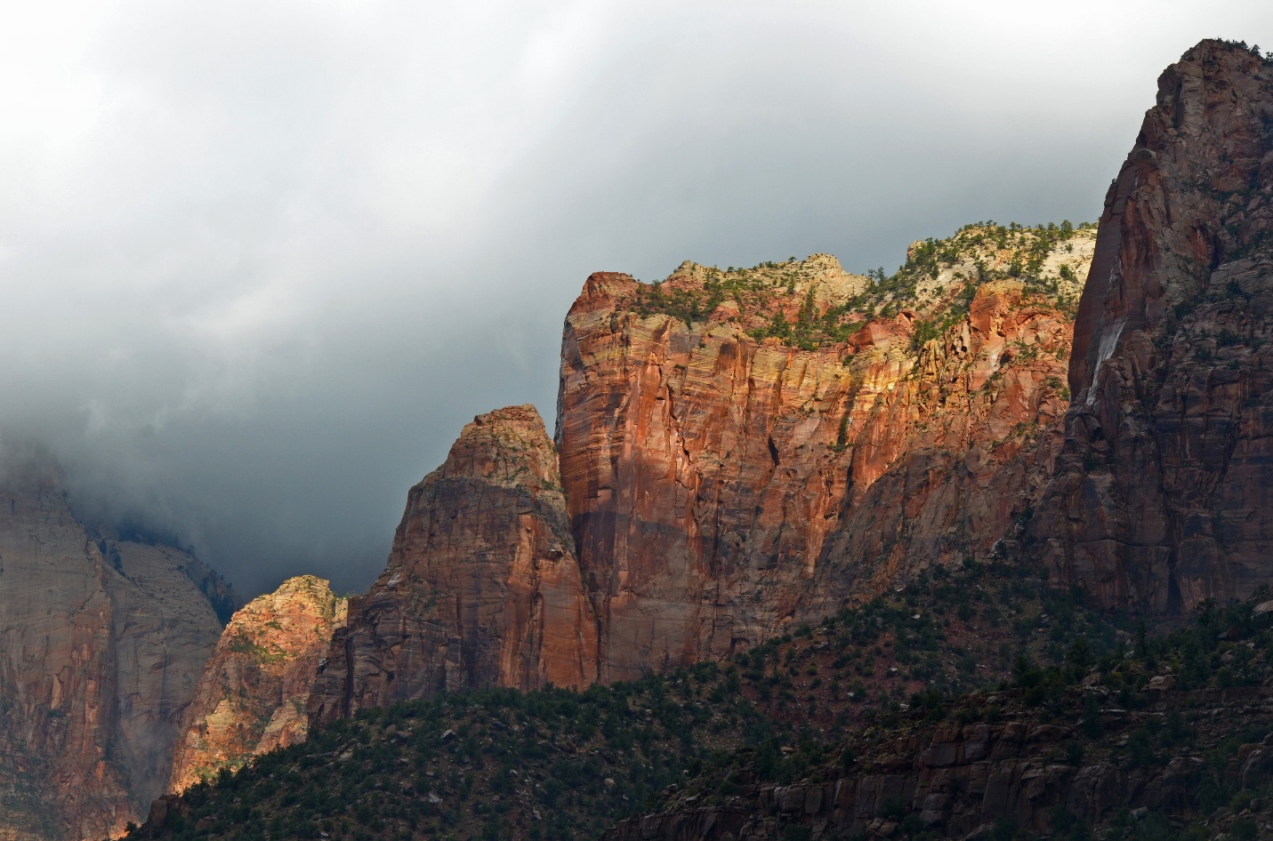
Figure 5: Zion Canyon is easily recognized by its massive cliffs and striking geology.

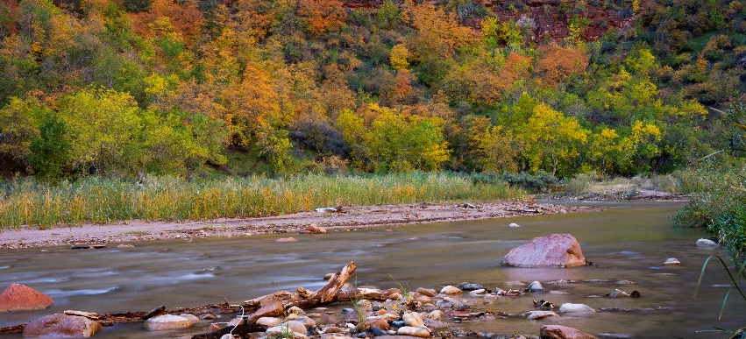
Hydrology
Rivers and Major Streams: 96 miles
Intermittent Streams: 455 miles
The North Fork of the Virgin River is the driving force of erosion in
Zion Canyon.
Figure 6: The life-giving Virgin River is home to myriad plants and animals.
- Length in park: 17.95 miles
- Average gradient of the Virgin River through the park:
71 feet/mile
- Chamberlain Ranch to Temple of Sinawava: 87 feet/mile
- Temple of Sinawava to South Campground: 55 feet/mile
- Sediment transport: One million tons per year on average
(extremely variable year-to-year)
The Narrows is a 16-mile section of the North Fork of the Virgin River above the Temple of Sinawava that in places is only 20-30 feet across with 2,000+ foot canyon walls on each side.

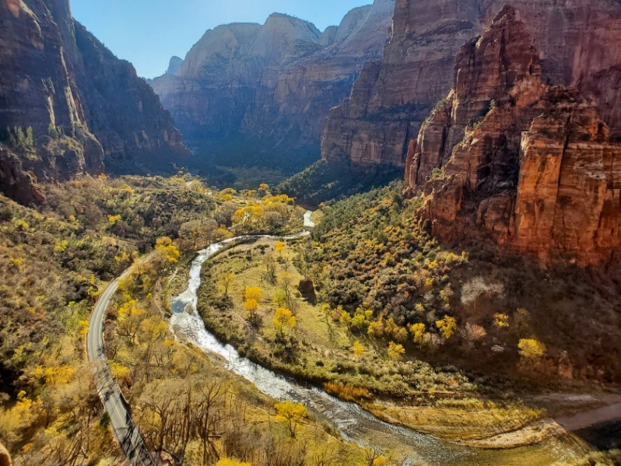
Zion Canyon
Below The Narrows, the North Fork of the Virgin River has carved a 6.5-mile canyon from the Temple of Sinawava to the town of Springdale, UT.
Highest Point above Zion Canyon: West Temple – 8,710 ft (2,380 m)
Lowest Point in Zion Canyon: Watchman Campground –
3,920 ft (1,195 m)
Figure 7: Big Bend is just one incredible location along the river.

Zion Canyon Climate and Weather
Highest Recorded Temperature: 115 °F (46 °C) on July 1, 1950, July 10, 2021, July 11, 2021
Lowest Recorded Temperature: -15 °F (-26 °C) on Jan. 21, 1937
Maximum Precipitation: 31.65 in (80.4 cm) in 2005
Minimum Precipitation: 5.01 in (12.7 cm) in 2002

Zion Canyon Temperatures and Precipitation by Month
Month | Normal High Temp  (°F) | Daily Highs over 100 °F | Normal Low Temp  (°F) | Daily Lows below 32 °F | Normal Precipitation (in)
January | 54 | 0 | 30 | 20 | 2.0”
February | 58 | 0 | 34 | 13 | 2.1”
March | 66 | 0 | 39 | 9 | 2.0”
April | 73 | 0 | 44 | 3 | 1.2”
May | 84 | 0 | 53 | 0 | 0.8”
June | 95 | 6 | 62 | 0 | 0.2”
July | 100 | 16 | 70 | 0 | 1.2”
August | 98 | 10 | 69 | 0 | 1.6”
September | 91 | 2 | 61 | 0 | 1.2”
October | 78 | 0 | 49 | 1 | 1.2”
November | 64 | 0 | 37 | 10 | 1.2”
December | 53 | 0 | 29 | 18 | 1.6”
Annual | 76 | 34 | 46 | 74 | 16.2”
Temperature data sourced from NOAA 1991-2020 Climate Normals.
Precipitation data sourced from the Utah Climate Center; "Normal" period 1981–2010. Additional data provided by Dave Sharrow, former park hydrologist for Zion.

Cultural Resources
Approximately 22% of Zion National Park has been surveyed for cultural and archaeological resources.

Museum Collection:
55.38% of the collection is cataloged.

Collection of Objects by Field
Field | Art | History | Geology | Archives | Archeology | Ethnology | Biology | Paleontology
Number of Objects in Collection | 104 | 1,182 | 716 | 722,300 | 30,387 | 110 | 25,965 | 612

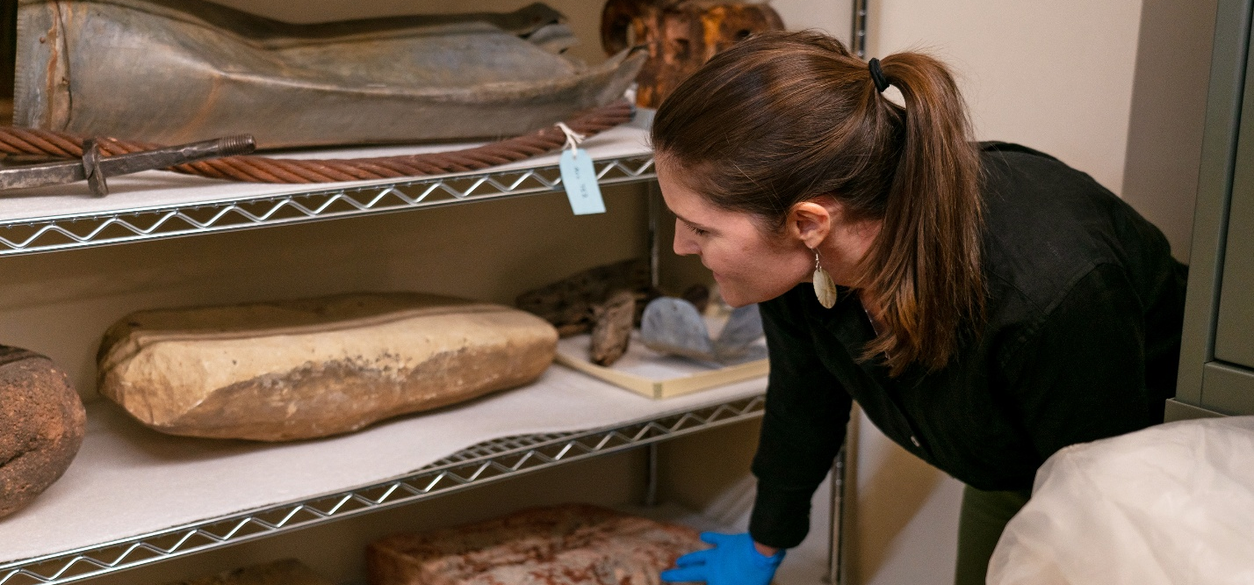
Figure 8: The park museum manages a wide collection of documents, artifacts, and donated works.

Archeological Resources
622 archeological sites with affiliations ranging from Middle Archaic to Mission 66

Cultural Landscape
Periods of Significance for the Zion Canyon Cultural Landscape extend between circa 1862 – 1967 and encompass 4 historic contexts:
- Pioneer Settlement (1862 – 1909)
- Early Park Development and Rustic and Naturalistic Design (1909 – 1933)
- New Deal-era Park Development and Rustic and Naturalistic Design (1933 – 1942)
- Mission 66 and Park Service Modern Design (1945 – 1967)

Historic Districts
Most historic structures are found within these districts:
- Pine Creek Historic District (1862 – 1932)
- Oak Creek Historic District (1862 – 1951)
- Zion Lodge / Birch Creek Historic District (1924 – 1937)

National Register of Historic Places
94 registered places
- Includes 2 ancestral archeological sites and 92 historic structures / buildings listed on Multiple Property Nominations

Selected Detail of Historic Structures / Buildings
- 3 roads (including related road features: bridges, retaining walls, culverts, parking areas, tunnels)
- 8 hiking trails
- 4 irrigation ditches
- 24 residences and 6 garages, 3 dormitories, 15 cabins
- 3 comfort stations
- 11 office and utility buildings
- 28 other structures and buildings

Biological Resources

Flora
1,074 total taxa (including subspecies and variations)
- Trees: 40
- Shrubs: 137
- Ferns: 28
- Grasses, Sedges, or Rushes: 129 perennial, 35 annual
- Other Herbaceous Plants: 492 perennial, 213 annual
46 are local endemic species
162 species are introduced, 10 listed as noxious weeds by the state of Utah

Fauna
374 total species
- Mammals: 71
- Birds: 292
- Reptiles: 29
- Amphibians: 7
- Fish: 4

Non-Native Fauna
11 non-native species
- Mammals: 3
- Birds: 3
- Fish: 5

Threatened or Endangered Species
4 bird species and 1 reptile species found within the park are at risk of extinction in the wild. “Critically endangered” species face the highest risk of extinction, while “threatened” species are likely to become endangered if preventative action is not taken.
- Mexican Spotted Owl (Threatened)
- Yellow-billed Cuckoo (Threatened)
- Southwestern Willow Flycatcher (Endangered)
- California Condor (Critically Endangered)
- Mojave Desert Tortoise (Critically Endangered)

Species of Special Concern
8 mammals, 17 birds, 1 reptile, 2 amphibians, 3 fish, and 8 invertebrates are designated as “Species of Special Concern.” While they do not yet meet the criteria to be listed as threatened or endangered, they are considered particularly vulnerable.
- Arizona Toad  - Northern Leopard Frog  - Gila Monster  - Bald Eagle  - Black Swift  - Black-chinned Sparrow  - Cassin’s Finch  - Clark’s Nutcracker  - Evening Grosbeak  - Ferruginous Hawk  - Flammulated Owl  - Golden Eagle  - Grace’s Warbler  - Gray Vireo  - Lewis' Woodpecker  - Long-eared Owl  - Northern Goshawk  - Olive-sided Flycatcher  - Peregrine Falcon  - Pinyon Jay | - Desert Sucker  - Flannelmouth Sucker  - Virgin Spinedace  - Coarse Ramshorn  - Lindahl's Pyrg  - Montane Snaggletooth  - Thin-lipped Vallonia  - Top-heavy Column  - Zion Snail  - Monarch Butterfly  - Western Bumblebee  - Allen's Big-eared Bat  - Fringed Myotis Bat  - Long-legged Myotis Bat  - Long-eared Myotis Bat  - Spotted Bat  - Townsend's Big-eared Bat  - Western Red Bat  - Yuma Bat
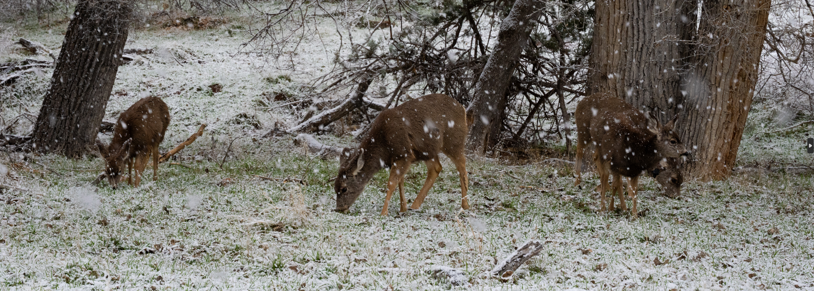
Figure 9: Mule deer are a common sight in Zion Canyon.

Ongoing Projects

Zion Canyon Deer Project
A project that is studying population demographics, health, and habitat through the main canyon. Results from this study will be used for the development of a Zion Canyon Deer Management Plan which will: (1) allow Zion NP to maintain a herd size that reflects the availability and quality of the habitat, (2) improve quantity and quality of forage, and (3) reduce human-deer conflict.

Mexican Spotted Owl
Zion National Park provides critical habitat for the federally threatened Mexican Spotted Owl. Staff monitor site occupancy and reproductive status annually from March-August.

Mountain Lion Study
Detailed GPS data on mountain lion movement is being collected to fully understand the extent of mountain lion resource selection and/or avoidance and how humans might be influencing that selection. This GPS data, combined with researcher visitation of lion activity centers, will provide critical insight into how mountain lions interact with and contribute to the Zion National Park ecosystem, including the diet composition of mountain lions and the extent to which lions benefit scavengers such as the California condor.

Front-country Facilities
and Development

Campgrounds

Watchman Campground
- Open year-round
- 184 sites: 92 electric, 18 walk-in, 6 group, 8 accessible

South Campground
- Closed for construction, scheduled to reopen in 2026
- 108 planned sites: 18 walk-in, 4 group, 7 accessible

Lava Point Campground
- Typically open spring through fall, closed in winter based on road conditions
- 6 sites: all primitive

Other Facilities and Development
4 Picnic Areas (Grotto, Kolob Canyons, Zion Nature Center, Zion Canyon Visitor Center)
89.4 miles of hiking trails
36.6 miles of roads (2.4 miles are unpaved)
Zion-Mt. Carmel Highway Tunnel
- Constructed 1927-1930
- Cost: $1,896,000
- Length: 5,613 feet (1.06 miles)
- Width: 22 feet
- Height: 16 feet

Visitor Services

Visitation (Calendar Year 2025)
In 2025, ZION recorded 4,984,525 recreational visits, up 0.8% from 2024
- 2025: 4,984,525
- 2024: 4,946,592
- 2023: 4,623,238
- 2022: 4,692,417
2021 was the highest year of visitation and the first year over 5,000,000 visits. 2025 was the second highest year of visitation in Zion. 2024 was the third highest year of visitation.
Visitation has increased by 36.6% in the last 10 years (2015: 3,648,846)
Five months of the year (April, May, June, July, October) had more than 500,000 visitors.
Average # of visitors per day during the peak months:
- April – 17,952
- May – 19,009
- June – 19,501
- July – 17,090

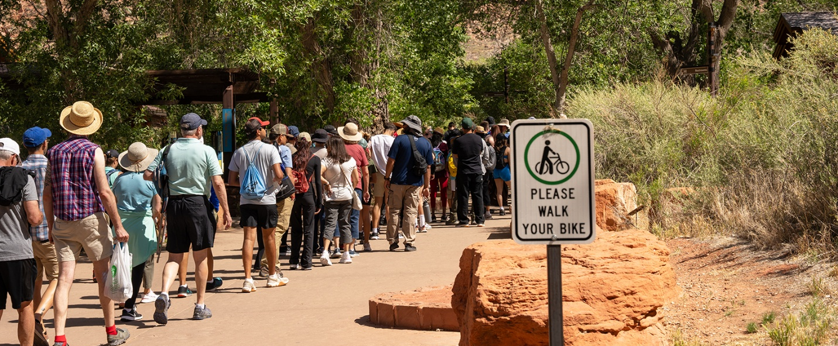
Figure 10: Holiday weekends are especially busy in Zion Canyon.
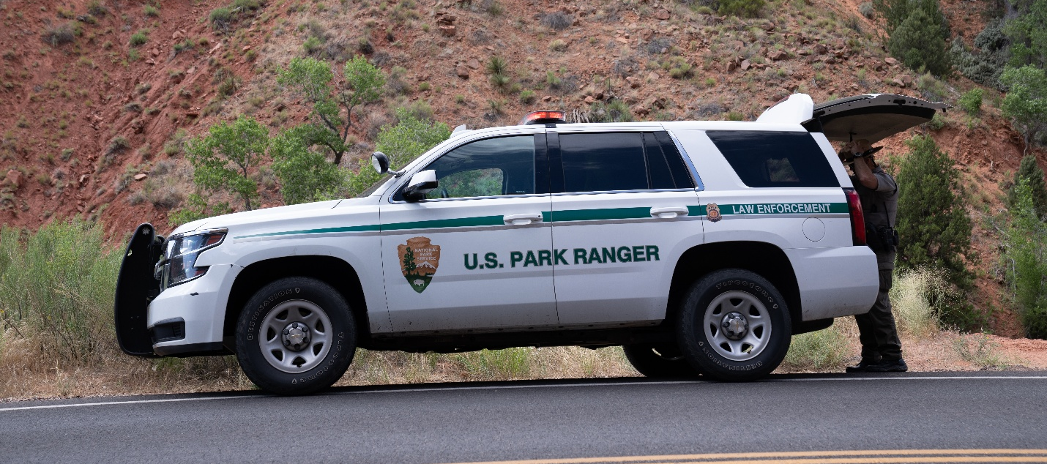
Figure 11: As visitation rises, so has the demand for visitor protection services.

Visitor Protection (CY 2025)
- Law Enforcement Incidents: 3,125 total
  - 2,447 law enforcement calls
  - 598 visitor assists
  - 80 hazard calls (rock falls, flash flooding, etc.)
- Emergency Medical Services Calls: 376
- Search and Rescue Incidents: 158
- Structural Fire Callouts: 55
- Mutual Aid Calls: 44
- Fatalities: 4

Fire Management (CY 2025)
The Fire and Aviation Management Program at Zion National Park provides oversight and management for the following park units: Zion National Park, Bryce Canyon National Park, Capitol Reef National Park, Glen Canyon National Recreation Area, Rainbow Bridge National Monument, Pipe Spring National Monument, Cedar Breaks National Monument, Golden Spike National Monument, and Timpanogos Cave National Monument.
Wildland Fires: 15 fires burned 191 acres
Fuel Treatments (e.g. mechanical, prescribed fire, herbicide treatments): 32 acres

Zion Wilderness Use (CY 2025)
Wilderness Permits are required for all overnight backpacking trips, overnight climbing bivouacs, all through-hikes of The Virgin River Narrows and its tributaries, all canyons requiring the use of descending gear or ropes, and all trips into Left Fork of North Creek (The Subway). Most day hikes and day climbs do not require permits.
Type of Permit | Number of Permits | Number of Visitors
Overnight Backpacking Permits (not including Narrows) | 2,056 | 4,782
Day Canyoneering Permits, including Narrows | 8,183 | 27,357
Boating Permits | 1 | 3
Overnight Climbing Permits | 128 | 261
Overnight Canyoneering Trips, including Narrows | 854 | 2,593
Totals | 11,221 | 34,993

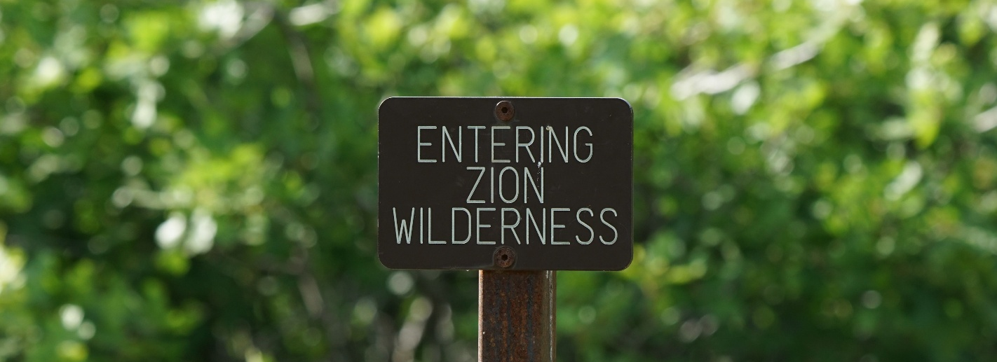
Figure 12: Each year, thousands of visitors explore Zion Wilderness for the first time.

Interpretation and Education

Programming (CY 2025)
Interpretive Programming | Number of Programs | Number of Contacts
Ranger-led Programs (Traditional Interpretation) | 1,306 | 38,628
Informal Ranger Roves (Traditional Interpretation) | N/A | 217,082
Ranger-led Programs (Youth Programming / Nature Center) | 539 | 11,078
Junior Ranger Stations | 511 | 45,573
Distance Learning | 62 | 2,528
Classroom outreach | 108 | 3,713
Field Trips | 16 | 453
Concrete-To-Canyons | 15 | 76
Note: Regular programming was interrupted by a lapse in federal funding, which lasted 43 days starting October 1, 2025.

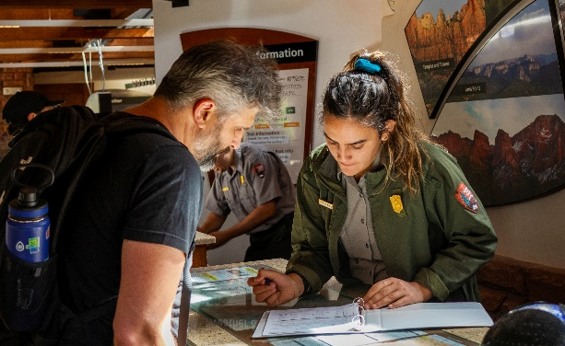
Contact Stations (CY 2025)
Zion Canyon Visitor Center: 1,423,649 visitors
Zion Human History Museum: 194,661 visitors
Kolob Canyons Visitor Center: 160,361 visitors
Zion Nature Center: 10,973 visitors
Zion Info Room: 11,307 visitors
Figure 13: Park rangers and guides are responsible for helping visitors plan their trip through the park.

Distance Learning (CY 2025)
In 2017, Zion piloted the Distance Learning Program as part of its “Every Fourth Grader in the Park” program.
In 2025, the park carried out 62 Distance Learning Programs, reaching 41 Schools and 2,528 students and teachers.

Concrete to Canyons (CY 2025)
Concrete to Canyons is an award-winning, place-based environmental education program. Launched in 2013, the program was designed to connect urban youth with their public lands.
In 2025, Zion connected with 76 students and teachers through this program.

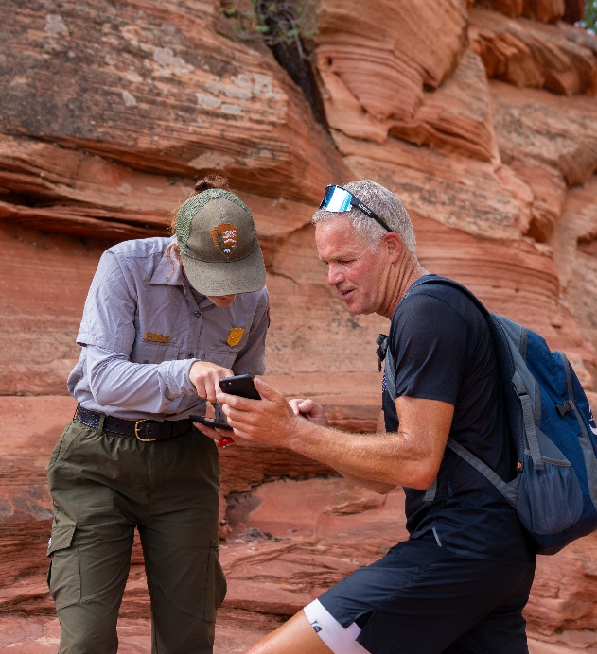
Angels Landing Pilot Program (CY 2025)
The National Park Service implemented the Angels Landing Pilot Permit Program in April of 2022. This program was created in response to concerns about crowding and congestion on the Angels Landing Trail.
Throughout the pilot, Zion staff have been collecting important information and monitoring trail conditions that will inform ongoing visitor use planning.
In 2025, 238,042 visitors hiked Angels Landing using permits.
Figure 14: Angels Landing remains one of the most sought-after destinations in Zion National Park.

Volunteers-in-Parks and Youth Programming
In Fiscal Year 2025, 152 position volunteers contributed 18,950 hours of service. Interpretation Volunteers, Campground Hosts, and Natural Resources Volunteers made up the majority of those hours at 6,240 hours, 6,174 hours, and 4,751 hours respectively. Moreover, 262 short-term event volunteers donated 1,101 service hours, creating a combined total of 414 volunteers and 20,051 volunteer hours.
3 Artists-in-Residence (AIRs) were hosted in 2025. A basket weaver, a harpist, and a stop-motion animator contributed a total of 323 volunteer hours to the park.
Additionally, in Fiscal Year 2025 the park hosted 63 youth interns from various programs, including the Intergovernmental Internship Cooperative (IIC), American Conservation Experience (ACE) work crews, Great Basin Institute, Latino Heritage Internship Program (LHIP), Scientists-in-Parks, and more.

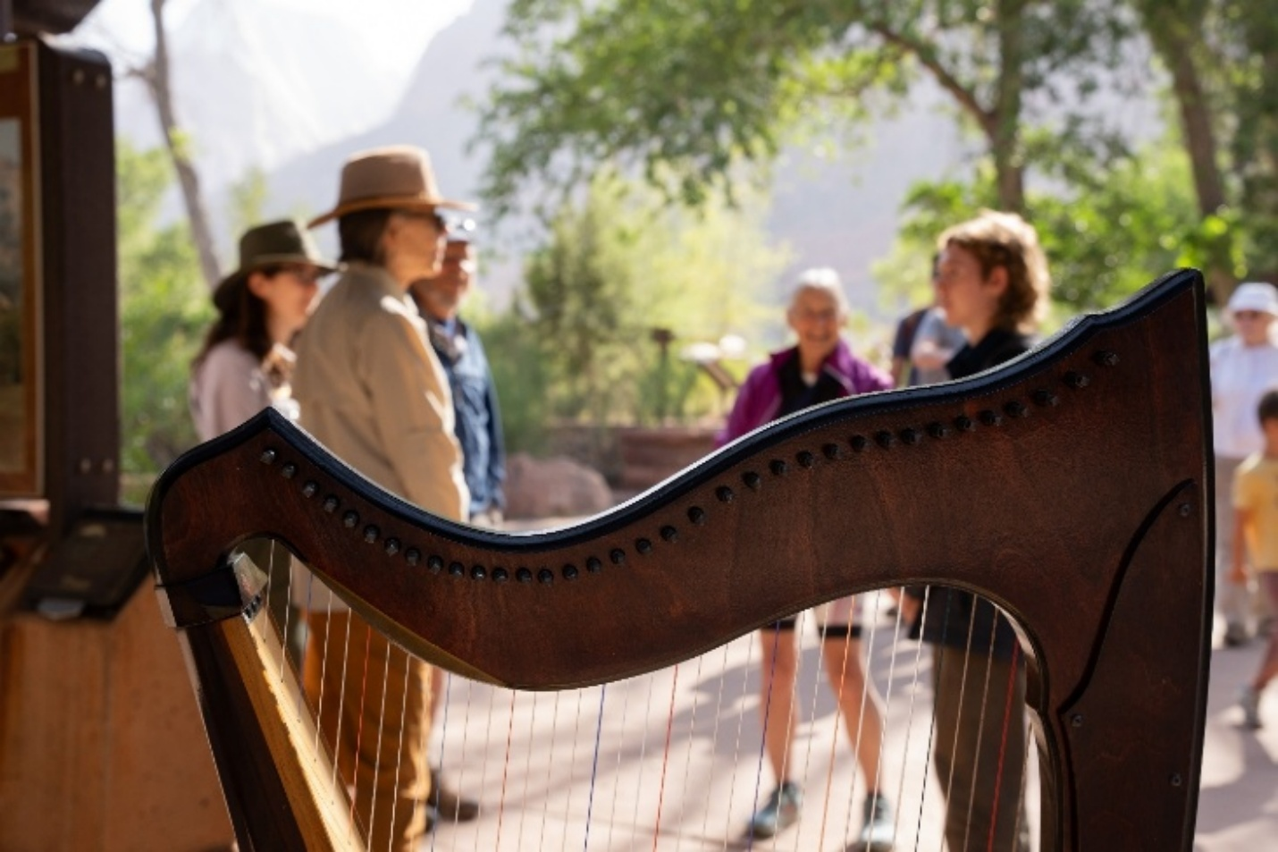
Figure 15: In 2025, three artists volunteered in Zion Canyon as part of the Artist-in-Residence program. During their stay, they hosted public programs and demonstrations to share their art.

Administration

Approximate Number of Employees
Approximate number of employees includes both base and project-funded positions, including employees who remained on payroll after leaving Federal Service through special Executively-directed programs.
Work Group | Permanent | Career Seasonal (STF) | Terms | Seasonals
Administration | 12 | - | - | -
Interpretation | 5.4 | 10.7 | 7 | 15.7
Visitor Resource Protection (Includes Fire) | 34.7 | 16.2 | 0.2 | 7.3
Maintenance | 21.3 | 15.6 | 1.5 | 4
Resource Management | 10.7 | 2.7 | 1.9 | 6.3
Totals | 84 | 45.2 | 10.6 | 33.3

Operating Budget
The base appropriation of money is broken down as follows:
Work Group | Budget
Administration and Management | $1,184,878
Interpretation | $1,516,522
Visitor Resource Protection (Includes Fire) | $1,297,549
Facility Maintenance | $2,296,744
Resource Management | $2,562,307
Combined | $8,858,000

Service Contractors

Zion Transportation Shuttle System
In May 2000, Zion implemented a mandatory shuttle bus system for park visitors along the six-mile Zion Canyon Scenic Drive. The system also provides service in the town of Springdale. The shuttles typically operate full time March through November, though dates vary. The Springdale Loop consists of several stops made by a 40-foot shuttle and the Zion Loop consists of nine stops made by a 60-foot bus.
In 2024, Zion received 30 electric buses to replace the previous fleet of propane-powered buses.

Ridership (CY 2025)
5,531,342 boardings in 2025 (up 4.58% from 2024’s 5,289,350)
Busiest days of 2025
- Memorial Day Weekend Sunday: 35,745 boardings
- Memorial Day Weekend Saturday: 34,306 boardings
- Labor Day Weekend Sunday: 31,028 boardings

Ranger-led Shuttle Tours (Ride with a Ranger)
“Ride with a Ranger” programs are offered once per day during the summer season, which typically runs from mid-May through mid-September.
- Total Rides: 124
- Total Attendance: 2,237 riders (a 13% decrease vs 2024)

Concession Operators

POWDR Adventure Lifestyle Co.
POWDR operates the Zion Lodge, which offers motel units, historic cabins, a restaurant, a snack bar, a gift shop, and other services. The lodge is open year-round, with somewhat reduced services in winter.

Canyon Trail Rides, Inc.
Canyon Trail Rides offers guided horse trips in Zion Canyon from March through October.

Commercial Use Authorizations (CUA) and Special Park Uses (SPU)
The CUA program includes commercial interpretive services (guided hiking), bicycle tours, motorcycle tours, photography and painter workshops, and trailhead shuttles. In 2025, Zion issued 136 CUAs (compared to 154 in 2023 and 123 in 2022).
SUPs are special events or activities that provide a benefit to an individual or group (rather than the public as a whole) and require written authorization and management control from the NPS. Zion issued 182 special use permits in 2025 for weddings, filming, 1st Amendment activities, church services, and more (compared to 251 in 2023 and 184 in 2022).

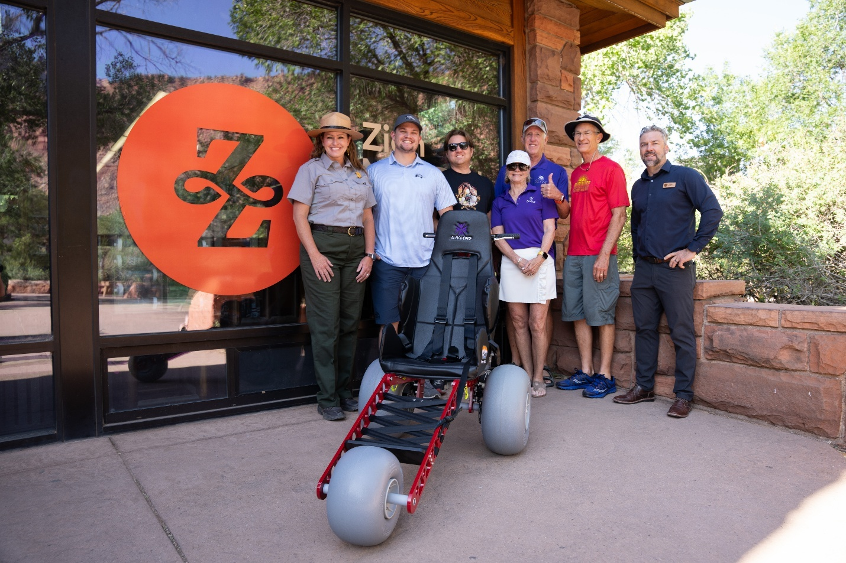
Figure 16: Zion Forever Project supports a variety of park projects, such as the acquisition of this trail-capable wheelchair for use by the public.

Zion Forever Project
Zion Forever Project (ZFP) is Zion’s official nonprofit partner. ZFP connects visitors with resources by offering educational and interpretive products in its park stores (located in the park visitor centers), offering more than 50 field courses each year, and serving as the park’s philanthropic and outreach partner.
Through strategic planning with park management, ZFP seeks donations of professional services, expertise, and funding to address the park’s highest priorities in resource protection, visitor experience, education, and sustainability. Their important work will ensure the park’s margin of excellence for generations to come.

