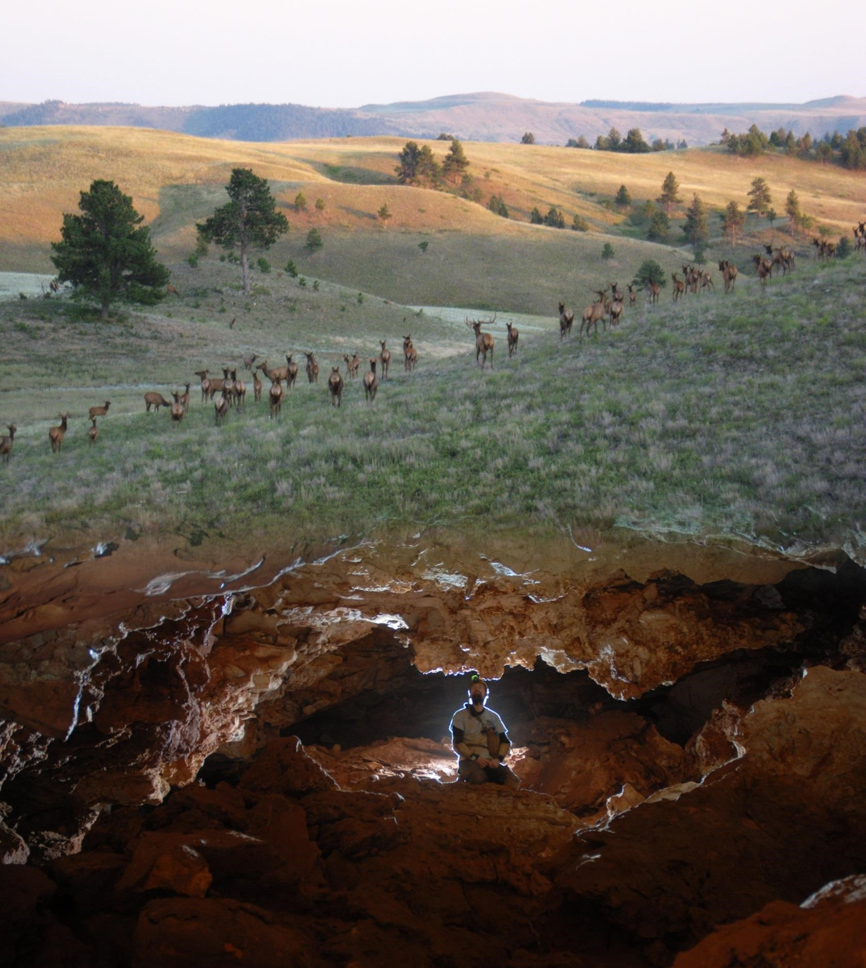
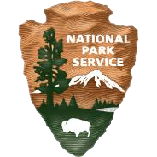

Junior Ranger
Online Activity Book

385
US HWY
26611

Hot Springs, SD 57747

Wind Cave National Park

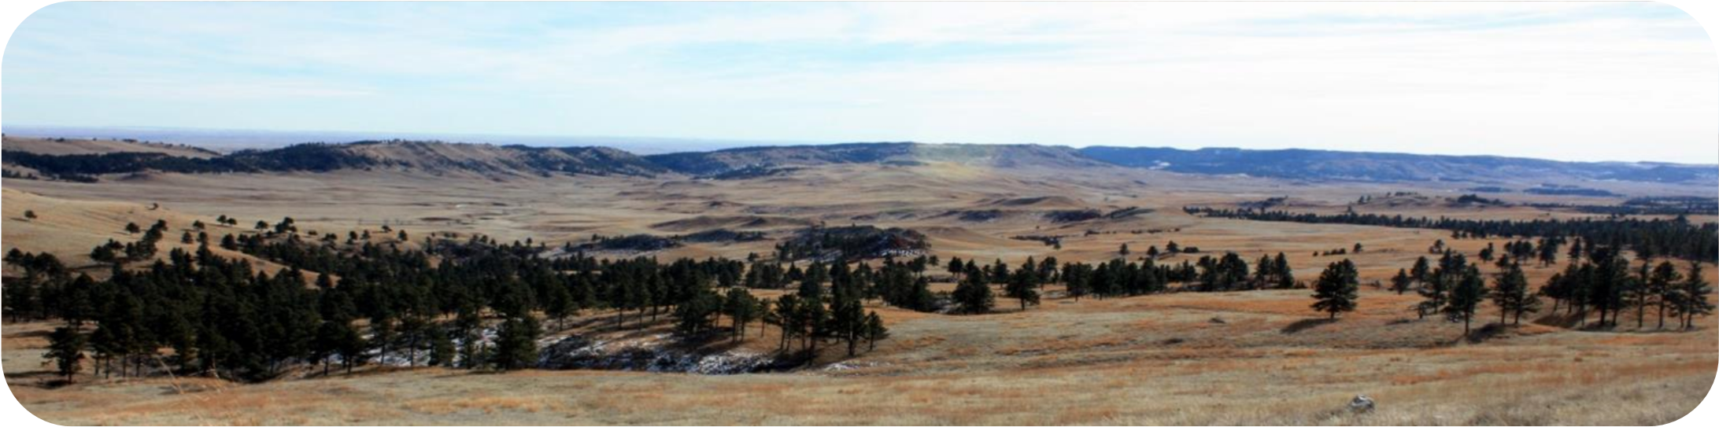

Welcome to Wind Cave National Park

D
ISCOVER TWO PARKS IN

ONE
!

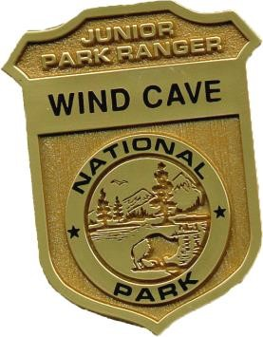

How to Become a Junior Ranger

To become a Junior Ranger and earn your badge complete the following number of activities:

•

Ages 5 and under: complete 4 activities

•

Ages 6 to 9: complete 6 activities

•

Ages 10 to 14: complete 8 activities

•

Ages 15 and older: complete all of the activities

When you finish your book you can receive your Junior Ranger badge by sending your book to:

Wind Cave National Park

26611
US Highway 385

Hot Springs, SD 57747

As a Junior Ranger, you will discover what makes this park unique. You will
learn how you can protect this park and its resources. You will also
recognize what you can do at home to protect nature.

Name
:
__________________________

Age:
__________

Mail my Junior Ranger Badge to:
_____________________________________________________________________________________________________________________________________________
A Night at the Movies

Wind Cave National Park is full of stories and history. Many of those stories are told by rangers in videos on the park website, www.nps.gov/wica.
Watch one of the videos on the website, such as:
Buffalo Jump, CCC, Lakota Emergence Story, Elk Management, etc.

Which video did you watch? _________________________________

What was something that you liked about the video? ______________________________________________________________
______________________________________________________________

List one fact that you found interesting or learned.
____________________________________________________________________________________________

Wind Cave is home to many different kinds of formations.
What’s in a Cave?
Match the formation name with the pictures below.
Word Bank:
Stalactite Dog Tooth Spar Flowstone
Frostwork Popcorn Boxwork

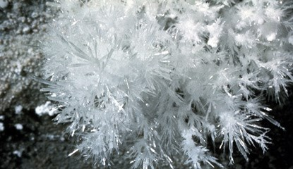
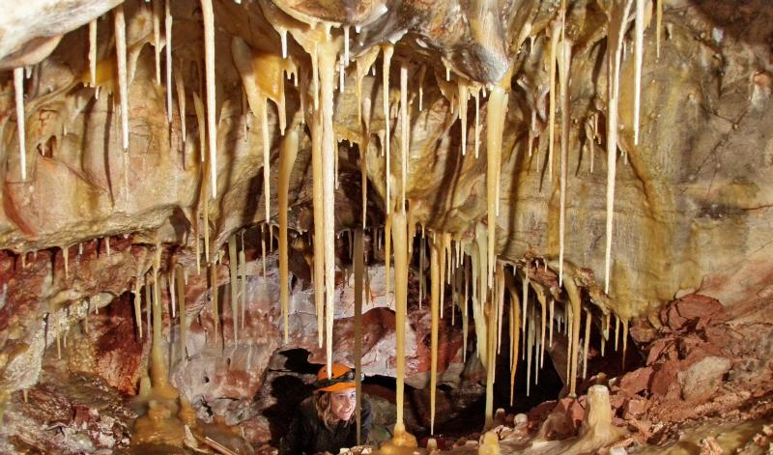

2.
1.
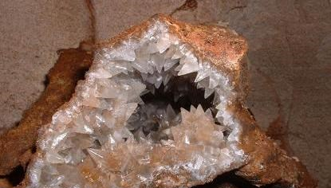
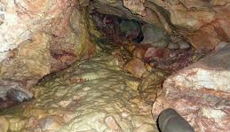
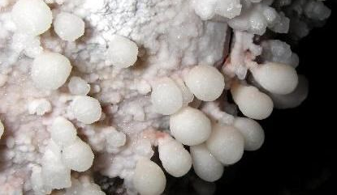
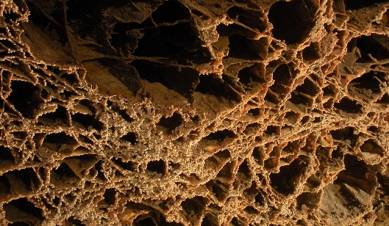
4.
5.
6.
3.
Some animals are hard to find in the wild. Rangers look for signs like scat (poop) and tracks to learn about them. Tracks can tell us about an animal, like where it was going and how fast it was moving. Have you seen any tracks around where you live?
Who Was Hunting in the Prairie?
Solve the riddles below using the animals from the word bank. Then, draw the track to that animal in the box next to the riddle.
I am the top predator at Wind Cave National Park.
I am part of the feline family.
I can retract my claws so they don’t leave a mark.
I am a __________________________

Draw Track
I am often found around prairie dog towns.
I howl to keep in touch with my fellow animals.
I am part of the canine family.
I am a ___________________________

Black Footed Ferret
Golden Eagle

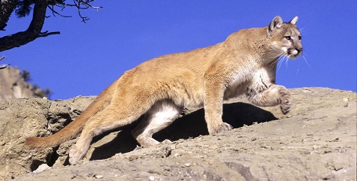
Mountain Lion
Coyote

Draw Track
I am an endangered species. I live in the prairie dog burrows.
I have 5 toes.
I am part of the weasel family.
I am a __________________________

Draw Track

Draw Track
I hunt from the skies.
I live in nests.
I have a 6 to 7.5 ft. wingspan.
I am a ___________________________
Wildlife - Here and There?
Wind Cave National Park is mostly made up of mixed-grass prairie. Many of the species that live in this habitat are also found in other areas across the Great Plains. The habitat and wildlife on the prairie might be different than what you find near your home.

What kinds of wildlife live near you?

What kinds of habitats do you see near where you live?

Find the species list on the park website. To find it, go to “Learn About The Park,” then “Nature,” finally click on “Species List.”

Compare your list of wildlife to the Wind Cave species list. Do any of the animals from where you live match the Wind Cave species list?
If yes, what kinds of animals were they? If no, why do you think they are different?
________________________________________________________________________________________________________________________________________________________________________________________________________________________________________________________

Take a Hike!
Going for a hike is a great way to see the many areas of the park. Wind Cave National Park has over 30 miles of hiking trails.

Take a virtual hike on one of the 360 Photo Stations.
To find it on our website go to the “Learn About the Park” tab, go down to “Education” and click on “360 Photo Stations.”

Which trail did you pick?
_____________________________________________

What would you take with you on the hike in real life?

The rangers at Wind Cave National Park always give wildlife plenty of space when they hike. What are some things you can do to stay safe while hiking on the trail?

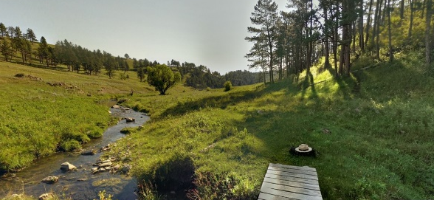

Can You Be a Cave Explorer?
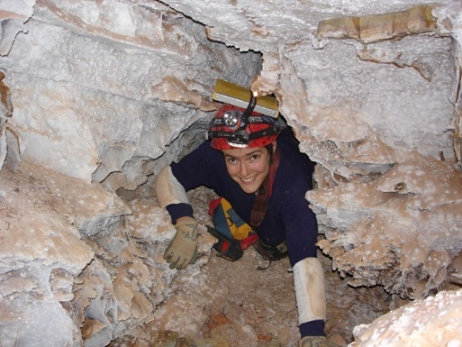
Yes, you can! People have been exploring Wind Cave for over 100 years. The first to start exploring was Alvin McDonald in the 1890’s. Using just a tape measure, a string, a compass and a sketch pad he was able to map the first 8-10 miles of Wind Cave.
Pick a room in your house. Survey, measure, and sketch out your “cave passageway.” Using the same skills that Alvin and the other explorers have used.
Use your imagination. Do any of the things found in your room remind you of cave formations? Are there formations on the walls? Are there big rocks in the room?
Example:

Windowsill Ledge
Bed Rock
Bean-Bag Chair Flowstone
Stalactite Ceiling Fan

Home on the Range
Many People from America’s eastern cities moved out west in the 1800’s to farm and start a new life on undeveloped lands called homesteads. Pioneers faced many struggles including lack of water, bad weather, disease, and snake bites. Life was so difficult that many moved away, and these land later became part of Wind Cave National Park. One homestead, the Sanson Ranch is preserved in the park today.
Avoid the obstacles as you find your way to the Sanson Ranch homestead.
Supermarket of the Plains

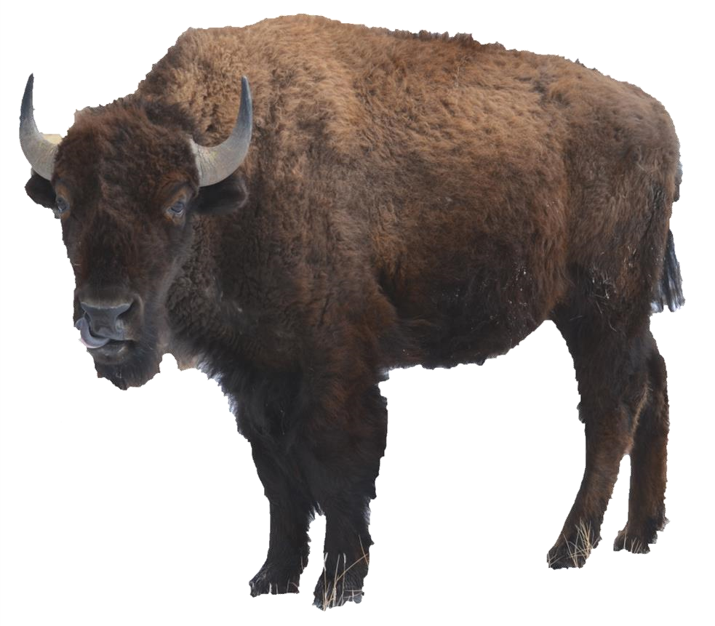

American Indians hunted bison in this area. These animals were important for survival, providing
food as well as other useful items that we find
in stores today.
.
Below are some of the uses Native
Americans had for different parts of the bison.

For each part of the bison, write down a use from the list below.

Blanket

Water storage

Cups

Tools

Clothing

Glue

Fly swatter

(
bones)

1)
(hide) Blanket

2)
(hide)

(
bladder
)

(
)
horn

(
hoof)

(
tail)

The Family Tree of the Ecosystem
At Wind Cave National Park the prairie dog is the keystone species. A keystone species is important because almost every animal has an interaction with the prairie dog in some way. Without the prairie dog many of the other species that live in Wind Cave National Park would not be able to survive.
Do you have a keystone species where you live? __________________________
Match up the animals and plants that rely on the prairie dog to how they rely on them. Can you think of another animal that might also rely on the prairie dog? Write it here:_____________________
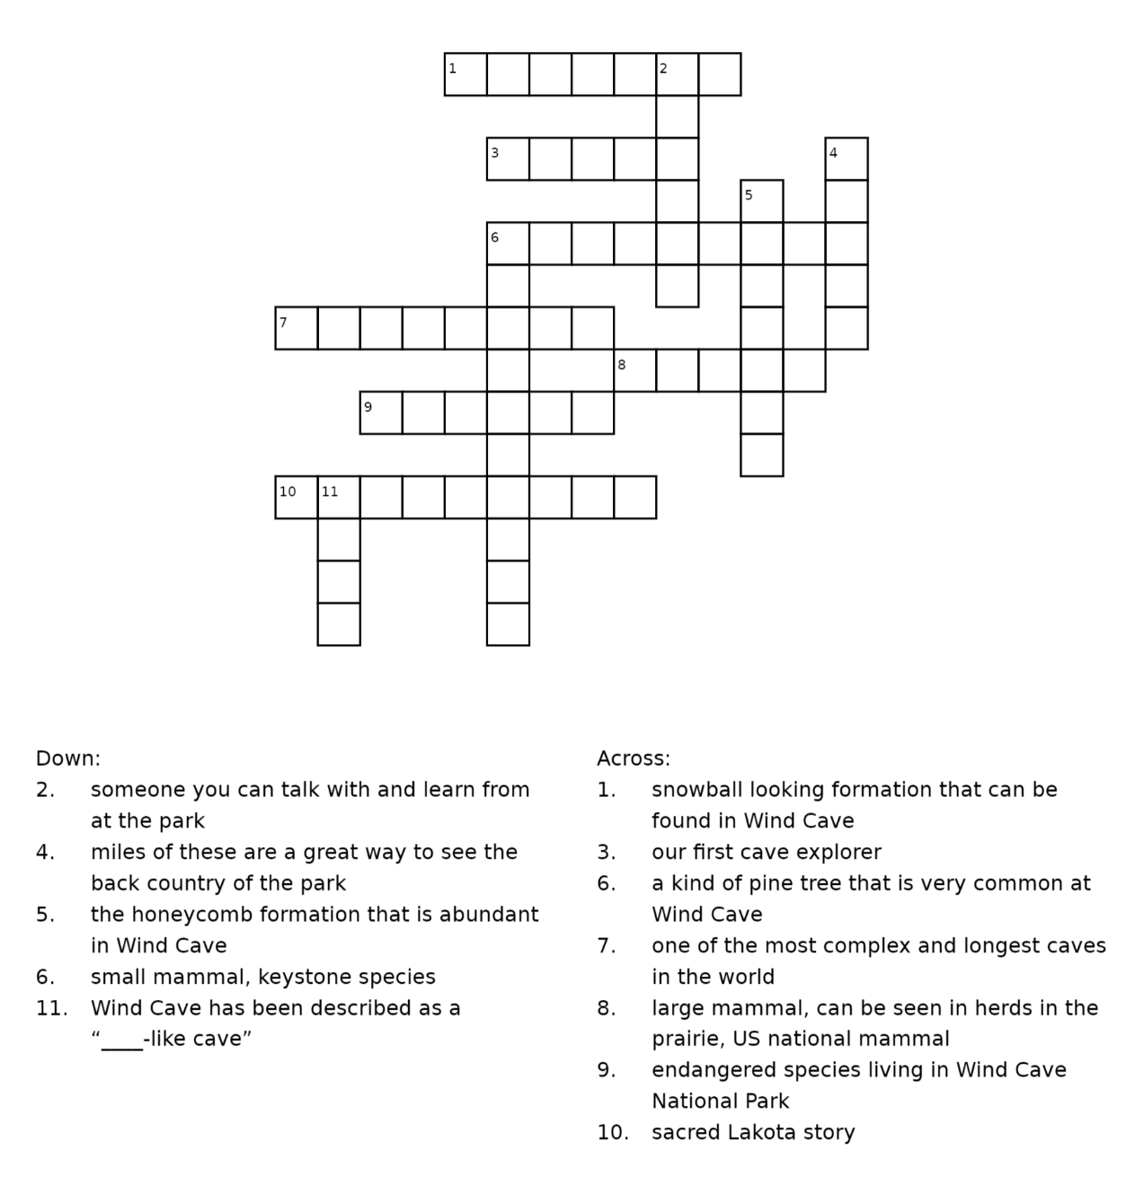
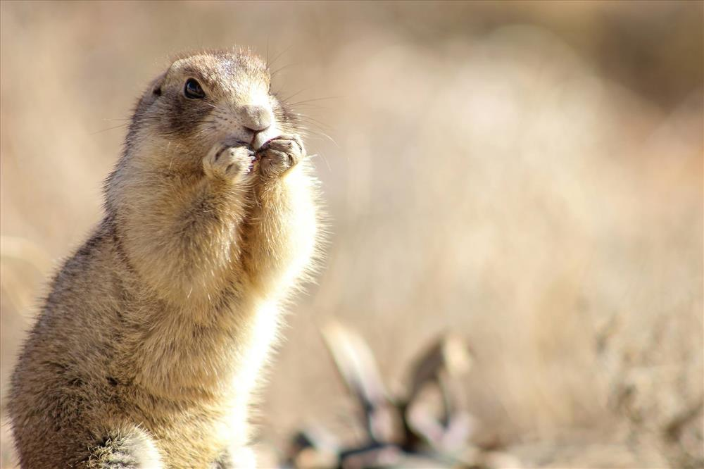
Lives in the burrows
3.
Hunts around prairie dog towns but doesn’t hunt prairie dogs
Word Bank:
Burrowing Owl Grasses
Bison Ferret
Fertilizers
Prairie dogs are great gardeners, they dig up the ground, allowing more seeds and water into the soil.
1.
Prairie dogs improve the soil, giving them more grass to eat.
2.
Lives in the burrows
4.
Hunts prairie dogs
Word Bank
Alvin
Bison
Boxwork
Emergence
Ferret
Maze
Ponderosa
Popcorn
Prairie Dog
Ranger
Trail
Wind Cave
Wind cave has been called two parks in one. One park is the cave; the other park is the prairie. All resources are important to the park.
Complete the crossword to learn about the resources found at Wind Cave National Park.
Wind Cave Crossword
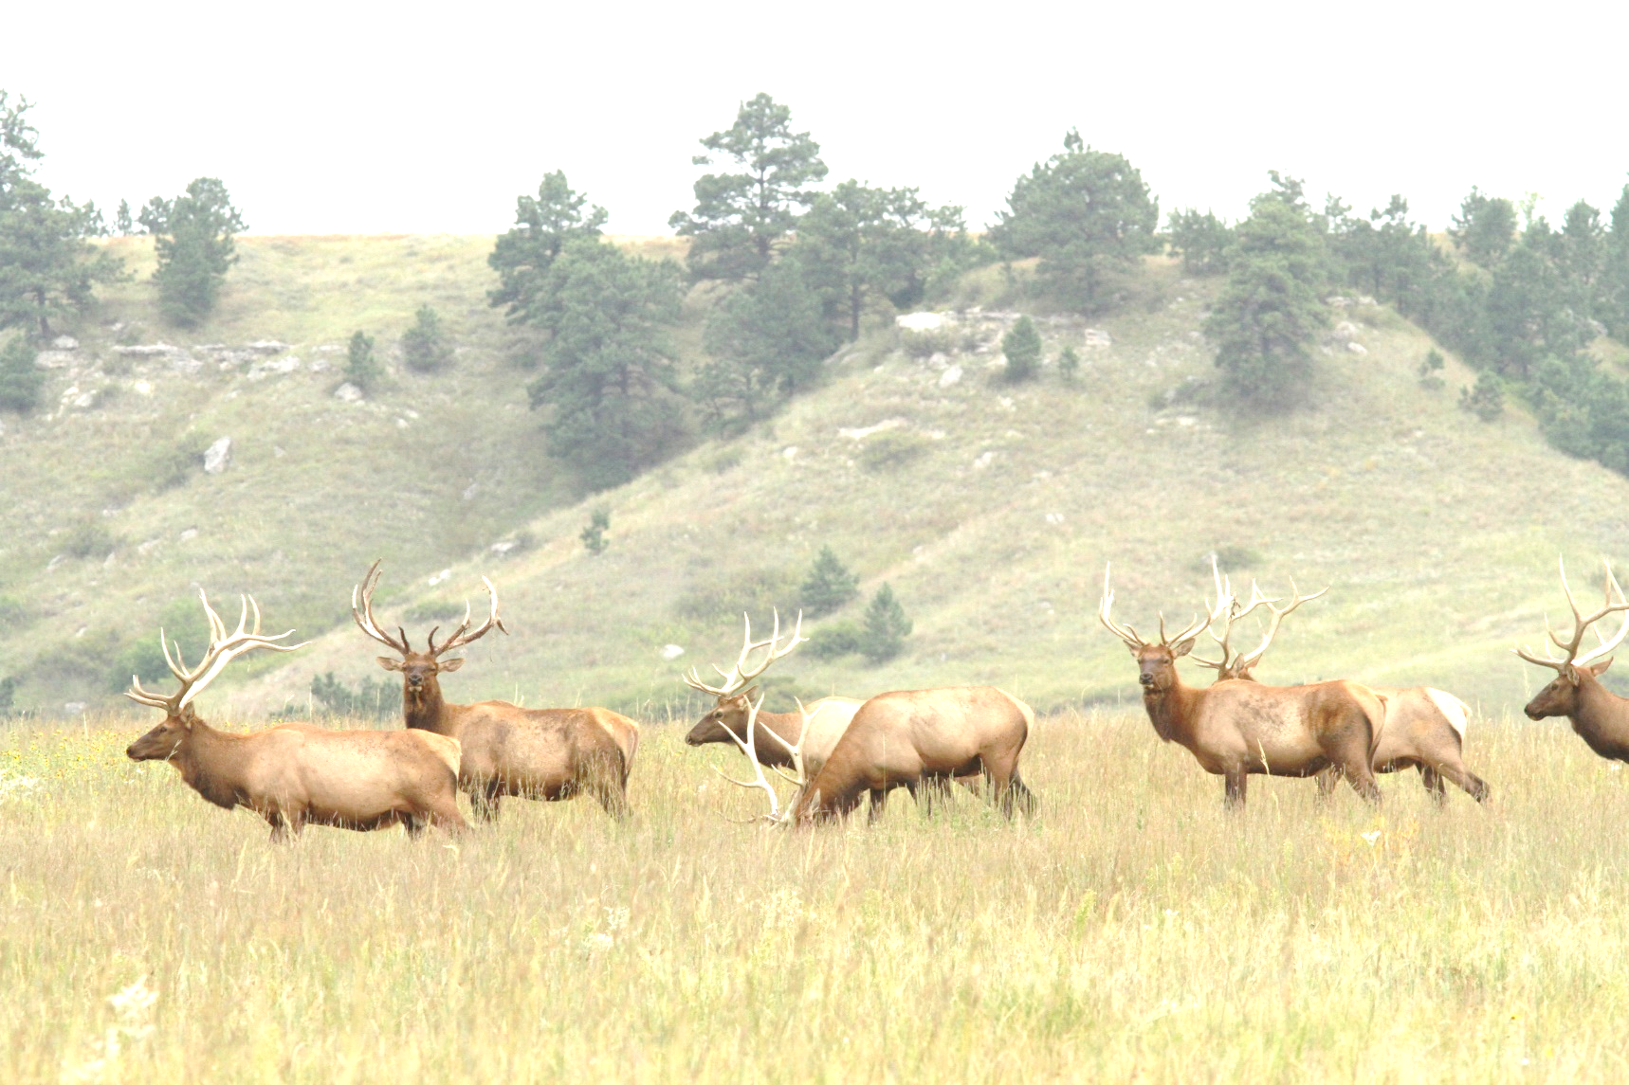
Certificate of Completion

______________________________
Has Earned The Title of
Junior Ranger
at Wind Cave National Park

___________________ _________________
Park Ranger Signature Date

Online Junior Ranger Book answers

What’s in a Cave?
- Stalactite
- Frostwork
- Boxwork
- Popcorn
- Dog Tooth Spar
- Flowstone
Who Was Hunting in the Prairie?
- Coyote
- Mountain Lion
- Black Footed Ferret
- Golden Eagle

Supermarket of the Plains
Horn = cups
Hoof = Glue
Bladder = Water Storage
Bones = Tools
Hide = Blanket & Clothing
Tail = Flyswatter
The Family Tree of the Ecosystem
- Grasses
- Bison
- Black Footed Ferret
- Burrowing Owls
Wind Cave Crossword
Down
2. Ranger
4. Trail
5. Boxwork
6. Prairie Dog
11. Maze

Across
1. Popcorn
3. Alvin
6. Ponderosa
7. Wind Cave
8. Bison
9. Ferret
10. Emergence

