
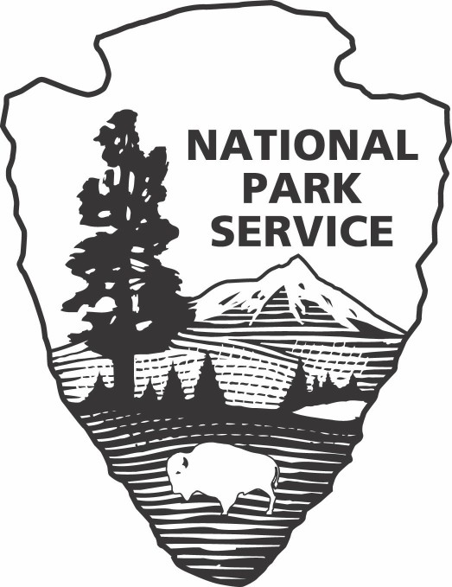
APPLICATION FOR SPECIAL USE PERMIT

[Tonto National Monument]
[26260N. Highway 188 Lot 2]
[Roosevelt, AZ 85545]
[928-467-2241 x 400]

Please supply the information requested below. Attach additional sheets, if necessary, to provide required information. A nonrefundable processing fee of $100.00 must accompany this application unless the requested use is an exercise of a First Amendment right. You must allow sufficient time for the park to process your request; check with the park for guidelines. You will be notified of the status of the application and the necessary steps to secure your final permit. Your permit may require the payment of cost recovery charges and proof of liability insurance naming the United States of America an additional insured.
* Enter either a Social Security Number OR a tax ID number; we do not require both.

Applicant Information | Company/Organization Information
Applicant Name: | Company/Organization Name:
Social Security Number*: | Tax Identification Number*:
Street Address: | Street Address:
City: | City:
State: | State:
Zip Code: | Zip Code:
Country: | Country:
Telephone Number: | Telephone Number:
Cell Phone Number: | Contact Name:
Fax Number: | Fax Number:
Email Address: | Email Address:

Activity Details
Description of Proposed Activity (attach diagram and/or additional pages, if necessary)

Location Details
Requested Location

Equipment Details
Support equipment (list all equipment; attach additional pages if necessary)

Timing
Set-Up Begins |  | Activity Begins |  | Activity Ends |  | Removal Completed
Date:  Time:  AM PM |  | Date:  Time:  AM PM |  | Date:  Time:  AM PM |  | Date:  Time:  AM PM
Date: Time:  AM | PM | Date: Time:  AM | PM | Date: Time:  AM | PM | Date: Time:  AM | PM
Date: Time:  AM | PM | Date: Time:  AM | PM | Date: Time:  AM | PM | Date: Time:  AM | PM

Vehicles & Participants
If using any vehicles, attach a parking plan to this form.
Type | Maximum Number
Participants (best estimate)
Cars
Vans/Light Trucks
Utility Vans/Trucks
Buses/Oversized Vehicles

Support Personnel
List support personnel including addresses and telephones; attach additional pages if necessary
Name | Address | Cell Phone Number

Individual in Charge
Individual in charge of activity onsite who is authorized to make decisions related to the permitted activity

Name | Cell Phone Number

Activity Questions
Is this an exercise of First Amendment Rights? Y N

Have you visited the requested area? Y N

Do you plan to advertise or issue a press release before the event? Y N

Have you obtained a permit from the National Park Service in the past? Y N
(If yes, provide a list of permit dates and locations on a separate page.)

Will you distribute printed material? Y N

Is there any reason to believe there will be attempts to disrupt, protest, or prevent your event? Y N
(If yes, please explain on a separate page.)

Do you intend to solicit donations or offer items for sale? Y N
(These activities may require an additional permit.)

Is this permit to carry out a Good Samaritan Search and Recovery Mission? Y N

You are encouraged to attach additional pages with information useful in evaluating your permit request including: staging, sound systems, parking plan, security plans, sanitary facilities, crowd control, emergency medical plan, use of any building, site clean-up, etc.
The applicant by his or her signature certifies that all the information given is complete and correct, and that no false or misleading information or statements have been given.

Name
Date
Signature

NOTICES

IMPORTANT NOTICE TO APPLICANT
This is an application only and does not serve as permission to conduct any special activity in the park. The information provided will be used to determine whether a permit will be issued. Send the completed application along with the application fee in the form of a [cashier’s check, made payable to the National Park Service] to Tonto National Monument at the park address found on the first page of this application.
If your request is approved, a permit containing applicable terms and conditions will be sent you. The permit must be signed by the responsible person and returned to the park for final approval by the Park Superintendent before the permitted activity may begin.

Customers Making Payment by Personal Check

When you provide a check as payment, you authorize us either to use information from your check to make a one-time electronic fund transfer from your account or to process the payment as a check transaction. When we use information from your check to make an electronic fund transfer, funds may be withdrawn from your account as soon as the same day we receive your payment, and you will not receive your check back from your financial institution.
Privacy Act Statement

General: This information is provided pursuant to Public Law 93-579 (Privacy Act of 1974), December 21, 1984, for individuals completing this application.

Authority: The authority to collect information on the attached form is derived from 54 U.S.C. 100101, Promotion and regulation; 54 U.S.C. 100751(a), Regulations; 54 U.S.C. 103104, Recovery of costs associated with special use permits; and 54 U.S.C 100905 Commercial Filming.

Purposes and Uses: The information being collected to allow the park manager to make a value judgment on whether or not to allow the requested use. Information from the application may be transferred to appropriate Federal, State, and local agencies, when relevant to civil, criminal or regulatory investigations or prosecutions.
Effects of Nondisclosure: It is in your best interest to answer all of the questions. The U.S. Criminal Code, Title 18
U.S.C. 1001, provides that knowingly falsifying or concealing a material fact is a felony that may result in fines of up to
$10,000 or 5 years in prison, or both. Deliberately and materially making false or fraudulent statements on this form will be grounds for not granting you a Special Use Permit

Information Regarding Disclosure of Your Social Security Number Under Public Law 93-579 Section 7(b): Your Social Security Number (SSN) is needed to identify records unique to you. Applicants are required to provide their social security or taxpayer identification number for activities subject to collection of fees and charges by the National Park Service. Failure to disclose your SSN may prevent or delay the processing of your application. The authority for soliciting your SSN is 54 U.S.C.103104. The information gathered through the use of the SSN will be used only as necessary for processing this application and collecting and reporting any delinquent financial obligations. Use of the social security number will be carried out in accordance with established regulations and published notices of system of records.
Paperwork Reduction Act Statement

We are collecting this information subject to the Paperwork Reduction Act (44 U.S.C. 3501) to provide the park managers the information needed to decide whether or not to allow the requested use. All applicable parts of the form must be completed in order for your request to be considered. You are not required to respond to this or any other Federal agency- sponsored information collection unless it displays a currently valid OMB control number.

Estimated Burden Statement
Public reporting burden for this form is estimated to average 30 minutes per response including the time it takes to read, gather and maintain data, review instructions and complete the form. Direct comments regarding this burden estimate, or any aspects of this form, to the Information Collection Clearance Officer, National Park Service, 12201 Sunrise Valley Drive Reston, Virginia 20192. Please do not send your form to this address.

INTERNAL AGENCY USE ONLY
Project Number/BILL:
Date Processed:
Permit Number:
Prepared By:
Organization Name:

PREVIOUS PARKS SERVICE PERMITS ACQUIRED:

