Make Your Own Fossils
Fossils are the remains of once living things and give scientists evidence of what environments were once like when those things were alive. Fossils are also helpful to sciences trying to distinguish periods of geologic time. 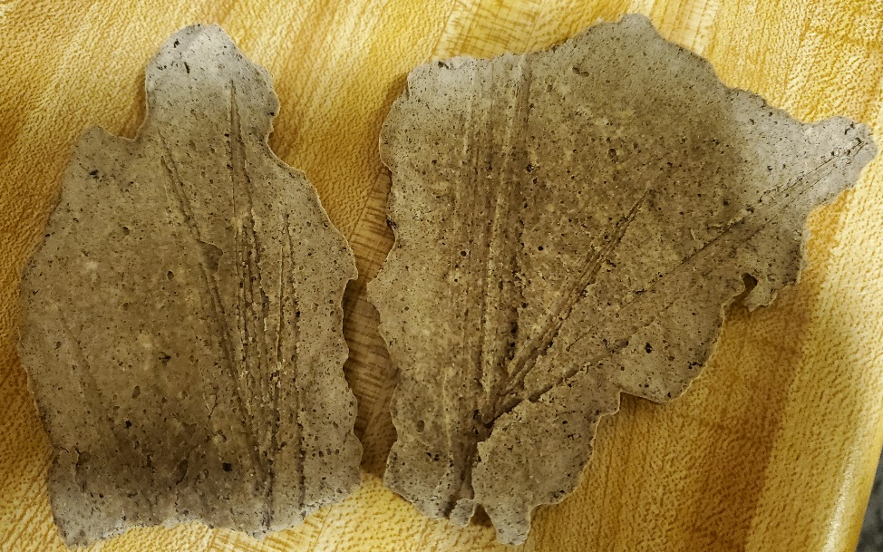

You will need:
- A large bowl
- Spoon
- Wax paper or foil
- 1 cup of flour
- ½ cup of salt
- 1 cups of cold coffee or water
- 1 cup of used coffee grounds (optional)
- Leaves, sticks, etc. you want to make fossils of
- Paint (optional)
There are a variety of ways that fossils can form that often depend on the characteristics of the organism. Some common types of fossilization include: molds and casts, permineralization, replacement, compression, trace fossils, and freezing.
In mold and cast fossils, sediment fills in the cavities of an organism producing a 3D model of it. In permineralization, the organic material (such as carbon) decays and is replaced by a mineral while retaining most of the information about the organism. The petrified redwood stumps at Florissant Fossil Beds National Monument were formed by permineralization. Volcanic mudflows called lahars had covered the bottoms of the redwood trees and provided enough silica that replaced the organic material of the wood.
Replacement is when the organic matter decays and is completely replaced by minerals. This leaves very little information about the original organism behind. Trace fossils are not usually an organism but are evidence that an organism had been there while it was still alive. Trace fossils include things such as tracks and footprints, and excrement/vomit (coprilite/regurgitite). There are some trace fossils found at Florissant Fossil Beds such as bird tracks and regergitite (vomit) and coprolites (feces) from fish. Fossils formed by freezing are more rare, but they can preserve even the internal organs normally lost in other fossils. Freezing has fossilized mammoths, and some even have hair still left!

Instructions
Step One: In the bowl, mix 1 cup of flour and ½ cup of salt. Add 1 cup of used coffee grounds. Hint: Let the grounds dry out or use a bit less liquid.
Step Two: Add 1 cup of cold coffee or water and mix well.
During the Eocene there were many different organisms living in the Florissant valley. The delicate plant and insect fossils in Florissant Fossil Beds National Monument were formed by compression. The plants and insects would fall into the ancient Lake Florissant and settle to the bottom. As the organisms got buried more sediment was deposited on top and squished them.
Step Three: Lay out you leaves and sticks on a sheet of wax paper or tin foil. Make sure there’s a bit of space between each item.
Step Four: Cover your leaves and sticks in the “sediment” mixture you made. It might help to use the spoon to do it bit by bit. Leave some space as you cover them to create separate fossils, or you’ll get a huge sheet!
Step Five: Let your fossils dry completely. You can leave them in a widow to let the sun help.
As the organisms decomposed they left behind a thin carbon film resulting in a dark stain from the organism. This is called carbonization. The carbon films can be thought of as a micro-cast of the organism. Some of the more sturdy plants, insects, and mollusks (such as snails or clams) were hard enough to leave behind an impression along with a carbon film.
Step Six: When your fossils are completely dry flip them over and carefully remove the remaining leaves and sticks. You should be left with an imprint of them in your new fossils.
Step Seven (Optional): If you want, you can use brown or tan paint to color the imprints of your fossils to look like carbon left behind by the leaves.

Vocabulary:
- Fossil: noun; a trace or print or the remains of a plant or animal of a past age preserved in earth or rock
- Cast: noun; the sediment that fills in a mold and takes the shape of the original organism
- Mold: noun; the frame in which something is constructed or shaped; the sediment that formed around the organism and remains after the organism decays away retaining its form
- Compression: noun; the act, process, or result of becoming pressed together or reduced in size, amount, or volume by pressure
- Permineralization: noun; in which minerals are deposited by water and form internal casts of organisms by filling in the spaces inside the organic materials
- Replacement: noun; the act of new minerals taking the place of the original minerals
- Trace fossil: noun; the fossil of a footprint, trail, burrow, or other evidence left by a past organism while it was living
- Carbonization: noun; the process of being changed into or becoming carbon
- Regurgitalite: noun; fossilized vomit
- Coprolite: noun; fossilized feces
- Freezing: verb; to harden into or be hardened into a solid by the loss of heat; to become fixed or motionless

Alt Text:
- Dried "coffee fossils" showing impressions of long sprigs of grass.

