Plate Tectonics
In science, theories are explanations proposed by scientists that are tested to see if they are correct. Evidence is used to either support or to disprove a theory. Geologists and paleontologists develop theories using the evidence they find in the field such as fossils. A scientist named Alfred Wegner is credited with developing the modern theory of plate tectonics. In this activity you will explore this fun theory Wegner gave us.

You will need:
- Continent templates (included)
- Fossil evidence (included)
- Pangaea map (included)
- Scissors
- Pencil
- Crayons (optional)

Instructions
The theory of plate tectonics states that the Earth’s crust (the fourth layer of the Earth) is broken up into pieces or plates that move while floating on top of the denser mantle. It is the movements of these plates that cause things such as earthquakes, volcanoes, mountain building and the movement of continents.
Step One: Can you name each continent? Write their names on them with the pencil. You can look at a world map to help.
Step Two: Cut out the continents by cutting along the dotted lines. Line them up how they would appear on a map of the world. If you would like to, color them in. Do you notice anything about their shapes?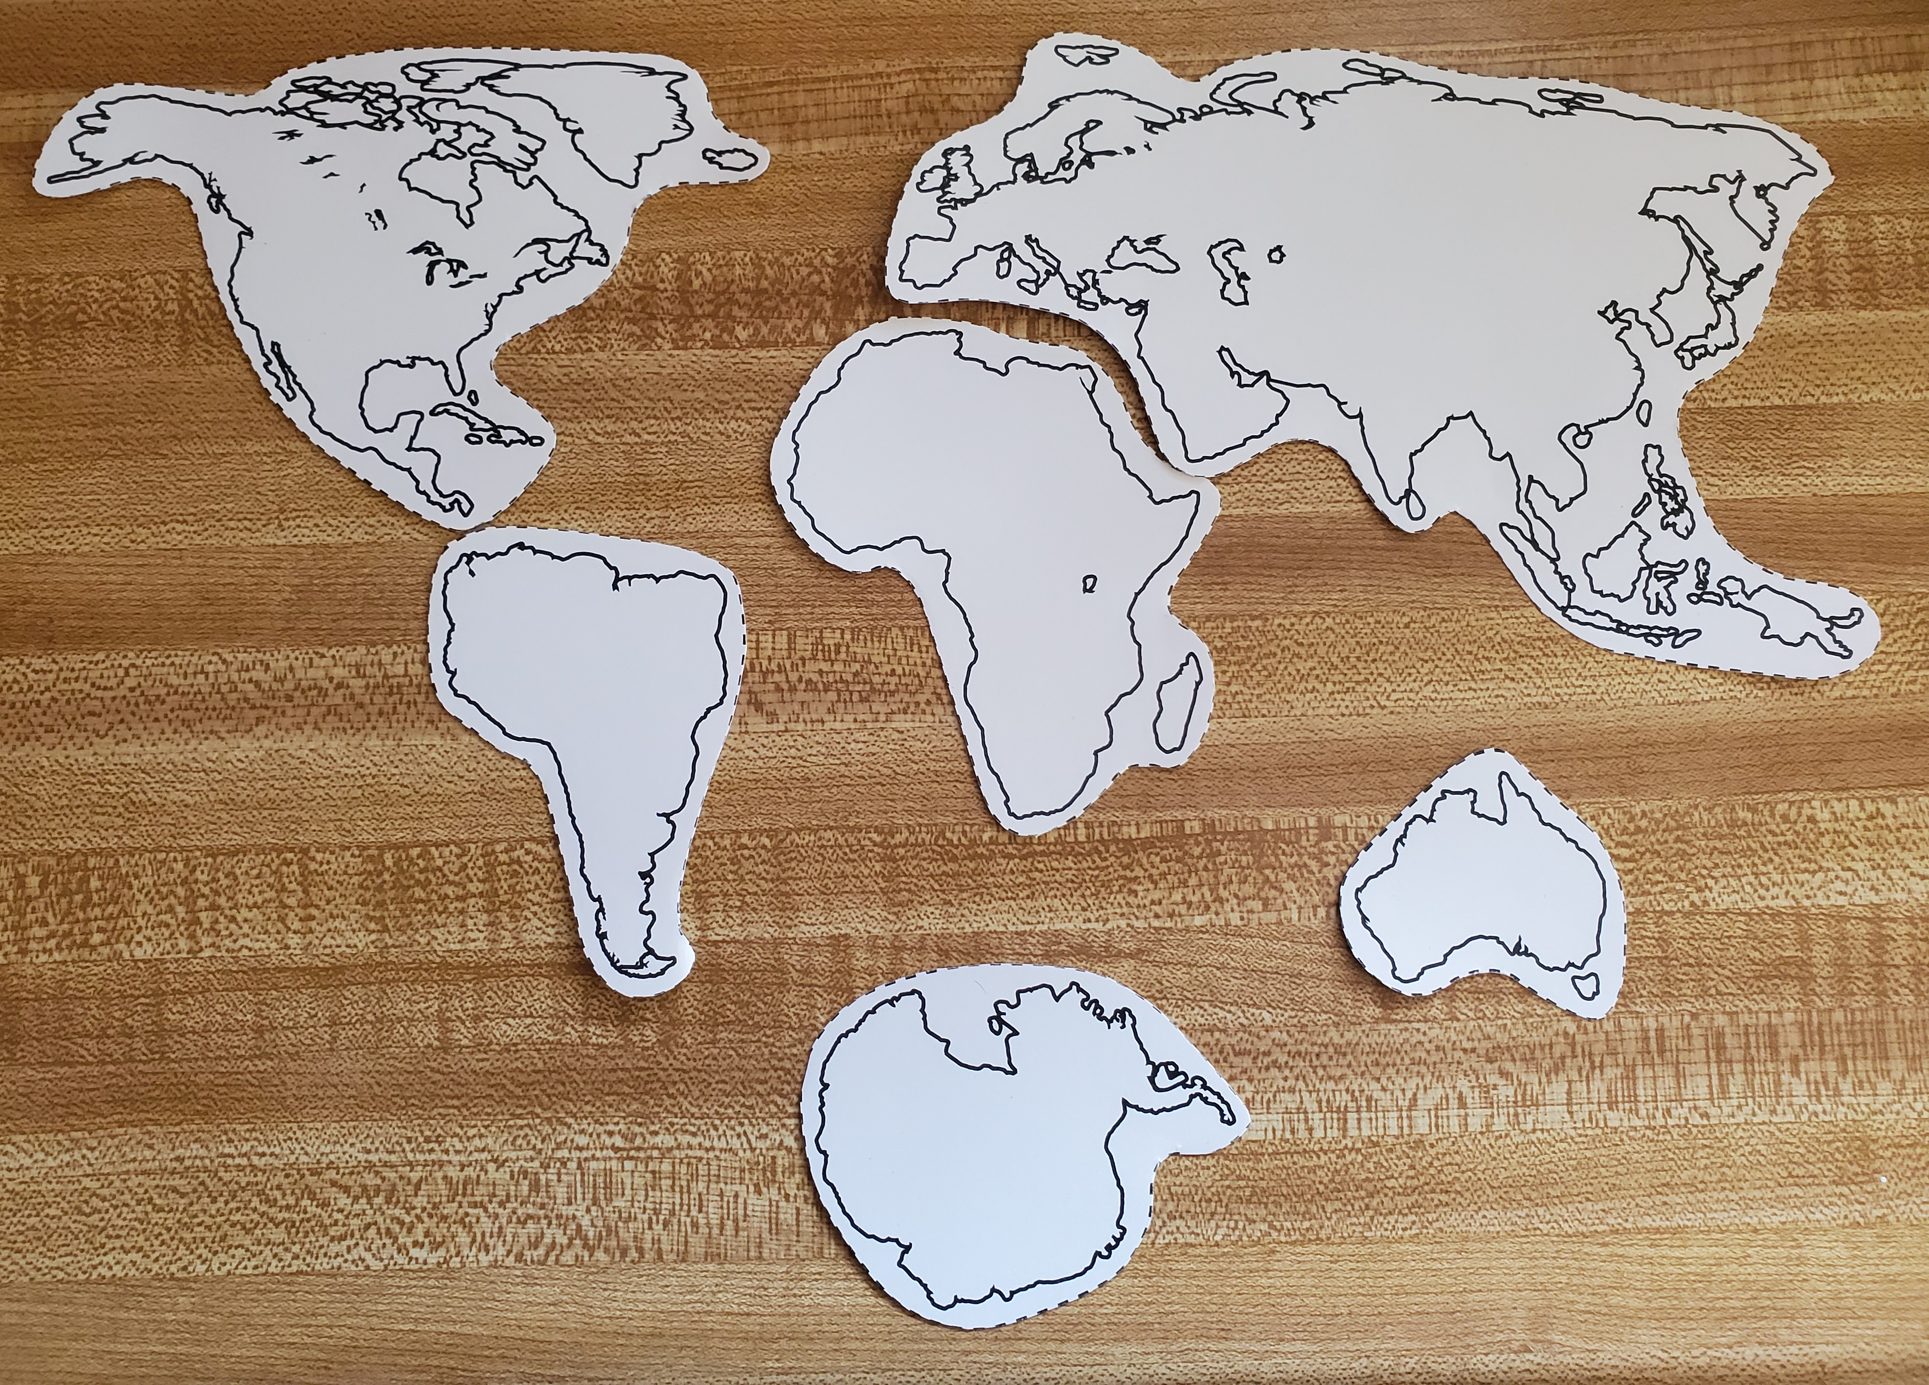
Step Three: Try to arrange the continents so that they fit together like a puzzle.
Wegner’s theory of plate tectonics was based on geological, paleontological, and climatological evidence that he found. Some of the things he noticed were
- the shapes of the continents fitting together like puzzle pieces.
- similar rock sequences of the same age found on separated continents.
- fossils of extinct plants and animals separated by distant continents.
- mountain ranges and glacial deposits that match up when continents are pushed together.
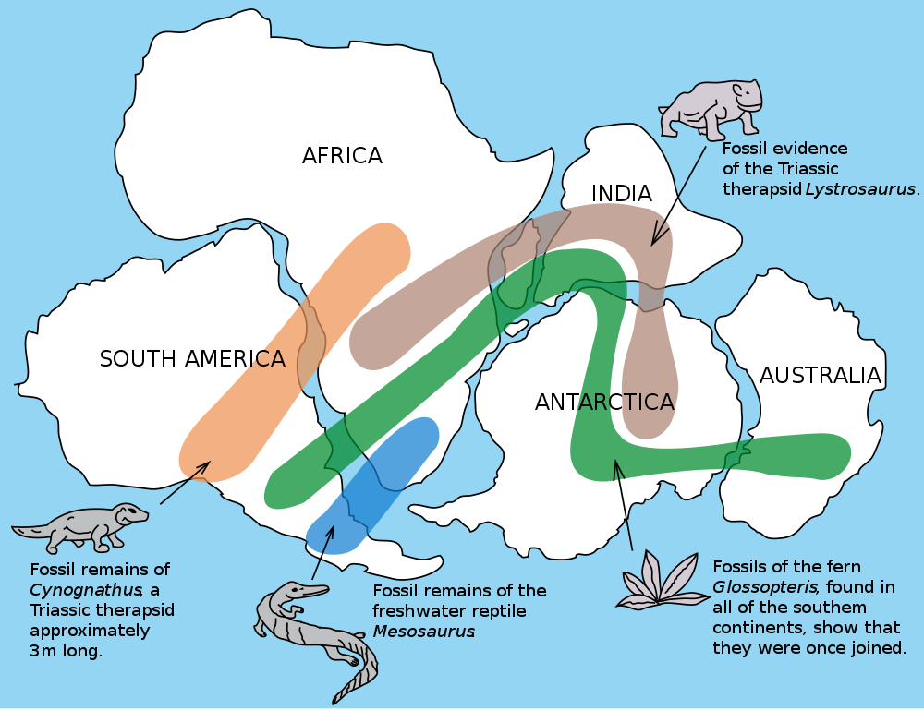
Step Four: Look at the fossil evidence that Wegner found and see if it helps you fit the continents together.
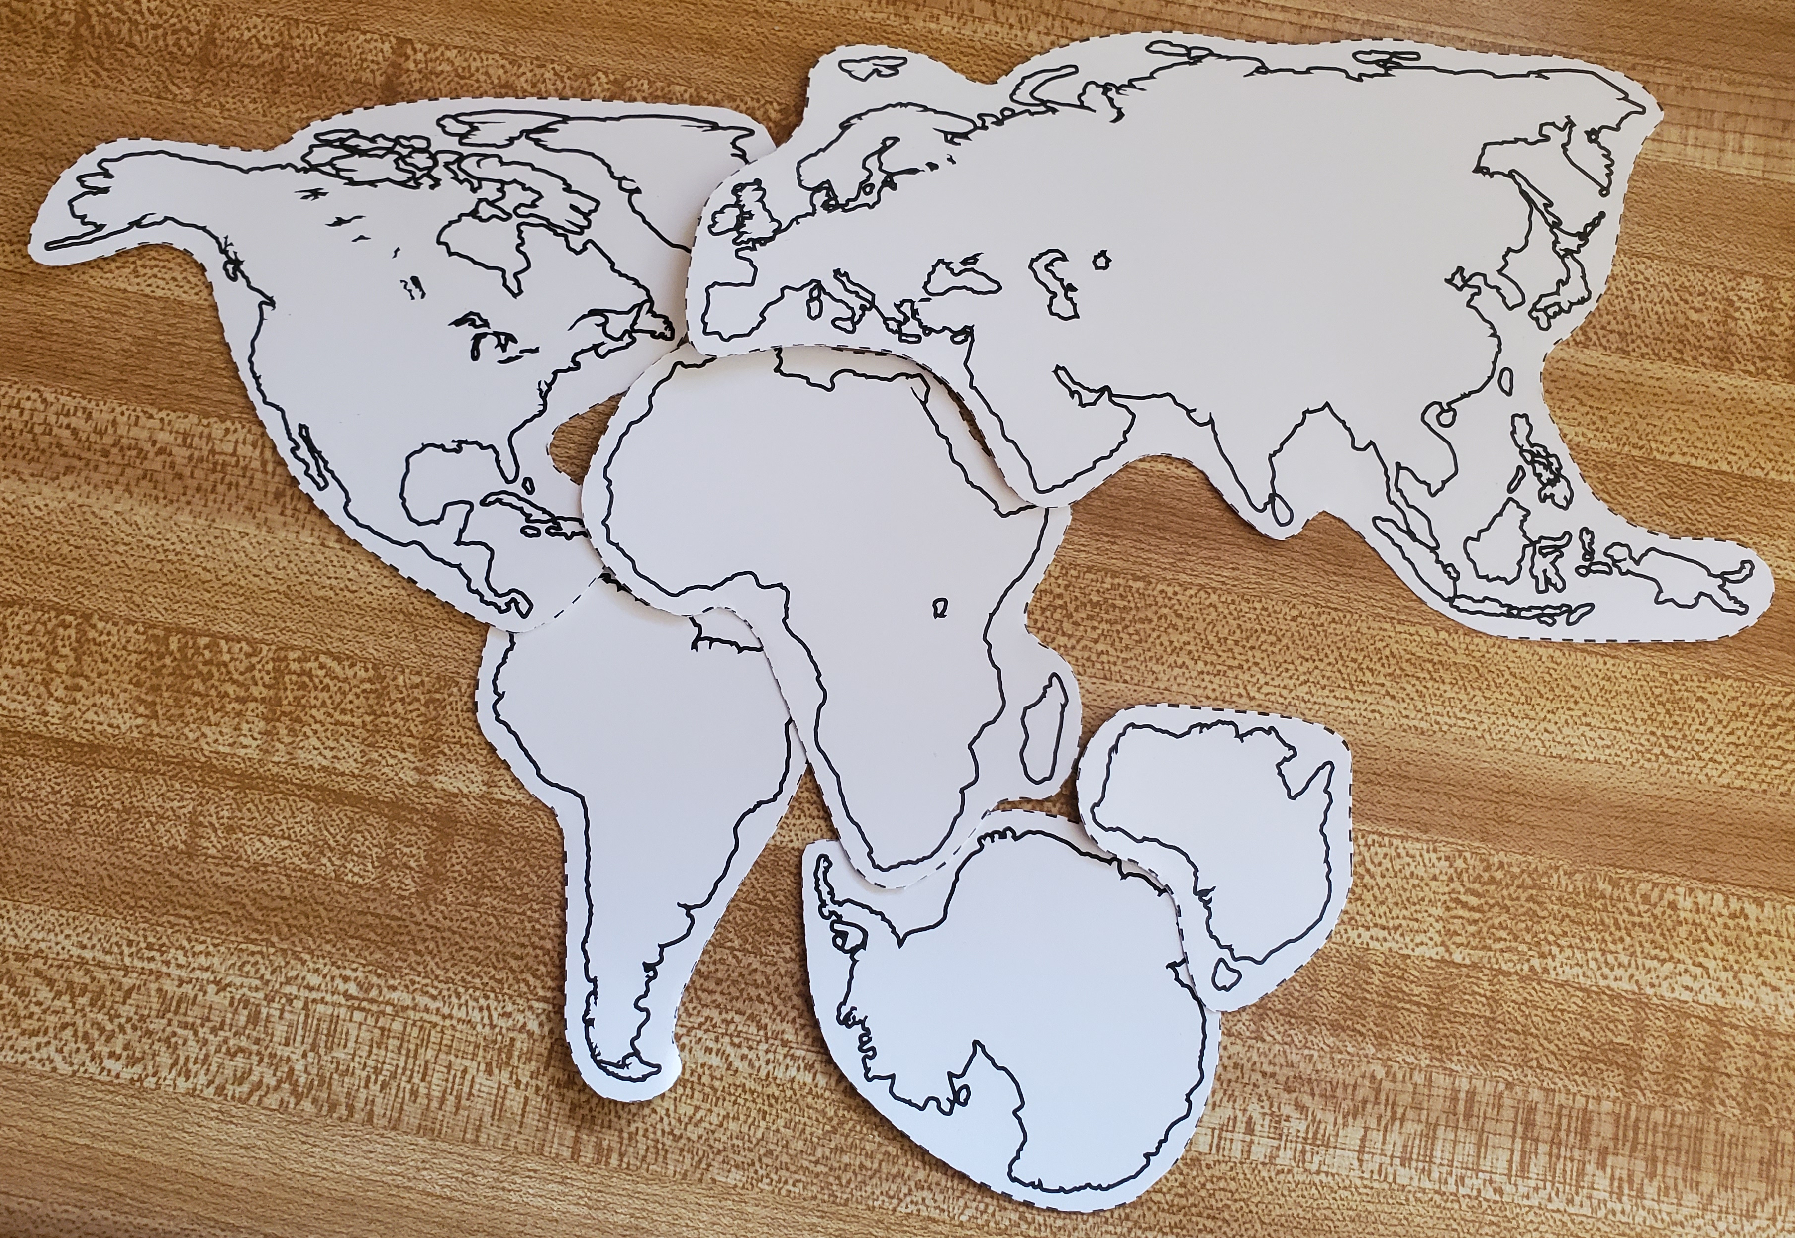
What Wegner found suggests that at some point in time the continents had all been connected. The large landmass created by all the continents being joined together is called a supercontinent. It is likely that over the Earth’s long lifetime multiple supercontinents have been formed and broken apart. The most recent supercontinent was named Pangaea (meaning “all earth”). This is the supercontinent that dinosaurs were walking on.
Step Five: Look at the provided map of Pangaea and compare it to your arrangement of continents. Were you close? 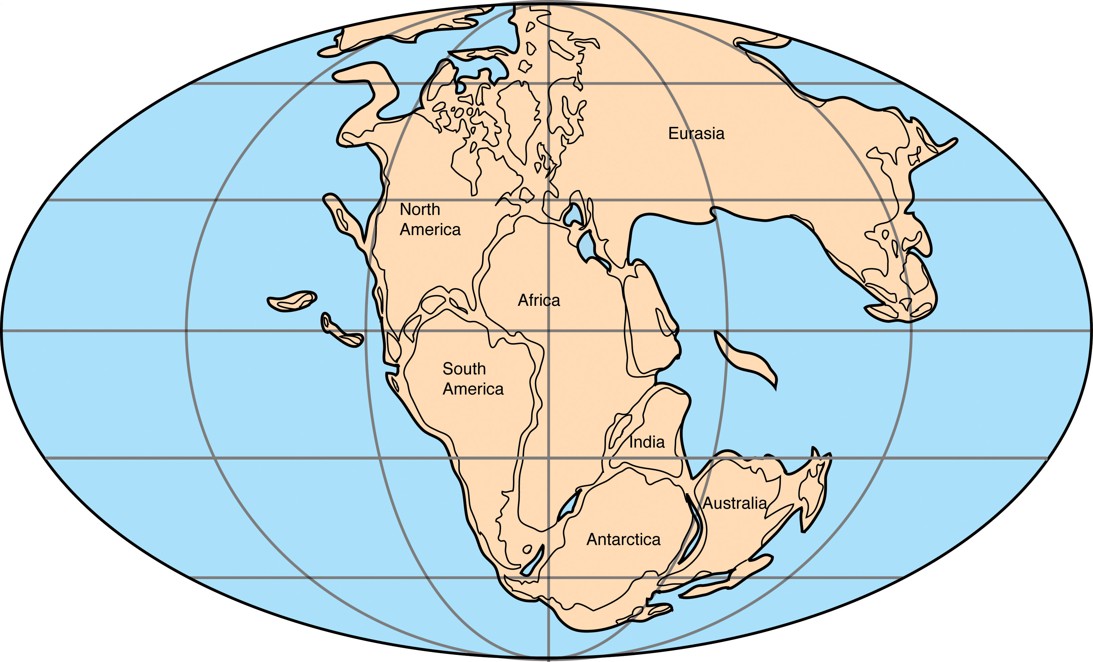
Do you think the tectonic plates are still moving today? Because they are! But scientists know that they move so slowly that we usually can't feel it.
What do you think could cause them to move? Most scientists agree that there are convection cells in the mantle where magma is rising and sinking in a circular pattern as it is heated by the core and cools under the crust. This causes the plates to be pushed along at the top of those circles. Sometimes the movement of the plates causes them to scrape against each other or get pushed under or over one another. This is what causes earthquakes. Have you felt an earthquake before? If so, you have firsthand experience with evidence of the plates moving!
Why do you think animals in Australia are so different from those on other continents? Scientists believe that Australia broke off from Pangaea earlier than the rest. That allowed the animals on the new continent to adapt to their surroundings separately from those on the other continents.

Vocabulary:
- Theory: noun; an idea that is the starting point for argument or investigation
- Evidence: noun; material presented to prove or disprove something and help find the truth of a matter
- Continent: noun; one of the great divisions of land on the globe (Europe, Asia, Africa, North America, South America, and Antarctica)
- Plate Tectonics: noun; a theory in geology that states that the lithosphere of the earth is divided into a small number of moving plates whose movement causes seismic activity such as earthquakes
- Paleontology: noun; a science dealing with the life of past geological periods as known especially from fossil remains
- Paleomagnetism: noun; magnetic polarization in minerals in a rock which formed at the time the rock was formed

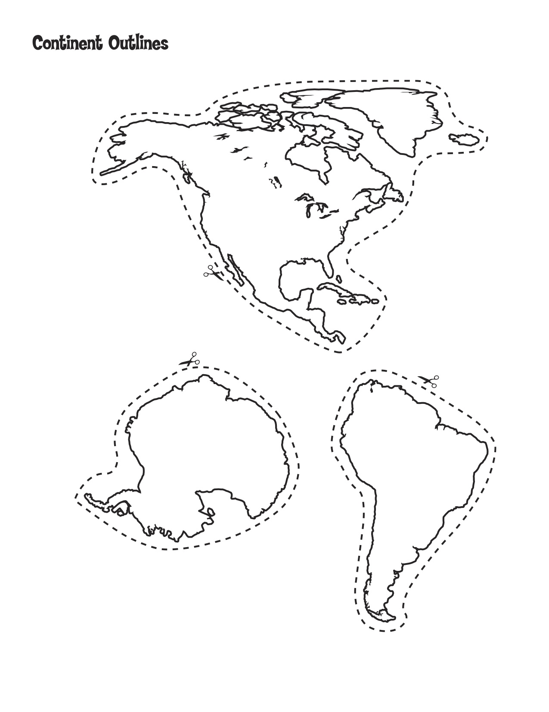

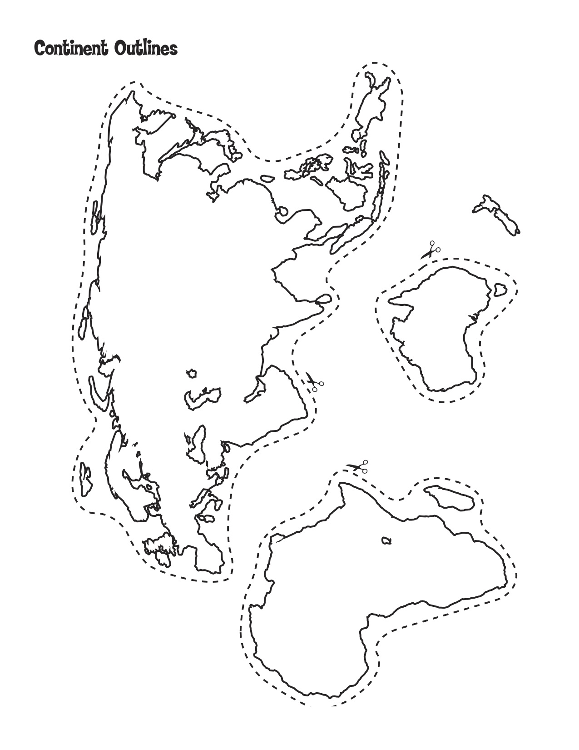
Alt Text:
- Paper cutouts of the seven continents arranged on a table as they are on a modern map.
- A simple map of Pangea showing the ranges of fossils of prehistoric organisms found across today's continents.
- Paper cutouts of the seven continents arranged to join together as they were to create the prehistoric super continent Pangaea.
- Map of the Mesozoic supercontinent Pangea with today's continents outlined and labeled within it.
- Templates of North America, South America, and Antarctica to be cut out.
- Templates of Africa, Australia, and Europe and Asia to be cut out.

