Rocky Mountain National Park
Wildlife Safe Distance Campaign
Social Media Posts and Timeline
Note: All links have been shortened with custom URLs for tracking purposes for the research. Below each post that contains a link is a description of the web page it should link to, if applicable.
Times were selected based on general effective posting times for each platform and desired audience (weekend visitors who may be up and browsing social media earlier in the morning than typical).
Consider using Hootsuite (free version) or another manager of choice to schedule posts ahead of time within a single interface. Otherwise, both Facebook and Twitter for business have options to schedule posts in advance, but Instagram does not. Syncing Hootsuite with your mobile device and NPS Instagram account is required to post to Instagram: https://blog.hootsuite.com/how-to-schedule-instagram-posts/

Timeline Summarized
Date and Post Description | Time and Channels
Thursday, 9/14  Campaign graphic | Noon, Twitter  1 p.m., Facebook  3 p.m., Instagram
Friday, 9/15  Do not disturb | 8:00 a.m., Facebook and Instagram
Saturday, 9/16  Photo tip | 8:00 a.m., Twitter, Facebook, Instagram
Sunday, 9/17  Never get close | 9:30 a.m., Facebook and Instagram

Thursday, Sept. 14: 1 post each to Twitter, Facebook, Instagram
Twitter at Noon
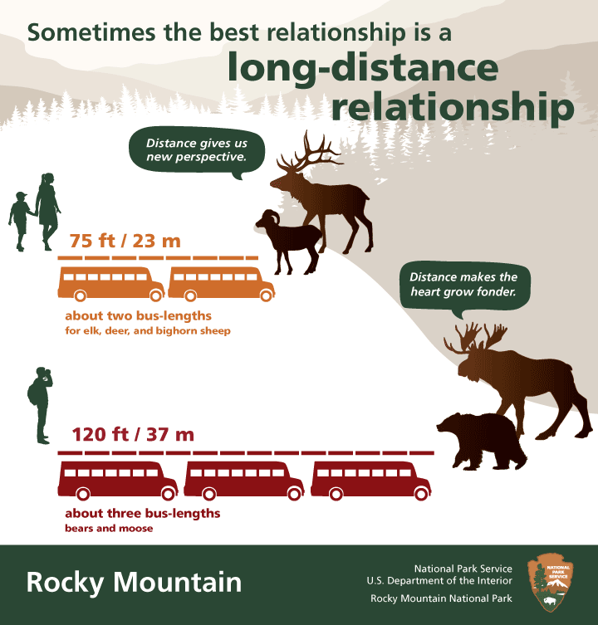
Image: 9-14_campaign_graphic.png
Caption/text: A great #RMNP trip starts w/ the safe distance from wildlife. More on how 2 see wildlife: https://goo.gl/DyR17h #FindYourDistance
Link should direct to Wildlife Viewing and Photography page:
https://www.nps.gov/romo/planyourvisit/wildlife_view.htm

Facebook at 1:00 p.m.
Image: 9-14_campaign-graphic.png
Caption/text: A great Rocky Mountain National Park experience starts with the safe distance from wildlife. We think a long-distance relationship is the best kind of relationship because it allows you to stay safe and give wildlife the space they need. For more on how to view wildlife in our park, go to: https://goo.gl/B97ZJx
Link should direct to Wildlife Viewing and Photography page:
https://www.nps.gov/romo/planyourvisit/wildlife_view.htm
Instagram at 3:00 p.m.
Image: 9-14_campaign-graphic.png
Caption/text: A great #RMNP experience starts with the safe distance from wildlife. We think a long-distance relationship is the best kind of relationship because it allows you to stay safe and give wildlife the space they need. For more on how to view wildlife in our park, go to the link in our bio. #FindYourDistance
***Replace the profile/bio link with: http://bit.ly/2y0vcFz (please keep as link in bio until Monday)
Link should direct to Wildlife Viewing and Photography page:
https://www.nps.gov/romo/planyourvisit/wildlife_view.htm
***You will have to replace the existing bio link with this one. Instagram only allows one link in the bio.
Friday, Sept. 15: 1 post each to Facebook and Instagram
Facebook at 8:00 a.m.
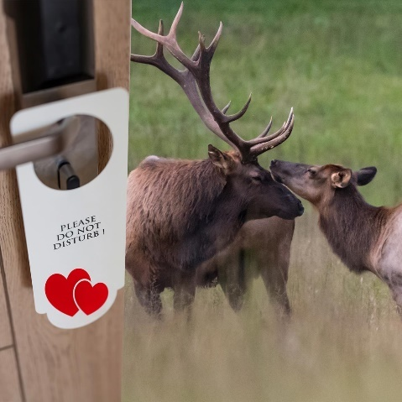
Image: 9-15_do-not-disturb.jpg
Caption/text: It’s the elk rut, and you know what that means. They don’t mind you looking on, and neither do we, so long as it’s from the safe distance: at least 75 feet or 2 bus-lengths. A bit of a long-distance relationship with the elk and other wildlife is truly the best kind. Get more tips on how to see wildlife in the park: https://goo.gl/SyDQjL
Link should direct to Wildlife Viewing and Photography page:
https://www.nps.gov/romo/planyourvisit/wildlife_view.htm

Instagram at 8:00 a.m.
Image: 9-15_do-not-disturb.jpg
Caption/text: It’s the elk rut, and you know what that means. They don’t mind you looking on, and neither do we, so long as it’s from the safe distance: at least 75 feet or 2 bus-lengths. A bit of a long-distance relationship with the elk and other wildlife is truly the best kind. See link in bio for more tips on how to see wildlife in the park. #RMNP #FindYourDistance
Link in Bio remains the same.
Saturday, Sept. 16: 1 post each to Twitter, Facebook, Instagram
Twitter at 8:00 a.m.
Image: 9-16_photo-tip.jpg
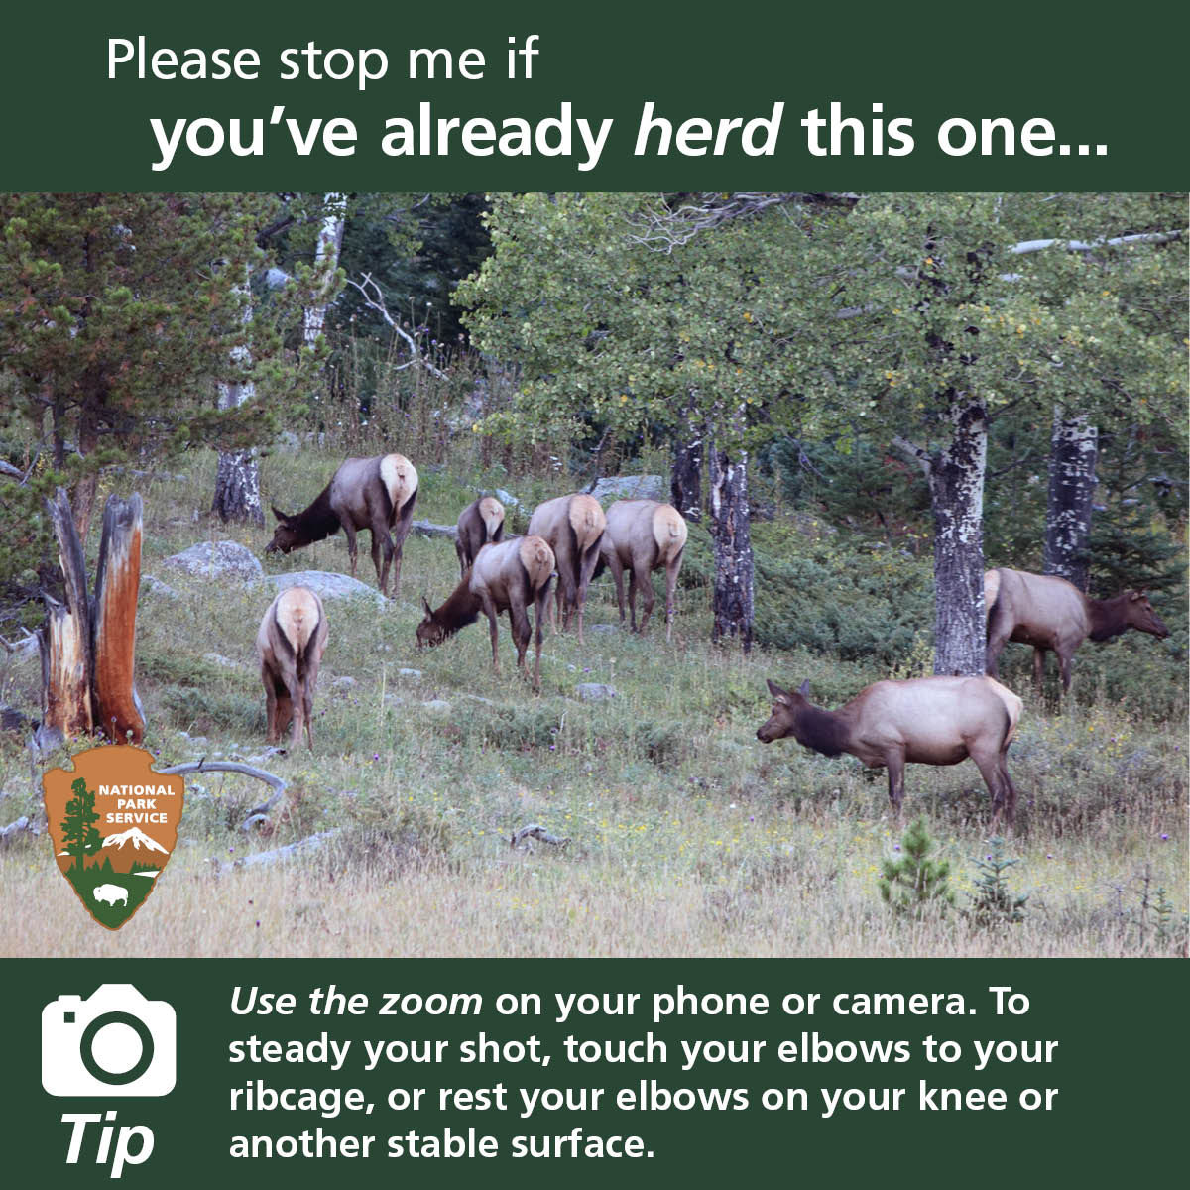
Caption/text: Share your wildlife photos taken from the safe distance using #RMNP #FindYourDistance. See more tips: https://goo.gl/tcJiW3

Facebook at 8:00 a.m.
Image: 9-16_photo-tip.jpg
Caption/text: It’s easy to capture amazing wildlife photos, even from a distance. What are your tips for getting wildlife photos from the safe distance? If you’ve got a photo taken from the safe distance (about 2 bus-lengths or 75 feet), let’s see it in the comments. See all of ours at: https://goo.gl/X2SkhF
Link should direct to Wildlife Viewing and Photography page: https://www.nps.gov/romo/planyourvisit/wildlife_view.htm

Instagram at 8:00 a.m.
Image: 9-16_photo-tip.jpg
Caption/text: It’s easy to capture amazing wildlife photos, even from a distance. What are your tips for getting wildlife photos from the safe distance? If you’ve got a photo taken from the safe distance (about 2 bus-lengths or 75 feet), share it using #RMNP #FindYourDistance or tag us.

Sunday, Sept. 17: 1 post each to Facebook and Instagram
Facebook at 9:30 a.m.
Image: never-get-close-elk.jpg
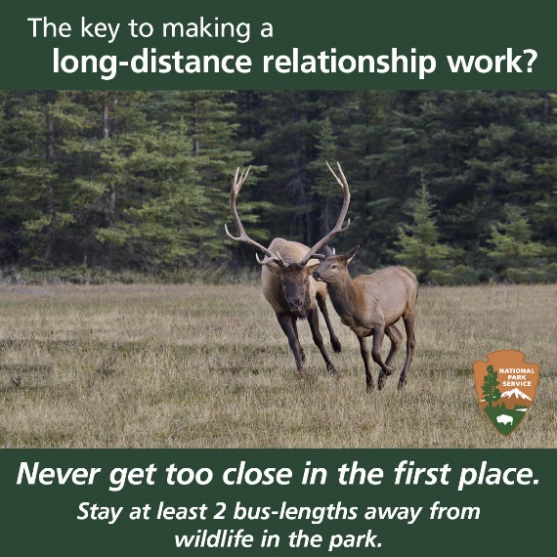
Caption/text: Many know to keep their distance from animals with sharp claws and teeth. But even seemingly docile or familiar animals can have a fierce temper. That’s why we recommend a bit of a long-distance relationship with wildlife. For more on wildlife viewing and safety: https://goo.gl/MQZ1e9
Link should go to Wildlife Safety page: https://www.nps.gov/romo/planyourvisit/wildlife-safety.htm
Instagram at 9:30 a.m.
Image: 9-17_never-get-close.jpg
Caption/text: Many know to keep their distance from animals with sharp claws and teeth. But even seemingly docile or familiar animals can have a fierce temper. That’s why we recommend a bit of a long-distance relationship with wildlife. For more on wildlife viewing and safety, see link in bio. #RMNP #FindYourDistance

