Assateague Island National Seashore
Wildlife Safe Distance Campaign
Social Media Posts and Timeline
Note: All links have been shortened with custom URLs for tracking purposes for the research. Below each post that contains a link is a description of the web page it should link to, if applicable.
Times were selected based on general effective posting times for each platform and desired audience (weekend visitors who may be up and browsing social media earlier in the morning than typical).
Consider using Hootsuite (free version) or another manager of choice to schedule posts ahead of time within a single interface. Otherwise, both Facebook and Twitter for business have options to schedule posts in advance, but Instagram does not. Syncing Hootsuite with your mobile device and NPS Instagram account is required to post to Instagram: https://blog.hootsuite.com/how-to-schedule-instagram-posts/

Timeline Summarized
Date and Post Description | Time and Channels
Thursday, 7/27  Campaign graphic/launch | Noon, Twitter  1 p.m., Facebook  3 p.m., Instagram
Friday, 7/28  Selfie cat (2 different versions: 1 for FB, 1 for IG) | 8:30 a.m., Facebook and Instagram
Saturday, 7/29  Hold your horses | 8:30 a.m., Twitter, Facebook, Instagram
Sunday, 7/30  You can’t foal us | 9:30 a.m., Facebook and Instagram

Thursday, July 27: 1 post each to Twitter, Facebook, Instagram
Twitter at Noon
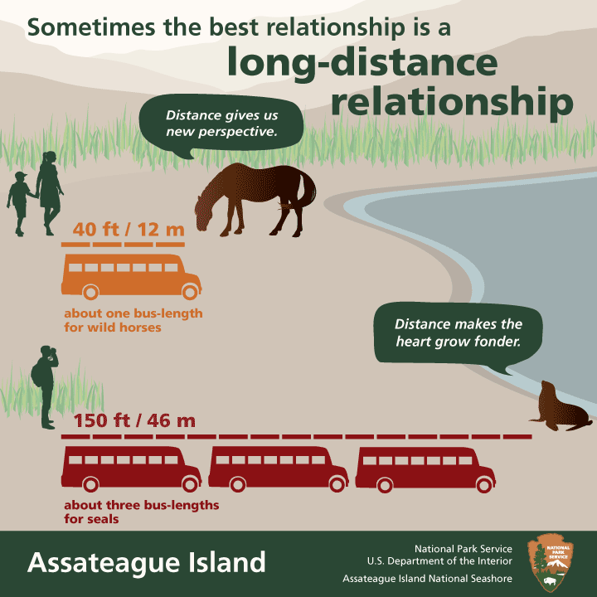
Image: 7-27_campaign_graphic.png
Caption/text: A great #Assateague trip starts w/ the safe distance from wildlife. More on how 2 see wildlife: https://goo.gl/tEHBNu #FindYourDistance
Link should direct to Wildlife Viewing and Safety page:
https://www.nps.gov/asis/planyourvisit/wildlife-viewing-and-safety-tips.htm
Facebook at 1:00 p.m.
Image: 7-27_campaign_graphic.png
Caption/text: A great Assateague Island National Seashore experience starts with the safe distance from wildlife. We think a long-distance relationship is the best kind of relationship because it allows you to stay safe and give wildlife the space they need. For more on how to view wildlife in our park, go to: https://goo.gl/R2yPNq
Link should direct to Wildlife Viewing and Safety page: https://www.nps.gov/asis/planyourvisit/wildlife-viewing-and-safety-tips.htm
Instagram at 3:00 p.m.
Image: 7-27_campaign_graphic.png
Caption/text: A great #Assateague Island National Seashore experience starts with the safe distance from wildlife. We think a long-distance relationship is the best kind of relationship because it allows you to stay safe and give wildlife the space they need. For more on how to view wildlife in our park, go to the link in our bio. #FindYourDistance
***Replace the profile/bio link with: http://bit.ly/2uMjLlw (this link can remain in bio through the weekend since it also contains the link to the photography page)
Link should direct to Wildlife Viewing and Safety page: https://www.nps.gov/asis/planyourvisit/wildlife-viewing-and-safety-tips.htm

***Grand Canyon had trouble with a Google shortened link for their Instagram bio, so I’m trying a bit.ly one instead this time. From my understanding and experience, it should work, but if it doesn’t, just put the full regular URL to the Wildlife Viewing and Safety page in the bio instead of the shortened one.

Friday, July 28: 1 post each to Facebook and Instagram
Facebook at 8:30 a.m.
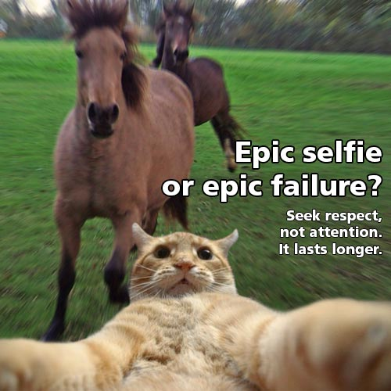
Image: 7-29_facebook_selfie_cat.jpg
Caption/text: Wildlife photos can still be epic, even at the safe distance: about one bus-length for wild horses and deer and about 3 bus-lengths for seals (who stop by in the winter). What are your tips for getting great pics of wildlife? See ours at https://goo.gl/eZnyqH
Link should go to Photography page: https://www.nps.gov/asis/planyourvisit/how-to-see-and-photograph-wildlife.htm

Instagram at 8:30 a.m.
Image: 7-29_instagram_selfie_cat.jpg
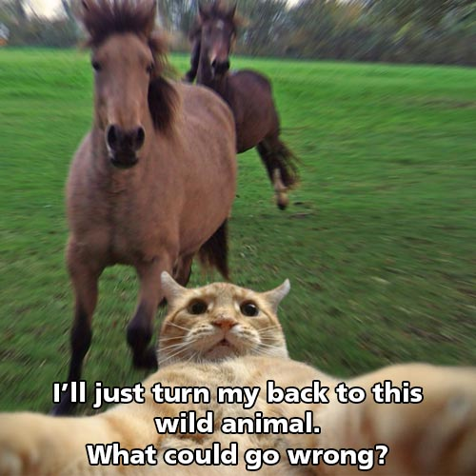
Caption/text: A lot more could go right if you take your wildlife photos at the safe distance: about one bus-length for wild horses and deer, and about 3 bus-lengths for seals (who stop by in winter). What are your tips for getting great pics of wildlife? Comment here or share your wildlife photos using #Assateague #FindYourDistance. See link in bio for our tips!

Link in Bio remains the same because the photography page is linked up from the safety page.

Saturday, July 29: 1 post each to Twitter, Facebook, Instagram
Twitter at 8:30 a.m.
Image: 7-29_hold_your_horses.jpg
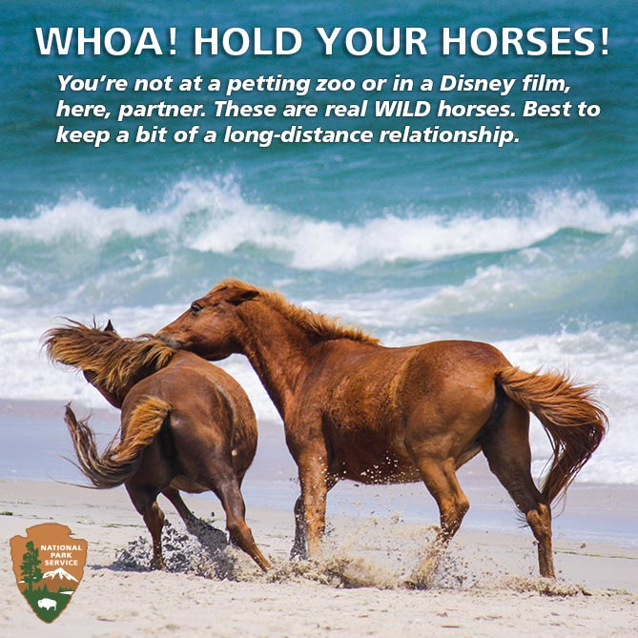
Caption/text: Help keep #Assateague unique by treating it like a national park. #HorsePlayOnWords #FindYourDistance
Facebook at 8:30 a.m.
Image: 7-29_hold_your_horses.jpg
Caption/text: We know keeping 40 feet away feels like we’re asking a lot when you’re all giddy with excitement about seeing our wild horses on the beach. Staying that distance is what helps keep these horses and other creatures here wild. Help us keep Assateague unique and special by treating it like a national park. #HorsePuns4Days #HorsePlayOnWords #ISeeWhatYouDidThere #FindYourDistance
Instagram at 8:30 a.m.
Image: 7-29_hold_your_horses.jpg
Caption/text: We know keeping 40 feet away feels like we’re asking a lot when you’re all giddy with excitement about seeing our wild horses on the beach. Staying that distance is what helps keep these horses and other creatures here wild. Help us keep #Assateague unique and special by treating it like a national park. #FindYourDistance #HorsePuns4Days #HorsePlayOnWords #ISeeWhatYouDidThere
Sunday, July 30: 1 post each to Facebook and Instagram
Facebook at 9:30 a.m.
Image: 7-30_cant_foal_us.jpg
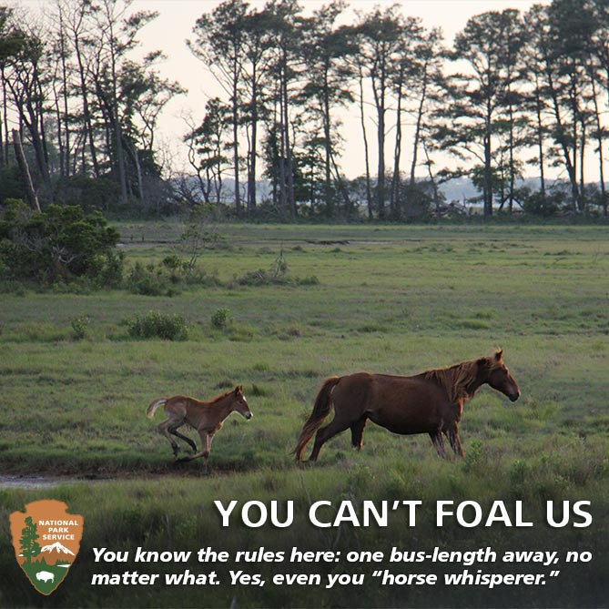
Caption/text: Many know to keep their distance from animals with sharp claws and teeth. But even seemingly docile or familiar wildlife can have a fierce temper, especially when their young are nearby. Remember, distance makes the heart grow fonder. For more on wildlife viewing and safety: https://goo.gl/JnqVXY (Photo credit: Ron Shawley)
Link goes to wildlife safety page: https://www.nps.gov/asis/planyourvisit/wildlife-viewing-and-safety-tips.htm
Instagram at 9:30 a.m.
Image: 7-30_cant_foal_us.jpg
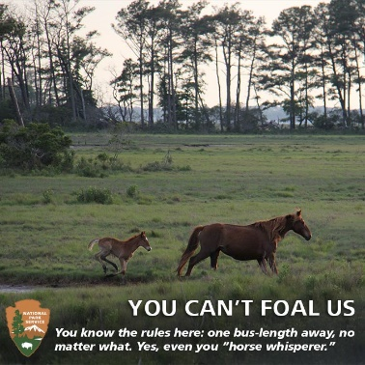
Caption/text: Many know to keep their distance from animals with sharp claws and teeth. But even seemingly docile or familiar wildlife can have a fierce temper, especially when their young are nearby. Remember, distance makes the heart grow fonder. For more on wildlife viewing and safety, see link in bio. #Assateague #FindYourDistance (Photo credit: Ron Shawley)

