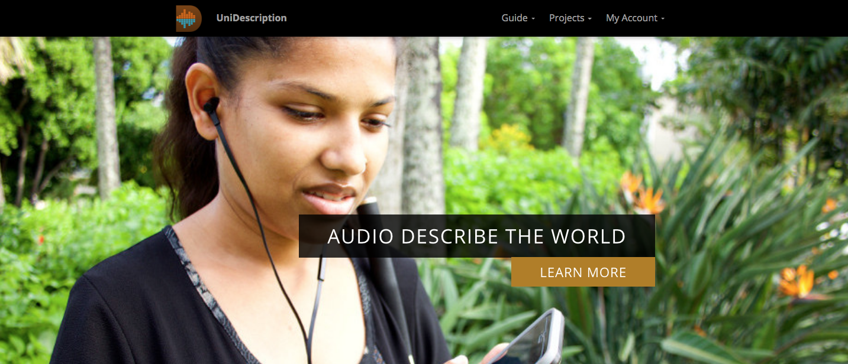

The UniDescription Project: Delivery and Playback

Executive Summary
The community of users who are blind, have low vision, have a print-related disability, or are auditory learners are diverse. They use different equipment based on their needs and technology skills. The UniD system allows for multiple outputs to make audio-described “unigrid” brochure content accessible.
Each audio-described NPS unigrid brochure in this project has been added to the UniDescription mobile app, available for free on the App (Apple / iOS devices, https://goo.gl/zAWWj6) and Google Play (Android devices, https://goo.gl/EU9pjc).
The UniD system allows additional formats to be created (HTML5, Mp3 audio files and text files), for distribution on websites, social media or person-to-person sharing, based on the user’s needs and available tools. These distribution formats are intended to cover all use-case scenarios involving park visitors who are blind, have low vision, have print-related disabilities, or are audio-oriented learners.
Below are step-by-step instructions for accessing and downloading the app, and exporting and uploading UniD files onto each park’s NPS.gov website. Denali National Park and Preserve is an early adopter of this project. Their webpage is a helpful example of how these formats can be shared.
Points of Contact:
- Dr. Brett Oppegaard, University of Hawaii, brett.oppegaard@hawaii.edu, 360-521-8150
- Michele Hartley, Harpers Ferry Center, michele_hartley@nps.gov, 304-535-6083

Dissemination Steps

Encourage Everyone to Download this Free App
The UniD team recommends that park users download the UniD mobile app, which has been designed to be the most efficient and effective method for accessing the audio-description material. The app makes available all of the park brochures created within UniD (more than 50 to date, across the country).
- For Android users, either open this link: https://goo.gl/SH3dNS or, open the Google Play app on your smartphone or tablet computer. Then, search for “UniDescription.” Download the free app. Open and use.
- For iOS (Apple) users, either open this link: https://goo.gl/EU9pjc or, open the App Store on your smartphone or tablet computer. Then, search for “UniDescription.” Download the free app. Open and use.
NOTE: The UniD app automatically downloads the park content (its text and Mp3s) when the app is opened and the particular park file is selected (while online). Once downloaded the content is available in the app, even with no connectivy.

Create a Website Page for UniD Content
- Create a page entitled “Park Brochure” in the Plan Your Visit section of the park’s NPS.gov website.
- Place that page in the navigation under Plan Your Visit > Basic Information.
- Place a text element at the top of this page and add some introductory text such as, “The park brochure is available in a variety of formats including braille, audio description, and text-only.”
- Provide a link to this page from other pages on your website that would make users aware of this content, such as your Accessibility, Maps and/or Publications pages.

Next, Export UniD Content
- On the Park Brochure page (see above for instructions to make such a page), create a section with the header “Audio-Described Version”
- In the UniD web tool, www.unidescription.org, sign in. Locate your project file, under My Projects.
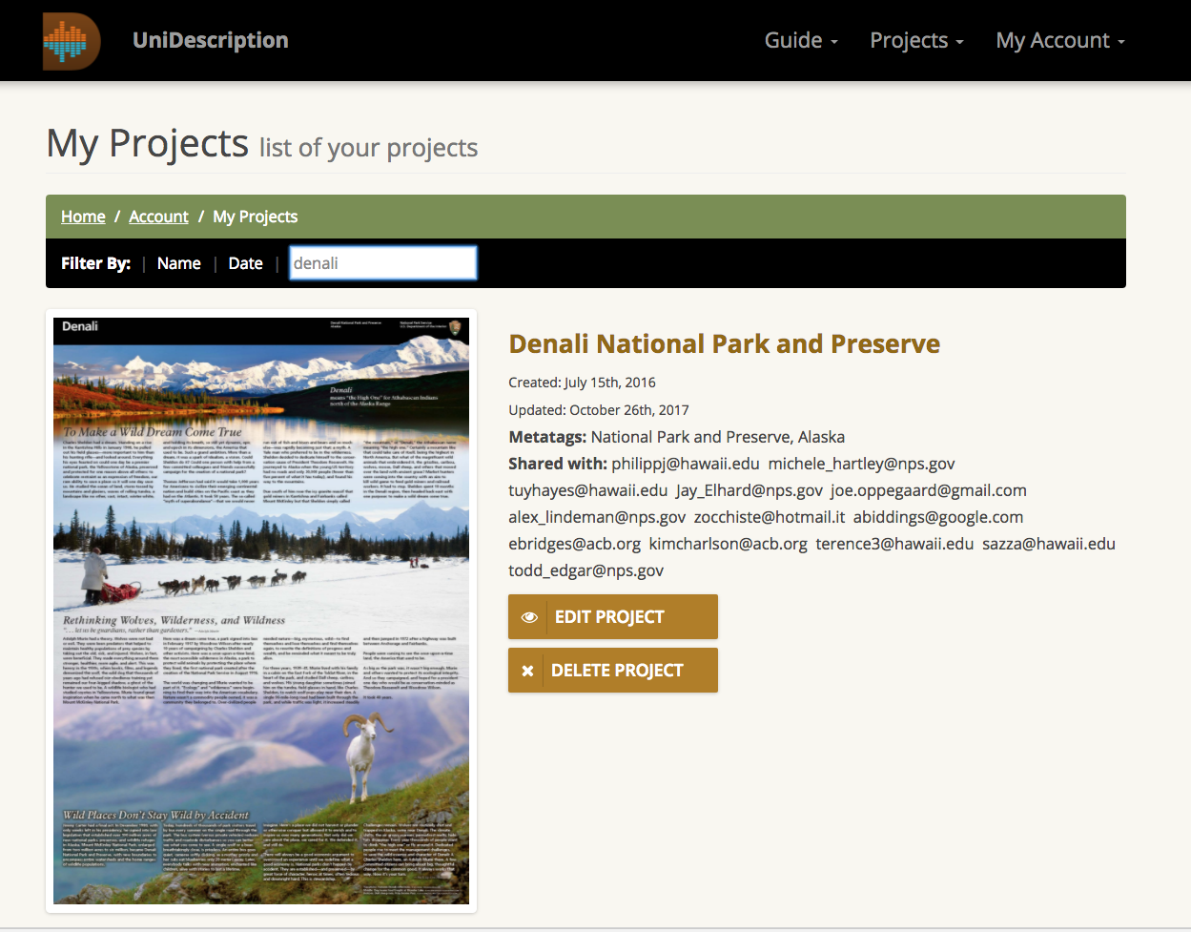
- If you were not involved in the park’s UniD brochure project and do not have an account, you will need to register for a free account and get access to the park’s project. See “For More Information” below for contact information to discuss access to a particular project.
- Choose Edit Project.
- On the Backstage tab, locate the Export options. The UniD website is scalable based on your screen size and how big you make the window when you are on the UniD website. If you cannot find the Export options, scroll to the bottom of the page. Pictured below, Export options are at the bottom right.
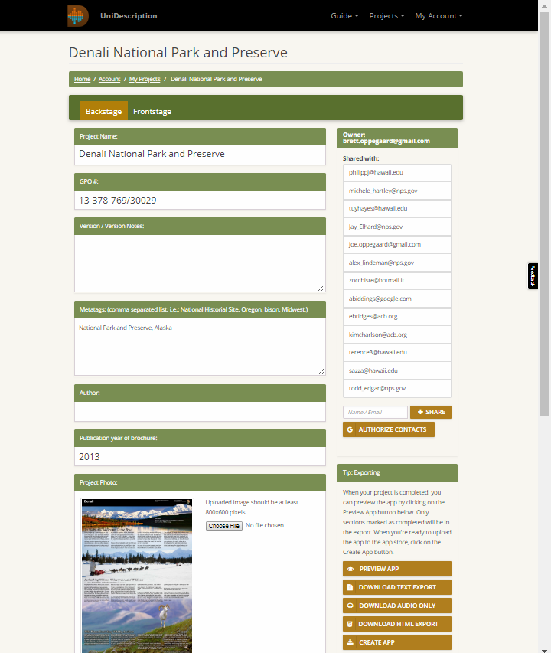

Gather and Upload Mp3 Audio Files
- On the Overview tab of the UniD web tool (see above), locate the Export options in the right-hand column. Choose Download Audio Only.
- This action will create a folder with (machine-voiced) Mp3s of all of the audio descriptions on the UniD tool that have been selected as “complete (green check mark in the Table of Contents).” Files not checked as complete in the Table of Contents will not be exported.
- Individual audio files also can be downloaded by clicking on the download icon on the Table of Contents tab. In addition, alternative recordings (such as human voice recordings) can be uploaded to replace the machine voice.
- Audio files can be shared online as a static Zip file (will need to be updated with new content) or as individual audio files (also static).
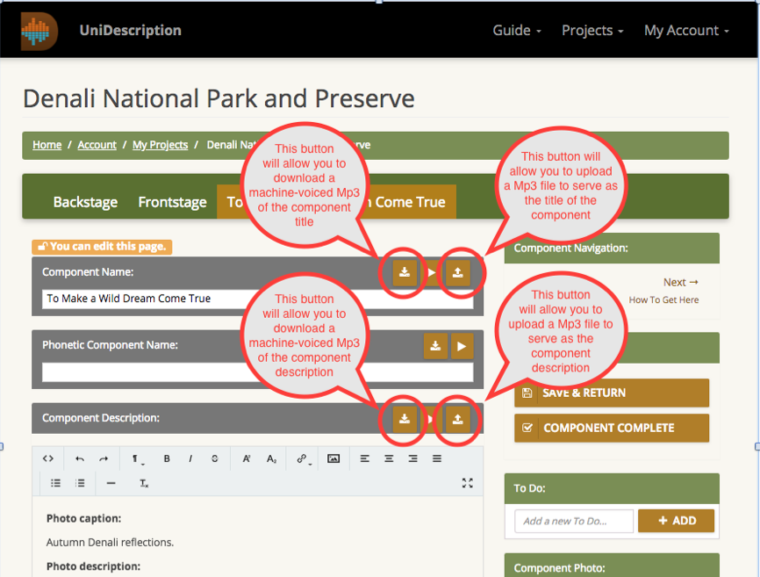

Upload a Text Version
- On your Park Brochure page (see above for instructions to make such a page), create a section with the header “Audio-Described Version (Text Only)”
- Per the above export process, select the Download Text Export link.
- A txt file will be created and shared with you.
- Open the text document that you just downloaded. You have a few options for how to place this text onto a page in the CMS.
    - Copy and paste the text into one or more text elements, a paragraph at a time. Apply the heading styles (heading 1, heading 2, etc.) to match the titles and Table of Contents structure within UniD. If you’re comfortable working in HTML, you might find it quickest to mark up your downloaded text document with the appropriate <p>, <br> and <h> tags, and then just copy and paste the entire body of marked-up text into the HTML editor of a single text element in the CMS.
- You may need to do some additional clean up to the text, such as deleting any hard returns at the end of each section.

Braille Version Option
The UniD project is not involved with the production of braille versions of brochures, but there is a good chance that the park has a supply for visitors. Confirm if the park has brailled versions of its unigrid brochure. If the park does not know, contact the Harpers Ferry Center’s Publications Program. If the park or Harpers Ferry Center has the digital files for the brailled brochure:
- Make a section with the header “Braille Version.”
- Upload that braille printable file and link to it in this section. Be sure to include a note such as, “Please note, you must have access to a Braille printer to make use of this file.”

Promote the Availability of Your Alternative Formats
- Reach out to local organizations that represent and serve individuals who are blind, have low vision or other print disabilities.
- Consider issuing a press release.
- Remember to link your UniD webpage to your accessibility page.

For More Information
If you have questions about working within the content management system of nps.gov, please contact the park’s regional web coordinator. If you have questions about The UniD Project and working with its files, please contact the UniD folks below:
- NPS UniD Liaison: Michele Hartley, Media Accessibility Coordinator, Harpers Ferry Center, michele_hartley@nps.gov, 304-535-6083
- UniD Project Contact: Dr. Brett Oppegaard, University of Hawaii, brett.oppegaard@hawaii.edu, 360-521-8150 (C)
- UniD Tech Support Contact: Joe Oppegaard, Montana Banana Web and Mobile Development, joe.oppegaard@gmail.com, 360-910-1970 (C)

