Saratoga National Historical Park Patch Program

Thanks to Saratoga Troop 3130 for developing this Patch Program in 2002.

Requirements:
Daisy & Brownie: Complete 3 activities including at least 1 of the starred activities.
Junior: Complete 4 activities including both starred activities.
Teen: Complete 5 activities including both starred activities.

Activities:
- **Attend a Park Ranger’s presentation or watch the park orientation film Something More at Stake
- **Tour the battlefield. Depending on the season, you can hike, bike, or drive! Write down something you learned from each tour stop you visit. The number of tour stops you are required to visit varies by your age level:
Daisy: one tour stop (we suggest Stop 7)
Brownies: two tour stops (we suggest Stops 2 & 7)
Juniors: three tour stops (we suggest Stops 2, 6, & 7)

Tour Stop Number | What Did You Learn?

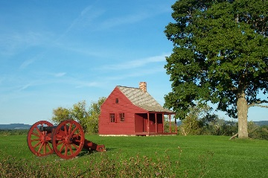 | 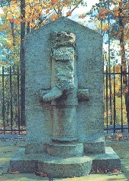 | 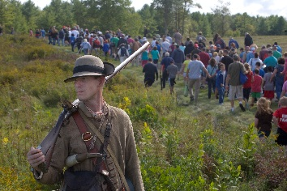
Figure 1: Neilson House, Stop 2 | Figure 2: Boot Monument, Stop 7 | Figure 3: Soldier at Freeman’s Farm, Stop 6

- Use the displays at the visitor center to find the following
  - Two roles women served as they followed the army on campaign:

  - The number of nations in the Iroquois Confederacy:

  - From which nation did one third of Burgoyne’s army come from?

  - The date of General Burgoyne’s surrender:

  - A set of pewter waistcoat (vest) buttons – how many are there?

  - A French ‘Charleville’ musket and a British ‘Brown Bess’ musket:

  - Two British halfpennies and a Spanish real (pronounced ‘real’):

  - Write down what your liked best about the display here:

- Study the brochure map of the battlefield; find at least four of the things listed on the map legend (ie. picnic area, monument, walking path, restrooms, tour stop, etc.)
- Visit the Neilson House. Write about what it would have been like to have been Lydia Neilson, or one of her daughters, living here.
- Interview a Park Ranger. What kind of Ranger are they? What type of education is needed to become a Ranger? What other training or background did the Ranger get to prepare for the job? Do they enjoy being a Ranger? Have they worked at any other National Parks? If so, which one(s)?
- Share what you learned about the Battles of Saratoga with a group of younger Girl Scouts.
- Contact the park and arrange to do a service project there.
- Visit the Schuyler House (open seasonally, call 518.670.2985 for information). The house is located in Schuylerville, about 7 miles north of the battlefield.
- Visit the Saratoga Monument (open seasonally, call 518.670.2985 for information). The monument is located in Victory, about 8 miles north of the battlefield.
- Visit a living history event at the battlefield – a calendar of events is available on the battlefield's website
- Draw a picture of at least one site that you visited, either on the Tour Road or Wilkinson Trail.
- Do at least two activities from the Junior Ranger book (available in the visitor center).
- Visit another Revolutionary War site such as Fort Ticonderoga, Crown Point, Fort Stanwix, or Bennington Battlefield.
- Make up your own activity, count how many National Park Service employees you can talk to, or make a quiz based on the visitor center film, etc.

Patch Program Evaluation

Council: | Troop: | Service Unit: | Age Level:
Leader’s Name:
Address:
Phone: (h) | (w) | E-mail:

How many girls in this troop?
Which Patch Program was completed?

Please complete the following evaluation with responses from the girls.
- Why did you choose this program?
- How much time did you spend on it?
- What outside resources did you use? (people, facilities, equipment, etc.)
- What part did you like best?
- What would you do differently another time?
- What are some things you learned to do for the first time or better?
- How did the adults feel about the program?
Patches may be obtained from the GSNENY Store.

