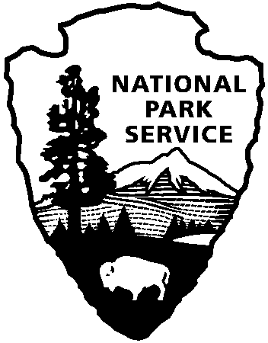
INTERIM PROGRESS REPORT
_____________________________________________________________________________________
Japanese American Confinement
Sites Grant Program
National Park Service
U.S. Department of the Interior

Note: Interim reports are due every six months throughout the life of the grant. Failure to submit timely and acceptable progress reports places a grantee in noncompliance with the terms and conditions of the Grant Agreement and can result in withholding, suspension, or termination of the grant award.

1. Project Title:______________________________________ 2. NPS Grant #: __________

3. Attach a completed FFR, Federal Financial Report (Standard Form 425), for this report period. Directions for completing the SF-425 form can be found in the Grant Manual.

4. Briefly describe the progress through (date) ___________ in completing the objectives listed under the Grant Agreement Scope of Work (typically Special Condition #15).

5. Briefly describe any difficulties you have encountered in completing the grant work to date.

6. Describe the status of complying with all applicable Special Conditions required under your grant agreement. These may include:

- Nonfederal matching share
- NPS concurrence with consultant selection
- NPS review of plans and specifications or other draft products
- Section 106 consultation with the State Historic Preservation Office
- Project sign installation

7. Specify any changes to the Scope of Work and/or Budget you would like to request at this time.

8. If you need an extension to the end date of this project, please explain why and provide a new timeline for completion of the grant work.

9. Please provide any documentation demonstrating project performance. For example, you may attach newspaper articles, press releases, copies of project-related contracts, draft reports, plans and specifications, or photographs or digital images showing grant work completed during the reporting period. Images may be printed or submitted on CD.

Name/Title: ___________________________________________________________

Date: ________ Telephone: ____________ Email: __________________________________

*Please submit this form and any additional documentation by e-mail, mail or private carrier to the NPS Grant Program Manager:
Kara Miyagishima, Program Manager, Japanese American Confinement Sites Grant Program
National Park Service, Intermountain Region
12795 W. Alameda Parkway
Lakewood, CO 80228
Email: Kara_Miyagishima@nps.gov Phone: 303-969-2885

This Interim Progress Report form is also available electronically at the grant program website:
http://www.nps.gov/history/HPS/hpg/JACS/index.html

