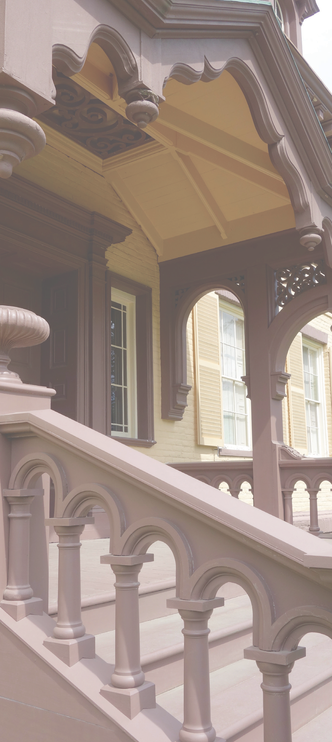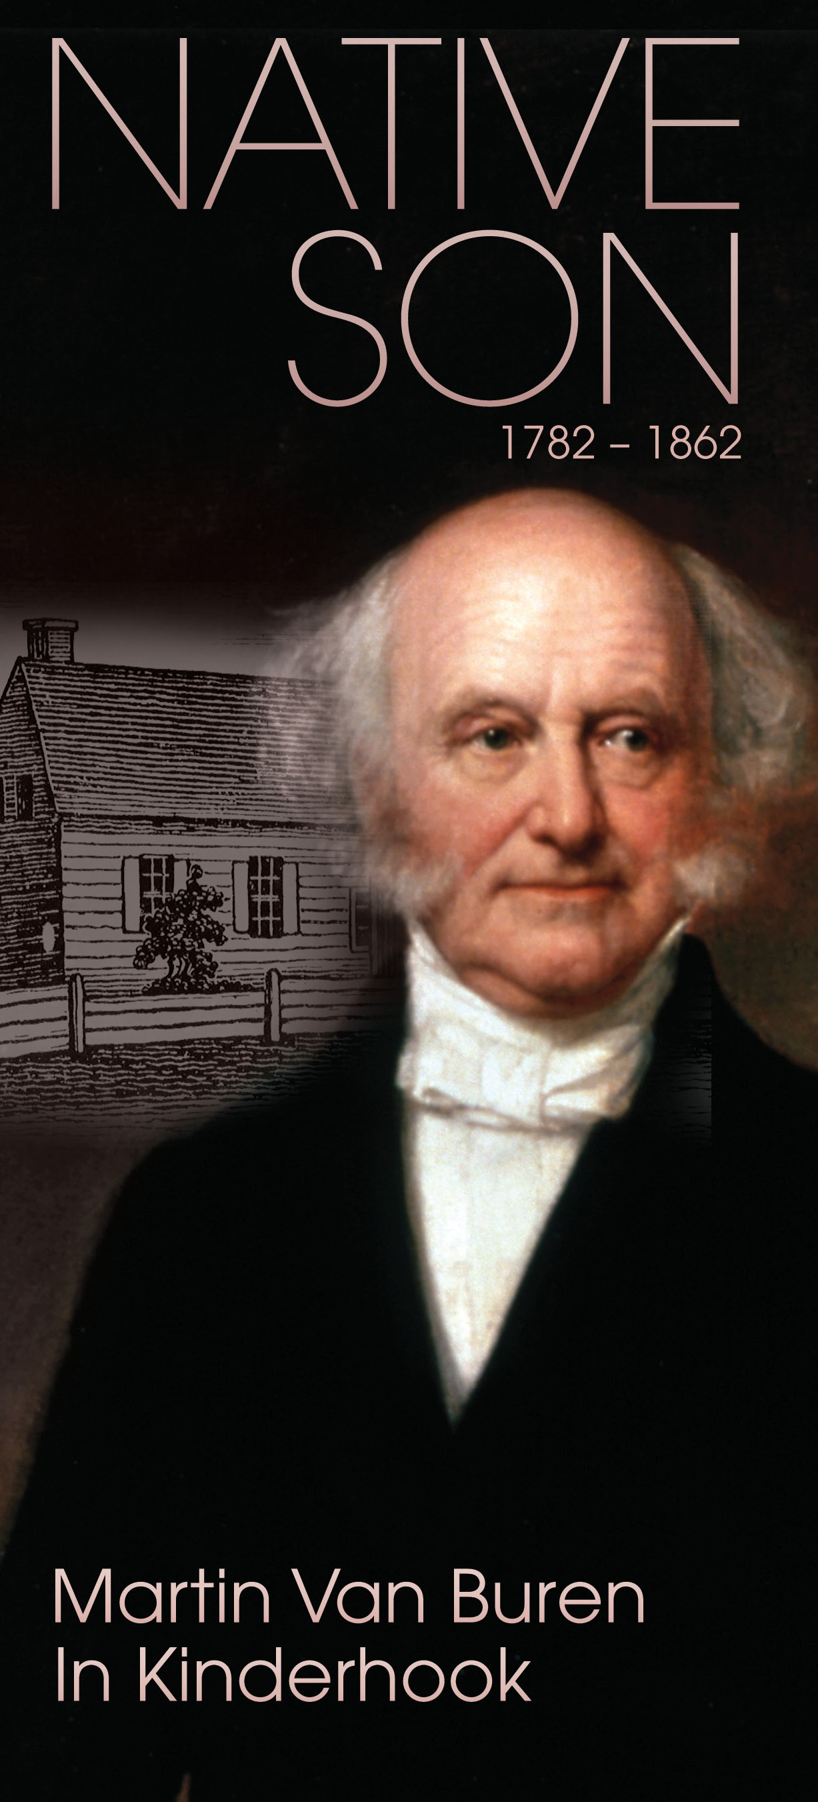Martin Van Buren
Eighth President of the United States, 1837 – 1841
Van Buren was born in Kinderhook on December 5, 1782. His parents, Abraham and Maria, were of Dutch descent. Abraham made a modest living as a farmer and tavern keeper. Young Martin was raised in his parents’ tavern, which was also the family home, and attended local schools.
Martin was set on his life’s course when, unable to afford the cost of college, Abraham secured a place for his son in the office of a local lawyer.
Despite his humble background, Van Buren steadily progressed up the professional ladder. He opened his first law office in Kinderhook in 1803. Four years later, he married his childhood sweetheart, Hannah Hoes. The couple had four sons. In 1819 Hannah died of tuberculosis. Van Buren never remarried.
Van Buren’s star rose quickly in state and national politics. His reputation as a shrewd politician earned him the nicknames Little Magician (Van Buren stood at just 5 feet 6 inches) and the Red Fox of Kinderhook. During the years 1812 to 1820 he served as state senator and state
attorney general. In 1821 he was elected to the U.S. Senate. In 1828 Van Buren gave up his senate seat upon his election as governor of New York. He subsequently resigned to serve as Andrew Jackson’s secretary of state. In his second term, Jackson chose Van Buren as his vice president. In 1836 Van Buren easily won election to the presidency.
Van Buren holds many firsts in presidential history. He was the first president born of Dutch descent, the first to
be born an American citizen, and the only president whose first language was not English. Van Buren may be one of the only presidents to have inspired an addition to the lexicon by popularizing the term “OK,” an acronym for “Old Kinderhook.”
The trajectory of Van Buren’s presidential career took a turn during the economic collapse known as the Panic of 1837. He lost his bid for reelection in 1840 and failed to secure the Democratic nomination in 1844 because of his opposition to the extension of slavery. By 1848 Van Buren was a central figure in the intensifying debate over the future of slavery, running for president as candidate of the Free Soil Party.
In 1840 Van Buren took up residence at Lindenwald,
his estate and farm just outside of Kinderhook. Between 1840 and 1848, Lindenwald served as a busy political hub. The final years of Van Buren’s life were happy, though restless, as he sensed that war was coming. Van Buren died in 1862 not knowing whether the nation he had helped forge would endure.
Cover Images:
John Warner Barber, Van Buren Tavern, 1841, Woodcut,
Historical Collections of the State of New York.
George Peter Alexander Healy, Martin Van Buren, 1858,
Official White House Portrait, The White House Historical Association, Washington, D.C.

VILLAGE OF KINDERHOOK
The settlement at Kinderhook (Dutch, meaning children’s
corner) was founded in the 1660s by Dutch families from Albany. Originally called het Dorp or Groot stuk, the settlement formed on the western bank of the Kinderhook Creek on lands purchased from the Mahican Indians.
During Colonial times large farms and spacious lots were common in and around the hamlet. Roads established during this time, first William Street and later Hudson, Albany, and Broad streets, established a pattern of development that remains to this day.
Colorful historic figures passed through Kinderhook during the American Revolution. Colonel Henry Knox’s horse-drawn sledges carried artillery through the village in January 1776 en route from Ticonderoga to Boston. Turncoat Benedict Arnold spent a night here, suffering from wounds sustained in battle. And British General John Burgoyne was hosted as
a prisoner of war in a home on Broad Street after the British defeat at Saratoga in late October 1777.
Following the Revolution, Kinderhook experienced
significant growth as it emerged as a postal and stagecoach stop between Albany and New York City. By the time of its incorporation in 1838, the village had become a bustling commercial and manufacturing center, with shops that supplied groceries, dry goods, books, pots, pans, and stoves. Hats and carriages were the principal manufactured products. A printing office published an important newspaper, and several lawyers and physicians helped villagers live more
law-abiding and healthy lives. Three taverns afforded lodging, food, and drink and served as ideal locations to air new political ideas. This was the atmosphere in which young Martin Van Buren grew up.
As manufacturing in the village declined during the nineteenth century, Kinderhook became an increasingly residential village. Over time an eclectic collection of houses in the architectural styles of two centuries, including the Dutch Vernacular, Federal, Georgian, and Greek Revival styles, lined the village’s streets.
Today visitors discover historic buildings that appear much as they did when the retired President Van Buren made his favorite horseback ride from Lindenwald to his native village. Preservation of the village’s architectural heritage is recognized by Kinderhook’s listing on the National Register of Historic Places and its designation as a Preserve America Community.

- Martin Van Buren Statue, Village Square
This life-sized statue of Martin Van Buren welcomes visitors to the historic Village of Kinderhook. Located in a small pocket park, the statue, created by sculptor Edward Hlavka, was dedicated on July 14, 2007. Gift of Friends of Lindenwald.
- James P. Vanderpoel House (ca. 1816), 16 Broad St. Currently operating as an exhibition space with historic paintings and decorative arts from Columbia County Historical Society collections, Vanderpoel House is one of the finest examples of Federal architecture in the Hudson Valley. Vanderpoel, a prominent lawyer and politician, was a friend, colleague, and relative by marriage of President Van Buren.
- Peter Van Schaack House (ca. 1787), 20 Broad St. Built by attorney Peter Van Schaack, this house is noted as the site of New York State’s first law school. Many distinguished guests were entertained here, including Martin Van Buren, Aaron Burr, Chief Justice John Jay, and writer Washington Irving.
- Burgoyne House (1774), 24 Broad St.
This Georgian-style home was given the moniker “Burgoyne” after British General John Burgoyne reputedly dined here after his decisive loss at Saratoga in October 1777.
- Persons of Color Cemetery, Rothermel Lane
In 1815 Kinderhook landowner John Rogers stipulated that a portion of his property be “intended as a cemetery for the people of color.” Although only fifteen headstones remain, it is estimated that hundreds of individuals may have been interred here.
- Benedict Arnold House (1770), 28 Broad St. Wounded in the Battle of Bemis Heights, General Arnold was brought to this home to recuperate. Later,
while commanding the fort at West Point, an embittered Arnold plotted to surrender the fort and later switched his allegiance to the British. His name is now synonymous with treason.
- The School l Jack Shainman Gallery (1930),

13

12

5 2
3 1
4 11
9
6 8
7 10

14

Rt. 9H

15

16
- Francis Silvester House (ca. 1805), 7 Sylvester St.
At the age of fourteen, Van Buren began his legal studies as a clerk in the office of attorney Francis Silvester.
Although Van Buren and Silvester didn’t always agree on politics, Van Buren was warmly welcomed in this house by two generations – by Francis himself, his daughter Margaret, and his nephew Francis, Jr.
- Kinderhook Memorial Library (ca. 1933), 18 Hudson St. This Colonial Revival building was designed by renowned architect Mantle Fielding and commissioned by Caroline Davie Lloyd in memory of her father, George Davie.
- Columbia County Historical Society Museum & Library (1915), 5 Albany Ave.
The Royal Arch Masons constructed this building as a meeting hall. Now owned by Columbia County Historical Society, it houses the society’s offices, collections, and library. The library holds documents and manuscripts
on the genealogy of Martin Van Buren and the Van Buren family.
- Martin Van Buren Gravesite, Kinderhook Reformed Church Cemetery (1817), Albany Ave. On July 24, 1862, Van Buren died in his bed at Lindenwald of heart failure and bronchial asthma (an
illness he called his “old enemy”). Van Buren is interred alongside his beloved wife, Hannah Hoes, who died of tuberculosis in 1819, his parents, and son Martin Jr.
The family grave is marked by an unadorned 15-foot-tall granite obelisk.
- Martin Van Buren Birth Site (Historic Marker), 46 Hudson St.
Van Buren was born on December 5, 1782, at the small tavern owned by his parents, Abraham and Maria. The lively atmosphere in the tavern, where local gossip and political discussion were bandied about, played a role in sparking young Martin’s interest in politics. Van Buren had two sisters, two brothers, and two half-siblings.
- Luykas Van Alen House (1737) and Ichabod Crane Schoolhouse (ca. 1850), 2589 Route 9H This thirty-three-acre homestead is located near

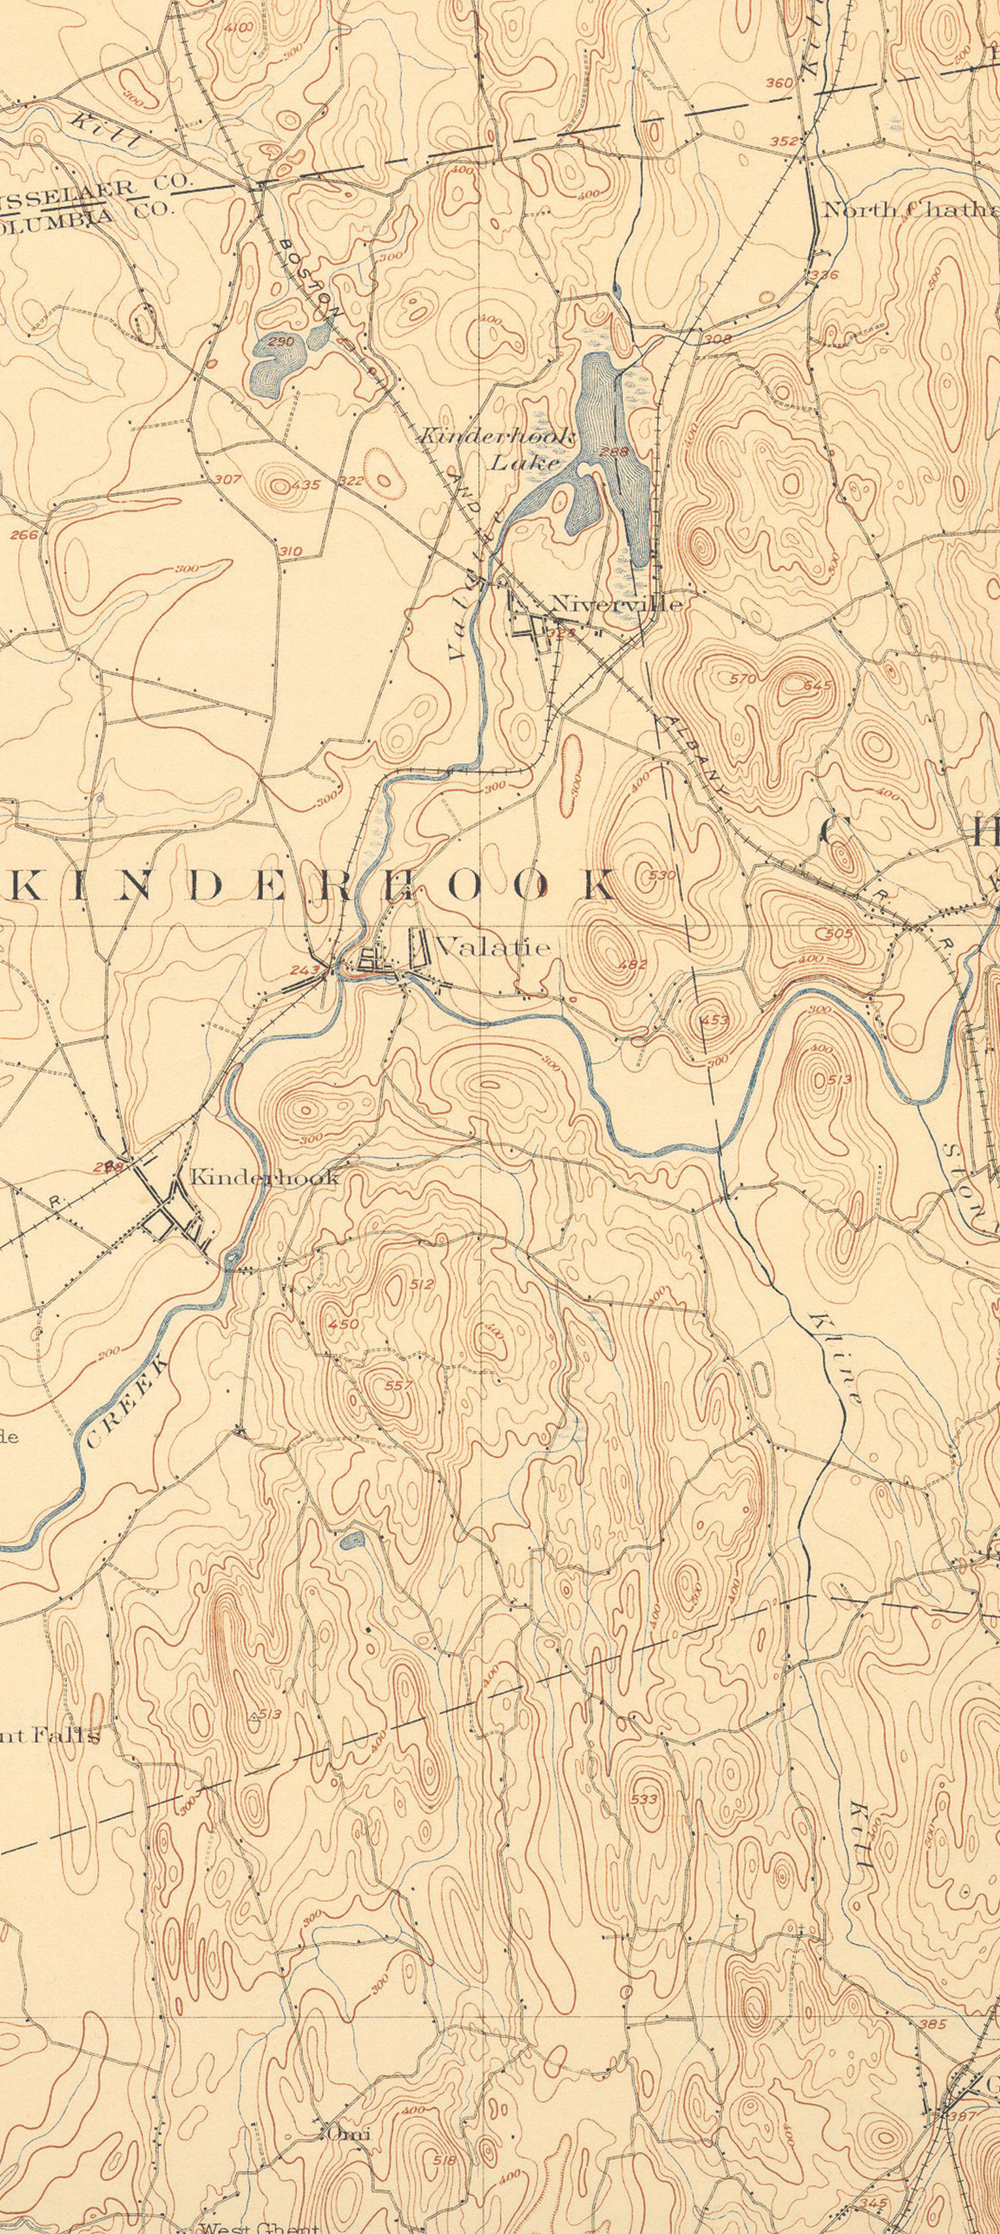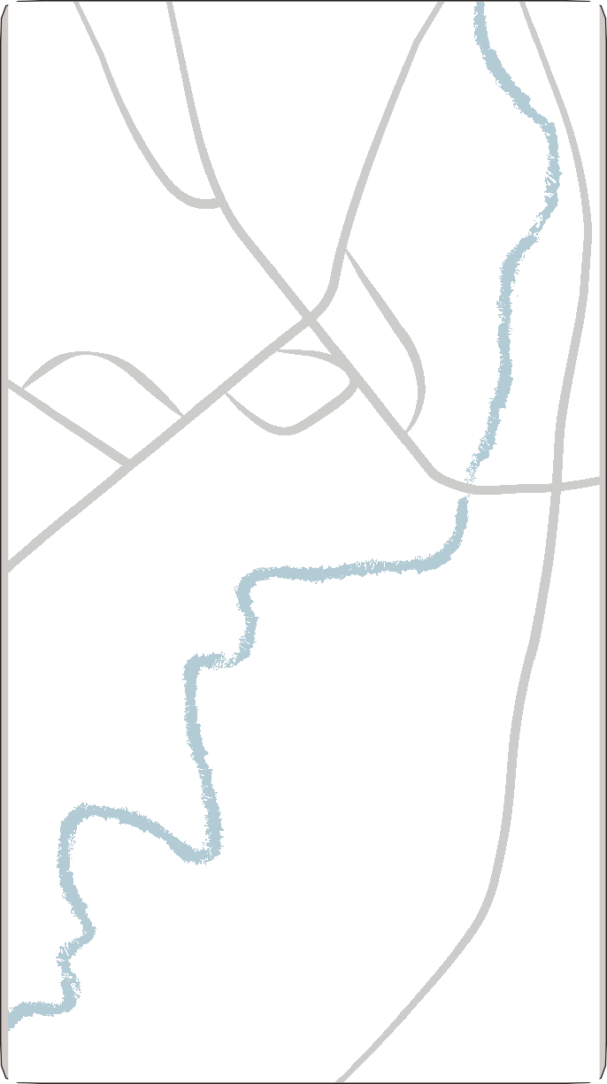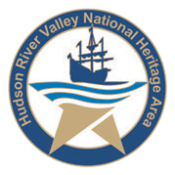25 Broad St.
Formerly the Martin Van Buren School, this building replaced several of the one-room schoolhouses in the area. Dedicated in 1930 by then-Governor Franklin Delano Roosevelt, the building was repurposed for use as a contemporary art space in 2014.
- Kinderhook Reformed Church (1869), 21 Broad St.
Van Buren attended church here every Sunday, occupying the box pew in the sanctuary’s northeast corner. The church has a receipt dated 1799 that was signed on behalf of his father by sixteen-year-old Van Buren. It may be the first legal document signed by the future president.
- St. Paul’s Episcopal Church (1852), 6 Sylvester St. Smith Thompson Van Buren, the youngest of Van Buren’s four sons, was responsible for contacting well-known architect Richard Upjohn who designed this church in the Gothic Revival style. The five Tiffany windows in the sanctuary were donated to the church in 1914.
Life and Times of Martin Van Buren Other Kinderhook Village Historic Sites

“Ex-President Van Buren returned to the place of his nativity on Saturday last... After the lapse of a long series of years, spent in the service of his country, he has returned to the home of his youth, probably to spend the evening of his days among those who have long appreciated the splendor of his genius and admired his virtues.”
– Kinderhook Sentinel, May 1841

This project/plan was funded in part by a grant
from the Hudson River Valley National Heritage Area.
The views and conclusions contained in this document are those of the authors and should not be interpreted as representing the opinions or policies of the U.S. Government. Mention of trade names or commercial products does not constitute their endorsement by the U.S. Government.
Lindenwald. Van Buren often rode through adjoining woodlands or past this property on his way to Kinderhook. The name for this one-room schoolhouse comes from Washington Irving’s famous character in “The Legend of Sleepy Hollow.” Van Buren’s friendship with Irving and Kinderhook schoolmaster Jesse Merwin inspired Van Buren to pen a letter “certifying” that Merwin was the model for the character in the story.
- Martin Van Buren National Historic Site (1797), 1013 Old Post Road
Following his presidency, Van Buren returned to Kinderhook and to the 230-acre estate he purchased from William Paulding. Van Buren named the property Lindenwald (German, for linden woods). There he continued to be deeply involved in the politics preceding the Civil War and spent his twilight years as a gentleman farmer and an esteemed member of the community.

