Biography of
President Martin Van Buren
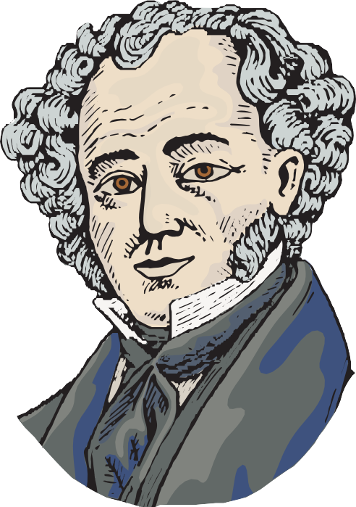
Martin Van Buren was born in Kinderhook, New York on December 5, 1782. Martin’s childhood included lessons with a schoolteacher and chores at home with his seven brothers and sisters. The future president’s family spoke Dutch, and he learned English as a second language! As a teenager, Martin studied law from books for seven years. He passed the test to become a lawyer before his 21st birthday.
Opening a law office was the first of many choices that would lead to forty years away from Kinderhook. Martin and his wife Hannah moved to the state capital of Albany when he was elected as a New York State Senator. Eight years later, Van Buren moved to Washington D.C. as a United States Senator. This work taught Martin Van Buren how to lead his peers, and he helped them compromise when they disagreed with each other. Martin Van Buren worked with Andrew Jackson from Tennessee to organize the Democratic Party. This is one of the two major political parties we still have today. Jackson was elected as the 7th President of the United States and Van Buren was his vice president.
Van Buren became the nation’s 8th president in 1836. After one term in the White House, President Van Buren was defeated by William H. Harrison and came home to Kinderhook. He ran for president as a Democrat in 1844 and as a Free Soil Party candidate in 1848. The Free Soil Party opposed the extension of slavery into new states. Both of these campaigns were unsuccessful.
President Van Buren retired to the farm he named Lindenwald. He hired a gardener and a farm manager and made improvements on the land. Farmhands grew flowers and vegetables in the gardens and green- houses, and planted apples and pear trees in an orchard. Animals on the farm included sheep and cows.
All four of Martin and Hannah’s sons spent time here with the “Ex-President,” as they called their father. Three sons married and had children, and the family grew to seventeen people! The dining room table was big enough for all of them. Family time included songs and stories in the parlor. Outdoor fun meant horseback riding and fishing.
President Van Buren lived here until his death at the age of 79. He wrote in his will in 1860, “I, Martin Van Buren of the Town of Kinderhook, County of Columbia and State of New York, once Governor of the State and more recently President of the United States, but for the last and happiest years I was a farmer in my native town.”

Civics & Politics

As Martin Van Buren was growing up, the country’s founders were setting up the system of government we know today. The United States had just declared independence from a king, and the founders wanted to make sure no one person or group had too much power. They created a government with three “branches” and a system of “checks and balances.”

This branch is made up of
lawmakers. Legislators exist on the local, state, and federal level, and include the Senate and the House of Representatives.
Legislators are elected to represent the people! Martin Van Buren was a

in the 1820s.
This branch enforces the laws created by the legislators and includes governors and the President of the United States.
In addition to serving as President, Van Buren was also
, another job in this branch.
This branch interprets the law in the courts and has the power to declare laws unjust. The biggest court is the United States Supreme Court, which interprets the Constitution.
Martin Van Buren was in the courts as a

at the beginning of his career.

The country’s founders struggled with the future of slavery in a growing nation. Some believed the labor of enslaved men, woman and children was necessary for a successful economy. Others believed enslaving people was wrong and should be abolished or gotten rid of. Some were willing to allow slavery where it already existed, as long as it was not allowed in new territories or states. This struggle eventually led to the American Civil War.
What are two connections Van Buren had to slavery in his lifetime? (Hint: the election of 1848)

Enslaved people in the early 1800s were not considered citizens and could not vote. How would you feel if your future was decided on by representatives you could not help choose?

Families on the Move!
D
u
t
ch
L
e
a
r
n

english:

migrate
!
Migrate - to move from one place, state

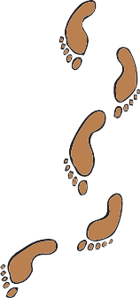
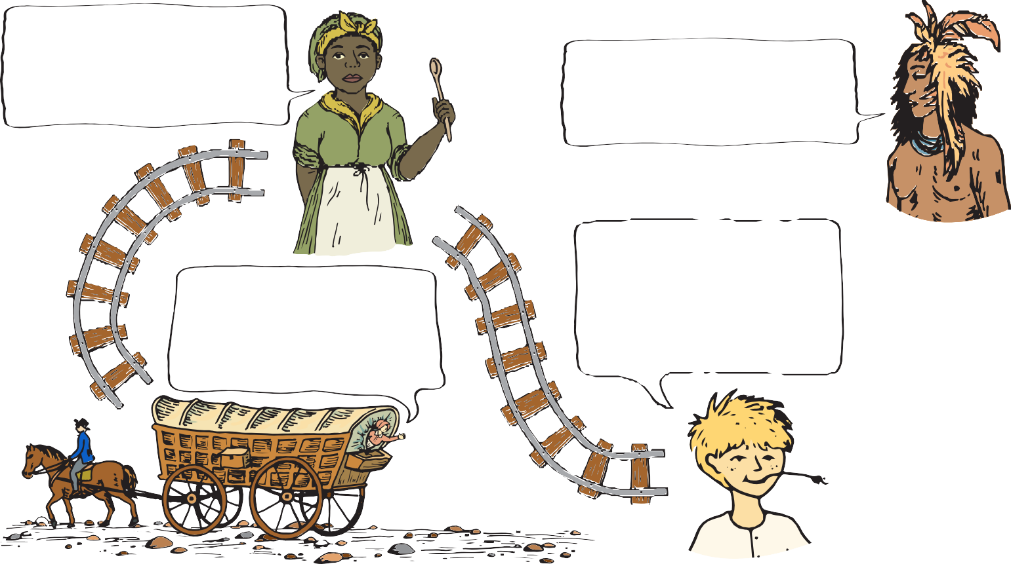
dutch: or country to another and live there
trekken

The United States doubled in size when President Thomas Jefferson purchased the Louisiana Territory from France in 1803. The United States border moved 1000 miles west from the Mississippi River to the Rocky Mountains. This territory would become states beginning with Louisiana in 1812 and ending with Oklahoma in 1907. After the Mexican-Ameri- can war in the 1840s, the country expanded all the way to the West Coast. Compare the maps on the timeline and see if you can spot your state!

I was an enslaved cook on a
plantation in Virginia. When my I am a member of the Cherokee
master’s son decided to move west, Nation. The government forced my
I was sent with him. family west on the Trail of Tears.

After coming to America from Germany, my family settled in
My husband and I are New York, but it is crowded.
bound for California, We heard there is more farmland where people are finding gold. west of the Mississippi.
They say anyone can strike it rich!

Why do you think the people pictured on this page migrated from the East Coast to places like Kansas, Missouri, and California?

Archeology Dig
Excavations at Lindenwald have turned up many day-to-day items that were used long ago when Martin Van Buren lived here. These items teach us a lot about what life was like for them. Imagine archeologists 200 years from now are digging below your house. What sort of items would they find? Draw some of those items in the space below. What would these items tell them about how we live now?

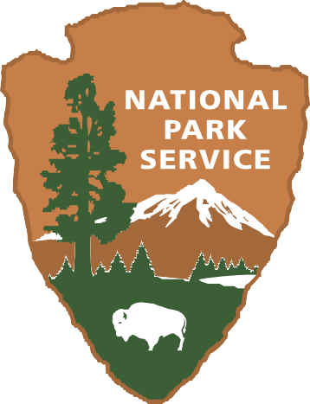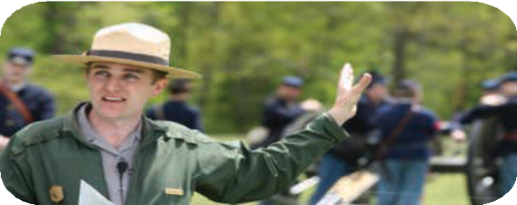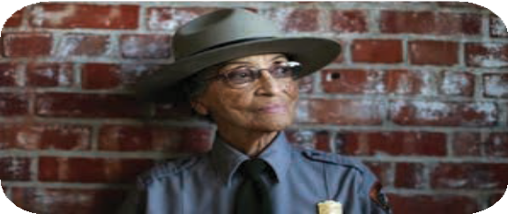

So, you want to be a National Park Service Ranger?
The National Park Service preserves natural and cultural resources for the enjoyment, education, and inspiration of people today and for future generations. There are over 400 national parks from Maine to Guam and many places in between. We partner with communities across the country to preserve their history and create places for outdoor fun.

The NPS has one of the most diverse workforces in the world. Park rangers wear many hats, from protecting the parks to telling the stories of the plants, animals, and people that make these places important. There is a career with the NPS for everyone!

Our local park, Martin Van Buren National Historic Site, preserves and tells the story of our eighth president’s home. In order to run smoothly, the park needs historians, curators, maintenance staff, law enforcement, administrators, naturalists, and many others. Volunteers also to help staff and maintain our sites.

The National Park Service is committed to telling the stories of all Americans, and you can help us protect these special places for the future!
