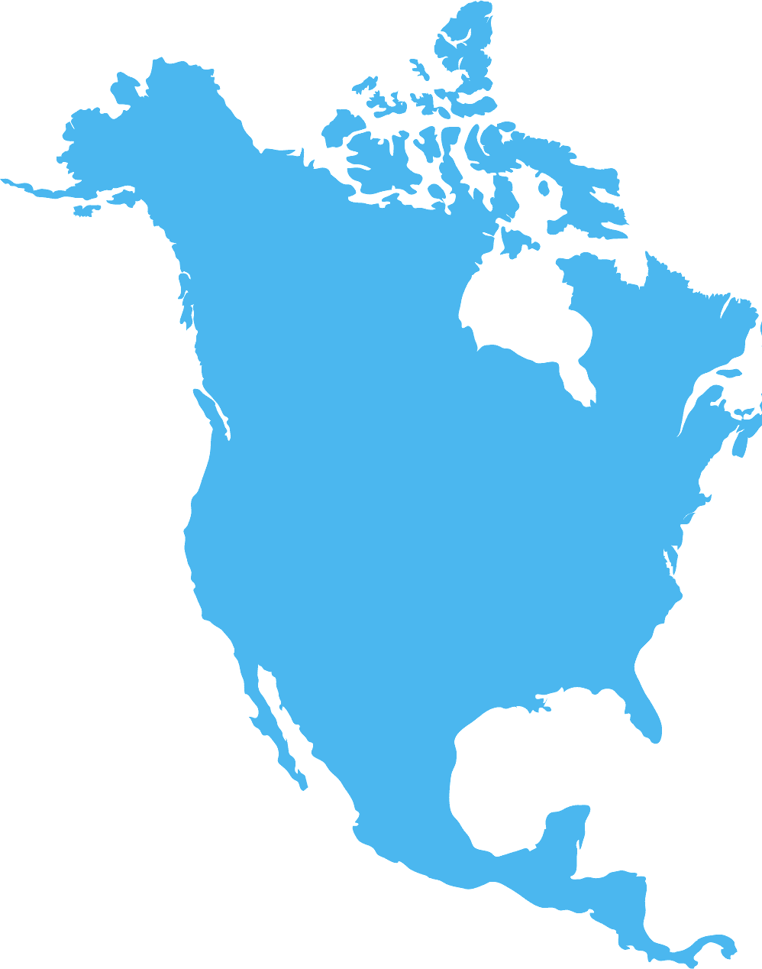

NORTH AMERICA

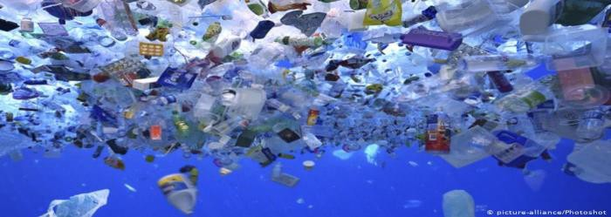
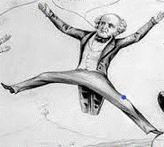
A plastic ‘garbage patch’ in the ocean.

North America
Plastics in the
world’s oceans is a problem facing every continent. Sadly, a large portion of it comes from North America.
How is this possible when so many recycle their plastic trash?
The majority of items placed in a recycle bin at home is shipped to other countries.
The countries are unable to recycle all the plastic they receive, so it ends up abandoned or improperly dumped – often ending up in the ocean.
Governments are trying to improve the situation by reducing the amount of plastic used in the first place.

In Martin’s Time
Plastic was invented in 1869, seven years after
Martin Van Buren’s death.
It was invented for a New York company that offered $10,000 to anyone who could recreate the look of ivory.
Elephants were becoming extinct because people wanted items made of ivory, found in the main part of the elephant tusk.

Sustain means the ability to constantly exist...

Plastic was invented to sustain the lives of a living creature.

Now plastic puts creatures large and small in danger.

What Are Microplastics?

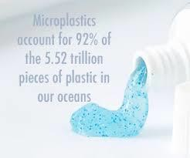
What did you find that can be swapped for a non-plastic item?

Microplastics are easily detectable because they look like very tiny colored pebbles, confetti or balls. They were once part of a larger plastic item that had broken down. Some microplastics are so small it takes a microscope to detect
them.
Microplastics have caused problems for North America because they get into oceans and wash up on beach shores.
Fish and animals mistake them for food and eat them. In turn, people eat the fish and can ingest (in-jest: taken by mouth) these tiny pieces of plastic.
Activity:
Here is an activity to help you easily become a Plastics Earth Hero:
- Get a piece of paper and something to write with or draw.
- Put your thinking cap (or cape) on, this will take some creativity.
- Go around your house and find items made of plastic you can swap out for something more
environmentally friendly.

