The National Park Service Presents:

An Online Interactive Program
for the
Pre-School – Kindergarten Set
For the Adults of Ranger Time participants:
Ranger Time is an on-line interactive themed program offering sensitively explained age-appropriate lessons to help adults introduce: Civics, American history and Martin Van Buren to the pre-school and kindergarten child/children in their lives.
Each program includes lessons with multi-generational activities, and always with a connection to America’s eighth president, Martin Van Buren.
The programs require a minimal amount of time and supplies to complete, and step-by-step instructions are provided for easy following.

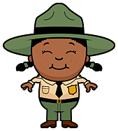
No. 3 2021:
What Makes a Citizen?

1.Read:
‘Have you ever visited Lindenwald?’
2. Read:
Ranger Time
No. 3“Introduction”
3. Read and Do:
“What Does It Really Mean?”
& “Your Turn”
3. Read and Do:
“Children are Citizens” & “Don’t Be afraid to Share “

5. Read and Do:
“Responsibility”

6. Write a Story about:
“Citizen Rights and Responsibilities”

7. Read and Do:
“Pretend It’s a Real Story”

8. Read and Play:
“Traits of a Citizen”

9. Read:
“Martin Connection”

10. Do:
“Grow to be a strong Citizen”

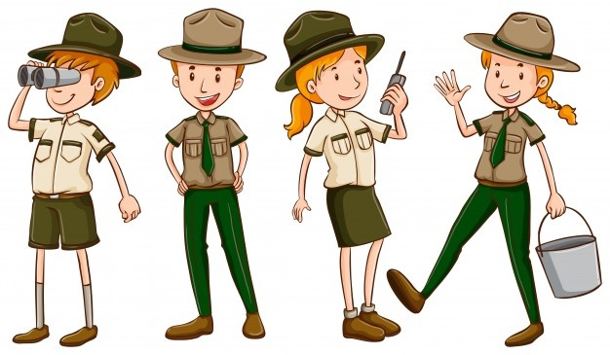

Have you ever visited the Martin Van Buren National Historic Site named Lindenwald?
Do you know who once lived there and was the eighth President of the United States?
Martin Van Buren, of course!
Lindenwald is a beautiful place to walk around and enjoy nature.
If you visit, make sure to stop and introduce yourself to the Park Rangers.
They are always happy to meet visitors and answer questions.

No. 3 2021
Intro:
What Makes a Citizen?

Welcome back to Ranger Time!
We hope you enjoyed the previous lesson about one of America's most important documents, The United States Constitution, and had fun signing your own.
This time we are focusing on you. Yes, you! Because you are also important, and not just to those who love you.
You are important to your community, state and America because you are a citizen. Yes, even children are citizens.
What does it mean to be a citizen?
That's what this Ranger Time program will help answer.

Are you ready to begin?

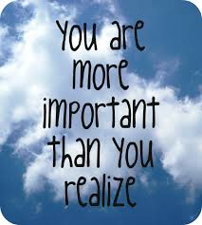

Meanings of words can be a little confusing, especially when describing big ideas.
Let’s try to make the idea of citizenship a little easier to understand.

What is a family? Think about it for a moment.
A family can be one you were born into or not. The meaning of family is special to each person, but you are a member (part of a group) of some kind of family. Who are they?
I am a member of the ______________________ family.

Citizens are members of the country where they were born and where they now live.

Think of the meaning of citizenship in the United States of America this way:

First, you are a citizen of the village, town or city where you live.

Your village, town or city is your community.

Next, you are a citizen of the state your village, town or city is located.

Last, you are a citizen of your country.
You are a citizen of the United States if you were born in America. People born in another country can also become citizens of the United States if given permission through a court of law.
You are a citizen of a community, state and country; at the same time!

Pretty awesome, right? See how important you are!

Some places have nicknames for their citizens. Citizens from the city of Boston are called Bostonians, and citizens of New York state are called New Yorkers.

Where are you a citizen? Let’s find out!

I live in the (circle): Village Town City

Of: ___________________ Citizens from my ______ are called: ________.

My state is: ________________________

They call citizens from my state: _____________________________

I am a citizen of the country called: ________________

A citizen of The United States of America is called an:
______________________.

*The children in the photo below are Nepalis (ne-pall-eez) because they are Nepal citizens.
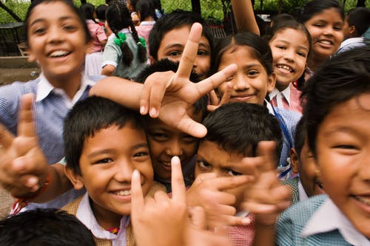
“Group of People Taking Photo” by R. Zaal.
Citizens of the United States all have certain rights, including children, because children are citizens!
Some of these rights are explained in the United States Constitution. 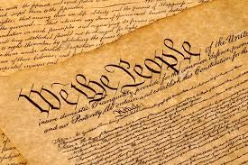
You learned about this important document in the last Ranger Time program.
Some rights are found in the laws (rules) where you live. 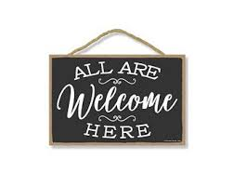

rights you have as a citizen in your community, state and the United States are:
1) The right to help decide on things grownups in charge of your community, state and America make for you.

2) You have the right to talk to grownups in charge of your community, state and the United States on how you feel about decisions they make for you.

Have you ever talked to someone in charge of your community?
Here is a way to help get you started.

Do you have a special place in your community where you go to play?

Where do you go to play? _______________________

Have you ever had an idea on how it can become an even better place to play?

Imagine you could make it a better space for children to play; what would you do?

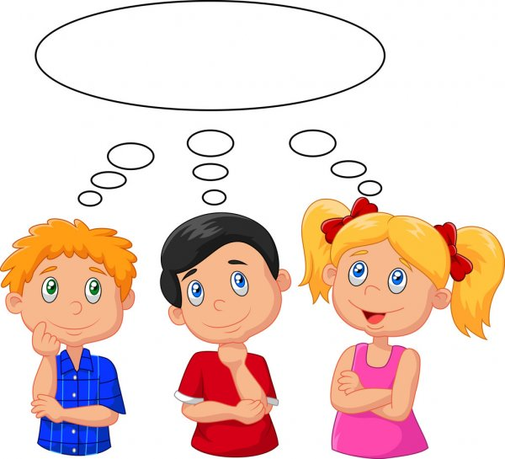
Draw or write your idea.
My idea is: __________________________________________________________
___________________________________________________________________
Why? ______________________________________________________________
___________________________________________________________________

Share your idea with a grownup in charge of the place you play.

Who knows, maybe they’ll use it to make the play area an even better place for all children in your community.
You’re a citizen and have a right for your voice (what you have to say) to be heard. Sharing an idea with grownups in charge of your community is a way to use your voice.
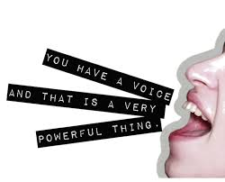
In America, a citizen may ‘use their voice’ (speak up when) for a right, but with that voice is the responsibility to remember that other people have rights too.
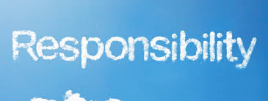
It’s a big word with a big meaning, and being a citizen requires a lot of responsibility.

Do you have responsibilities (things you must do) at home? Name two of them:
1. _______________________________________________ 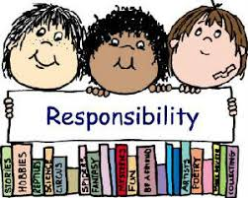

2. ________________________________________________
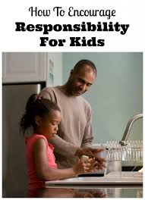 Do your family members have responsibilities? Write them here.
Who: ______________________ Their responsibility: __________________
Who: ______________________ Their responsibility: __________________

What would your home be like if everyone in your family ignored their responsibilities?
Super crazy? Super messy? Would you have meals to eat?

One way of respecting the rights of others is by remembering your responsibilities.
Doing so creates a better home life, community, state and country for everyone.
Let’s write a story to learn and talk more about a citizen’s
Rights and Responsibilities.
This girl 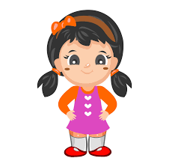(you choose her name) ___________________ owns a dog.
You choose the dog’s name: ________________.
There is only one park in the community where ______________lives. She takes her dog _________________ to the park every day for play time.
_______________________ uses a leash to walk _______ to the
park, but takes off the leash to let ______________ run around the park.
This boy _____________is afraid of dogs.
He uses his voice to talk about his fear of dogs with the grownups in charge of the park. The boy requests (asks) that all dogs be kept out of the park – at all times.
Is the boy’s request fair? Why or Why not?
Well, ______ is a citizen of her community and has a right to play with her dog ____________ at the park.
_________ is also a community member and has a right to be safe from dogs bothering him while he’s visiting the park.

Pretend it was a true story; what should the grownups in charge do?

Keep this in mind; If the story was true, the grownups in charge of the park would be responsible for doing everything possible to keep park visitors safe.

The grownups in charge of the park would also have a responsibility to respect all citizen’s rights by making the fairest decision possible.

Do you believe citizens have the right to be safe from dogs in parks?

Why or Why not?

Do citizens have the right to bring their dogs in the park?

Why or Why not?

Do citizens who own dogs have the right to let their dogs run free in the park?

Should dogs have rights?

Why or Why not?

Imagine you were one of the grownups in charge of the park.
How would you decide? 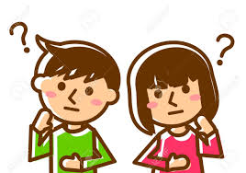
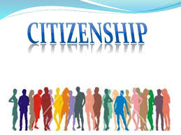

Have you ever heard of the word “traits” used to describe what is special about you?
Traits are the things that make you different from everyone else. Your traits make you special. A few traits are listed below, do they describe you?
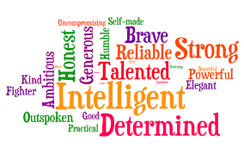
Your traits help make you a strong citizen because many are needed to show:
Activity:
Have a grownup blow bubbles for you, and as you pop them,
shout out traits you have that make you special.
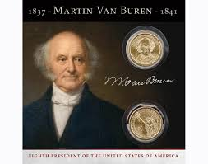
Martin
Connection:
Martin:
Citizen and Lawyer”
Martin Van Buren did not just become President of the United States. He began as a Lawyer in Hudson, New York. The previous Ranger Time included the story of how Martin Van Buren became a lawyer through an apprenticeship.
Lawyers study the documents and laws of their country to help protect citizens' rights. In America, lawyers must also learn the laws of their state for the same reason.
It takes a special citizen with certain traits to become a lawyer. One man described a few of Martin Van Buren's traits that helped make him a strong citizen and lawyer:

“Martin Van Buren was not like the others. He did not tell stories of how things were done in the courts of England, and with older and more experienced lawyers against him he was not afraid. He was careful, which is needed for courage.”
“Not skilled enough to change people’s feelings, but a strong talker, He was very calm and polite; and with the trust of people, the farmer’s son of Kinderhook, since he was very young, was born to be a lawyer.”

- Note: The quotes were paraphrased for a child’s understanding. The original texts can be found in the footnote.

Grow to be a Strong Citizen!

(1) Write ‘Citizenship’ in the cloud.
(2) On each raindrop, write a trait mentioned in the story of Martin Van Buren that made him a strong citizen and lawyer.

Who knows?
Maybe you’ll grow up to be President of the United States like him.

Bancroft, George. Martin Van Buren: To the End Of His Public Career, (Franklin Square New York: Harper & Brothers, 1889), 9-10. (9) “Van Buren stood alone, resisting analogies drawn from the English courts, and having the ablest of his seniors at the bar arrayed against him. by nature intrepid, he had caution which is the rightful companion of courage.” (10) “Unskilled in appeals to passion, yet gifted with a rapid eloquence, he excelled in calmness and urbanity; and by the trust of the body of the people, the farmer’s son of Kinderhook from very early life was born onward in his professional career.”

