The National Park Service Presents:

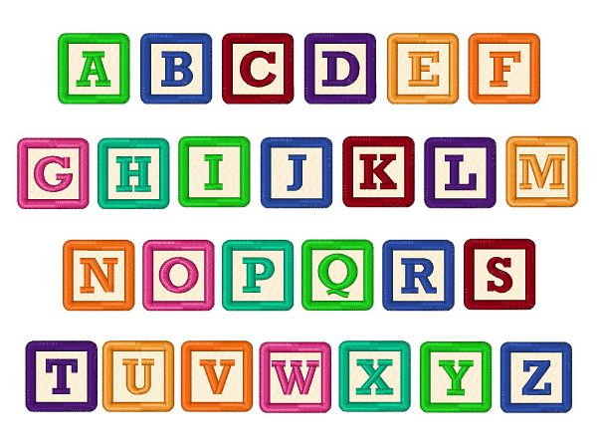

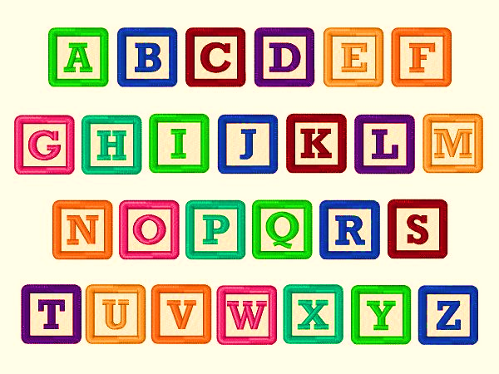

2021 Theme: The Making of America

This year’s Ranger Time builds upon the 2020 theme; Democracy and how Americans choose a president.

The focus for 2021 is on America; how it was formed and the idea of citizenship.

- You can find, “I Voted!” – Ranger Time Election” under Ranger Time 2020.

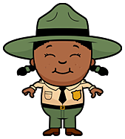
Ranger Time Program No. 1:

The American Revolution

1.Read:
‘Have you ever visited Lindenwald?’
2. Read:
“January’s Introduction”
3. Do:
“Vocabulary Game”

4. Do:
‘I Spy Like a Spy’
5. Read:
“Colonies to States.”
6. Do:
“This is My Country.”
7. Read:
“Martin Connection.”
8. Do:
“Martin’s Kinderhook:
Then and Now.”

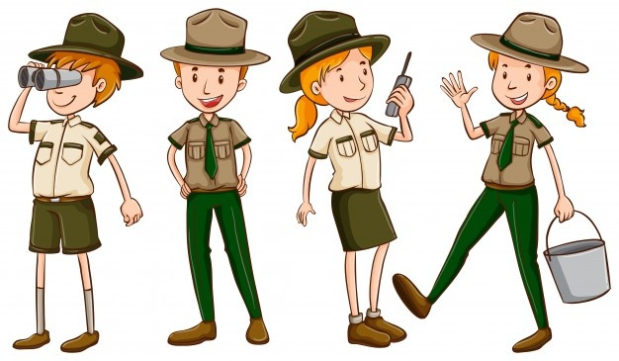

Have you ever visited the Martin Van Buren National Historic Site named Lindenwald?
It’s a beautiful place to walk around and enjoy nature.
Do you know the name of the person who once lived there and was the eighth President of the United States?
It’s Martin Van Buren, of course!
While visiting Lindenwald you might even see a Park Ranger.
They are always happy to talk to visitors and answer any questions you may have.

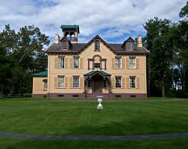

Lindenwald

Ranger Time 2021 No. 1:
The American Revolution

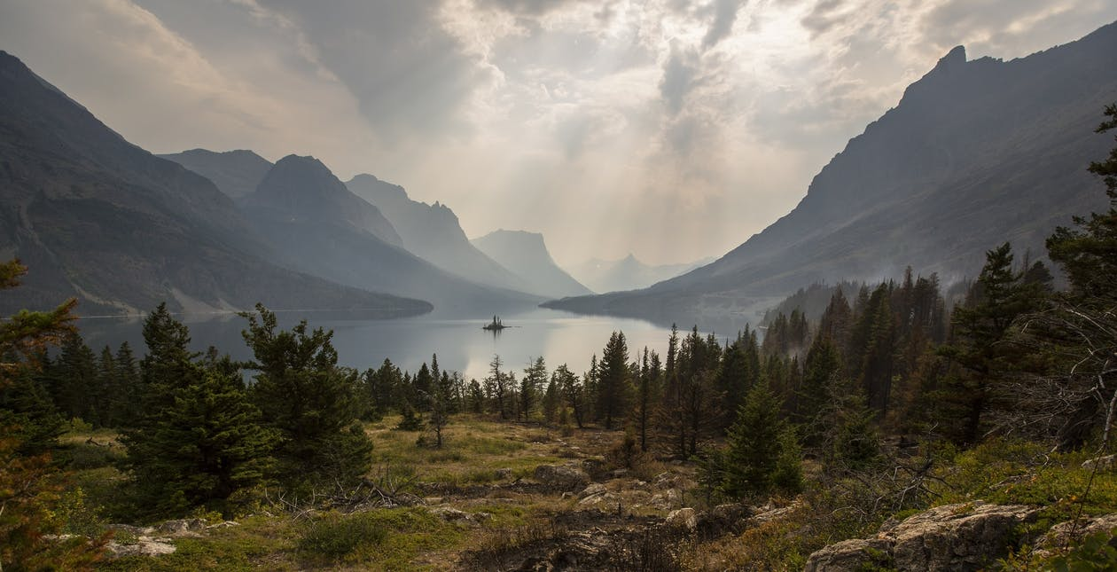

Pixabay

Welcome to Ranger Time!

This year you will learn how America was created and what it means to be a citizen.

Now, are you ready to get started?

The American Revolution

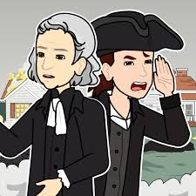

Have you ever wondered how America began?

Did it suddenly magically appear?

I mean, how exactly do you create a country ?

There aren't any books to tell you how to do it, and it isn't something that children learn in school.

It's a big question, isn't it?

America didn’t just happen, it took a long war before becoming what it is today.
The war is called the American Revolution.

It was a war fought by people living in 13 different colonies in America who were ruled by the Kingof called Britain; which at the time included the countries of England (including Wales) and Scotland.

The war occurred because people living in the thirteen colonies of America no longer wanted the King of Britain to rule (be in charge of) them.

The Americans won the war and created a country of their own.

When the American Revolution ended each of the
thirteen colonies became a state,
together they created the United States of America.

How brave they were and how scared they must have been too.

Nothing like America had even been done before- in all the world!

For this reason, people called America an 'experiment' (a test to check if something works) they hoped would not fail.

They must have done something right, America has continued for over 200 years!

The 4th of July is America’s birthday. It’s celebrated every year with fireworks and parades with marching bands.

Oh, and hot dogs. You can’t forget the hot dogs!

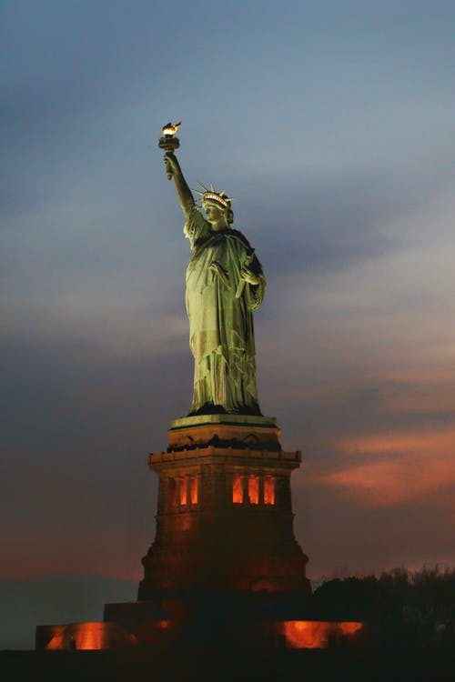
Nicolas Poupart

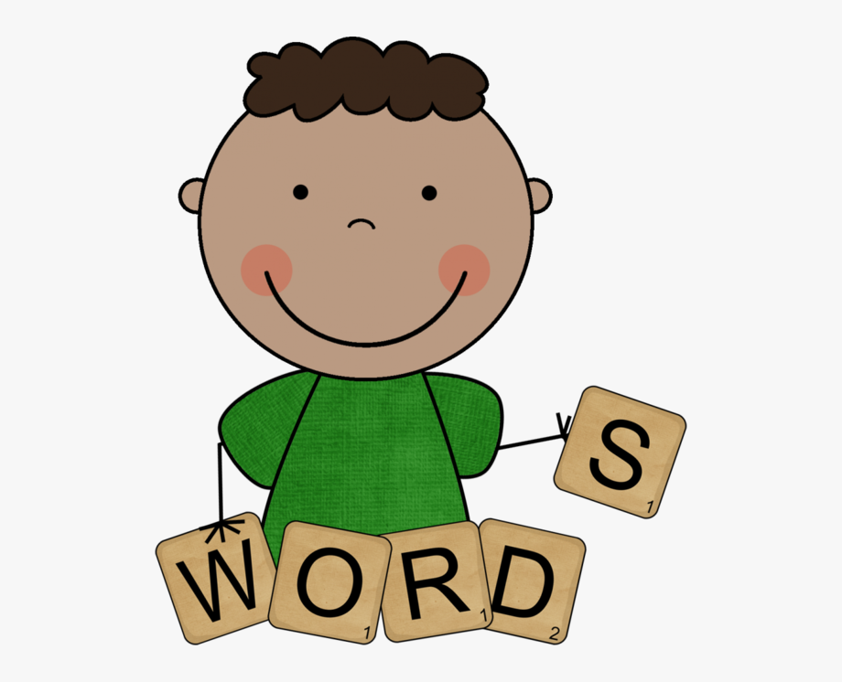

Do you remember these words and what they mean?

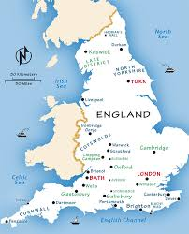
England:
The country where the King of Britain, who once ruled America, lived.

RickSteves

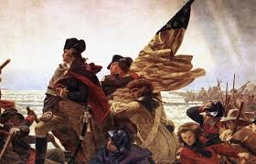
American Revolution:
The war that ended Britain’s rule over America.

Emanuel Leutze

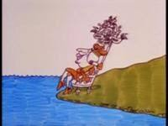
School House Rock
Rule: To be in charge of people who were not allowed a vote or choice, like King George of Britain.

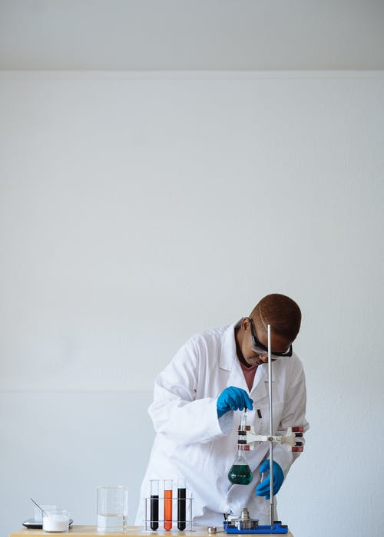
RF._.studio
Experiment:
A test to check if something works.

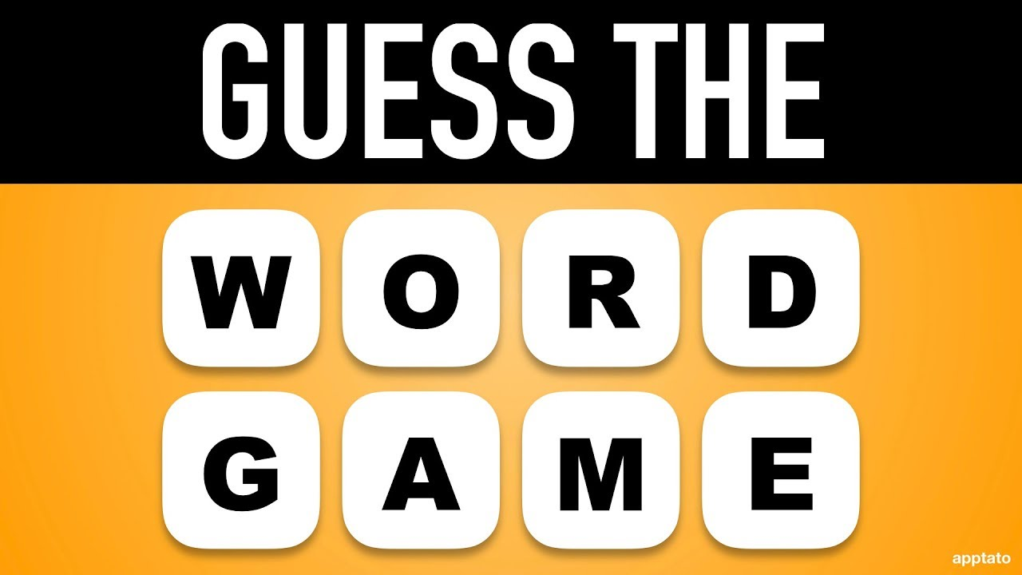

Can you guess the word belonging to the pictures above by just one clue?
Good Luck!

1. Test: _________________________________ (Experiment).

2. King: _________________________________ (Rule).

3. Country: ______________________________ (England).

4. A War: _________________________________ (American Revolution).

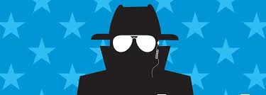
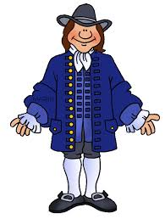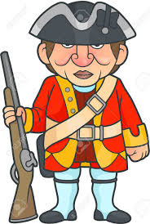
‘I
Spy
Like
a
Spy’

The American colonists and the British Army often used spies to find out what the other side was doing.
During the American Revolution ordinary people served as spies for both sides, sometimes even children smuggled messages.
Messages were often written in invisible ink, and numbers were used instead of the names of military officers.
General George Washington used the numbers 711 instead of his name.
Would you like to create your own message in invisible ink?
That’s the next activity.
Be sure you hide the message well to avoid getting captured!


‘How to Make an Invisible Ink Message’
Supplies Needed:
Baking Soda
Water
Small amount of Dark Colored Juice, Food Coloring or Kool-Aid mixed with a few drops of water.
1 Piece of White Paper
1 Watercolor Paintbrush or 2 Cotton Swabs
2 small bowls
Instructions:
- Mix ¼ cup of Baking Soda and ¼ Cup of Water in a small bowl.
- Dip the brush or 1 swab in the bowl and ‘paint’ your message on the paper:
Make it a short message or draw a picture.
Include numbers instead of letters for your name.
- Let the message dry on the paper.
- Prepare a cup of the coloring with a few drops of water.
- When the paper is dry, dip the brush or the second swab into the colored liquid and paint over the message you created with the baking soda and water.

Your invisible message should appear, does it show what you wrote?
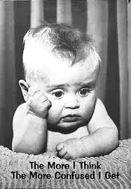
Colonies to States:
You have
probably
heard the word
Colonies
quite
a bit.
Are you
confused by what it
means?

A Colony is:
When people leave their country to create a new place to live in another country, but
the country they left is still in charge of them.

Many left Britain for America where 13 colonies (more than one colony) became part of King George’s kingdom.
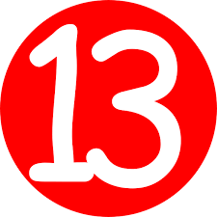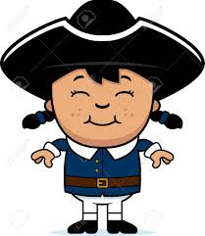Colonies



Virginia

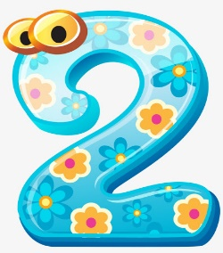
New York

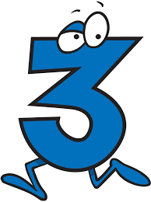
Massachusetts
- What is now Maine was once part of Massachusetts.

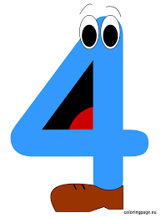
Maryland
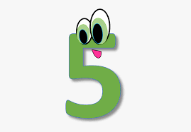
Rhode Island
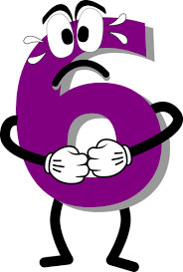
Connecticut

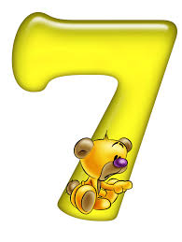
New Hampshire

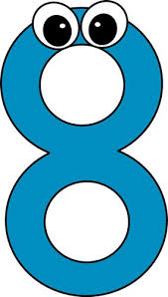
Delaware
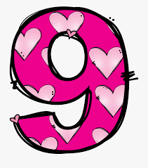
North Carolina

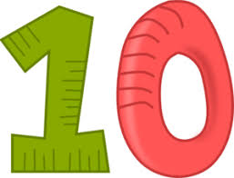
South Carolina

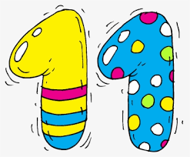
New Jersey

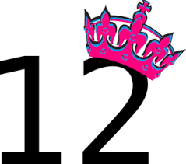
Pennsylvania

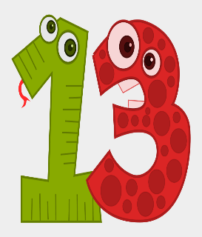
Georgia

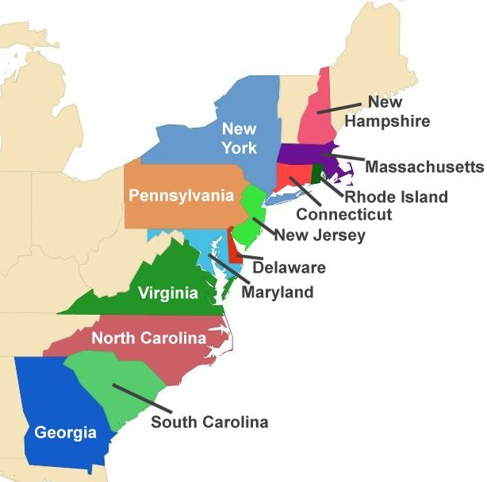
Ducksters
Using the Colonies guide, find each colony by name and write the correct number next to it.
For example, Virginia – 1.
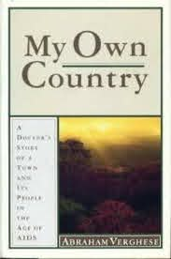
Create Your Own Country
What will you name it? _____________________________
 Where in the world will your country be located?

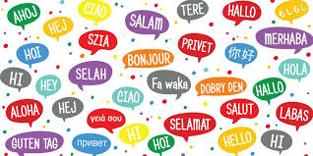 What language is spoken in your country?
*Be creative and think up a language that sounds very silly.
________________________________________________________
Make  rule everyone must follow:
*It can be funny or serious; it’s your country, so you decide!
_________________________________________________________
 Pick a song as your country’s national anthem:
_______________________________________________________

Draw or make a flag for your country:
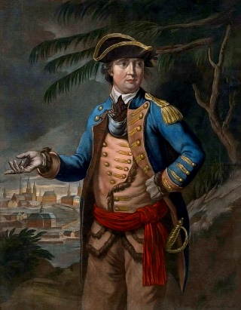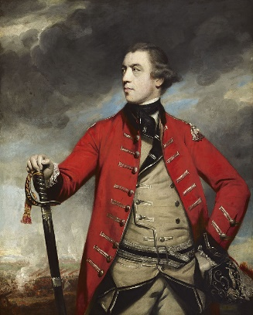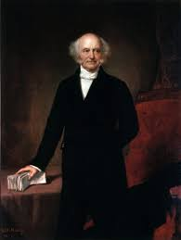
Hart Reynolds Healy
General Benedict Arnold General John Burgoyne Martin Van Buren
‘Martin’s Connection’
Martin Van Buren was born in the village of Kinderhook, New York. At the time of his birth, no one knew the terrible war between the thirteen colonies and Britain was almost over or that the colonists would win!

Kinderhook residents met some of the King’s soldiers five years before Martin Van Buren was born. The meeting took place when British soldiers captured at Saratoga, New York were brought to Kinderhook village for a meal before being sent off as prisoners to Boston.

One of the prisoners was the famous British General John Burgoyne. He was often called ‘Gentleman Johnny’ because of his polite manners.

A General for the Continental Army (Army of the 13 colonies) was also cared for in a Kinderhook home after being injured while fighting the British Army.
General Benedict Arnold was his name. He would later turn against the colonists to help the British Army.

Many buildings and homes that were around during the American Revolution and when Martin Van Buren lived in Kinderhook are still standing; you can walk the village and see them today.
Martin Van Buren’s Kinderhook
‘Then’ and ‘Now’

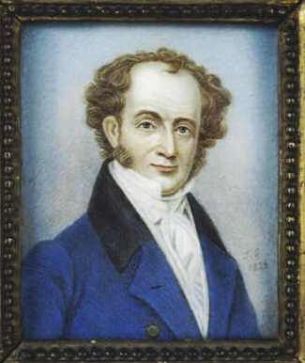
Hello, and thanks for participating!
Are you ready to learn about Martin Van Buren’s Kinderhook?

This activity revolves around a ‘Then’ sentence connected to President Van Buren’s life in Kinderhook.

‘Now’ sentences will offer a clue to a location in today’s Kinderhook’s Village.

1. Then:
Martin Van Buren prepared for a career in Law without attending university. He studied under the lawyer Francis Sylvester.

Now:
A private home.

2. Then: British General ‘Gentleman Johnny’ had dinner here before being sent as a prisoner.

Now: Private Home.

3. Then:
Colonial General Benedict Arnold was treated here for injuries at a battle.

Now: Private home.

4. Then:
President Van Buren bought Lindenwald to return to the community he loved.

Now:
Where in Kinderhook can you still see the President observing community life?

5. Then:
Baby Martin was baptized by Reverend Johannes Ritzema 10 days after birth.

Now: What historic Kinderhook church did President Van Buren attend service?

‘Then and Now’ Answer Key

1.Francis Sylvester House, 7 Sylvester Street (#10)

2. Burgoyne House, 24 Broad Street (#4)

3. Benedict Arnold House, 28 Broad Street (#6)

4. Martin Van Buren Statue, Village Square (#1)

5. Kinderhook Reformed Church, 21 Broad Street (#8)

The number in the parenthesis corresponds to a location noted in the ‘Native Son’ brochure.

While walking around the village, use the brochure map find other buildings still standing before the American Revolution and during Martin Van Buren’s time when he lived in Kinderhook.

- Note: Many of the buildings are now private homes or businesses, preventing entry.

* If you live too far from Kinderhook:

Check your village, town or city to find out if they have a link to the American Revolution.

If your state came after the American Revolution, find out if a family member fought in the revolution.

