
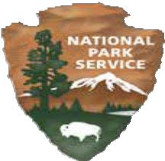
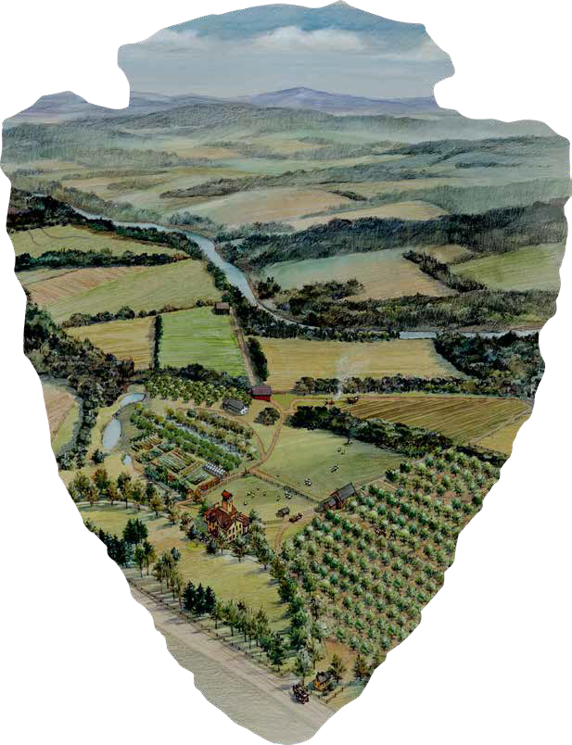
Martin Van Buren National Historic Site
Junior Ranger Book

Biography of
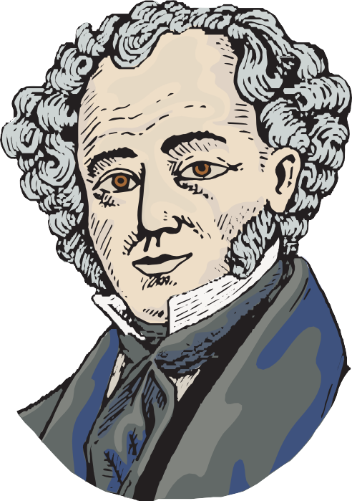
President Martin Van Buren
Martin Van Buren was born in Kinderhook, New York on December 5, 1782. Martin’s childhood included lessons with a schoolteacher and chores at home with his seven brothers and sisters. The future president’s family spoke Dutch, and he learned English as a second language! As a teenager, Martin studied law from books for seven years. He passed the test to become a lawyer before his 21st birthday.
Opening a law office was the first of many choices that would lead to forty years away from Kinderhook. Martin and his wife Hannah moved to the state capital of Albany when he was elected as a New York State Senator. Eight years later, Van Buren moved to Washington D.C. as a United States Senator. This work taught Martin Van Buren how to become a leader, and he helped his peers compromise when they disagreed with each other. Martin Van Buren worked with Andrew Jackson from Tennessee to organize the Democratic Party. This is one of the two major
political parties we still have today. Jackson was elected as the 7th President of the United States and Van Buren was his vice president.
Van Buren became the nation’s 8th president in 1836. After one term in the White House, President Van Buren was defeated by William H. Harrison and came home to Kinderhook. He ran for president as a Democrat in 1844 and as a Free Soil Party candidate in 1848. The Free Soil Party opposed the extension of slavery into new states. Both of these campaigns were unsuccessful.

President Van Buren retired to the farm he named Lindenwald. He hired a gardener and a farm manager and made improvements on the land. Farmhands grew flowers and vegetables in the gardens and green houses and planted apples and pear trees in an orchard. Animals on the farm included sheep and cows.

All four of Martin and Hannah’s sons spent time here with the “Ex-President,” as they called their father. Three sons married and had children, and the family grew to seventeen people! The dining room table was big enough for all of them. Family time included songs and stories in the parlor.
Outdoor fun meant horseback riding and fishing.

President Van Buren lived here until his death at the age of 79. He wrote in his will in 1860, “I, Martin Van Buren of the Town of Kinderhook, County of Columbia and State of New York, once Governor of the State and more recently President of the United States, but for the last and happiest years I was a farmer in my native town.”

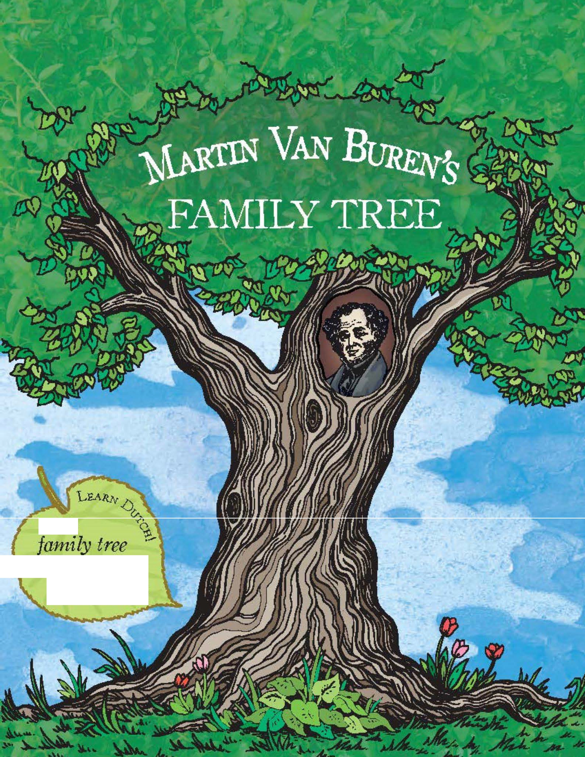

E..NGLI&H:

DUTCH:

stambootn

english:

mother/father
dutch:

Johannes Van Alen
ca. 1740–1777

Marytje Van Alen
b. 1768

Johannes Van Alen
b. 1770

Jacobus Van Alen
Married 1770 ?

Maria Hoes Van Buren
1743–1817

Married 1807
Married 1778 ?

Abraham Van Buren
1737–1817

Abraham Van Buren
b. 1788

Lawrence Van Buren
b. 1786

Hannah Van Buren
b. 1780
Derike Van Buren

moeder/vader
b. 1773 Martin Van Buren Hannah Hoes
1782–1862 1783–1819
b. 1778
english:

brother/sister
dutch:

broer/zus

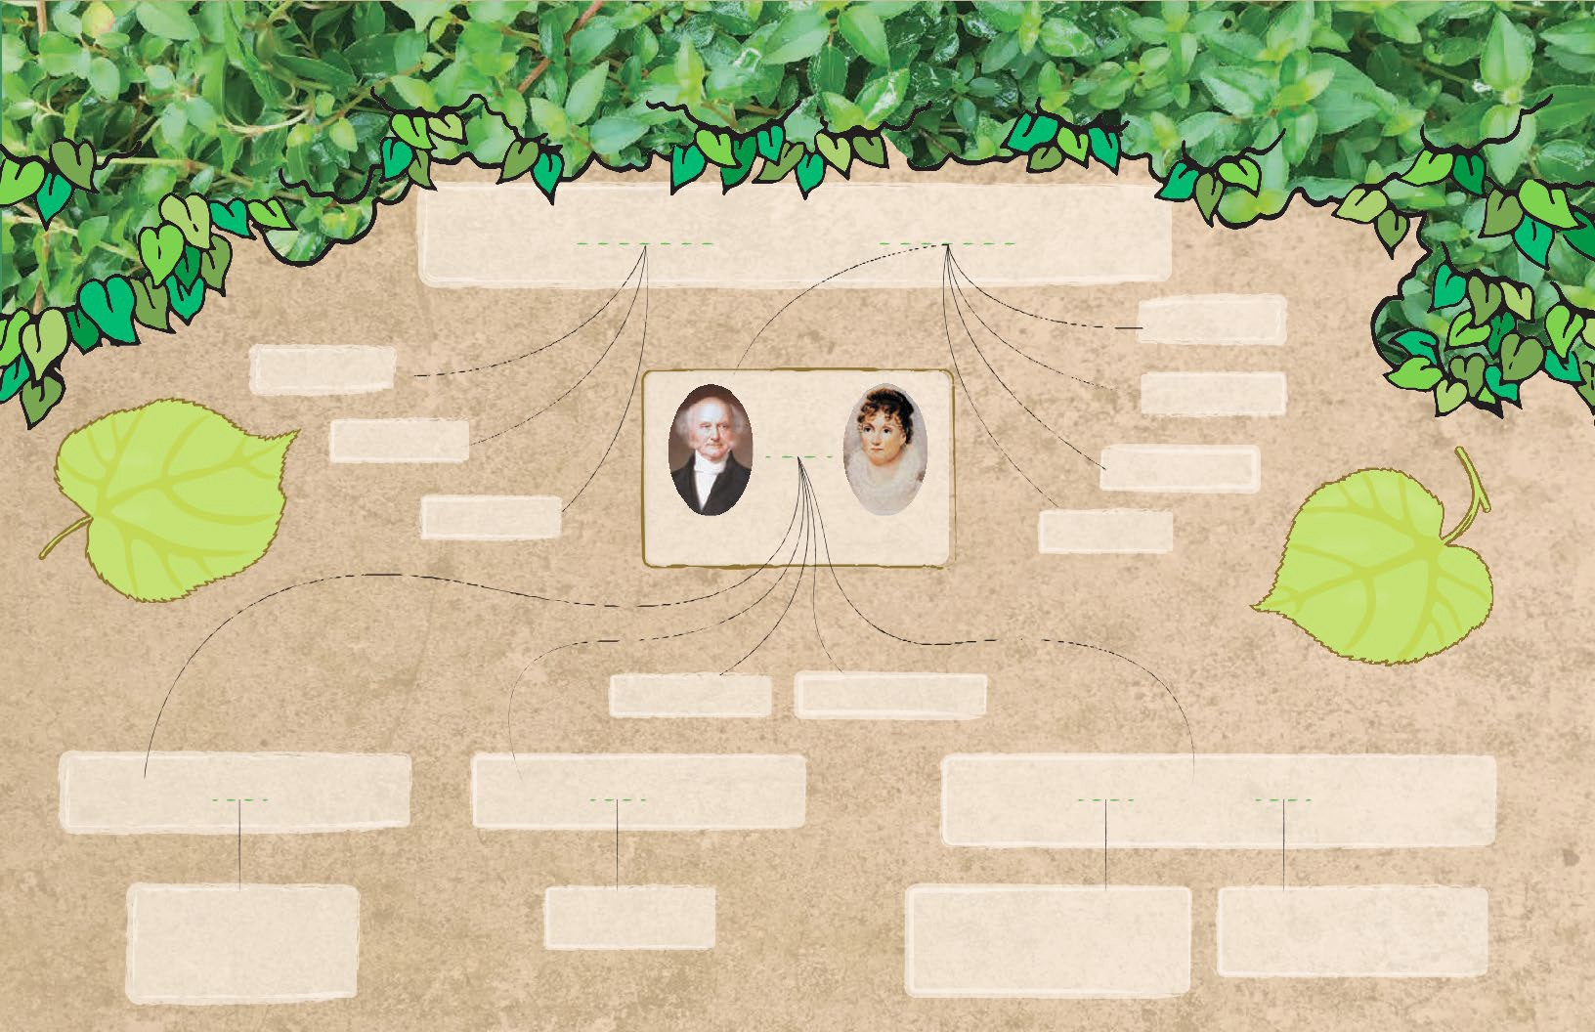

Martin Van Buren, Jr. Winfield Scott Van Buren
1812–1855 1814–1814

Married Married Married Married
1838 1841 1842 1855
Abraham Van Buren Angelica Singleton John Van Buren Elizabeth Vanderpoel Ellen King James Smith Thompson Henrietta Eckford Irving
1807–1873 b. 1816 1810–1866 1810–1844 1813–1849 Van Buren 1832–1921
1817–1876

Rebecca Van Buren 1840–1840 | Sarah Anna Van Buren | Ellen James Van Buren 1844–1929 | Martin Van Buren 1856–1942
Singleton Van Buren 1840–1879  Martin Van Buren b. 1844–1885  Travis C. Van Buren b. 1848–1889 | 1842–1923 | Hannah Van Van Buren 1846–1846  Edward Singleton Van Buren 1848–1873  Katherine Van Buren b. 1849–1942 | Eliza Eckford Van Buren 1858–1942  Marion Irving Van Buren 1860–1928

Create Your Own Family Tree
Write down the members of your family in the sections below.
Draw lines between people who are married and between parents and their children. How big is your family compared to Martin Van Buren?

Grandparents
Aunts & Uncles Parents Aunts & Uncles
Brothers & Sisters Me! Cousins


Kinderhook in the Mid-1800s

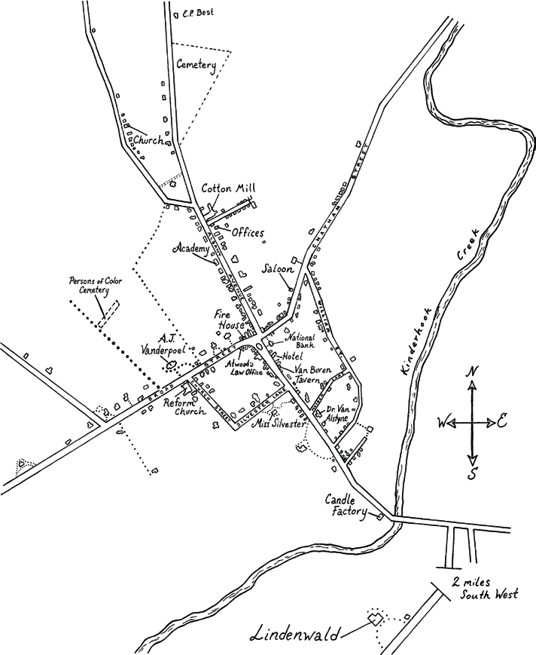
english:
D
u
!
t
c
h
L
e
a
r
n
church
dutch:
kathedraal

Neighborhood Map
The world has changed a lot since the mid-1800s.
What does your neighborhood look like now?
Draw a map of notable places below.

Hometown & Community Heritage
L

Tin &
english:
Academy governess
dutch:

IronWorks Cemetery
k Cotton Mill

gouvernante

Family Cook Fire House

Candle Factory

Governess Domestic
Workers

Hat-Maker

Church Farm Workers Tavern

L
1
english:

cook

dutch: Law Office

keukenmeid

Bank
Hotel


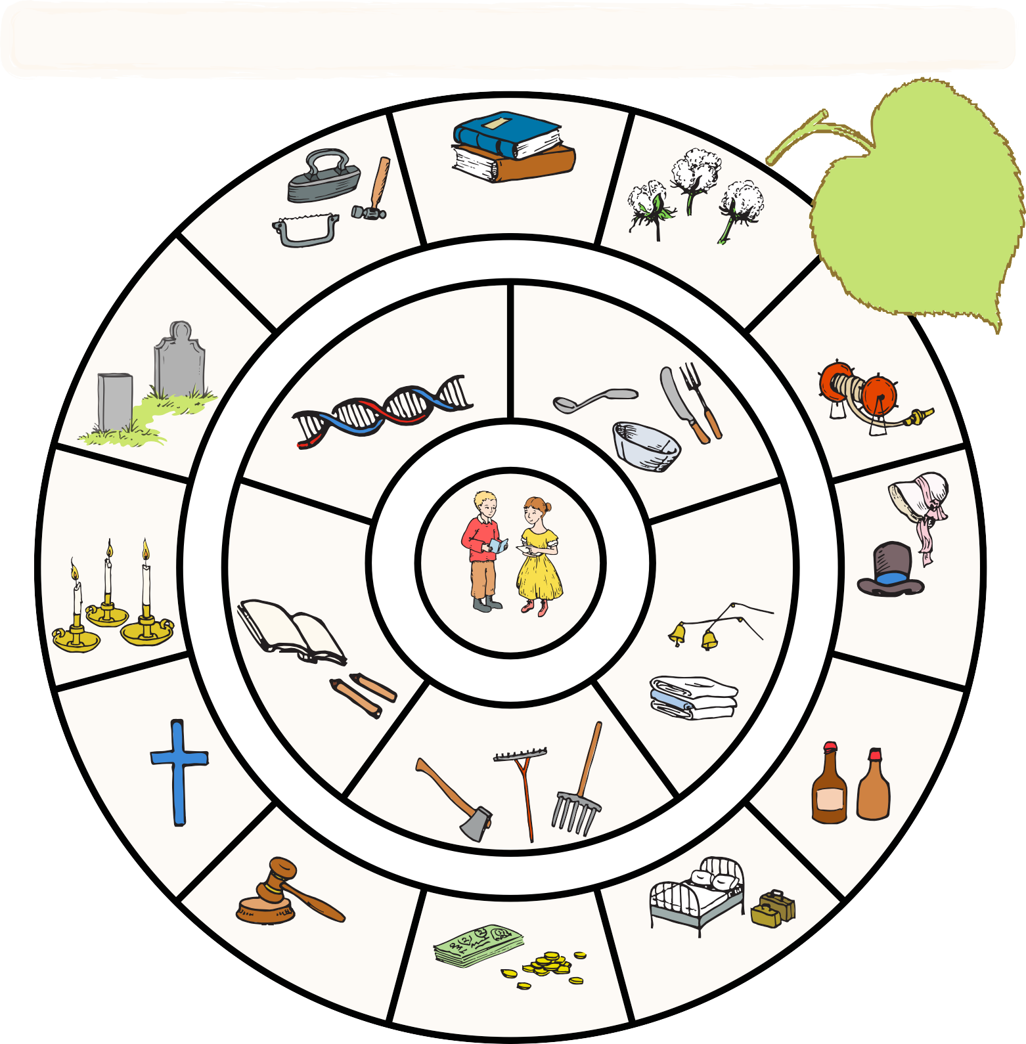



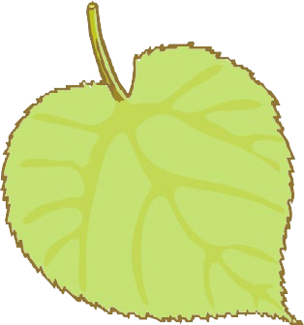









Martin Van Buren was deeply connected to Kinderhook and later to Lindenwald. This fostered a profound love and caring for his communities. The love for Kinderhook and Lindenwald in all their parts - people, structures, the land - created a desire to protect and serve his community, that is a civic sense.
This community wheel shows the people and places that surrounded MVB’s grandchildren at Lindenwald and in the greater Kinderhook community. Compare this wheel with the map of Kinderhook on the previous page. Then, think about the people and places that surround you today and create your own community wheel and neighborhood map on the attached activity pages.

Create Your Own
Community Wheel
Using the community wheel about MVB’s grandchildren as a guide, think about the people and places that surround you at home and in your neighborhood or town.
Draw yourself in the center and then fill in the wheel!



Draw Your Own Coat-of-Arms
The Van Buren family coat-of-arms features a shield and imagery that symbolizes what the family stood for back when it was created. On the left is a greyhound for loyalty and on the right embattled stripes of red and gold for strength and generosity. Use the shield template below to draw your own coat-of-arms, using symbols that represent you. You can use the list of heraldic symbols on the next page for inspiration, or make up your own!

Heraldic Symbols
These are some symbols that have been popular throughout history as parts of coats-of-arms, and their meanings. Use them as inspiration for designing your own coat-of-arms, or invent your own!

Colors:
Yellow or Gold : Generosity
White or Silver : Peace and sincerity Black : Constancy, sometimes grief Blue : Loyalty and truth
Red : Strength, military fortitude
Green : Hope, joy and sometimes loyalty in love Purple : Royal majesty, sovereignty and justice Orange : Worthy ambition
Maroon : Not hasty in battle, and yet a victor

Other Symbols:
Axe : Dutiful
Bridge : Signifies a governor or magistrate Crosses : Christian sentiments
Crown : Authority
Fire : Zeal
Flaming Heart : Passion
Fleur-de-lis (stylized Iris flower) : Purity (associated with France)
Hand : Faith, Sincerity, & Justice Heart : Sincerity
Horns & Antlers : Fortitude Lightning : Decisiveness Moon : Serenity
Oyster Shell : Traveler Ring : Fidelity Scepter : Justice
Star : Honor, Achievement and Hope
Sun : Glory Sword : War-like
Tower or Castle : Fortitude & Protectiveness
Animals:
Bear : Protectiveness Bee : Industriousness Camel : Perseverance Dog : Loyalty
Eagle : Leadership & Decisiveness Dragon : Defender of Treasure Falcon or Hawk : Eagerness
Fox : Cleverness
Griffin (part eagle, part lion) : Bravery Horse : Readiness to Serve
Lion : Courage
Pelican : Generosity & Devotion Raven : Constancy
Snake : Ambition
Stag, Elk, or Deer : Peace & Harmony Tiger : Fierceness & Valor
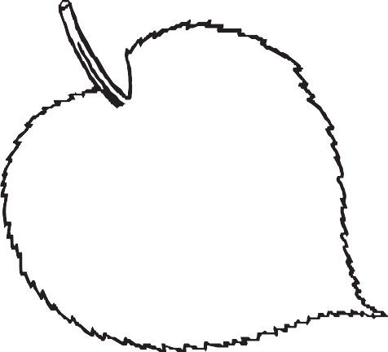

Unicorn : Extreme courage Wolf : Constant Vigilance

english:
coat of arms
dutch:
wapenschild

Civics & Politics
As Martin Van Buren was growing up, the country’s founders were setting up the system of government we know today. The United States had just declared independence from a king, and the founders wanted to make sure no one person or group had too much power. They created a government with three “branches” and a system of “checks and balances.”

This branch is made up of
law-makers. Legislators exist on the local, state, and federal level, and include the Senate and the House of Representatives.
Legislators are elected to represent the people! Martin Van Buren was a

in the 1820s.
This branch enforces the laws created by the legislators, and includes governors and the President of the United States. In addition to serving as President, Van Buren was also

, another job in this branch.
This branch interprets the law in the courts, and has the power to declare laws unjust. The biggest court is the United States Supreme Court, which interprets the Constitution.
Martin Van Buren was in the courts as a

at the beginning of his career.










The country’s founders struggled with the future of slavery in a growing nation. Some believed the labor of enslaved men, woman and children was necessary for a successful economy. Others believed enslaving people was wrong and should be abolished, or gotten rid of. Some were willing to allow slavery where it already existed, as long as it was not allowed in new territories or states. This struggle eventually led to the American Civil War.
What are two connections Van Buren had to slavery in his lifetime? (Hint: the election of 1848)

Enslaved people in the early 1800s were not considered citizens and could not vote. How would you feel if your future was decided on by representatives you could not help choose?

Families on the Move!
english:
_{migrate} Migrate - to move from one place, state
dutch: or country to another and live there
trekke
The United States doubled in size when President Thomas Jefferson purchased the Louisiana Territory from France in 1803.
The United States border moved 1000 miles west from the Mississippi River to the Rocky Mountains. This territory would become states beginning with Louisiana in 1812 and ending with Oklahoma in 1907.
After the Mexican-American war in the 1840s, the country expanded all the way to the West Coast.

I was an enslaved cook on a plantation in Virginia. When my
master’s son decided to move west, I was sent with him.

I am a member of the Cherokee
Nation. The government forced my family west on the Trail of Tears.


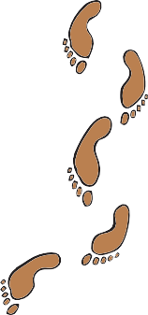

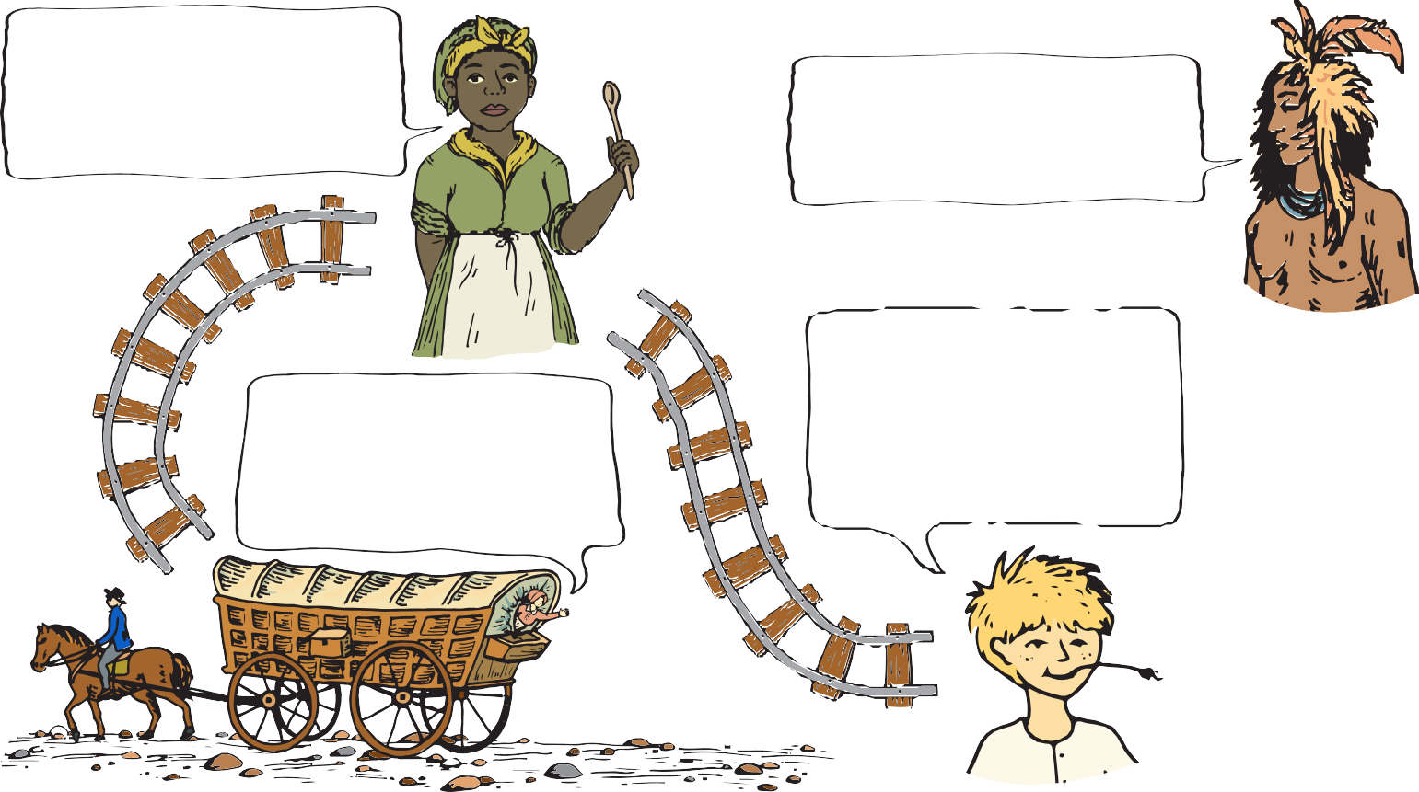
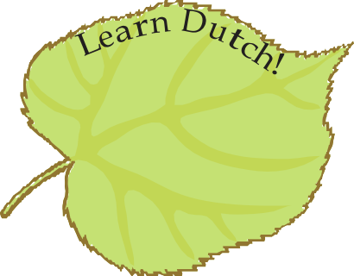

After coming to America from Germany, my family settled in
My husband and I are New York, but it is crowded.
bound for California, We heard there is more farmland where people are finding gold. west of the Mississippi.
They say anyone can strike it rich!

Why do you think the people pictured on this page migrated from the East Coast to places like Kansas, Missouri, and California?

Archeology Dig
Excavations at Lindenwald have turned up many day-to-day items that were used long ago when Martin Van Buren lived here. These items teach us a lot about what life was like for them. Imagine archeologists 200 years from now are digging below your house. What sort of items would they find? Draw some of those items in the space below. What would these items tell them about how we live now?


Mother Goose Children's Songs and Rhymes

Baa, baa, black sheep, Have you any wool?
Yes sir, yes sir, Three bags full;

One for my master, One for my dame,
And one for the little boy That lives down the lane.
Hot-cross buns! Hot-cross buns!
One a penny, two a penny, Hot-cross buns!
If you have no daughters, Give them to your sons; One a penny, two a penny, Hot-cross buns!

Peter Piper picked a peck of pickled peppers;

A peck of pickled peppers Peter Piper picked;

If Peter Piper picked a peck of pickled peppers,

Where's the peck of pickled peppers Peter Piper picked?

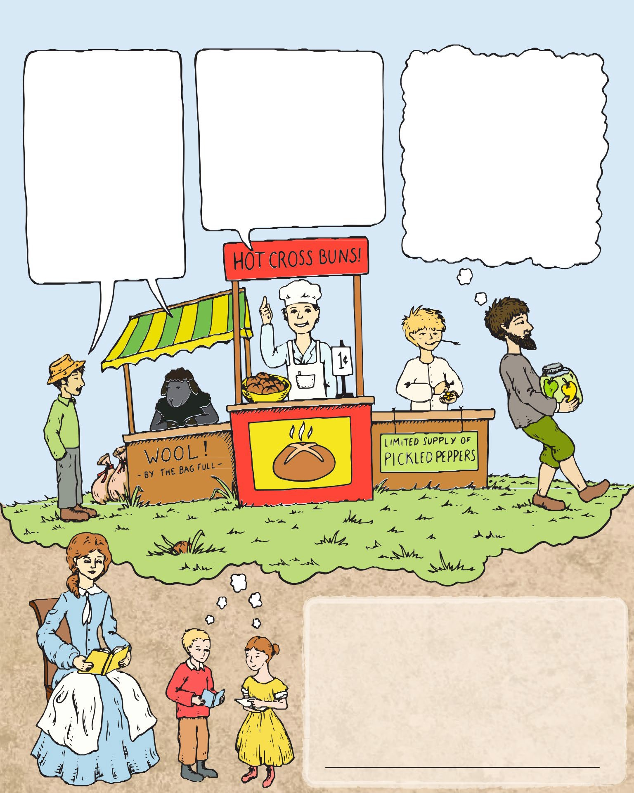

In our 21st century world, we have many different ways to learn and entertain ourselves. In the 19th century, President Van Buren’s grandchildren and other children on the farm would read or sing or share rhymes. The children would have learned rhymes such as these from their parents as the family spent time in the parlor after supper. Give them a try!
What do you do for fun with your family?

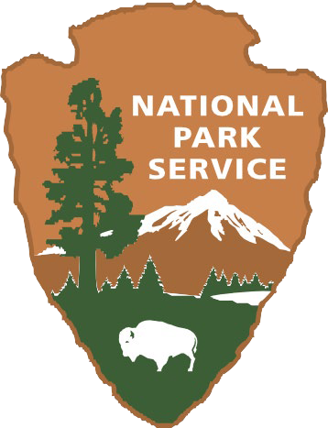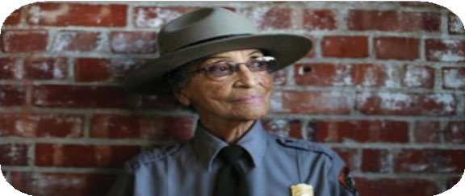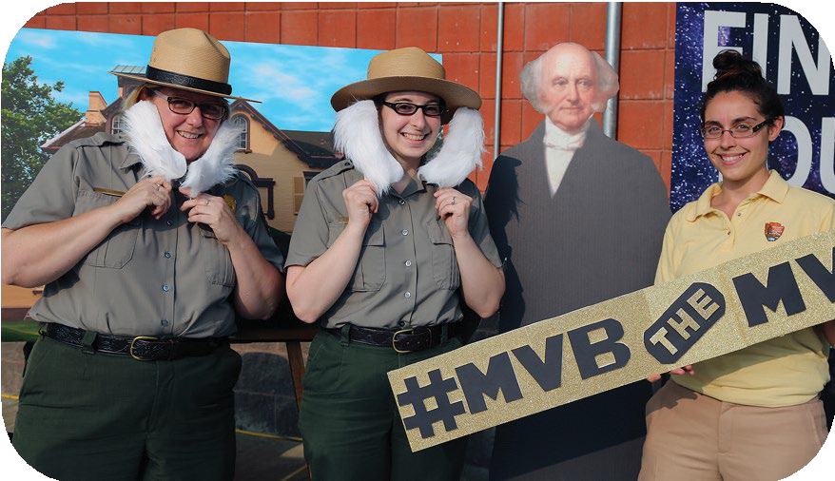

So you want to be a National Park Service Ranger?
The National Park Service preserves natural and cultural resources for the enjoyment, education, and inspiration of people today and for future generations. There are over 400 national parks from Maine to Guam and many places in between. We partner with communities across the country to preserve their history and create places for outdoor fun. The NPS has one of the most diverse workforces in the world. Park rangers wear many hats, from protecting the parks to telling the stories of the plants, animals, and people that make these places important. There is a career with the NPS for everyone!

Our local park, Martin Van Buren National Historic Site, preserves and tells the story of our eighth president’s home. In order to run smoothly, the park needs historians, curators, maintenance staff, law enforcement, administrators, naturalists, and many others.
Volunteers also help staff and maintain our sites.

The National Park Service is committed to telling the stories of all Americans, and you can help us protect these special places for the future!

Want to participate in the Junior Ranger program but can't finish the book today? Not a problem. Completed Junior Ranger booklets can be emailed or mailed back to the park. We’ll review it and return your Junior Ranger booklet with your badge.
Email: MAVA_Info@nps.gov Mail: Martin Van Buren NHS
1013 Old Post Road Kinderhook, NY 12106

