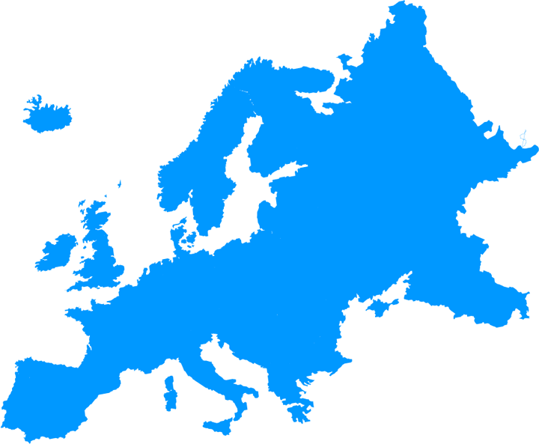
EUROPE

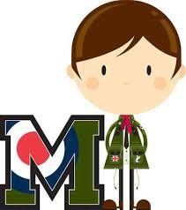

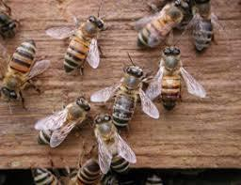

Europe
For the past 20 years Europe has watched its bee population disappear.

Scientists believe it is a combination of chemicals used on plants and flowers, as well as disease and insect infestation.

To deal with the problem leaders in Europe have banned harmful chemicals and are encouraging organic farming.
Their efforts are slowly increasing the bee population.
In Martin’s Time
Beginning in the late 1800s and into the 1900s, bees in America contracted a bacterium that dropped the bee population.

The only way to keep the disease from spreading in bees was to require the burning of all affected hives and beekeeping equipment.

Those not willing to obey the law were jailed and fined
$100.00.

That would mean a fine of $3,108.00 in
today’s dollars.

Pollination ( paul – ih- na- tion) happens while bees are collecting a sugary liquid made by the flower called
nectar (neck-ter). Nectar is the bee’s food source.
While on the flower a type of yellow dust called pollen (paul – in) sticks on the bee.
When the bee stops for nectar on another flower the pollen stuck to the bee falls off and provides a kind of nourishment for the flower.
This is also how bees help make plants and flowers grow.

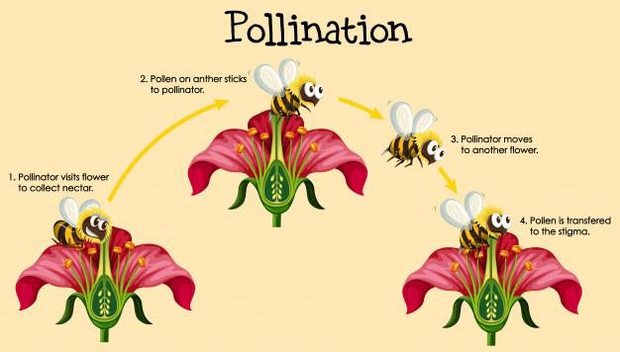

A large portion of the fruits, nuts and vegetables we eat grew because of the work bees did through pollinating plants.
The number of bees in Europe is less and less each year. This is causing worry for this reason.

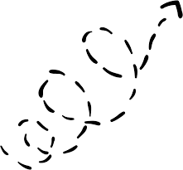

X2
Supplies needed:
- A tiny piece of sponge.
- A small bowl of water
- Less than1/2 a teaspoon of something powder-ish like:
  - Baking Soda,
  - Corn Starch or
  - Talcum Powder.
- Crayons

X1


- Draw a flower on each X.
- Shake a tiny bit of something that is a powder substance like: baking soda, cornstarch or talcum powder (pretend pollen) in the middle of the flower drawn on X1.
- Tap the bottom of your sponge (pretend bee) to draw some water
- (the pretend nectar), be sure to squeeze the water out so it doesn’t make a mess on
the paper.
- Land your bee on the middle of the flower with the powder.
- Have the bee follow the dotted line to the other flower.
- Make sure your bee lands in the middle of the other flower to ‘pollinate’ it.

