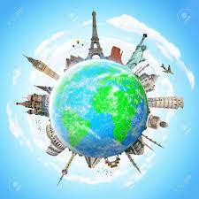

ATrip Around the
World Without Leaving Home
___________________________ Earth Day is everyday!
MartinVan Buren National Historic Site Kinderhook, NewYork

My Earth Hero name is:

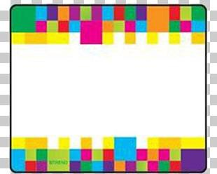

Place or draw your Earth Hero
passport photo here

My Earth Hero superpower is:

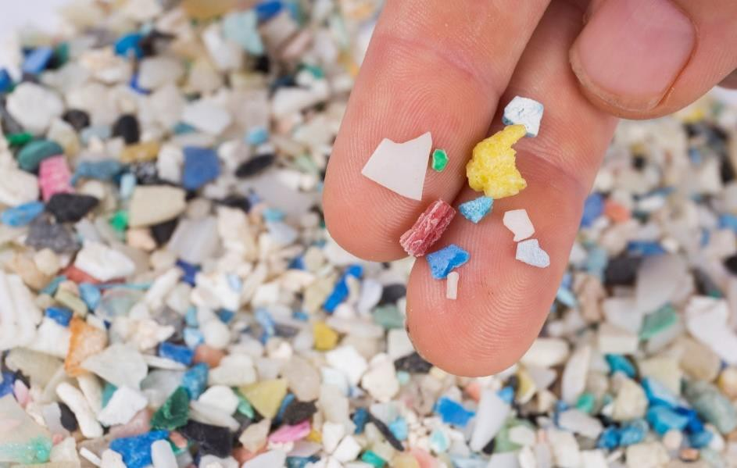

North America’s Earth Problem: Microplastics
Draw your passport stamp for North America in the box

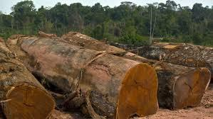
South America

Earth Problem: Amazon Rainforest Tree Removal

Europe

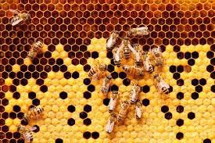


Earth Problem: Disappearing Bees

Australia
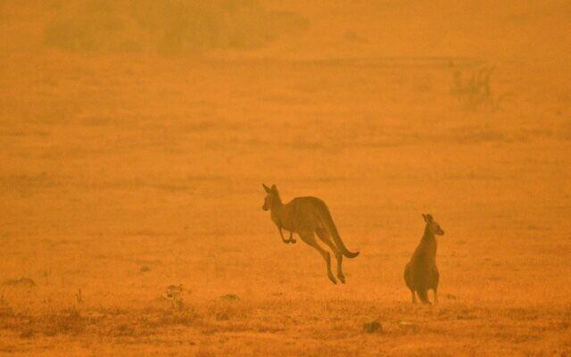

Earth Problem: Bush Fires

Asia
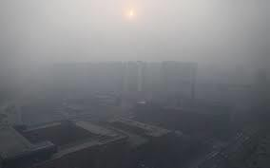

Earth Problem: Air Pollution—Smog

Antarctica

‘I
f
B
,
f
,
f
’
David Suzuki

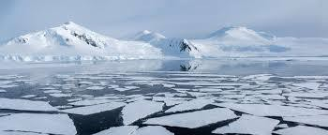
Earth Problem: Melting Glaciers
_____________
___________
Be a Climate Change Hero!

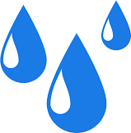
__________________

Africa
Are you a Water Hero or a Water Waster?
- Do you let the water run when you brush your teeth? Yes No
- Do you turn on the shower and do something else before getting in? Yes No
- Do you carry a refillable water bottle? Yes No

If you answered Yes 2 out of 3 times: Water Waster.
  - Now that you know, it is easier to adjust these habits. If you answered No 2 out of 3 times: Water Hero
  - Good job! Keep up the good work!
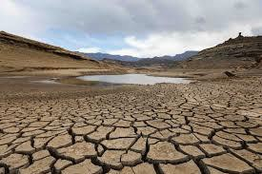
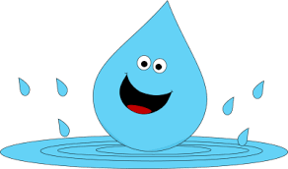
Earth Problem: Not enough water

What else can you do to save water?





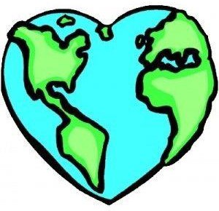

Earth Day
Martin Van Buren National HistoricSite

