

Australia





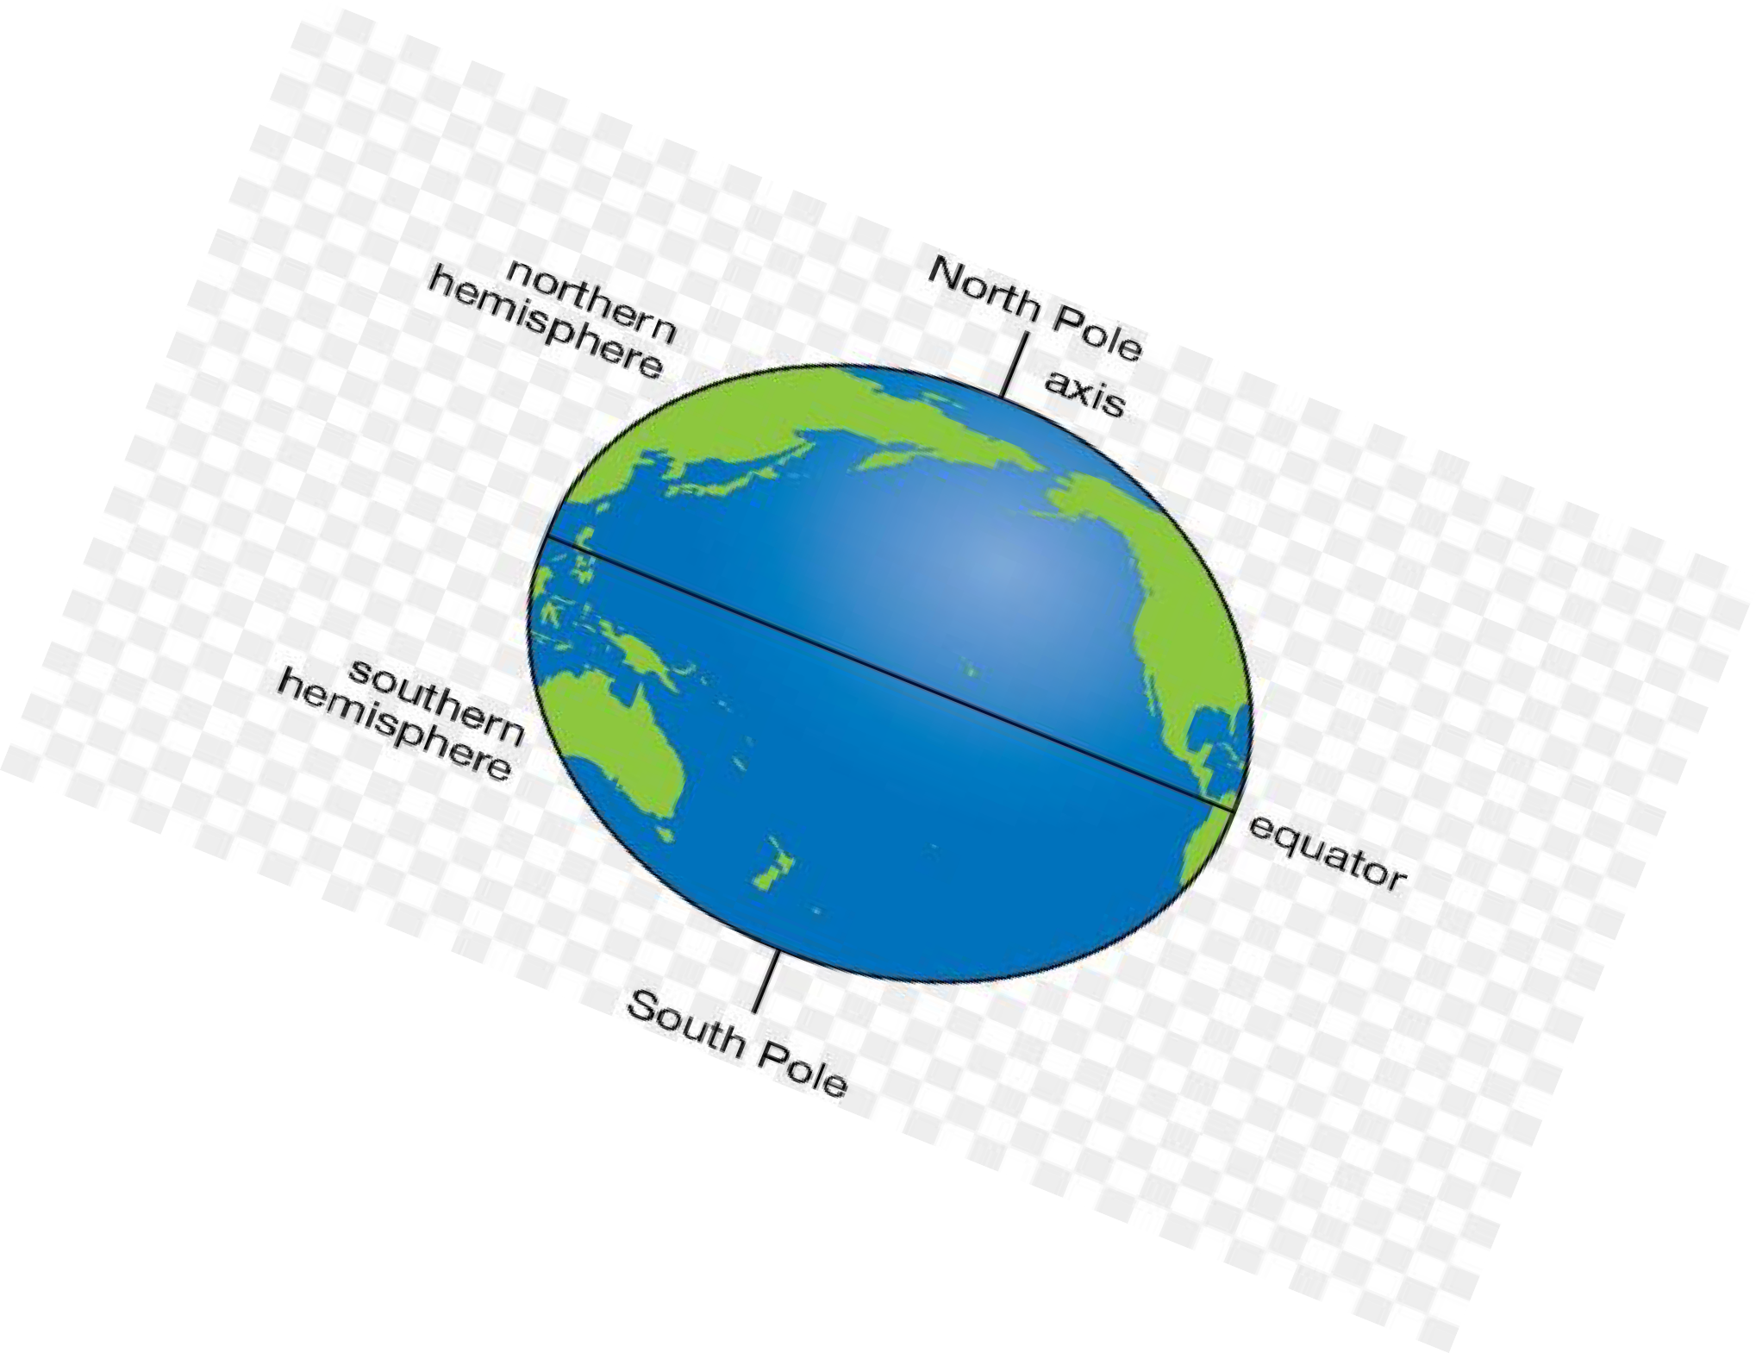
Australia
America

How about snow in July and
Summer vacation in December?
Crazy, huh? Not in Australia.

Australia sits south of the equator - an imaginary line to divide the earth into two hemispheres.

Between December and February, the earth tilts bringing the southern hemisphere closest to the sun.
It is why Australia experiences Summer while America experiences Winter.

June through August is when the northern hemisphere is closest to the sun giving
America Summer,
while Australia enjoys Winter.

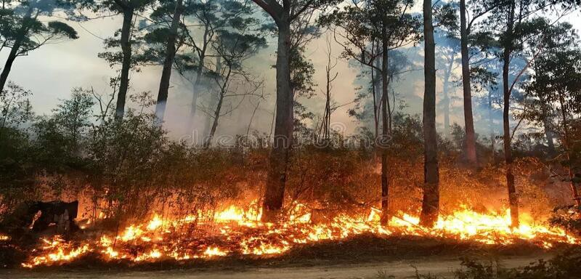

Australia
In Martin’s Time



December 2019 to
February 2020 gave Australia its hottest summer ever,
creating terrible bushfires.

Bushfires in late summer are common for Australia, but high temperatures
plus a drought caused the fires to be the worst in
Australia’s history.

Children in Victoria, Australia who experienced the fires
have used the scary experience to
become Fire Heroes.

They are creating plans
to help other children prepare for big emergencies.
New York City also had a great December fire during Martin’s lifetime.

The fire occurred on
December 16, 1835.

At the time, water to put out area fires came from the East and Hudson Rivers because fire hydrants didn’t exist.

It was winter and 17 degrees below zero.
The rivers were too frozen to draw water.

To stop the fire from spreading the
U.S. Marines were called out to blow
up buildings.

Altogether, the fire burned 17 city blocks.

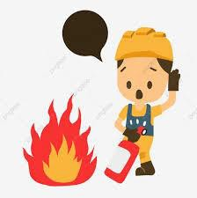
Fire is dangerous and can easily create a scary situation.
Be a Fire Hero with these suggestions:

- If there is a fire inside, get outside -fast!

- Do not go back inside.

- Tell an adult if you find matches or a lighter.
  - Don’t pick the matches or lighter if you can help it.
  - It’s best to bring the adult to them.

4. Don't leave toys in front of a heater or fire.
Your Fire Hero Plan
Having a plan to keep safe just in case something goes wrong is a very smart Fire Hero idea.
Sit down with an adult and discuss what is the
best thing to do should a fire occur in your home.
- Make sure you understand what the adults would do and what you should do.
- Know all the safe ways to get out of the house.
- Have the adult decide on a place outside
for everyone to meet up.

Play Safe and Be Safe!
It’s the Fire Hero Way.

