ASIA
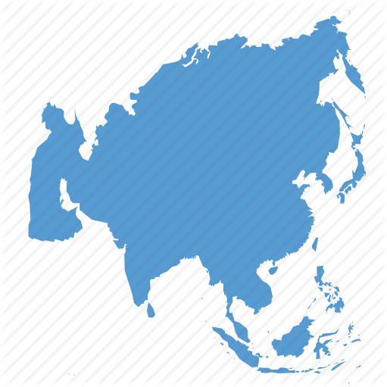
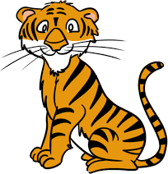

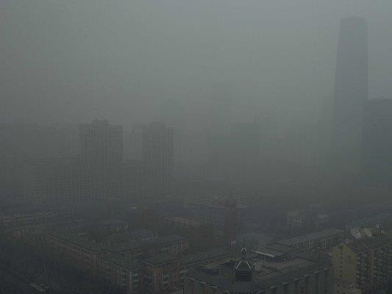
Smog gets its name from the two words; Smoke and Fog


Asia
We all know what smoke is, but what about fog?
Fog is like a cloud of tiny water droplets, or ice crystals, hanging very close to the ground.
Smog is a combination of smoke and fog.
There are two types of smog; nature-made and human-made.

Nature-made smog is fog and natural things in the air.
One example is ash from volcanos
– also known as Vog.

Human- made smog is fog and smoke from burning fuels like wood, gasoline, and coal.

Humans can’t control nature, but
we can change our habits.
In Martin’s Time


In 1831 Martin Van Buren made London, England his home for eight months.
He was representing the United States as
Minister to Britain.

At the time,
London had a smog problem like Asia has today.

London is built along the River Thames (pronounced: Temz) which produces a nature made problem -
heavy fog.

The human part was caused by hundreds of factories and homes that burned coal and wood for power and heat.

The English still refer to London by the nickname given back then,
‘The Big Smoke.’

In placeswhere Smog isa seriousproblem, a color systemactsasa warning systemtohelp peoplepreparefortheday.

Green = Good!
Yellow = Pretty Good
Orange = Not healthy for elderly people and
children with lung problems

Red = Not healthy for anyone

Purple = Super
Unhealthy for All
Dark Red =Dangerous for all

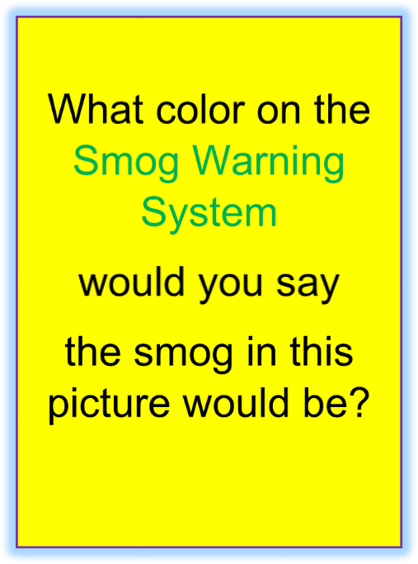

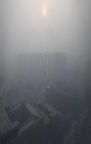

Be a Smog Hero by using the color system to help others who might have breathing problems prepare for the day.
Look up at the sky.
Do you notice Smog?
Yes or No?
Decide what color on the
Smog Warning System
is the air quality today.

