Fall
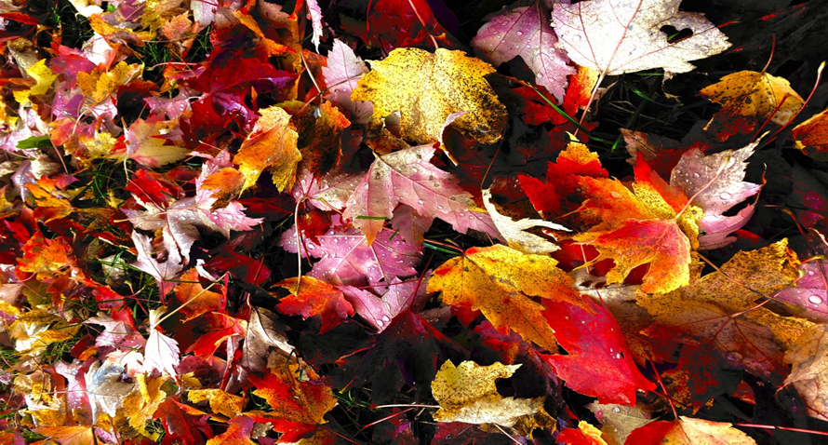
Fall, or Autumn, is when the temperature begins to cool and the leaves on trees put on a show of colors, from green to yellow, red, and orange. It is a great time to go for a hike or walk and see all the pretty colors
But why do leaves change colors?
Fallen leaves at Lindenwald
- Leaves, like you, need light, air, and water to be happy and healthy!
- But what about food? Leaves do not eat the same way you do.
Along with light, air and water, leaves also use a superpower called chlorophyll, pronounced: clor-uh-fill, to make food. This is what gives leaves their green color during Spring and Summer.
- Leaves get less light each day in the Fall and stop making food to prepare for Winter.
- Because they are making less food, the chlorophyll or green color, starts to go away leaving behind the pretty fall colors of yellow, red and orange.
- The leaves then fall to allow the tree to make new leaves in the Spring.
What are some of your favorite things to do in Fall? Write down three in the space below:

_____________________________________________________________________________________

_____________________________________________________________________________________

_____________________________________________________________________________________
Sugar Maple Leaf Color Scratch and Reveal
Materials: Sugar Maple leaf template, a coin for rubbing, orange, yellow, red, brown, and green crayons.
Instructions:
- Print out the Sugar Maple leaf template on printer paper.
- Allow your child to color the leaf however they want using orange, yellow, red and brown crayons.
- Invite your child to color over what they did in step 2 using the green crayon, until the previous color(s) are no longer visible.
- Using a coin, ask the child to scratch off the green to reveal the colors underneath. Supervise and provide assistance if needed.
- As they scratch, remind them that as the green color (chlorophyll) fades, the pretty fall colors of the leaf are revealed.

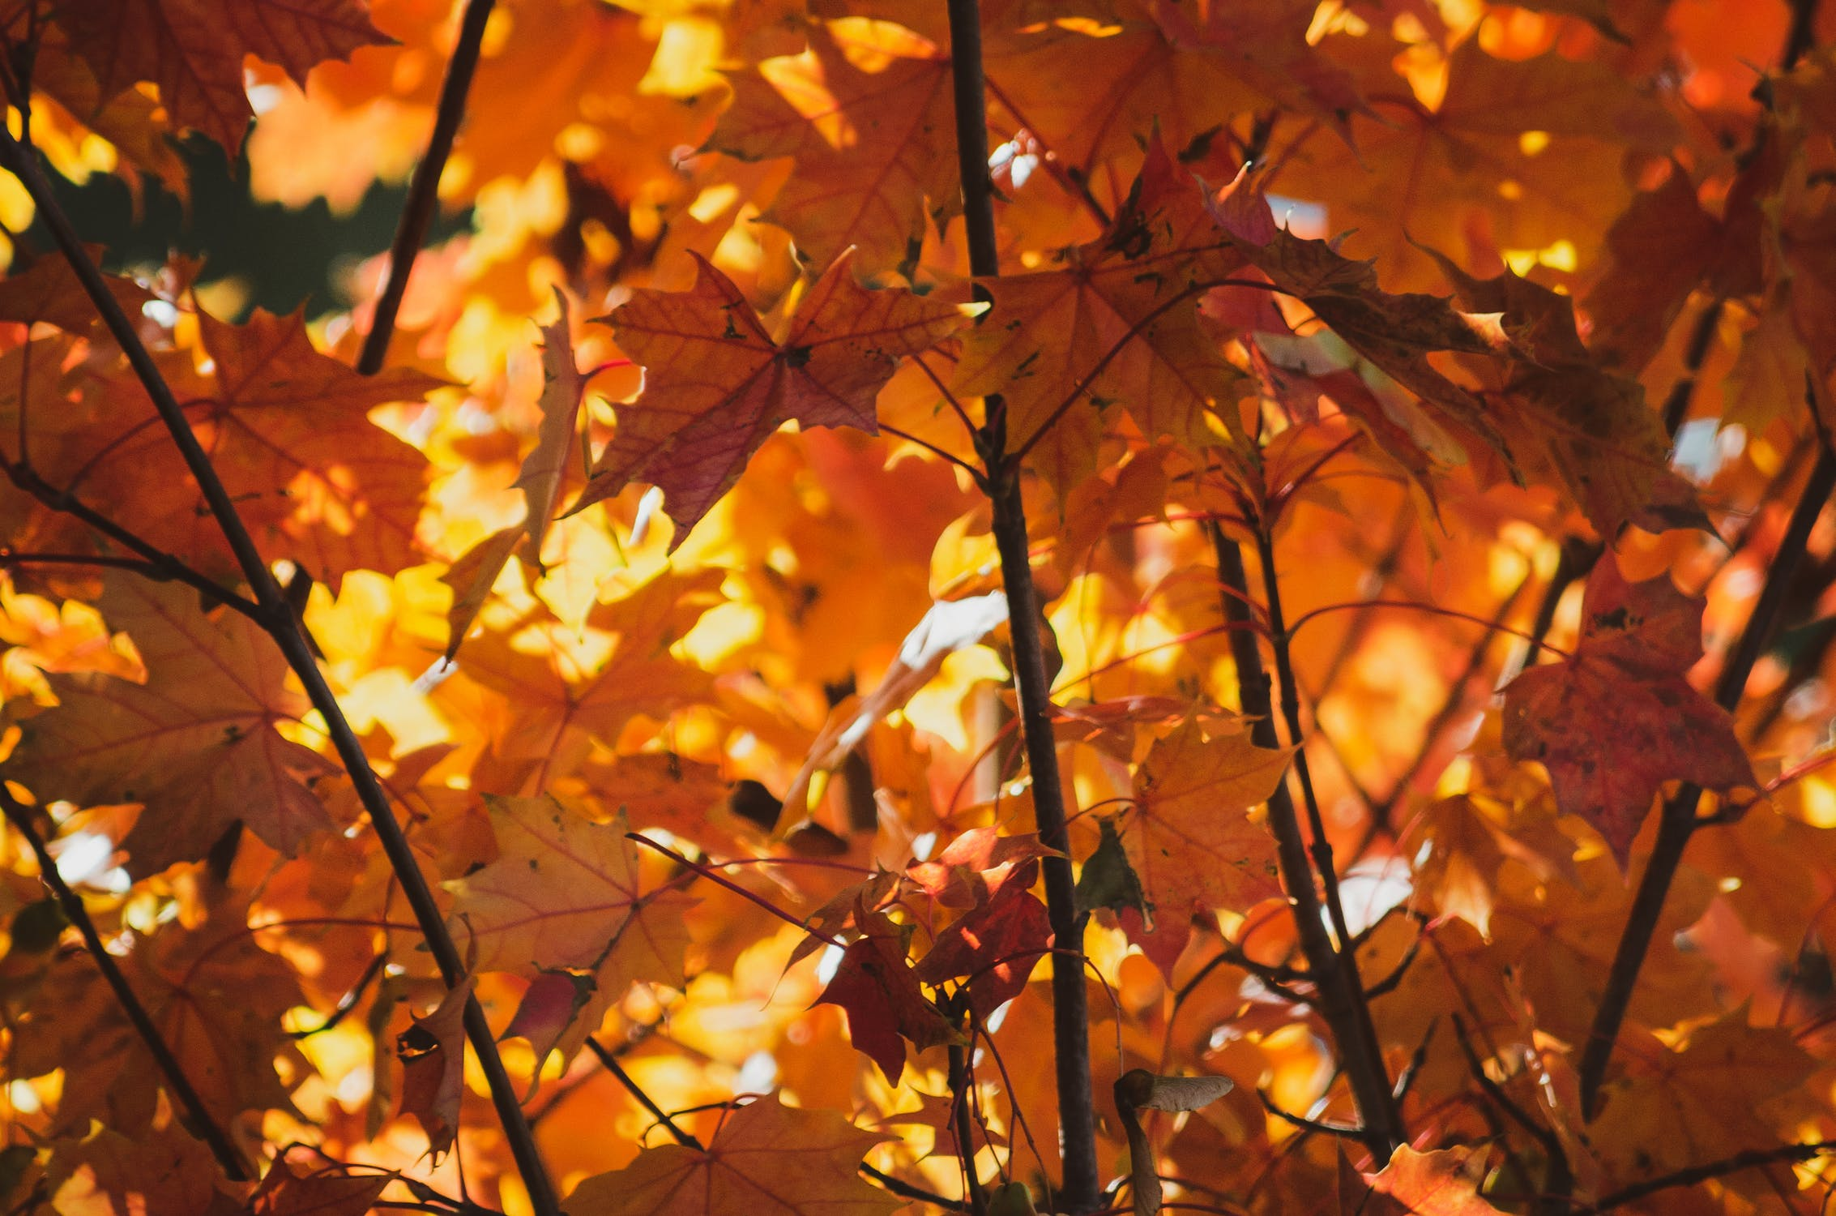
Sugar maple leaves

