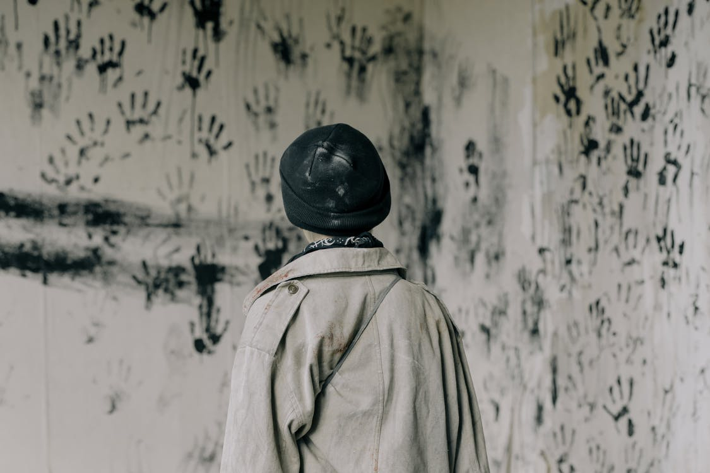
Breakage by touching is not the only way to damage a museum piece; our fingertips, therefore hands, contain oils that can ruin a sensitive object.
It’s also why Curators (those in charge of the items in a museum) wear cotton gloves when handling objects.
The next activity will introduce an old form of photography called the Daguerreotype (duh-ger-oh-type; the g is pronounced as the ‘g’ in go) with an exercise to show how oils on our fingertips can quickly damage one.
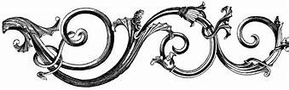
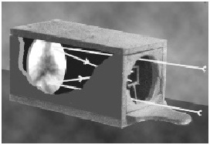¹
Daguerreotypes were images captured on a copper plate coated with silver.
The image appeared when exposed to light through a camera lens.

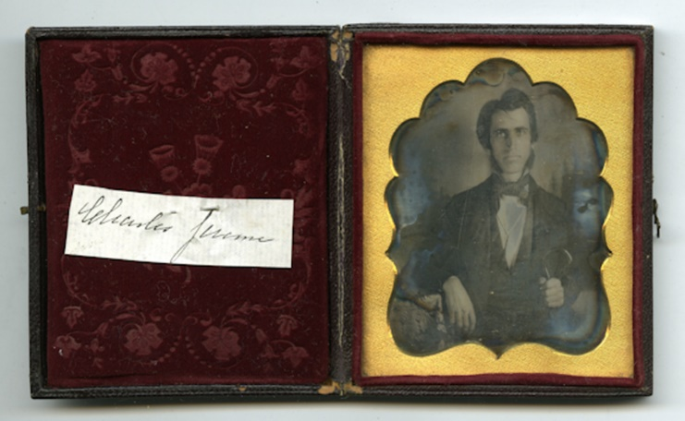
These small photo plate images were then placed into cases behind glass, with a silk or felt cushion inserted on the opposite side for protection.

Daguerreotype of Charles Jermone (1815-1873) taken by an unidentified photographer circa 1847-1851 (10051606a)
Daguerreotypes are fragile, meaning they damage easily. Their age is partly the reason, the other is the copper plate and silver used to capture the image. Later tin was used in place of copper.
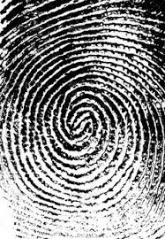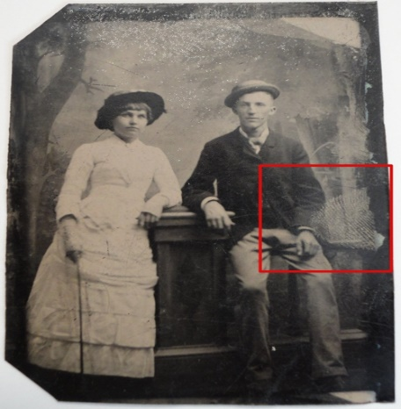
Human fingerprints are one of the most common causes of damage to daguerreotypes and other sensitive items.
The couple's likeness is captured here on tin,
but just like a copper-plated daguerreotype,
one touch of a human's finger was enough to begin erasing the image.

Activity 5: “Erase His Face”
Supplies:
1. A print out of the Martin Van Buren daguerreotype.
2. An Ink pad
or
Paint – a very, very tiny amount is all that’s needed.
Directions:
It’s your turn to see how easy it is to damage a daguerreotype with one finger.

Press a finger into the ink pad
or
lightly dip it into the paint and place it on the middle of President Van Buren’s face.

If the picture were an actual daguerreotype, his face would disappear due to the oils in our fingers coming into contact with the silver coating on the image plate.

It is reasons like this why you are often asked not to touch items in a museum.
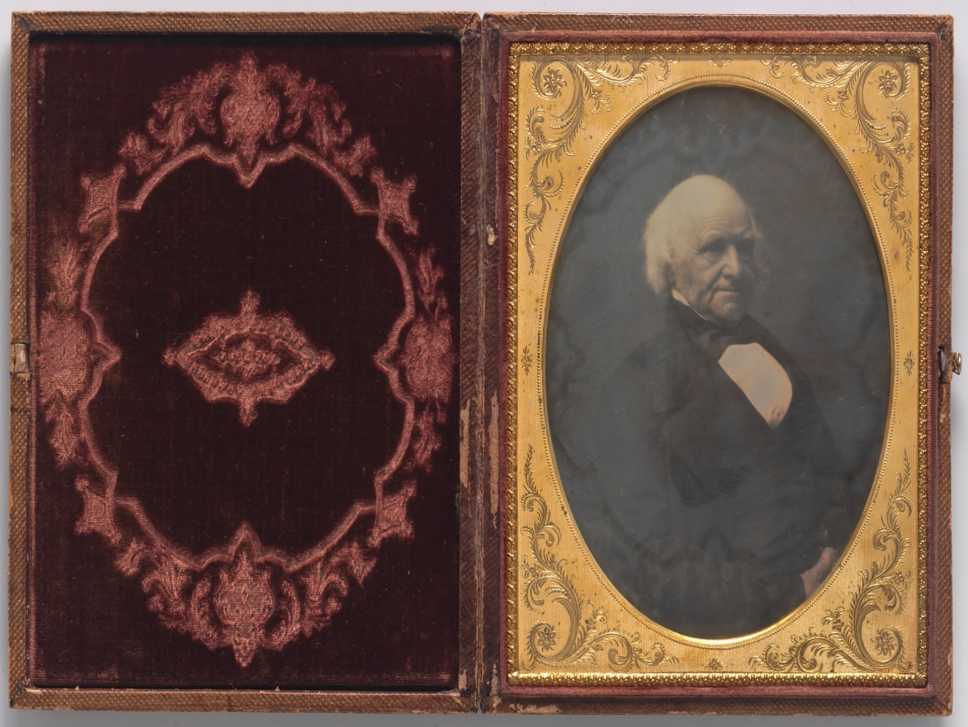
This daguerreotype of Martin Van Buren was taken in 1852 by the soon to be famous
Civil War photographer Matthew Brady.

Cottonbro. “Person in Brown Coat and Black Hat Standing Near White and Black Floral Wall.” Pexels, 21 June 2020, accessed 10 November 2020, https://www.pexels.com/photo/person-in-brown-coat-and-black-hat-standing-near-white-and-black-floral-wall-4874503
Dennis A. Waters,” Dating Very Early Daguerreotypes: A comprehensive explanation of the dating of daguerreotypes illustrated with many scanned images.” ‘Figure 8: Wolcott and Johnson Camera’ Fine Daguerreotypes & Photography accessed 12 November 2020, https://www.finedags.com/index.cfm?fuseaction=resources.datingdags
History Colorado. “Mad Hatters and the Anatomy of a Daguerreotype” 2 October 2014 accessed 10 November 2020, https://www.historycolorado.org/story/preservation/2014/10/02/mad-hatters-and-anatomy-daguerreotype
Andrea Piacquadio. “Woman In Gray Tank Top.” 8 June 2017, Pexels accessed 12 November 2020, https://www.pexels.com/photo/woman-in-gray-tank-top-3812731 ² UF, George A. Smathers Libraries.”Hugh and Catherine MacDonald” Date Unknown. Daguerreotypes, Ambrotypes and Other Imagery; Tin Types. accessed 12 November 2020, https://guides.uflib.ufl.edu/daugerrotypes
Matthew B. Brady ‘Martin Van Buren.’ Photograph, Half Plate Daguerreotype, c. 1852 National Portrait Gallery, NPG.76.104 , Smithsonian accessed 12 November 2020, https://npg.si.edu/object/npg_NPG.76.104

