Activity 4: “And, That’s Why They Can’t Have Nice Things”
Now that you’ve watched the YouTube video, the following page features actual photos of the damaged pieces mentioned in the clip.

For the record:
Adults, not children, damaged each of the historic pieces featured in that video.

Lesson:
Look at each picture on the next page, at the end of each description there is a ‘Lesson Learned.”
Think about each incident and what you can learn from it, write or talk about your answer with an adult or other child.

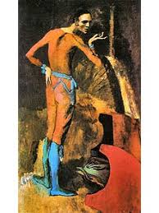
Pablo Picasso: "The Actor", 1904-05
©ARS New York, heirs of Pablo Picasso
‘The Actor’ by: Pablo Picasso.
Year: 1904 – 1905.
Materials and Dimensions: Canvas; height: 6 ft x width: 4 ft.
Site: The Metropolitan Museum of Art.
Location: New York City.
How did it get damaged? Woman stumbled while walking and fell through it. (2010)
Value at the time of damage: 130 million dollars.
You would be able to pay Cristiano Ronaldo to play on your soccer team - in 2018.
Damage: Small gash 6 inches long on the bottom right corner.
Repair: Yes.
Punishment: None.
Lesson Learned? _____________________________________________________
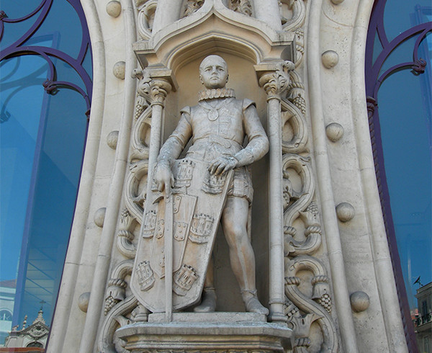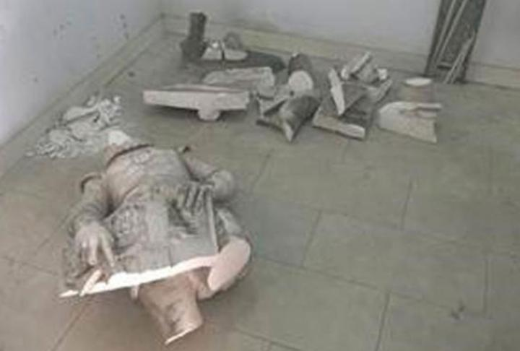
Peter Burka, via Flickr Creative Commons Infrastructure, Portugal
The statue of Dom Sebastiao (King D. Sabastiao)
Artist: Unknown
Year: 1890.
Materials and Dimensions:
Site: Rossio Train Station. Location: Lisbon, Portugal.
How did it get damaged? A man climbed on the statue to take a selfie. (2016)
Value at the time of damage: $ 1.8 million.
You can buy 684,410 school lunches for children in America.
(six hundred eighty-four thousand, four hundred ten)
Damage: See the photo above. Repair: None.
Punishment: Arrested after trying to run from the police and taken in front of a judge.
Lesson Learned? ______________________________________________

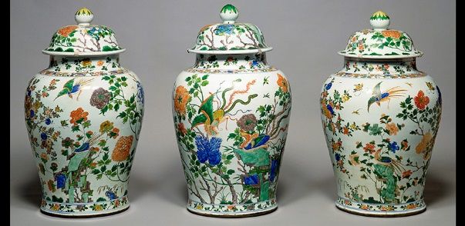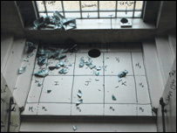
The three vases damaged. Shards after the break. © Fitzwilliam Museum
3 Qing Dynasty baluster jars with covers.
Year: Produced during the reign of Emperor Kangxi (1662-1722).
Materials and Dimensions: Approximately 100 pounds, hard porcelain.
Site: Fitzwilliam Museum.
Location: Cambridge, England.
How did it get damaged? Man went up wrong side of staircase with an untied shoe.
Value at the time of damage: over $650,000.
You can buy 433,333 candy bars. (four hundred thirty three- thousand, three hundred thirty three)
Repair: One vase had 400 pieces glued back together.
Punishment: The man was banned from visiting the museum.
Lesson Learned? _______________________________________________________

Pablo Picasso, “The Actor.” Metropolitan Museum of Art, New York. The Art Wolf: on line art Magazine 26 January 2010 accessed 10 November 2020, http://www.theartwolf.com/news/picasso-metropolitan-damaged.htm
Sarah Cascone, “126 Year Old Statue Destroyed by Man Taking Selfie: It was an ill -considered phot op” Artnet News: Art World, May 10, 2016, accessed November 3, 2020, https://news.artnet.com/art-world/126-year-old-statue-destroyed-by-selfie-493421
Cascone, ibid.
The Fitzwilliam Museum, Cambridge. ‘The three broken 'vases' - a covered baluster jar and two yan yan type vases - are part of a matching set, or 'garniture', of five (Fitzwilliam accession numbers C.17.1 & A-1948, C.17.2 & A-1948, C.17.3 & A-1948, C.17.4-1948 and C.17.5-1948) accessed 10 November 2020, https://www.fitzmuseum.cam.ac.uk/research/chinesevases/disaster
Paul Dance. “Fitzwilliam Museum’s Broken Vases Set for Restoration” Culture 24, 29 March 2006. The Fitzwilliam Museum, Cambridge accessed 10 November 2020, https://www.culture24.org.uk/history-and-heritage/art35722

