Meteor Whaaaat?
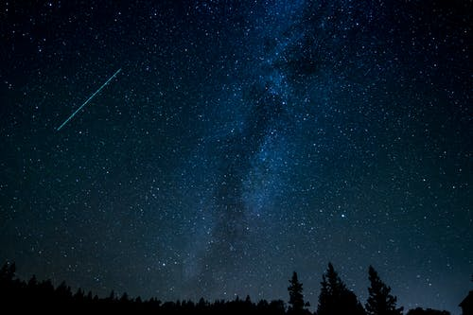
A Meteor what? (pronounced: meet-ee-or)

A Meteorologist. (pronounced: meet – ee- or – all- ih – jist)

It’s not a planet; it’s a job! They study the weather.

You will often see Meteorologists on the news giving a temperature and weather report.

The information they provide us throughout the day tells us how we should dress when going outside.

If it wasn’t for Meteorologists, we might wear flip-flops when it’s freezing or leave our water bottles at home when it’s actually hot out and should have them.

If you think about it, Meteorologists help save lives!

- Learn more about the job of a Meteorologist by watching a video created by:

JD Rudd – Chief Meteorologist for Spectrum News

https://www.youtube.com/watch?v=qWWx3reC9qA

