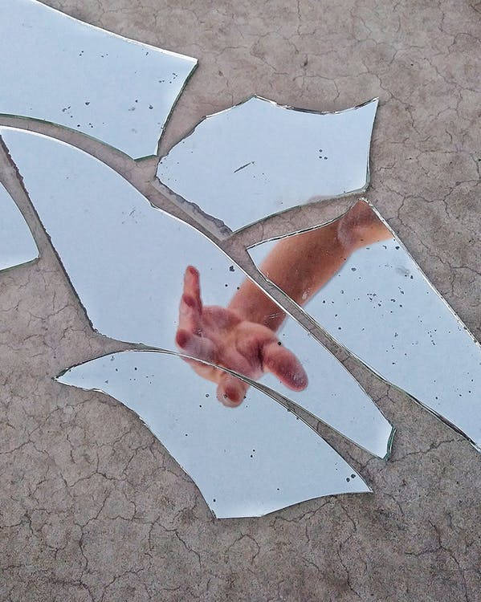 [1]

**Activity 2:**

**“What have you broken?”**

What have you broken that was worth a lot of money or special to someone?

____________________________

_____________________________

_____________________________

_____________________________

What happened after you broke it?

________________________________________________________________________

________________________________________________________________________

________________________________________________________________________

________________________________________________________________________________

1. # Thiago Matos, “Mirror Fragments on Gray Surface With The Reflection Of A Person’s Arm.” *Pexels,* 02, October 2019, accessed November 07, 2020, <https://www.pexels.com/photo/mirror-fragments-on-gray-surface-with-the-reflection-of-a-person-s-arm-3022456>

  