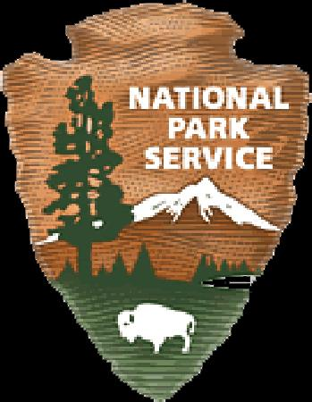
Volunteer Position Description Thank you for volunteering!
Marsh Billings Rockefeller National Historical Park

Visitor Services Front Desk Ambassador

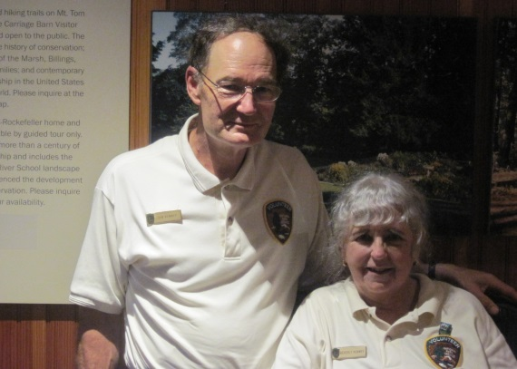
Most of our visitors park at the Billings Farm & Museum Visitor Center. The National Park has a front desk in that Visitor Center, often staffed by volunteers. Our Front Desk Ambassadors are crucial in welcoming visitors and in helping them to understand the significance of the park and what it offers. These volunteers may work alone or with another Ambassador. They never know what they may get asked net – Front Desk Ambassadors are friendly, welcoming, empathetic and good at thinking on their feet!

Requirements of this job:
- Willingness to learn about the history and significance of the park;
- Ability to communicate clearly with a wide variety of people;
- Interest in working with people;
- Good customer service skills;
- A sympathetic approach to people;
- Understanding of the park’s partnership with the Billings Farm & Museum;
- Ability to help visitors enjoy and appreciate the park and what it offers;
- Willingness to attend trainings as agreed, and to use two-way radio;
- Review volunteer job hazards and safety protocol with Volunteer Coordinator and agree to abide by park safety procedures;
- Report volunteer hours to Volunteer Coordinator.

Routine Duties:

- Become familiar with park’s mission, programs, events, and resources;
- Greet visitors and help them plan their visit;
- Share general visitor information about the park;
- Provide information about program schedules, special event details and park regulations;
- Assist visitors in making reservations for park programs;
- Cooperate with the Billings Farm desk with combination ticket arrangements;
- Be aware of other local attractions and able to direct visitors to non-park information;
- Be able to direct questions to appropriate park staff when the answer is not apparent;
- Inform visitors of the existence of handicap accessible parking inside the park if needed;
- Encourage visitors to see the film “A Place in The Land”;
- Take an active role to assist the NPS in its mission to preserve and protect both cultural and natural resources;
- Work safely – report potential safety hazards; follow common sense safety precautions to maintain a safe environment.

Supervisor:
Volunteer Coordinator/Chief of Interpretation

Equipment Provided by NPS: A volunteer shirt and name tag will be provided to volunteers who make a commitment to fulfill 30 hours of volunteer service within a year. Other clothing and equipment as needed.

Training Provided by NPS: General NPS orientation training will be offered to new volunteers individually or in small groups, by arrangement. Additional training will be provided to help volunteers learn the specific duties and procedures of this position.

Time commitment expected: A minimum of one four- hour shift per month during the season (late May through October) is desired.

Expected schedule: Shifts will be agreed upon by the volunteer and the project manager. Volunteer agrees to show up for an engagement which they commit to assisting with. If they cannot fulfill a volunteer commitment they will notify the VIP supervisor or Project Manager as soon as possible.

Estimated Length of Commitment, if determined: To be determined by volunteer and coordinator.

Work Conditions (location, weather, physical needs, etc.): This work is entirely indoors. Much of the time is spent standing. A chair is provided.

rev. 4/4/2016 jfl

