Name: Date:
Mining Mix-Up!
Unscramble the following words related to today’s lesson. After you have found the correct words, use them to ﬁll in the blanks in the story below. Use all the circled letters to ﬁll in the bonus word!
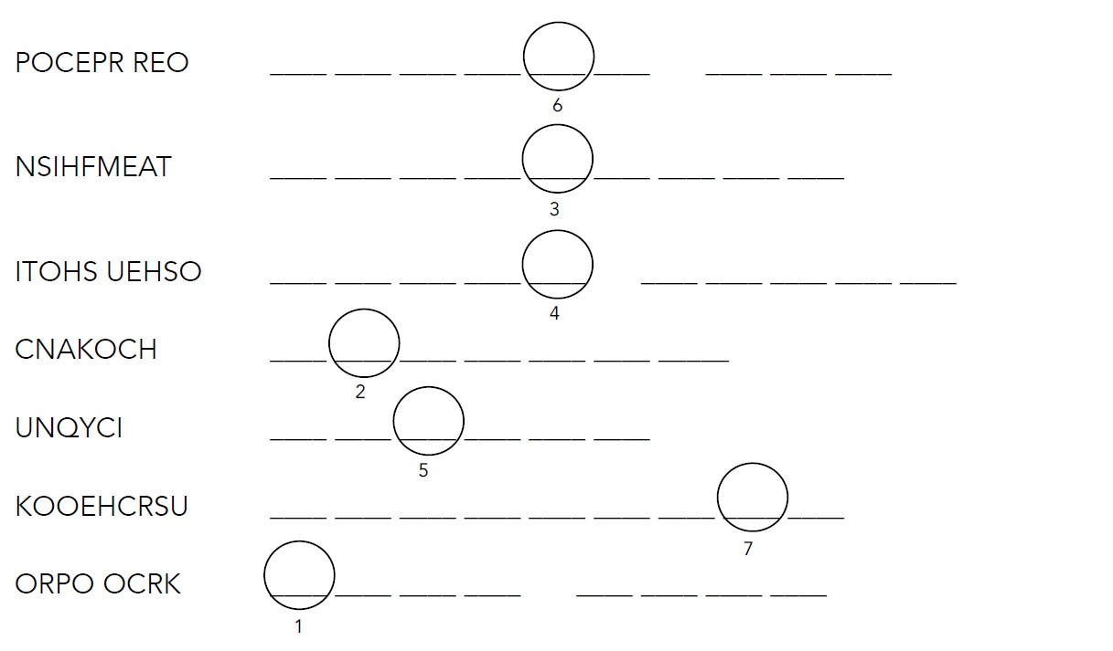

The miners in the Mine had a lot of work to do for their jobs. They would spend hours underground mining . Then they’d put it in cars that would be pulled up the by a steam hoist in the . In the , workers would sort out the rocks with copper in them. If a rock didn’t have a lot of copper in it, it was called and was thrown away outside. The nearby town of was formed because of this mine.

BONUS: Miners in the Keweenaw often brought , Cornish meat
1 2 3 4 5 6 7
pies, to work for their lunch.

