Beginning Your Genealogy Research

Overview tutorials Online
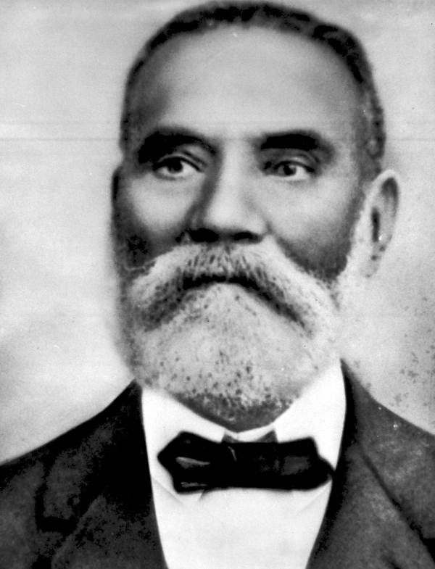 | Afrigeneas: African American Genealogy: An Online Interactive Guide for Beginners The Beginning Genealogist by Angela Y. Walton-Raji: Welcome Aboard  IAAM Center for Family History: Finding and Telling the African American Family Story: Beginning the Genealogy Journey by Angela Walton-Raji IAAM Center for Family History: Winning Gold When Beginning Genealogy by Nicka Smith  IAAM Center for Family History: Where a Death Certificate Can Lead by Robin Foster FamilySearch Wiki: A Guide to Research
 | Record What You Know: Genealogy Charts and Forms
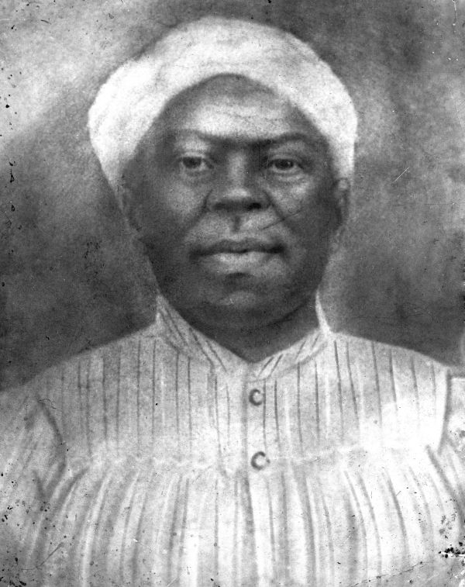 | Getting Started from FamilySearch: Finding Easy Information: Memory, Home, Family Editable Family Group Sheet Form from the Midwest Genealogy Center, a Family Group Sheet is used for recording couples and their children, with space to fill in dates and places that are important for researching each individual. You can edit this form and save it to your computer, or print it and fill it out by hand.  Free Genealogy Forms from Family Tree Magazine If you save these forms as text files you can edit them and save them to your desktop. If you save them as pdf files you can print them and fill them in by hand. Editable 6-Generation Pedigree Chart use this chart to list names, dates and places for you, your parents, grandparents and great grandparents. You can edit this form and save it to your computer, or print it and fill it out by hand.
 | Gather Family Oral History
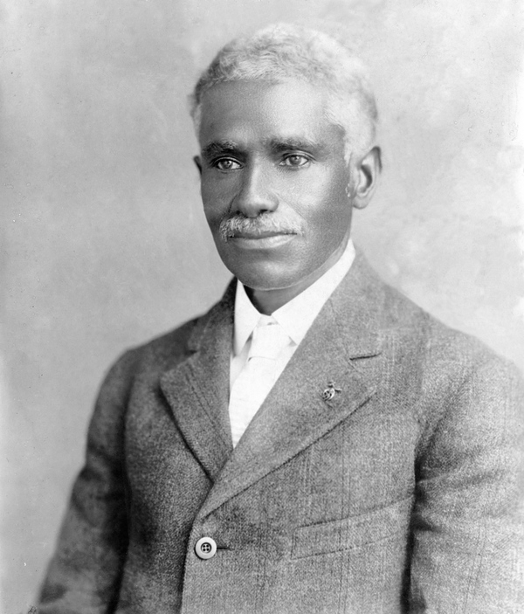 | The Beginning Genealogist by Angela Y. Walton-Raji: Oral History Conducting Oral History Interviews with Family Members: UCLA Libraries  FamilySearch Wiki: Creating Oral Histories The Smithsonian Folklife and Oral History Interviewing Guide  Step by Step Guide to Oral History by Judith Moyer Example Questions for Oral Histories: Fertilizing Your Family Tree with Conversation
 | Choose Records to Search
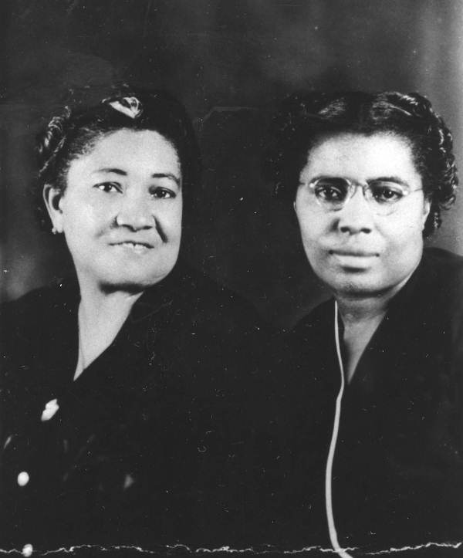 | Records and the Information They Contain a quick reference chart from FamilySearch United States Record Selection Table from the FamilySearch Wiki, a useful article to help you decide which records to search  Quick Guide to African American Records from the FamilySearch Wiki Principles of Family History Research: Select Records to Search from FamilySearch  Using the Census to Find Other Records About Ancestors from the FamilySearch Wiki Cyndi’s List and Linkpendium: Comprehensive resources for identifying online records to search  Geni Podcast: How Do I Find and Use Records? from Thomas MacEntee
 | Create a Research Plan
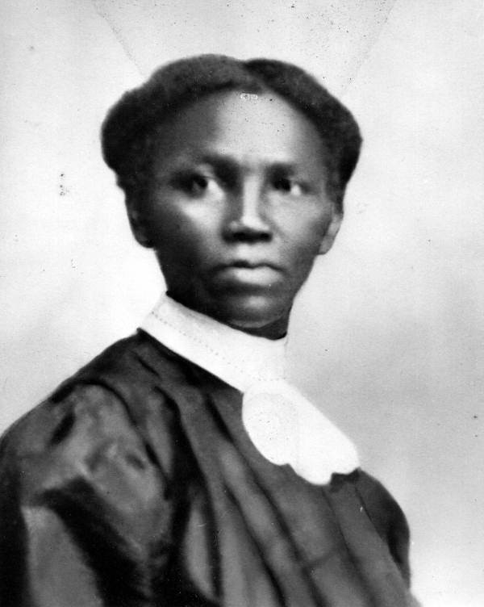 | The Beginning Genealogist by Angela Y. Walton-Raji: Plan Your Research Strategy Geni Podcast: Genealogy Research Logs from Thomas MacEntee of Abundant Genealogy, this podcast looks in-depth at why you need a research log.  Editable Research Log from Thomas MacEntee of Abundant Genealogy

 | Avoid Common Mistakes
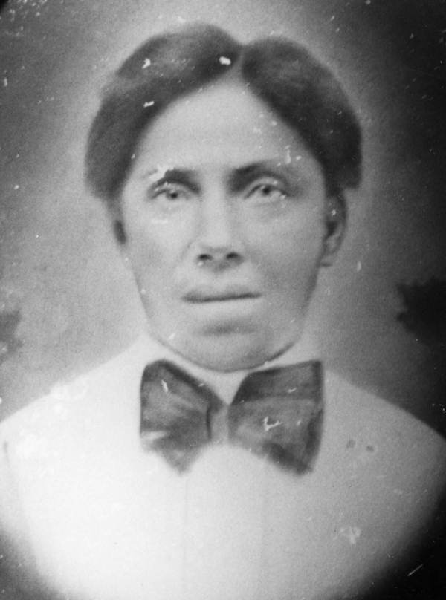 | Avoid Traps in African American Genealogy by Tony Burroughs: Archived Webinar on Ancestry.com Back to Basics: 10 Common Mistakes and How to Avoid Them from Sonoma Valley Computer Group  If Only I’d Known: Beginner Genealogy Mistakes by Beth Foulk of the Midwest Genealogy Center Top 10 Genealogy Mistakes to Avoid from About.com
 | Tools For Compiling, Organizing and Backing Up Your Research
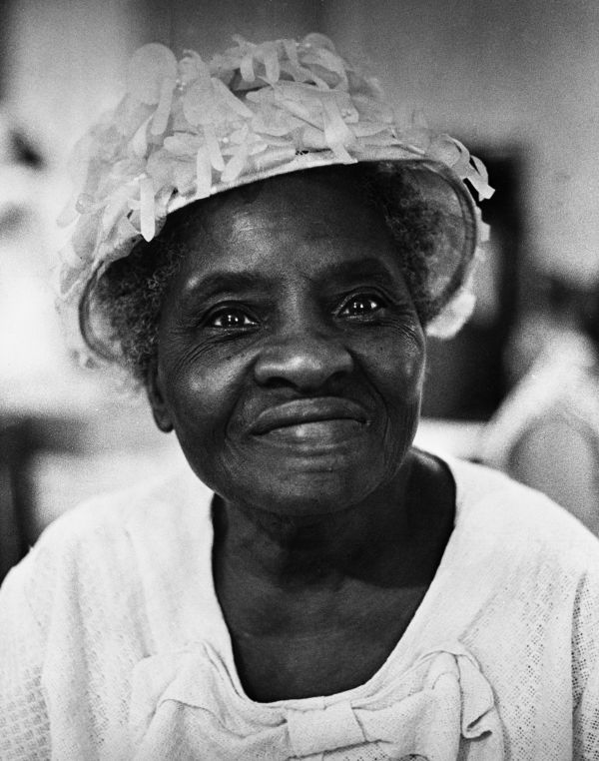 | Genealogy Software Review - From Top Ten Reviews A feature-by-feature comparison of leading genealogy software Cyndi’s List: Evernote for Every Genealogist by Cyndi Ingle, a compendium of great Evernote templates for organizing your genealogy research  The Genealogy Cloud: Which Online Storage Program is Right for You? Thomas MacEntee of Abundant Genealogy The Best Online Backup Services of 2017 from PC Magazine, a feature by feature comparison.
 | Begin Research, Compile As you Go
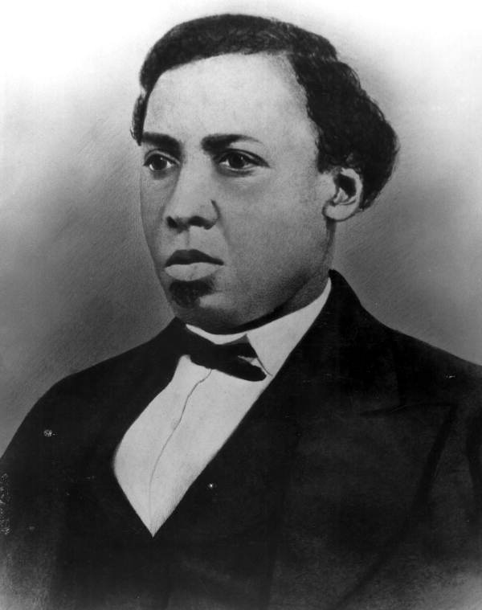 | FamilySearch Learning and How-To's Segment: Document As You Go! How to Conduct a “Reasonably Exhaustive Search” for Relevant Records by Michael Hait  Editable Research Checklist from the Midwest Genealogy Center. This form is helpful for determining if you have checked all of the available resources for each of your ancestors. You can edit this form and save it to your computer, or print it and fill it out by hand. Solving Tough Research Problems – Overcoming Brick Walls from FamilySearch  IAAM Center for Family History: Timelines Keep Your Genealogy Research Moving Forward by Shelley Viola Murphy IAAM Center for Family History Blog: genealogist Robin Foster teaches you step by step how to begin your search for African American ancestors
 | Evaluate Findings, Form New Research Questions
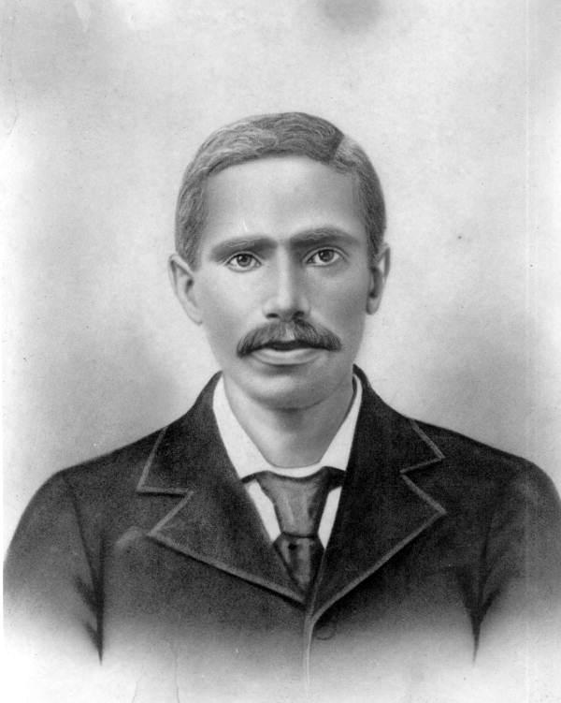 | FamilySearch Learning Center Segment: Principles of Family History Research: Use the Information Lowcountry Africana: Research Methods by Michael Hait: Segments: (1) What is the Genealogical Proof Standard? (2) What Constitutes a Genealogy Source Record? (3) Evaluating a Source Record (4) Evaluating a Record by Itself (5) Corroborating Evidence  Evaluate the Evidence from the FamilySearch Wiki Evidence Explained QuickLesson 17: The Evidence Analysis Process Map by Elizabeth Shown Mills  Using the Census to Find Other Records About Ancestors from the FamilySearch Wiki Principles of Family History Research: Restart the Research Process from FamilySearch

Connect With the Research Community

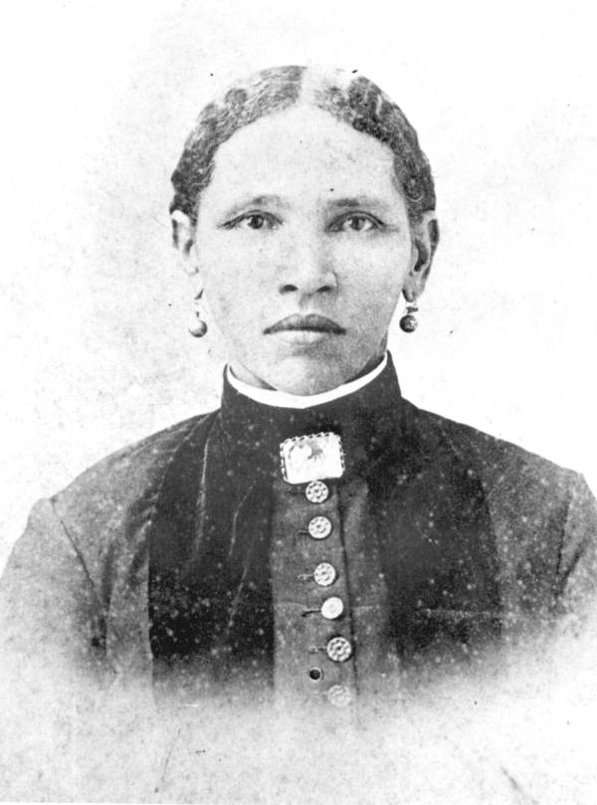 | IAAM CFH Facebook Research Group: connect with others researching African American ancestors, ask a research question anytime! Facebook Research Group: I’ve Traced My Ancestor’s Slaveholders  Facebook Research Group: Our Black Ancestry Facebook Group: The African Descendant’s Genetic Genealogy  Facebook Group: Enslaved Ancestors & Freedmen Genealogy! Just Ask! Facebook Group: AfriGeneas African American Genealogy Community  Facebook Group: African American Genealogy Forum Website: AfriGeneas a must online destination for anyone conducting African American or African Ancestored genealogical research. The AfriGeneas online research community features the AfriGeneas mail list, the AfriGeneas message boards and daily and weekly genealogy chats.
 | Share Your Family History
FamilySearch Wiki: Create a Family History | FamilySearch Wiki: Writing Your Family and Personal History
Twenty Reasons Why You Should Write Your Family History from the New York Public Library | The Secret to Writing a Compelling Family History by Sharon DeBartolo Carmack, CG
Blogging Your Family History by Thomas MacEntee of Abundant Genealogy | How to Self-Publish your Family History Book from Family Tree Magazine

