Indiana Dunes  Education | National Park Service  U.S. Department of the Interior  Indiana Dunes National Lakeshore  Education Department | 
Maple Sugar Time

Summary:
In the past 400 years, maple sugar production evolved from a winter survival food to a luxury item. During your Maple Sugar programs we are trying to emphasize how maple sugar affected peoples' lives and not just a story about the technological advances in maple sugar production.

Objectives: students will be able to

1. state that they are in a national park, which is their place to develop a sense of wonder and excitement regarding nature and history.

2. state how our harm to our environment can threaten this natural American process
state that this place is special and protected.

3. explain maple syrup's changing role in history--how it
was important to the American Indians, the pioneers, and the Chellbergs of the 1930's.
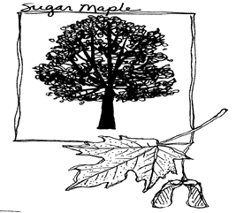

What to expect on during your trip:
A ranger or naturalist led one-hour tour of maple sugaring process through time followed by 30 minutes of house tour.

Setting:
Chellberg Farm fields, wooded paths, and historic structures

Grade:

All grades and ages.

Ratio of students to ranger:
up to 32; one adult for every ten students.

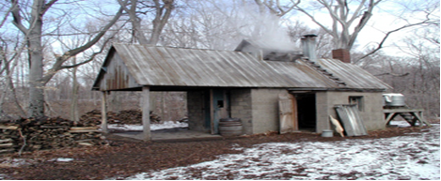
Safety Issues:
Weather conditions such as wind, cold, rain & snow. The farm grounds and surrounding trails may be hazardous when frozen. Some program sites have fire so be aware of blowing smoke, flames or hot stoves.

Background Information:
The earliest maple sugar farmers were the American Indians of the northeastern part of the United States and eastern Canada. They discovered that in the early spring when the nighttime temperatures were still below freezing, but the daytime temperatures rose about 40 degrees, the sap of the maple tree was slightly sweet. A process of cooking the sap was developed using hot rocks. When the cooking was complete, the sap had boiled down into sugar. Early pioneers and farmers refined the process of cooking the sap into syrup. Today, compared to days of yesteryear, few maple trees remain to produce syrup. Most pancake syrup in stores today contains corn syrup, not maple.

Prerequisite Classroom Activities:
Math Ideas

1. It takes forty gallons of maple sap to make one gallon of maple syrup. Count to forty by ones, fives and tens.

2. Make a pile of 40 blocks and another with just one.

3. Create a dot-to-dot drawing (using forty dots) of a maple tree, bucket or sugar shack.

4. Challenge the students to create as many math problems as they can that have the answer 40.

5. How many drops of sap are needed to make a gallon? Using an eyedropper, let the students count the number of drops that are needed to make an ounce. Use the data from all the groups to determine the average number of drops in an ounce. Multiply the average to figure the number of drops in one gallon. How many are needed for forty gallons?

Story Problems:

Problem 1:
The owners of a 50-acre sugarbush tap 600 maple trees. They tap ¼ of the trees twice and hang two buckets; they then hang one bucket on all the rest. How many buckets do they hang in total?

Problem 2:
In the Chellberg sugarbush, the number of times a tree is tapped is determined by its diameter. One tap is used for a 12” diameter; another tap is used for each additional 6” in diameter. No more than 3 taps per tree are allowed at the Chellberg Sugarbush, but in other places the number of taps per tree can be higher than three.
If a tree has a diameter of 20 inches, how many taps can be drilled?
How many for a 15 inch diameter tree?
For a tree with a diameter of 32 inches in the Chellberg Sugarbush?
For a tree with a diameter of 32 inches in a different sugarbush?
Why do you think we don’t allow anymore than three taps here at the Chellberg Farm in the national lakeshore?

Problem 3:
Forty gallons of sap makes one gallon of maple syrup.
How much sap must be collected to make five gallons of syrup?
To make twelve gallons of syrup?
Would you want to carry all that sap yourself up the ravine?

Problem 4:
If you tapped a maple tree in your backyard and filled up a three-pound coffee can each day for four weeks, how much sap would you collect?
A coffee can is a ¾ gallon capacity.
How much maple syrup would it make?

Problem 5:
It takes 48 drops of sap to fill one tablespoon.
How many drops would be needed to fill a gallon?
16 T spoons = 1 cup and 16 cups = 1 gallon

Problem 6:
A gallon of syrup weighs about 11 pounds. If it is cooked longer to make candy, 2 pounds of water are lost. If candy pieces are measured out to weigh
¾ ounce, how many pieces of candy can be made from a gallon of syrup?

Problem 7:
Maple sugar farmers use the “Rule of 86” when buying maple sap from other farmers. The sweeter the sap, the more they will pay for it. The “Rule of 86” says:
86 divided by the % of sugar content = how many gallons of sap to one gallon of syrup
How many gallons of sap would it take to make one gallon syrup if the sap sugar content was 2%, 3%, or 6%?

Problem 8:
Trees will give, on the average, 10 gallons of sap per tap hole.
If Tree A has four taps giving 3% sugar sap, and Tree B has 2 taps giving 2% sugar, how much syrup can be made in a season from those trees?
Answers to Maple Math Story Problems

Answers to Maple Math Story Problems

Problem 1:
600/4 = 150 x 2 = 300 600 – 150 = 450 300 + 450 = 750

Problem 2:
20” = 2 taps 15” = 1 tap
32” = 3 taps at Chellberg
32” = 4 taps at commercial Sugar Bush
(We are a national park so we only want to take enough sap to show you the process.)

Problem 4:
¾ gal x 28 = 84 divided by 4 = 21 gal of sap
Which is about a half gallon of syrup.

Problem 5:
48 x 16 = 768 crops per cup x 16 cups =
12,288 drops per gallon

Problem 6:
16 oz per pound x ¾ oz each = 21.3 pieces per pound
11pounds – 2 pounds = 9 pounds of candy
9 pounds x 21.3 pieces = 192 pieces
Problem 7:
43, 28.66, 14.33

Problem 8:
Tree A = 4 x 10 = 40 gallons of sap per season with 3% sugar
Tree B = 2 x 10 = 20 gallons of sap per season with 2 % sugar

Tree A = Rule of 86 divided by 3% = 28.66 gallons of sap to one gallon of syrup.
40 gallons collected divided by 28.66 gallons needed = 1.4 gallons of syrup

Tree B = Rule of 86 divided by 2% = 43 gallons of sap to one gallon of syrup.
20 gallons collected divided by 43 gallons needed = .46 gallons of syrup

Total = 1.4 + .46 = 1.86 gallons of syrup

Language Arts Activity Ideas

Write or tell a story. Suppose you lived on Chellberg farm and you broke a gallon jug of maple syrup. Tell how the accident happened and how you felt. How did you tell your parents? What was it like to clean up the mess?

Pretend the Chellberg family asked you to design a label for their maple syrup jugs. Draw a picture and write an advertisement that would attract people to buy the syrup. Develop a jingle or song for a radio commercial.

Read the label from a syrup container. Does it contain maple syrup?

Have the students make a drawing or write a letter to their ranger. The ranger is interested in hearing about how the students felt about the work involved in making maple sugar.

Make a joke book of farm and maple syrup jokes.

Perform a skit showing how people made maple sugar during the past 300 Years.

Write a poem or haiku about maple trees or making maple sugar.

Write a story from a maple tree's perceptive. Tell about the changes the tree has seen in the past 100 years.

How many words can the students make by using the letters in "maple syrup"?

Use a gallon jug to show the student how big it is. Let the student predict how many glasses you can fill with a gallon.

On a level spot in the playground pour a gallon of water out in a circle. Pretend that circle is a large pancake. Have the students predict how much area the water will cover.

Using a squeeze bottle put a taste of honey on each child's finger. Then taste real maple syrup. Do they taste the same? Try molasses and sugar water. Do maple sugar and sugar water taste the same? Discuss where these sweeteners come from.

Have a pancake breakfast in the classroom and use real maple syrup.

Make a survey of how many students would like to live on a farm, be a Native American 300 years ago; like maple syrup, etc.

Make a maple sugar song and record it on tape.

Adopt a maple tree and get to know it, how it feels, how it lives, how it changes.

Make or bring in some maple fudge or cookies or make the recipes below.

Sugar on Snow
A snowfall that comes late in the maple sugar season is called a "sugar snow".
It is at this time of year that the syrup is being evaporated into sugar.
A special treat for children who live near a sugar bush is sugar-on-snow or Jack Wax.

You may use fresh maple syrup, brown sugar mixed with water, or commercial maple flavored syrup.

Pour two cups of syrup into a saucepan. Bring it to a boil until it reaches the hard sugar stage on a candy thermometer, or until it remains waxy when dropped from a spoon on well-packed snow. Pour the syrup in bite size pools on well-packed snow or into a bowl of crushed ice. Serve with a fork to twirl wax.

Maple Syrup Fudge
2 cups of maple syrup
3/4 cup thin cream
1 tsp. Vanilla
3/4 cup walnut or butternut meats, coarsely chopped

Combine maple syrup and cream into a saucepan and place over a low flame. Stir constantly until the mixture begins to boil. Continue cooking without stirring until small amount of syrup forms a soft ball in cold water, about 30-35 minutes. Remove from fire and cool to lukewarm. Beat until the mixture thickens and loses its gloss. Add vanilla and nuts, pour into a buttered pan. When cool cut into squares.

Science Activities

Have the students mix salt with water in a glass jar. Boil the salt solution until the water evaporates. Demonstrate how the water comes off as steam and the salt is left behind.

Make a top ten list of ideas to answer the following question "What clues in nature can you see that tells us spring is coming?" Accept all the students' ideas (even the wrong ones) and write them on the blackboard. After collecting the ideas, let the students vote for the best ones. Limit each student to two or three votes. Tally the votes for each idea to make your top ten list.

Introduce the students to the parts of a tree. What does each part do?

Find out how a tree transports its food and water. We have a heart to pump our blood? Does a tree?

Draw a maple tree through all the seasons showing how it changes.

Investigate which animals use the maple tree for food eating sap, seeds, flowers and use the tree for shelter. Find out what kinds of animals live in a Beech-Maple forest. Each student could choose such an animal to investigate. Then in front of the class the student becomes that animal, telling all about him or herself. The class has to try and guess what animal that is.

Social Studies

Talk about tree conservation, clear-cutting, or urban sprawl.

Make spiles from Elderberry or Sumac branches. Elderberry branches have warts on them and Staghorn Sumac is fuzzy like a deer antler in the velvet stage. With a piece of coat hanger push out the pith until the twig is hollow. Cut one end off at an angle so it will go into the tree. Remove the top half of the other end of the spile to make a trough.

Ask students to write a story as if they were an Indian child at the time maple sugar was discovered. They would never have tasted anything sweet but wild berries.

Study maple trees; how to identify them, and all their uses to wildlife and humans.

Student could be asked to go home and list everything they can find in their house that comes from maples and other trees.

Maple Talk

(Ten of these thirteen words can be found in the crossword puzzle)

Sugarshack – The building where maple sap is boiled to make syrup.

Maple – A tree including sugar maples, red maples, silver maples and box elders.

Sugar Maple – The species of maple trees most often tapped for sap.

First Run – The first quality sap flow in the spring.

Sap – The liquid that carries water, minerals and food throughout the trees and other plants.

Tap – The hole drilled into a tree – about 2 inches deep. One tap to a 12-inch diameter tree. Two taps to an 18-inch diameter tree.

Spile – The hollow metal spike hammered into a tap hole.
Sap flows through the spile into the bucket.

Sugarbush – The area where sugar maples grow.

Evaporator – A flat pan used to boil the water out of the sap. It usually takes 40 gallons of sap to make one gallon of syrup.

Maple Syrup – Syrup made from evaporating most of the water from the sap of a maple tree.

Syrup Grade – Quality of syrup based usually on color. The lighter the color, the better the syrup.

Wax - Pouring hot candy-stage syrup on snow makes Maple Wax .

Roots – The underground storage tanks for the sap during the cold winter.

Maple Sugar Time
Word Search

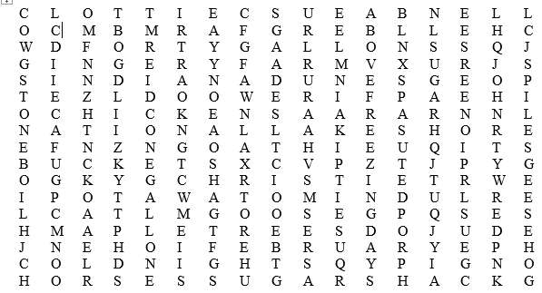

There are at least nine farm animal names written here in the puzzle also.

Indiana Dunes
National Lakeshore
February
March
Cold Nights
Above Freezing Days
Maple Trees
Spiles
Buckets
Forty Gallons
Sap
One Gallon
Syrup
Sugar
Potawatomi
Stone boil
Pioneers
Kettle
Firewood
Chellberg Farm
Sugar Shack

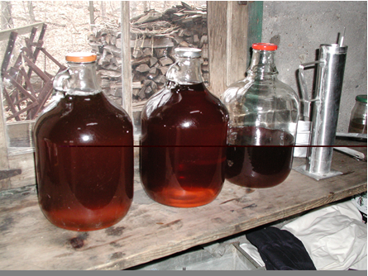
Maple Sugar Word Search

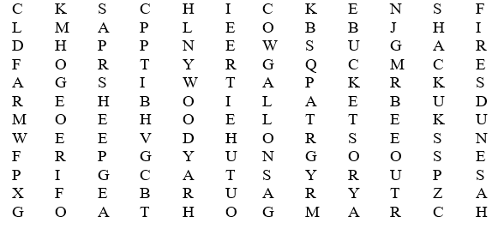
Maple
Tree
Tap
Bucket
Sap
Boil
Forty
Gallons
Kettle
Fire
Wood
Sugar
Shack
Farm
Syrup
Horses
February
March

At least eight more farm animal names are written in the puzzle too.

Draw a line from the sweet to the type of plant they come from. 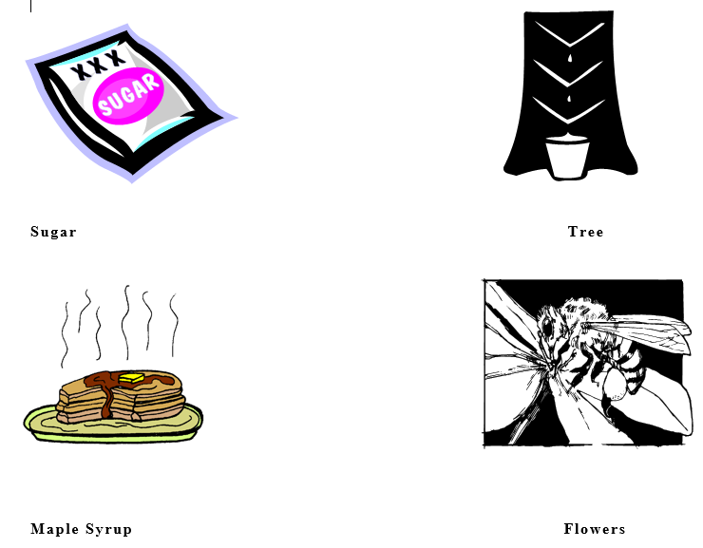
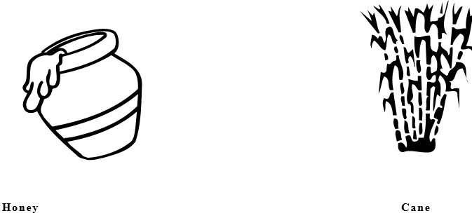
Time Photographs by _________________

Pretend you found a camera that would allow you to go back into time and take a picture of people making maple sugar. Using what you saw on your trip to Chellberg Farm, draw the picture you think your camera would take. Give each of your photos a one or two sentence title. For fun, pretend a squirrel was taking the pictures.
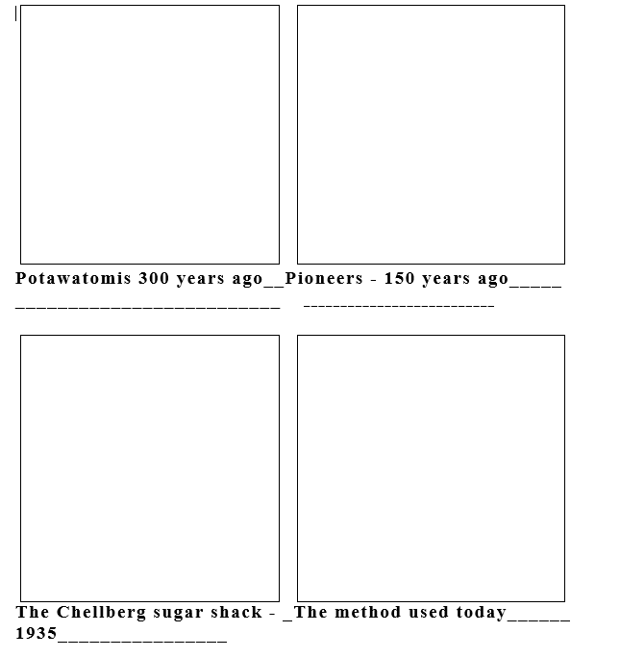
___________________________________________________

Indiana Content Standards:
The Maple Sugar Time program can assist teachers in meeting the following Indiana standards.
Kindergarten

Social Studies
History
SS.K.1.1 2007
Compare children and families of today with those in the past.
SS.K.1.3 2007
Listen to and retell stories about people in the past who showed honesty, courage, and responsibility
SS.K.1.4 2007
Chronological Thinking: Identify and order events that take place in a sequence.

Geography
SS.K.2.2 2007
Places and Regions: Locate and describe places in the school and community.
SS.K.3.5 2007
Physical Systems: Describe and give examples of seasonal weather changes and illustrate how weather affects people and the environment.
First Grade
History
SS.1.1.1 2007
Compare the way individuals in the community lived in the past with the way they live in the present.
SS.1.1.2 2007
Compare past and present similarities and differences in daily life by using biographies, oral histories, and folklore

Second Grade
Social Studies
History
SS.2.1.1 2007
Identify when the local community was established and identify its founders and early settlers.
Economics
SS.2.4.1 2007
Define the three types of productive resources (human resources, natural resources, capital resources) and identify productive resources used to produce goods and services in the community.
SS.2.4.2 2007
Identify community workers who provide goods and services for the rest of the community, and explain how their jobs benefit people in the community.
SS.2.4.4 2007
Research goods and services produced in the local community and describe how people can be both producers and consumers.
SS.2.4.7 2007
Explain why people trade for goods and services and explain how money makes trade easier.
Science
Technology
SCI.2.4.2 2010
Identify technologies developed by humans to meet human needs. Investigate the limitations of technologies and how they have improved quality of life.

Third Grade
Social studies
History
SS.3.1.1 2007
Identify and describe Native American Woodland Indians who lived in the region when European settlers arrived.
SS.3.1.2 2007
Explain how and why the local community was established and identify its founders and early settlers.
SS.3.1.4 2007
Give examples of people, events and developments that brought important changes to the regions of Indiana.
SS.3.1.8 2007
Chronological Thinking, Historical Comprehension, Analysis and Interpretation, Research: Write and illustrate descriptions of local communities and regions in Indiana past and present.

Fourth Grade
History
SS.4.1.1 2007
Native American Indians and the Arrival of Europeans to 1770. Identify and compare the major early cultures that existed in the region that became Indiana prior to contact with Europeans.
SS.4.1.2 2007
Native American Indians and the Arrival of Europeans to 1770. Identify and describe historic Native American Indian groups that lived in Indiana at the time of early European exploration, including ways these groups adapted to and interacted with the physical environment.
SS.4.1.12 2007
Growth and Development: 1900 to 1950. Describe the transformation of Indiana through immigration and through developments in agriculture, industry and transportation.
SS.4.1.13 2007
Contemporary Indiana: 1950 – Present. Identify and describe important events and movements that changed life in Indiana from the mid-twentieth century to the present.
SS.4.1.15 2007
Chronological Thinking, Historical Comprehension, Analysis and Interpretation, Research: Crate and interpret timelines that show relationships among people, events, and movements in the history of Indiana.
SS.4.1.17 2007
Chronological Thinking, Historical Comprehension, Analysis and Interpretation, Research: Using primary and secondary sources and online source materials, construct a brief narrative about an event in Indiana history.
Fifth Grade
Social Studies
History
SS.5.1.3 2007
Ways of Life Before and After the Arrival of Europeans to 1610. Identify and compare historic Indian groups of the West, Southwest, Northwest, Arctic and sub-Arctic, Great Plains, and Eastern Woodlands regions at the beginning of European exploration in the late fifteenth and sixteenth centuries.

**Note: Maple Sugar Time is a program that can be adapted for all grades; however, the content of the basic program is most suited to 1st through 4th grades.

Extension or Follow-up Activity

Class reflection paper or writing sample:
Ask each student to write a short essay, letter or story about what they learned on their field trip to Indiana Dunes National Lakeshore.
Rangers love receiving mail from their students.
Send the park the packet of essays with your ranger’s name on them from your class (or a copy of them), and The Education Department will send your class a certificate from the dunes.

Send your essays to:
Indiana Dunes National Lakeshore
Attn: Education Department
1100 N. Mineral Springs Road
Porter, IN 46304
If you are using this essay as a class assignment for a grade, we would like to suggest that each essay contain the following elements. Use the rubric below to score them.
* The name of the park and the location of their field trip—for example: Douglas Center, Indiana Dunes National Lakeshore
* Three facts they learned on the field trip about making maple syrup and sugar.
* A brief explanation of why Indiana Dunes is unique and therefore a national park.
* At least two things the student can do to help take care of his or her national park.
* Fill in the blank of this statement and provide an explanation:
I would like to learn more about __________ at Indiana Dunes.
*** For advanced groups, add the following element:
Tell the park rangers if you would like to bring your families and friends to the dunes and if so what would you do here and where would you go
Assessment:
Grading for Class reflection writing assignment:
- Writing and organization- 4 points the writing sample is very well written and organized by the elements provided. It has a strong introduction, middle and conclusion. 3 points the writing sample is well written and organized by the elements provided. It includes an introduction, middle and conclusion. 2 points the writing sample is choppy and is not well organized. It lacks an introduction or conclusion. 1 point the writing sample is very short and unorganized.

- Grammar & Spelling- 4 points Mistakes in spelling and grammar are minor or non-existent. 3 points Mistakes in spelling and grammar are minimal—about 4-5. 2 points mistakes in spelling and grammar are numerous—5-10. 1 point mistakes in spelling and grammar are more than 10.

- Facts and content- 4 points the writing sample demonstrates the student’s learning on the dunes program and includes three or more facts provided by the park staff. 3 points the writing sample demonstrates the student’s learning and includes only two facts provided by the park staff. 2 points the writing sample does not demonstrate much learning and only includes one fact provided by the park staff.1 point the writing sample does not demonstrate any learning and does not include any facts provided by the park staff.

- National Park Service theme - 4 points the writing sample clearly demonstrates the student’s understanding of the role of the NPS in preserving the dunes by explaining why Indiana Dunes is such a unique treasure.3 points the writing sample mentions the NPS and its role in preserving the Indiana Dunes. 2 points the writing sample mentions the NPS and Indiana Dunes. 1 point the writing sample does not mention anything about the NPS or its role at Indiana Dunes.

- Stewardship- 4 points the writing sample lists three things the student can do to assist in taking care of the Indiana Dunes. 3 points the writing sample lists two things the student can do to assist in taking care of the Indiana Dunes. 2 points the writing sample lists one thing the student can do to assist in taking care of the Indiana Dunes. 1 point the writing sample does not list anything about what the student can do to take care of the Indiana Dunes.

