Background Information

Native American Indians of the Potomac

When English colonists sailed up the Potomac River 400 years ago, they were surprised to find that earlier settlers had cleared fields, planted crops, built villages, and established profitable trade routes. Named for the title of their leader, the Powhatan Indians were a chiefdom of more than thirty tribes located along the coastal plain of Virginia; roughly the area encompassed by Washington, DC, Richmond, and Virginia Beach. Powhatan tribes in Virginia shared a common language, a dialect of Algonquian, and similar customs. While the “Powhatan” was a primary chief, local leaders, or werowances, governed tribes which averaged one hundred persons. Tribal village dwellings were occupied by extended single families who were related to the woman of the household.

Because of the fertile soil and abundant natural resources, tribes of the Potomac River region were populous and prosperous. A combination of hunting, gathering, fishing, and farming provided bountiful harvests throughout the year. Early inhabitants hunted, principally deer, and gathered nuts and berries. Over time, through cultivation of the land, they obtained corn, beans, squash, and pumpkins. In order to survive, the Powhatans adapted to seasonal changes in the environment. Crops were plentiful in summer, and large quantities of food could be stored for the fall. Late fall and winter were the hunting seasons, and spring brought spawning fish upriver.

A powerful practical and spiritual relationship between the people and their environment was forged by their dependence upon its resources. They relied heavily on the game they killed for items other than food. Deer skins could be used for clothing, insulation, beds, and blankets. Animal tendons and ligaments were pounded into sinewy string. Antlers became farming and flint knapping tools. Glue, needles, and fish hooks were made from hooves. The great river could be kind, bringing a bounty of its creatures, or cruel, flooding the land and destroying their villages. Land cleared for farming was limited to the needs of the tribe and with a view to restoring the forest. Ceremonies celebrating and giving thanks for the harvest and the hunt became important aspects of Powhatan life.

Men hunted and fished and constructed the tools that would enable them to be successful in these pursuits. These practical instruments included fish nets, fish traps, knives, spears, arrow shafts, and arrow points, as well as canoes. The men were also responsible for protecting the village and gaining more land and captives for the Powhatan Empire. The political and religious leadership of the tribe was also the province of men.

Food production was the primary responsibility of women. They planted, maintained, and harvested the crops, as well as gathered nuts and berries. Food preparation and preservation, house construction and maintenance, childbearing and rearing were among their domestic duties. Children assisted their mother until puberty when they developed gender-specific skills and assumed their roles as contributing members of the tribe. It is also believed that woman participated in flint knapping, tool making, and constructing houses.

While wealth and status accrued to the chiefs who claimed goods and services from their people, internal and external threats brought conflict to the region. The Algonquians may have feuded among themselves as they competed for prime fishing and hunting grounds. Siouans of the Piedmont and Iroquoians to the North also sought the region’s bounty. Ultimately, it was the Europeans who presented the greatest threat to survival of Powhatan peoples and their tribes. This threat could not be reversed.

Two significant points in the historical context of the Powhatan peoples should be emphasized. One is that of their well-developed culture and society. Not unlike societies of other humans around the world at the time, the Indian groups of the Potomac Valley had complex organizational structure in its society, politics and economics that had evolved over hundreds of years¹ (Potter). Though traditional viewed as primitive, these cultural groups exhibited complex systems still not fully understood. Secondly is their unique perspective on the environment of Great Falls.
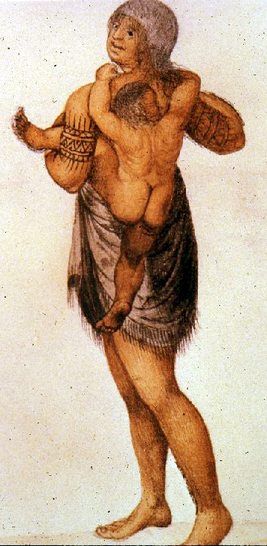
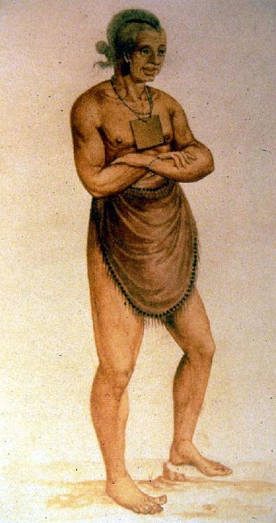
The area of lands between Washington D.C. (including Great Falls) and the western lands (Appalachia) on the Potomac River was a hotbed of activity for prehistoric peoples. This was principally for three reasons—it was a point for controlling access to critical seasonal resources, it was a point of constriction for controlling regional trade arteries, and it was a point of contact between different peoples¹ (Potter). Tying these two together presents a fascinating chapter in human history, and enduring ideas about human relationships to their environment.

Seasonal Powhatan Activities
Winter (Popanous)

Men: hunt deer, turkey; work on tools - cut wood, tan hides, process arrow heads and shafts, make sinew.

Women: collect firewood; make bone tools; sew; flint knap; weave mats and make baskets; cut rawhide and wood.

Children: gather nuts and firewood; bundle gear for the hunt; boys – hunt small game; girls – learn about nuts and bark.
Spring (Cattapeuk)

Men: slash and burn to prepare farm land; make fish nets, farm tools, canoes and paddles; fish.

Women: plant and weed garden; gather wood and bark; repair farm tools; make baskets; store winter clothes and tools

Children: gather firewood, nuts, berries, oats, rice, plums, grapes, cherries, tuckahoe; boys – hunt small game; girls – help plant and weed
Summer (Cahattayough)

Men: fish and gather in fresh and salt waters; hunt small game; tan hides; make garden tools.

Women: prepare grain and vegetables; gather fruits; maintain garden; gather clay and make pottery.

Children: boys – maintain garden, race, swim, canoe, gather and fish; girls – gather fruits and berries
Fall (orn Nepinough)

Men: fish and gather in fresh waters; hunt deer, turkey, migratory fowl; make tools – flint knapping, bows, quivers, knives.

Women: harvest, dry, and shell corn; cut reeds; thatch houses for winter.

Children: assist with harvest and preparations for winter.
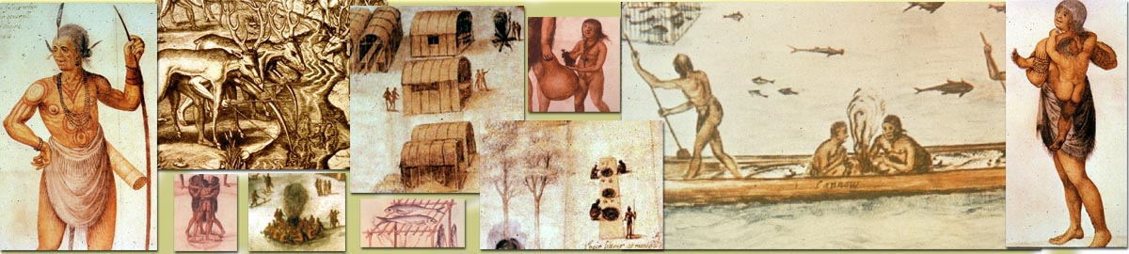
Algonquian Vocabulary

Algonquian – the language spoken by the Powhatan Indians, and many other Indian cultures believed to have migrated from the Great Lakes area hundreds of years before the first Europeans landed in Virginia and Maryland.

Some words in common use by the Powhatans, accompanied by their English translations:

aposoum – opossum arrahacoune – raccoon

attawp – bow attonce – arrows

chesapeake – big salt bay crenepo – woman

hominy – ground corn, soaked and cooked over a fire all day

mattassin – copper mockasins – shoes

musses – woods, pieces of wood nemarough – man

Oke – primary god pokatawer – fire

suckquohana – water tamahaac – hatchet

werowance – tribal chief yehakin – house

List of Terms

agriculture farming usually through cultivation of the soil
and planting crops

artifact tool, ornament or object made or changed by humans

barter trade or exchange of goods with the use of
money

breechcloth apron-like piece of clothing worn by Powhatan
Indians

copper highly valued soft metal available to Powhatans
prior to European contact

corn (maize) most important staple food grown by the
Powhatans

culture customs, traditions, the way of life of a people
which is passed down through the generations

dancing face ring of carved posts used by some tribes as a
circle of religious worship

flint knapping art of working stone into tools, such as arrow-
heads, knife blades, and spear points

hunter group of people who survive on food obtained by
gatherers hunting and foraging

longhouse oblong or rectangular dwelling made of saplings,
bark, reeds, and animal skins

oral history stories of a people’s past which are communicated
by word of mouth

palisade wall of closely-spaced sharpened tree trunks
surrounding a village

petroglyph carving or line drawing on rock, especially those
made by prehistoric people

reeds marsh grass that was cut and woven into mats for
dwellings, as well as for sitting and sleeping

scarecrow building where tribe’s customs were taught to
hut young boys as they protected crops from animals

sinew string made from the ligaments and tendons of
a deer used for sewing, tying, and lashing

slash and technique for clearing land in a heavily forested
burn area by bruising and burning selected trees

tribe group of people living and working together who
share a common ancestry, culture, and leader

Bibliographic Resources

Hyslop, Stephen G. “Life in America 400 Years Ago: When
Algonquian Culture Ruled our Region”. The Washington Post.
Wednesday, June 14, 1995.

Potter, Stephen R. Commoners, Tribute and Chiefs – The
Development of Algonquian Culture in the Potomac Valley.
Charlottesville, VA: University of Virginia, 1993.

Rountree, Helen C. The Powhatan Indians of Virginia. Norman,
Oklahoma: University of Oklahoma Press, 1989.

Turner, Randolph. An Archeological and Ethnohistorical Study on
The Evolution of Rank Societies in the Virginia Coastal Plain.
Michigan: University Microfilms International, 1984.

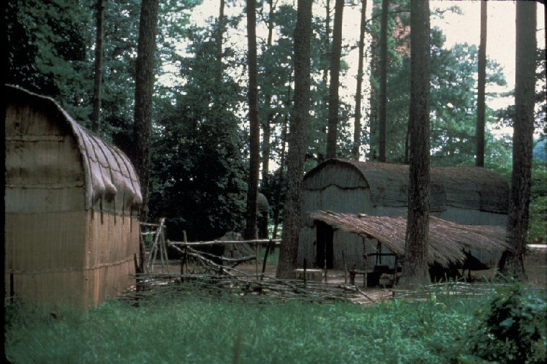
¹ (Potter), Discussions of Algonquian organizational systems; Dr. Stephen Potter and Brent O’Neill, November, 2003, National Capital Region, NPS.
Photograph of replica longhouse.

Large houses, referred to as Longhouses could house large or multiple families or serve ceremonial activities. Smaller ‘wigwams’ were common for most Potomac River families and appear more round in shape than long.

