Fort McHenry Buildings and Vocabulary

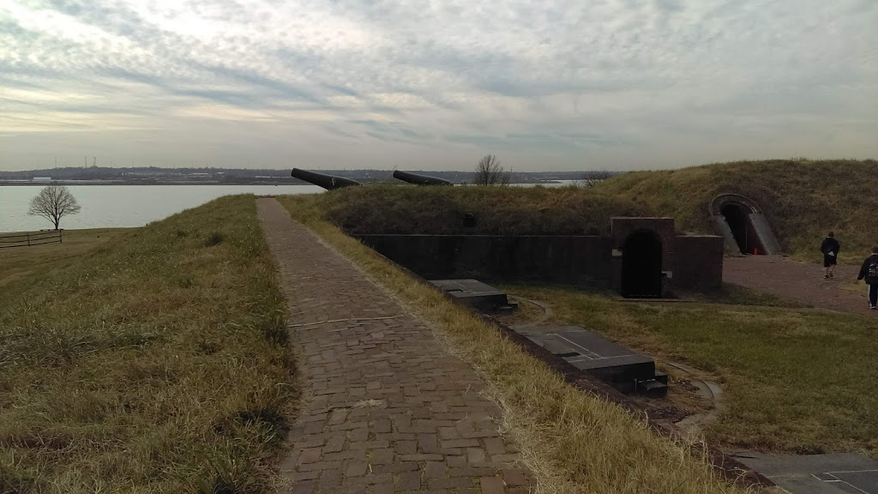

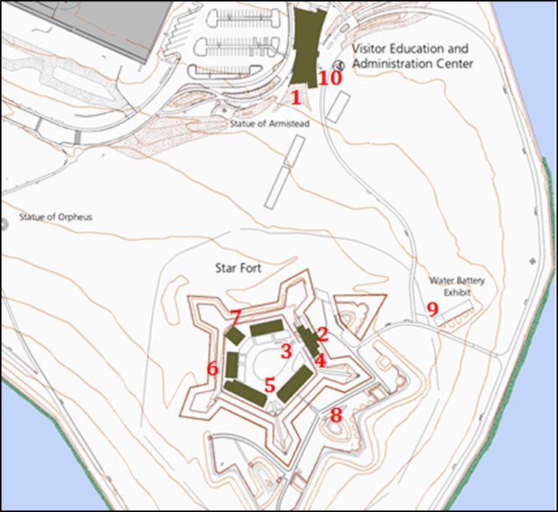
Sites to visit at Fort McHenry
- Movie – Inside Visitor Center
- Bombproof
- Flagpole
- Prison Cells
- Barracks
- Junior Officer’s Quarters
- Powder Magazine
- Ramparts
- Water Battery Cannons
- Exhibits—Inside Visitor Center
Bathrooms are located in the Visitor Center and within the Fort.
Water fountains are located at the Visitor’s Center only.

1. Movie – A 10-minute movie highlighting Francis Scott Key, the Battle of Baltimore, and the “Star-Spangled Banner.” This movie appears on our website on the Educational Resources for Digital Learning page.

2. Bombproof – The Bombproof was built directly after the bombardment of Fort McHenry, however, Fort McHenry was never bombarded again, and they were never used for their intended purposes. They are often confused with “dungeons” due to their iron gates.

3. Flagpole – The current flagpole stands in the exact spot that the flagpole stood during the Battle of Baltimore in 1814. The Flag is still changed every morning without fail. It was the raising of the flag on September 14th, 1814 which indicated to Francis Scott Key that Baltimore had successfully defended the Fort against the British.

4. Prison Cells – During the Civil War, Fort McHenry became a transfer prison camp for confederates/Southern sympathizers. People of all classes were imprisoned, including Francis Scott Key’s grandson.

5. Barracks – Fort McHenry has 4 Barracks. Up to 16 men lived in these small quarters at one time. Soldiers ate and slept in the Barracks. Other Barracks include the Junior Officer’s quarters and the Commanding Officer’s quarters.

6. Junior Officer’s Quarters – After visiting the Barracks for the enlisted men, the Junior Officer’s Barrack looks luxurious. Take a look at the meal set on the table. Do you think the enlisted men ate the same foods as the Junior Officers?

7. Powder Magazine – The powder magazine housed and secured the gun powder/ ammunition. Look above the door. Why might they have kept a light candle up top protected by glass, instead of bringing it in with them?

8. Ramparts – A rampart is a defensive wall. The walls surrounding Fort McHenry are considered the “ramparts.” Think “O’er the ramparts we watched…”
9. Water Battery Cannons – These were the main cannons used to defend the Fort during the Battle of Baltimore.
10. Exhibits in Visitor Center – Make sure to stop by the Visitor Center to explore the exhibits, including an interactive map of the Chesapeake during the War of 1812.
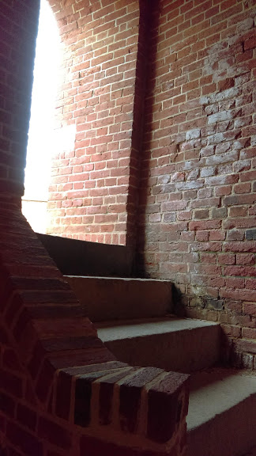
Vocabulary:

For more information about early American military history through the National Park Service, check out https://www.nps.gov/subjects/warof1812/index.htm.

For more information about the Underground Railroad through the National Park Service, check out https://www.nps.gov/subjects/ugrr/discover_history/terminology.htm.

Artillery: A section of a military force (usually army) whose primary role is using cannon, howitzer, mortar, and long guns

Barracks: A place where soldiers or military personal live

Battery: A line of cannons or similar weapons

Bombardment: The prolonged use of explosives, often by artillery, against a certain location or structure

Enlisted: Individuals who are part of the military but are not officers. Enlisted forces make up the majority of the military, even today. They usually receive less pay and worse accommodations than officers, perform the more physical duties of soldiering and are on the front lines.

Enslaved person: Someone forced into laboring for others with virtually no rights or freedoms. Enslaved persons served in wars on behalf of the colonies and later the United States and the British promised enslaved persons freedom for fighting on the British side in both the Revolutionary War and the War of 1812. Enslaved persons in America were of African descent, though not all enslaved persons came directly from Africa. Slavery was an institution in all 13 of the original colonies and in Maryland slavery was not abolished until 1864, only a year before it was abolished nationally through the 13th amendment. Enslaved persons might be bought and sold multiple times throughout their lives, often separated from their families in the process.

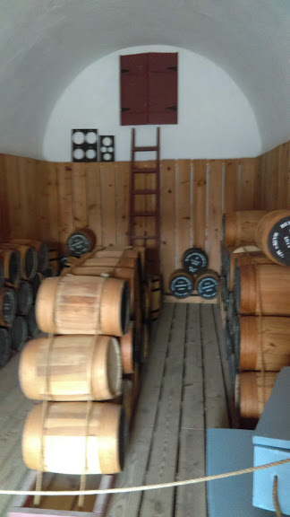
Flotilla: A collection of small ships (or boats) united with a common goal or purpose, often for military matters.

Fort: A defensive military structure that protects a strategic place or location (Fort McHenry was meant to defend the ports of Baltimore). Forts often house military units.

Freedom seekers: Enslaved people and indentured servants who ran away to seek a better life.

Impressment: The act of stealing or kidnapping an individual and forcing them into military service against their will.

Indentured servant: Someone who signed a contract with a “master” to serve that person for a specific number of years, with freedom promised at the end of the contract. Indentured servants in Baltimore could be black or white, and in the early years of slavery in the colonies, “term slavery” functioned in much the same way as indentured servitude for African enslaved persons. Contracts were not always honored and sometimes even passed on to family members if the contract signer became ill or injured.

Laundress: a woman who is employed to clean uniforms, clothes and linens

Manumission: Freeing a person or group of people who have been enslaved, using laws, a will (when someone dies, the will grants enslaved persons of a given plantation freedom) or purchasing freedom (which could be done by enslaved persons themselves, a person or persons in their community or by a “master” or “owner.”)

Militia: A military fighting force consisting of a local population. Militia units were not part of a regular army but rather everyday civilians that received some military training and only fought in emergencies or when called upon by either state or national governments.

Mulatto: Describes someone who is of white and black ancestors, usually one white parent and one black parent

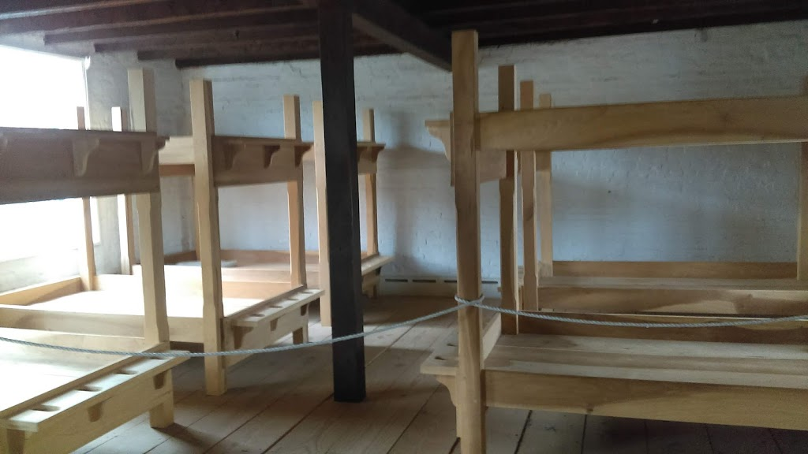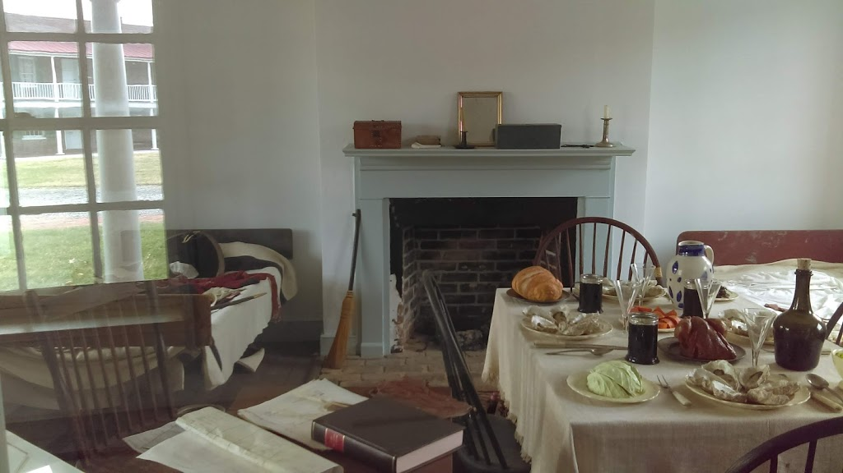

Negro: Word used to describe a person of African descent

Salt-water Negro: Word used to describe a person who had been born in Africa

Officer: Individuals who are part of the military but are not enlisted. Officers make up the minority of the military, even today. They usually receive better pay and better accommodations than enlisted soldiers. Officers are usually the ones in charge of military operations and do much of the planning and organizing of the military. Becoming an officer today requires a college degree, becoming an officer historically was less strict and could easily be accomplished simply by wealth, social standing, and political influence.

Shillings and pounds: Money used in England and in the colonies during the early years of the United States

