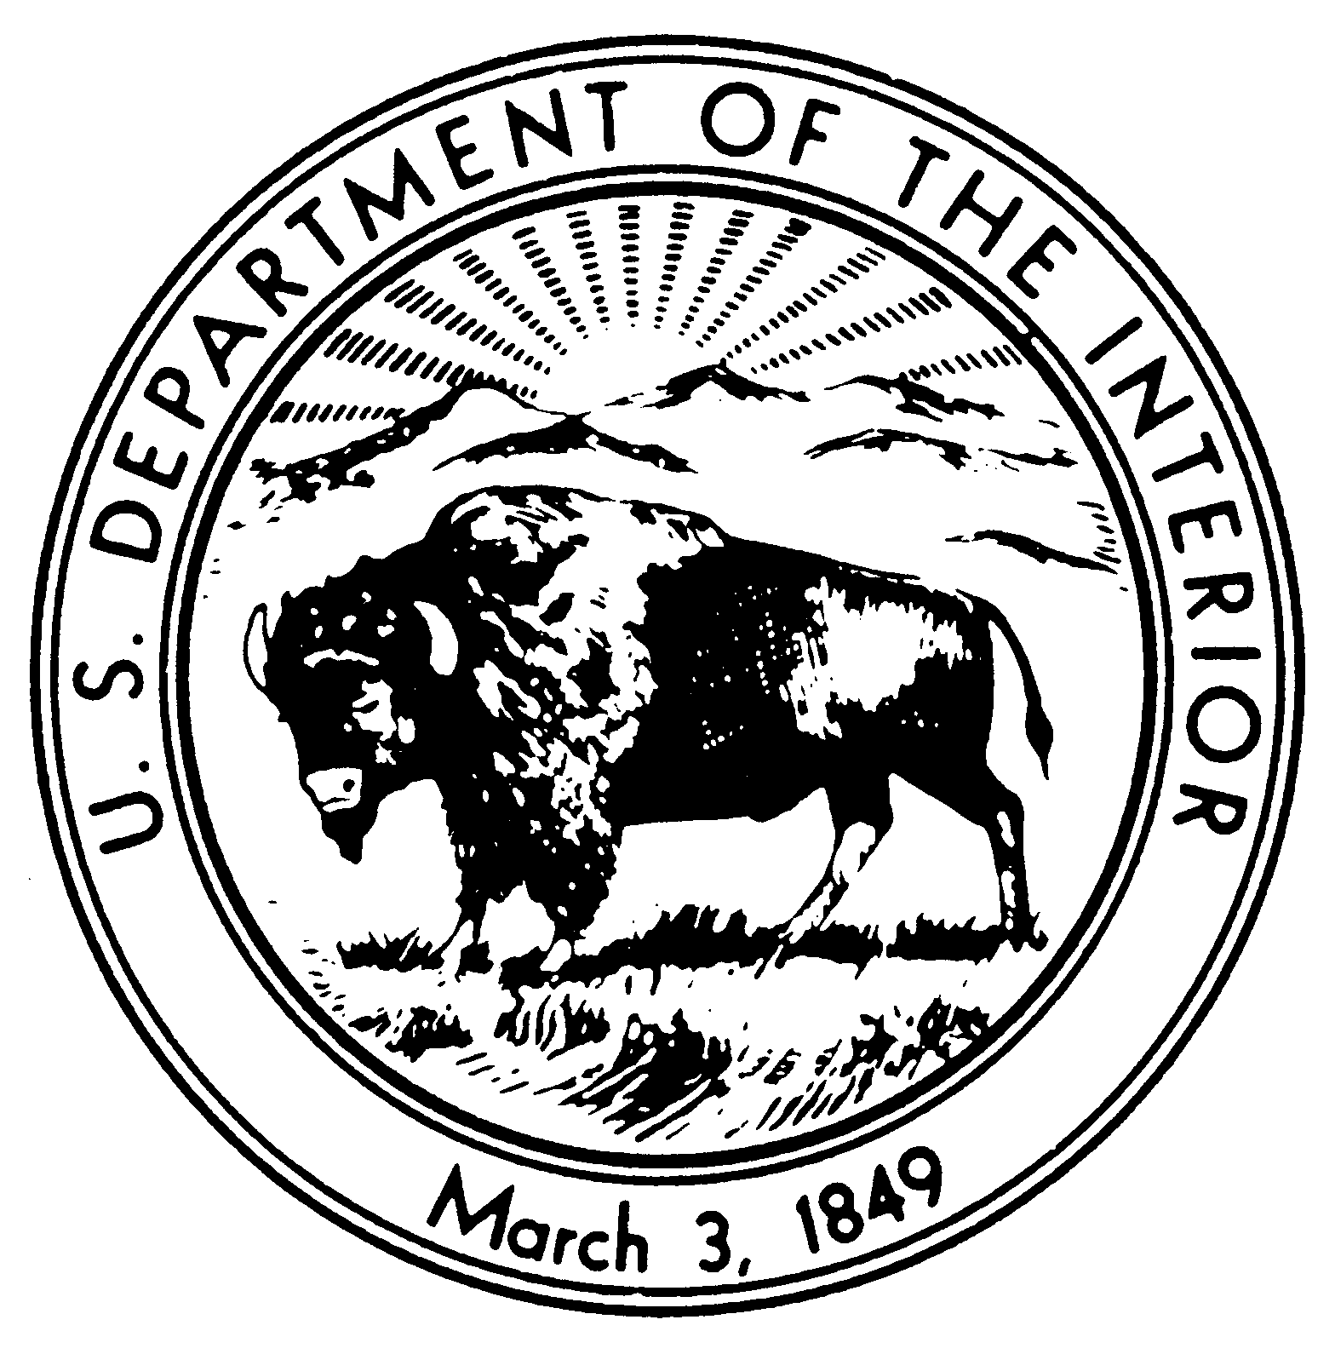
United States Department of the Interior

NATIONAL PARK SERVICE
Eugene O’Neill National Historic Site
P.O. Box 280
Danville, CA 94526

IN REPLY REFER TO:
10D (EUON-VRP)
Administrative Order #21-001

2/5/2021

Closures, restrictions and public use limits:

Restrictions and Public Use Limits: Under the authority provided to the Superintendent in 36 CFR 1.5(a)(2) the following activities are restricted in Eugene O’Neill NHS effective immediately, until further notice:

Individuals over the age of two years must wear masks, except when actively eating or drinking, in the following locations:

- All common areas and shared workspaces in buildings owned, rented or leased by the National Park Service, including, but not limited to, park visitor centers, administrative offices, gift shops and historic structures. This includes while being transported on the park shuttle.

2. The following outdoor areas, when others are present, where the superintendent has determined that physical distancing (staying at least six feet apart) cannot reasonably be maintained:
- Shuttle pick-up and drop-off locations
- Outside the old barn when a theater performance is being conducted
- In the Tao House courtyard

Masks must cover the nose and mouth and fit snugly around the nose and chin with no large gaps around the sides of the face. Masks not designed to be protective, masks with ventilation valves, and face shields do not meet the requirement.

Notice: This administrative order applies to all individuals subject to the regulatory authority of the National Park Service (NPS) within the boundaries of Eugene O’Neill NHS including park visitors, government employees, concession employees, park residents and stakeholders.

Finding: The NPS issues this administrative order for the purposes of maintaining public health and safety during the COVID-19 pandemic emergency. This order is consistent with Executive Order 13991, Protecting the Federal Workforce and Requiring Mask-Wearing.

These directives require the NPS to take the actions identified, as appropriate and consistent with applicable law, to require compliance with Centers for Disease Control and Prevention guidelines with respect to wearing masks, maintaining physical distance, and other public health measures by: on-duty or on-site Federal employees; on-site Federal contractors; and all persons in Federal buildings or on Federal lands.
In addition to physical distancing and hand washing, masks are a critical step to help prevent people from getting and spreading COVID-19. When you wear a mask, you protect others as well as yourself.

- COVID-19 spreads mainly from person to person through respiratory droplets. Masks are a simple barrier to help prevent respiratory droplets from reaching others.
- Masks can prevent the spread of the disease even when the wearer is not sick. This is because several studies have found that people with COVID-19 who never develop symptoms (asymptomatic) and those who are not yet showing symptoms (pre-symptomatic) can still spread the virus to other people.
- Masks may not be necessary when you are outside by yourself away from others, or with other people who live in your household.
- It is especially important to wear a mask indoors with people you do not live with and when you are unable to stay at least 6 feet apart because COVID-19 spreads mainly among people who are in close contact with one another.

This order is effective immediately and will remain in effect until further notice. The effectiveness of this order will be assessed on an ongoing basis, and the order will be modified or rescinded when conditions warrant.
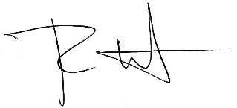

2/5/2021
Approval: ______________________________ _____________
Superintendent Date

