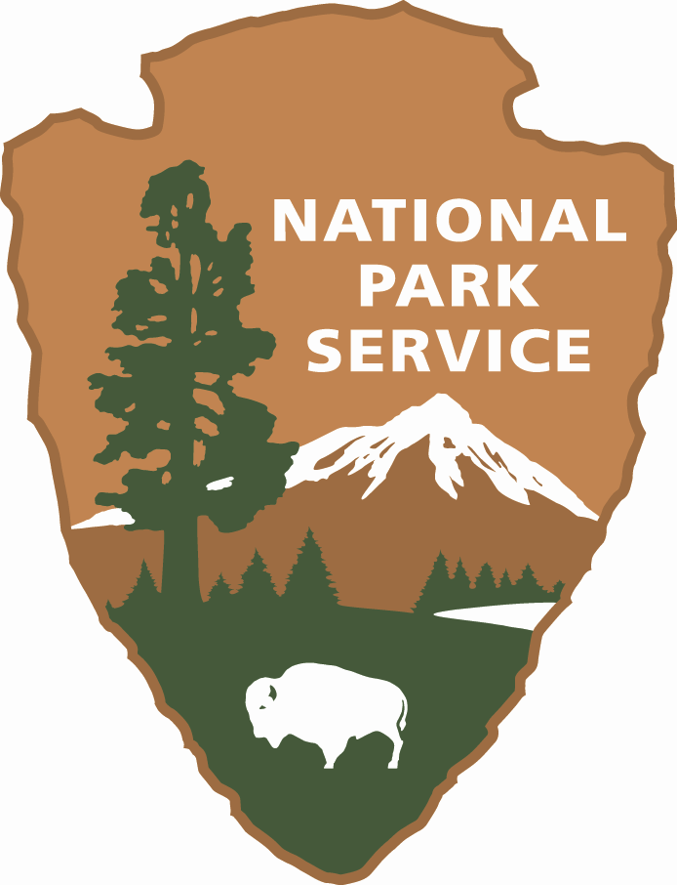

Essential Competencies - Ethnographer

Update to the GS-190 General Anthropology Series
Accepted for the Cultural Resources Training Needs Assessment and Plan
Training and Development Division
March 2000

Park Ethnography Program
National Park Service
1841 C St. NW, MS 2276
Washington, DC 20240

Contents

ENTRY LEVEL (GS-190) 1
Professional Discipline 1
Preservation Law, Philosophy, and Practice 1
Research 2
Program and Project Management 2
Writing and Communication 2
Training 2
DEVELOPMENTAL LEVEL (GS-190) 3
Professional Discipline 3
Preservation, Law, Philosophy and Practice 3
Research 4
Program and Project Management 4
Writing and Communication 4
Training 5
FULL PERFORMANCE LEVEL (GS-190) 6
Professional Discipline 6
Preservation Law, Philosophy, and Practice 6
Research 7
Program and Project Management 7
Writing and Communication 8
Training 8

ENTRY LEVEL (GS-190)

Description: A Bachelor's Degree in anthropology is required. Basic knowledge in cultural anthropology is needed to assist park management, planning, and operations meet their goal of cooperating with communities whose ways of life affect and are affected by parks. Candidates assist in the identification of park neighbors and park user groups, including Native Americans and others with traditional associations to resources within and adjoining parks. They assist in research and consultation; assist in the documentation and inventory of ethnographic resources (i.e., sacred, subsistence and other natural and cultural resources with which peoples are traditionally associated). Ethnographers provide basic anthropological knowledge and skills in providing technical assistance to the implementation of federal mandates and to the development and evaluation of programs, projects, databases, and community relationships affecting partnerships with park-associated groups. They also assist in developing training programs.

Professional Discipline

- Basic knowledge of professional activities and anthropological associations.
- Basic knowledge of concepts, information, and technology for ethnographic database development.
- General professional knowledge of the prehistory and ethnohistory of native cultures of the Americas; general familiarity with the history of the Americas from European contacts to the present.
- Basic knowledge of occupational and ethnic groups in North America and of urban and rural communities traditionally associated with parks.
- Basic knowledge of the standards and methodologies of cultural anthropology, especially applied anthropology, including methods for documentary research, analysis, and ethnohistory.
- Basic knowledge of the cultural and social dynamics of ethnic, occupational, and park-associated communities and with issues of race, class, and ethnicity in the United States; basic knowledge of cultural/human ecology.
- Basic knowledge of the current standards, theory, data, principles, practices, and methodologies of cultural anthropology/ethnography, especially applied anthropology, including methods for documentary research and analysis, ethnohistory, participant observation, oral history, surveys, demographic analysis, and interview.
- Basic knowledge of social/cultural organizational principles that support effective cross-cultural and multi-disciplinary teamwork.

Preservation Law, Philosophy, and Practice

- Basic knowledge of cultural resources management principles, concepts, methods and practices.
- Basic knowledge of the origins, theories, principles, laws, practices, and techniques of historic preservation, particularly as they apply to Native Americans and other park-affiliated groups and to preservation of ethnographic resources.

Research

- Ability to assist other professional anthropologists in collecting and analyzing data from published and unpublished sources and field research, and to assist with written reports on field research.
- Ability to conduct literature and documentary research and in-field interviewing under supervision following an established research design.

Program and Project Management

- Ability to work with partners inside and outside the National Park Service in cooperative projects.

Writing and Communication

- Ability to assist professional staff in preparing basic professional oral and written communications, and public presentations, which convey applied ethnographic data and concepts.
- Ability to prepare papers and presentations for conferences.
- Ability to assist in drafting correspondence, components of reports, informational articles and completing other written assignments.
- Ability to identify sources for culturally appropriate information about ethnographic resources and associated peoples, to be used in the preparation of films, maps, brochures, exhibits, and other public materials and programs.
- Basic skill and knowledge in promoting cultural sensitivity and ethnographic accuracy for interpretive purposes, and in assisting with effectively consulting with involved communities about appropriate images, messages, and information.

Training

- Ability to assist supervisor and other professional cultural resource staff in developing components of applied anthropological training curricula and training materials for non-specialists in anthropology.
- Ability to assist in developing and using training materials and curricula.
- Ability to assist in training situations and workshops.

DEVELOPMENTAL LEVEL (GS-190)

Description: A Master's Degree with a specialization in cultural anthropology is required. Broad knowledge in applied cultural anthropology is provided to help management, planning, and operations meet their goal of cooperating with peoples and communities whose ways of life affect, and are affected by, parks. Ethnographers identify park neighbors and park user groups, including Native Americans and others with traditional associations to resources within and adjoining parks. Through research and consultation, documents and inventories ethnographic resources (i.e., sacred, subsistence and other natural and cultural resources with which peoples are traditionally associated). Applies state-of-the-art cultural anthropological knowledge and assists in providing technical assistance to the formulation of policies, guidelines and park plans, to the implementation of federal mandates, and to the development and evaluation of programs, projects, databases and community relationships affecting partnerships with park-associated groups. Candidates assist in developing and implementing training programs. Identifies issues affecting parks and associated communities, and works with management to design culturally informed strategies to resolve them. Identifies data needs for planning, interpretive, and management purposes, designs and monitors professionally credible applied research, and disseminates research findings within the Service, the Department and inter-agency work groups, to professional colleagues, and to the general public.

Professional Discipline

- Participation in professional activities and anthropological associations.
- Knowledge of concepts, information, and technology for ethnographic database development.
- General professional knowledge of the formal history, prehistory and ethnohistory of native cultures of the Americas; general familiarity with the history of the Americas from European contact to the present.
- Knowledge of the cultural and social dynamics of occupational and ethnic groups in North America, and of urban and rural communities traditionally associated with parks.
- General familiarity with cultural and social dynamics of ethnic, occupational, and park-associated communities and with issues of race, class, and ethnicity in the United States; general familiarity with cultural/human ecology.
- General knowledge of the current standards, theory, data principles, practices, and methodologies of cultural anthropology, especially applied anthropology, including methods for documentary research and analysis, ethnohistory, participant observation, oral history, surveys, demographic analysis, individual and group interviews, transect walks, place name analysis, social impact assessment, subsistence mapping, and rapid assessment techniques.
- Working knowledge of social/cultural organizational principles that support effective cross-cultural and multi-disciplinary teamwork; bilingual skills.

Preservation, Law, Philosophy and Practice

- Knowledge of cultural resources management principles, concepts, methods and practices.
- Knowledge of Federal legislation affecting park programs, associated people and communities and ethnographically significant resources including: the National Historic Preservation Act (NHPA) of 1966, as amended; the National Environmental Policy Act (NEPA) of 1969; American Indian Religious Freedom Act (AIRFA) of 1978; Alaskan National Interest Lands Conservation Act (ANILCA) of 1980; the Indian Self-Determination and Education Act of 1994; and the Native American Graves Protection and Repatriation Act of 1990 (NAGPRA).
- Knowledge of the origins, theories, principles, laws, practices, and techniques of historic preservation, particularly as they apply to Native Americans and other park-affiliated groups and to preservation of ethnographic resources.
- Experience in conducting and coordinating consultation and compliance procedures.

Research

- Experience in identifying Servicewide research needs and in the design, conduct, and evaluation of professional field and documentary research on contemporary peoples and communities and their recent past.
- Ability to collect and analyze data from published and unpublished sources and field research and to prepare a professional synthesis or summary of the data.
- Ability to carry out literature and archival research and in-field interviewing, as demonstrated by completion of professionally accepted reports and manuscripts.

Program and Project Management

- Professional skills and ability to develop and implement cultural resource research, planning, technical assistance, and reporting projects.
- Working knowledge of program management and administration of budgets, contracts, and personnel.
- Ability to oversee the implementation of a variety of ethnographic research, planning, technical assistance, and reporting projects that affect and involve contemporary Native American and other cultural groups.
- Ability as a team member to coordinate the work of professionals from a variety of disciplines into a cohesive product for preservation planning, as well as the development, evaluation, and management of the Servicewide program in park applied ethnography
- Ability to identify appropriate partnerships inside and outside the Service for cooperative projects and to prepare cooperative projects and agreements for the completion of complex cultural resource programs.
- Knowledge of federal contracting requirements and procedures, and ability to assist in preparing scopes of work and requests for proposals.
- Ability to work with a team of park service staff and other public officials within a structured chain of command, and to solve problems under pressure.
- Ability to work effectively with Park Service staff, other public officials, Native Americans, local community consultants, colleagues, scientists from related disciplines, and other stakeholders.
- General knowledge of Park planning policies and procedures and demonstrated experience in applying them to projects or research.

Writing and Communication

- Ability to prepare basic professional oral and written communications, and public presentations, which convey applied ethnographic data and concepts.
- Ability to prepare papers and presentations for professional journals and conferences.
- Ability to draft policy letters, reports, and briefing papers; write informational articles and complete other written assignments.
- Ability to critically evaluate studies, planning documents, proposals, and other documents.
- Ability to identify sources for and communicate culturally appropriate information about ethnographic resources and associated peoples to be used in the preparation of films, maps, brochures, exhibits, and other public materials and programs.
- Skill and knowledge in promoting cultural sensitivity and ethnographic accuracy for interpretive purposes and in effectively consulting involved communities about appropriate images, messages, and information.

Training

- Ability to develop and implement applied anthropological training curricula, and develop training materials for non-specialists in anthropology.
- Knowledge in developing and using training materials and curricula.
- Experience in leading training situations and assisting with workshops.

FULL PERFORMANCE LEVEL (GS-190)

Description: A Ph.D. with a specialization in cultural anthropology is required. Expertise in applied cultural anthropology is provided to help management, planning, and operations meet their goal of cooperating with peoples and communities whose ways of life affect, and are affected by, parks. Ethnographically identifies park neighbors and park user groups, including Native Americans, and others with traditional associations to resources within and adjoining parks. Through research and consultation, documents and inventories ethnographic resources (i.e., sacred, subsistence and other natural and cultural resources with which peoples are traditionally associated). Applies state of the art anthropological knowledge and lends technical assistance to the formulation of policies, guidelines and park plans, to the implementation of federal mandates, and to the development and evaluation of programs, projects, databases and community relationships affecting partnerships with park-associated groups. Develops and implements training programs. Anticipates issues affecting parks and associated communities, and leads efforts to design culturally informed strategies to resolve them. Identifies data needs for planning, interpretive, and management purposes, designs and monitors professionally credible applied research, and disseminates research findings within the Service, the Department and interagency work groups, to professional colleagues, and to the general public.

Professional Discipline

- Demonstrated active participation in professional activities and anthropological associations.
- Authoritative state-of-the-art knowledge of concepts, information, and technology for ethnographic database development.
- Current professional knowledge of the formal history, prehistory, and ethnohistory of native and other cultures of the from European contacts to the present.
- Current authoritative professional knowledge of the cultural and social dynamics of occupational and ethnic groups in North America, and of urban and rural communities associated with parks
- Definitive knowledge of the current standards, theory, data, principles, practices, and methodologies of cultural anthropology, especially applied anthropology, including methods for documentary research and analysis, ethnohistory, participant observation, oral history, surveys, demographic analysis, individual and group interviews, transect walks, place name analysis, social impactw assessment, subsistence mapping, and rapid assessment techniques.
- General knowledge of methods and practices in related fields such as museum management, history, archeology, historical architecture, historical landscape architecture, and natural resource management.
- Authoritative cutting-edge knowledge of social/cultural organizational principles that support effective cross-cultural and multi-disciplinary teamwork, experience with conflict-resolution techniques, bilingual or multilingual skills.

Preservation Law, Philosophy, and Practice

- Functional knowledge of cultural resources management principles, concepts, methods and practices
- Functional knowledge of federal legislation, regulations, policies, and procedures affecting park programs, associated people and communities, and ethnographically significant resources: including the National Historic Preservation Act (NHPA) of 1966, as amended; the National Environmental Policy Act (NEPA) of 1969; American Indian Religious Freedom Act (AIRFA) of 1978; Alaskan National Interest Lands Conservation Act (ANILCA) of 1980; the Indian Self-Determination and Education Act of 1994; and the Native American Graves Protection and Repatriation Act of 1990 (NAGPRA).
- Functional knowledge of the origins, theories, principles, laws, practices, and techniques of historic preservation, particularly as they apply to Native Americans and other park-affiliated groups and to preservation of ethnographic resources.
- Extensive experience in conducting and coordinating consultation and compliance procedures.

Research

- Demonstrated professional experience in identifying Servicewide research needs and in the design, conduct, and evaluation of professional field and documentary research on contemporary peoples and communities, and their recent past.
- Proficiency in designing, assessing, conducting, and directing Ph.D. quality research, including selection of sources, methods, completeness, conformance to professional standards and NPS policies, and soundness of conclusions and recommendations.
- Expertise in analyzing data for practical implications and planning, conducting, and providing written reports on, and evaluating field research.
- Proficiency in carrying out literature and archival research and in-field interviewing, as demonstrated by completion of professional accepted reports and manuscripts.

Program and Project Management

- Working knowledge of program management and administration of budgets, contracts, and personnel.
- Expertise in overseeing the development and implementation of a variety of ethnographic research, planning, technical assistance, and reporting projects that affect and involve contemporary Native American and other cultural groups.
- Ability to complete and update short-term and long-term planning (setting direction and priorities) for diverse programs to meet and enhance agency and office missions.
- Ability to evaluate program needs.
- Ability as a team member to coordinate the work of professionals from a variety of disciplines into a cohesive product for preservation planning, as well as the development, evaluation, and management of the Servicewide program in park applied ethnography
- Ability to identify appropriate partnerships inside and outside the Service for cooperative projects and to prepare cooperative projects and cooperative agreements for the completion of complex cultural resource programs.
- Knowledge and proficiency in Federal contracting requirements and procedures, including preparing scopes of work and requests for proposals.
- Ability to exercise professional judgement to work independently, as well as with a team of park service staff and other public officials within a structured chain of command, and to solve problems under pressure.
- Ability to work effectively with Park Service staff, other public officials, Native Americans, local community consultants, colleagues, scientists from related disciplines, and other stakeholders.
- Demonstrated knowledge of park planning policies and procedures and demonstrated experience in applying them to projects or research.

Writing and Communication

- Ability and experience in preparing papers, articles, and presentations for refereed journals and conferences.
- Ability to present data and data analysis clearly in management reports, plans, instructions, guides, and other government documents.
- Demonstrated ability to write authoritatively on theory and practices of cultural anthropology for either technical or non-technical audiences.
- Demonstrated skill in identifying sources for, and communicating culturally appropriate information about, ethnographic resources and associated peoples to be used in the preparation of films, maps, brochures, exhibits, and other public materials and programs.
- Demonstrated skill in promoting cultural sensitivity and ethnographic accuracy for interpretive purposes and in effectively consulting involved communities about appropriate images, messages, and information.
- Demonstrated skill in communicating information and policies to the public in culturally sensitive ways, especially in settings involving culturally diverse people and concerns.

Training

- Expertise in developing and implementing applied anthropological training curricula, and developing training materials.
- Demonstrated proficiency in identifying training needs and target audiences for a variety of topics and target audiences for a variety of topics and skills.
- Expertise and advanced skills in developing and using a variety of training materials and curricula
- Advanced knowledge in developing training materials and curricula.
- Extensive experience in leading complex training and conferences, which may include agendas with numerous topics and speakers; participants with different backgrounds or levels of knowledge, experience, and motivation; or courses or meetings of several days duration.

