Accessibility Inspection Report Form
Buildings and Facilities
(Contractor Quality Control (CQC) & Final)
National Park Service (NPS) - Denver Service Center (DSC) | 2-14-19
Park: Project Management Information System (PMIS) Number:
Project:
Contract Number: Report Number:
Date of Inspection: Final Inspection: Yes No

Notes & Requirements
This report covers the most common accessibility requirements. Expand this form for elements not shown. Inspect for compliance with requirements of Architectural Barriers Act Accessibility Standards (ABAAS). Use applicable sections for each inspection. The inspection form is not comprehensive for all ABAAS requirements or all designs. (Images shown on this report are screen captures from Access-Board.gov > Architectural Barriers Act (ABA) Standards.)

Measuring Outdoor Improvements
A measuring device shall be capable of measuring to a precision of 1/16 inch. Angular or slope measuring devices shall be capable of measuring to a precision of 0.1 degree. Elevation measuring devices shall be capable of measuring to a precision of 0.01 feet. Measure slope/cross-slope by subtracting elevations and dividing by distance. Measure flatness using a 10 foot metal straightedge with not to exceed 1/4 inch space between hard surface and metal edge. ABAAS requirements identified in this sample refer to post construction measurements which include construction tolerances.

Upon completion of work, Construction Contractor shall complete a final accessibility inspection. List deficiencies in Section 10 and add to punch list. Correct deficiencies in a timely manner. ABAAS construction non-compliance will be replaced at Construction Contractor’s expense unless authorized by Contracting Officer (CO). File this report with CQC Daily Report in official project files.

Parking Spaces & Passenger Loading Zones
Access-Board.gov > ABA Standards > Chapter 4 Accessible Routes > 406 Curb Ramps & Chapter 5 General Site and Building Elements > 502 Parking Spaces:
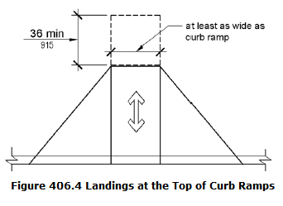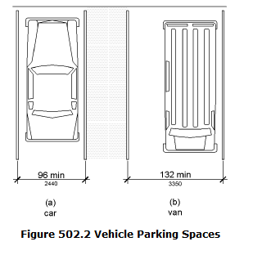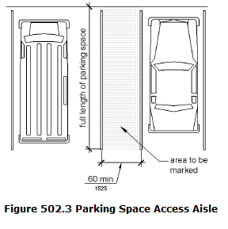

Procedure:
Attach copy of grading plan with each accessible parking space and passenger loading zone running and cross slope readings noted. Measure slopes and cross-slopes at 3 foot intervals.

Location/Notes:
_________________________________________________________________________________________________________________________________________________________________________________________________________________________________________________________________________________________________________________________________
- Yes No Not Applicable
Accessible spaces and access aisles running slope and cross slope is 1:48 (2%) or less. Measure at 3 foot intervals.
________________________________________________________________________________________________________
- Yes No Not Applicable
Car spaces are 96 inches wide minimum and van spaces 132 inches wide measured to striping centerline or face of curb.
________________________________________________________________________________________________________
- Yes No Not Applicable
Access aisles are 60 inches wide minimum measured to striping centerline and adjoin an accessible route.
________________________________________________________________________________________________________
- Yes No Not Applicable
Curb ramp running slope is 1:12 (8.33%) or less and cross slope is 1:48 (2%) or less. Measure at 3 foot intervals.
________________________________________________________________________________________________________
- Yes No Not Applicable
Curb ramp has a 36 inch minimum landing length at top and running slope and cross slope are 1:48 (2%) or less.
________________________________________________________________________________________________________
- Yes No Not Applicable
Curb ramp flared side slopes are 1:10 (10%) or less.
________________________________________________________________________________________________________
- Yes No Not Applicable
Passenger loading zone (drop-off area) running slope and cross slope are 1:48 (2%) or less. Area has flush curb.
________________________________________________________________________________________________________

Inspection Results:
_________________________________________________________________________________________________________________________________________________________________________________________________________________________________________________________________________________________________________________________________

Walking Surfaces & Accessible Routes
Access Board ABA Standards > Chapter 3 Building Blocks > 302 Floor or Ground Surfaces & 303 Changes in Level:
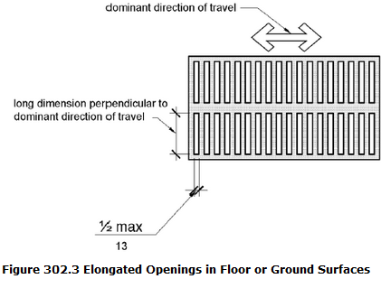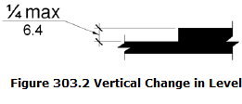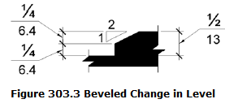

Procedure:
The accessible route is the pedestrian route from accessible parking and passenger loading zones to and between accessible facilities and features. Attach accessible route and/or grading plan with accessible route highlighted and running and cross slope readings noted.

Location/Notes:
_________________________________________________________________________________________________________________________________________________________________________________________________________________________________________________________________________________________________________________________________
- Yes No Not Applicable
Floor and ground surfaces are stable, firm, and slip resistant.
Access Board ABA Standards > Chapter 3 Building Blocks > 302 Floor or Ground Surfaces
________________________________________________________________________________________________________
- Yes No Not Applicable
Running slope of all walking surfaces on accessible route is 1:20 (5%) or less. Measure at 3 foot intervals.
________________________________________________________________________________________________________
- Yes No Not Applicable
Cross slope of walking surfaces is 1:48 (2%) or less. Measure at 3 foot intervals.
________________________________________________________________________________________________________
- Yes No Not Applicable
Clear widths of walking surfaces are 36 inches minimum.
________________________________________________________________________________________________________
- Yes No Not Applicable
Elongated openings in floor or ground surfaces are 1/2 inch wide or less.
________________________________________________________________________________________________________
- Yes No Not Applicable
Curb ramp flared side slopes are 1:10 (10%) or less.
________________________________________________________________________________________________________
- Yes No Not Applicable
Elongated openings are perpendicular to direction of travel.
________________________________________________________________________________________________________
- Yes No Not Applicable
Accessible route surface changes are 1/2 inch or less with 1/4 inch maximum vertical change.
________________________________________________________________________________________________________
- Yes No Not Applicable
Floor drains and grates on accessible route meet all above requirements.
________________________________________________________________________________________________________

Inspection Results:
_________________________________________________________________________________________________________________________________________________________________________________________________________________________________________________________________________________________________________________________________

Ramps
Access Board ABA Standards > Chapter 4 Accessible Routes > 405 Ramps:
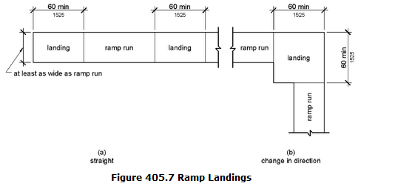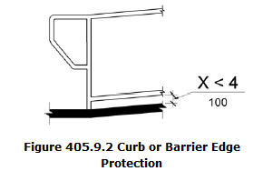

Procedure:
Ramps are walking surfaces on accessible route steeper than 1:20 (5%) but less than 1:12 (8.33%). Attach grading plan with running and cross slope readings noted.

Location/Notes:
_________________________________________________________________________________________________________________________________________________________________________________________________________________________________________________________________________________________________________________________________
- Yes No Not Applicable
Running slope is 1:12 (8.33%) or less. Measure at 3 foot intervals.
________________________________________________________________________________________________________
- Yes No Not Applicable
Cross slope is 1:48 (2%) or less. Measure at 3 foot intervals.
________________________________________________________________________________________________________
- Yes No Not Applicable
Clear width is 36 inches minimum and clear width between handrails is 36 inches minimum.
________________________________________________________________________________________________________
- Yes No Not Applicable
Rise for ramp run is 30 inches maximum.
________________________________________________________________________________________________________
- Yes No Not Applicable
Ramps have landings at top and bottom of each ramp run.
________________________________________________________________________________________________________
- Yes No Not Applicable
Landing clear length is 60 inches minimum and running slope and cross slope of landing is 1:48 (2%) or less.
________________________________________________________________________________________________________
- Yes No Not Applicable
Ramps with a rise greater than 6 inches have handrails.
________________________________________________________________________________________________________
- Yes No Not Applicable
Ramps and landings have edge protection on both sides preventing passage of 4 inch diameter sphere.
________________________________________________________________________________________________________

Inspection Results:
_________________________________________________________________________________________________________________________________________________________________________________________________________________________________________________________________________________________________________________________________

Handrails
Access Board ABA Standards > Chapter 5 General Site and Building Elements > 505 Handrails:
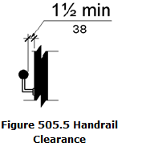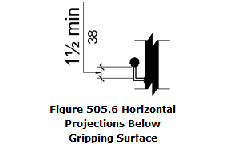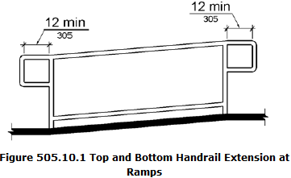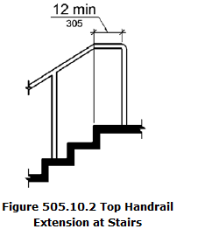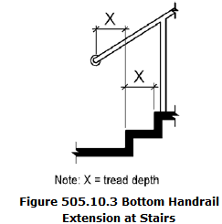

Procedure:
Verify each handrail.

Location/Notes:
_________________________________________________________________________________________________________________________________________________________________________________________________________________________________________________________________________________________________________________________________
- Yes No Not Applicable
Top of handrail is 34 inches minimum and 38 inches maximum vertically above walking surfaces.
________________________________________________________________________________________________________
- Yes No Not Applicable
Handrails extend 12 inches minimum beyond top and bottom of ramp runs.
________________________________________________________________________________________________________
- Yes No Not Applicable
Free standing handrails have edge protection preventing passage of 4 inch diameter sphere.
________________________________________________________________________________________________________
- Yes No Not Applicable
Handrails extend horizontally 12 inches minimum at top of stairs.
________________________________________________________________________________________________________
- Yes No Not Applicable
Handrails extend at slope of stair flight at bottom of stairs minimum one tread depth beyond last riser.
________________________________________________________________________________________________________
- Yes No Not Applicable
Handrail clearance is 1-1/2 inches clear minimum to walls and above horizontal attachments.
________________________________________________________________________________________________________

Inspection Results:
_________________________________________________________________________________________________________________________________________________________________________________________________________________________________________________________________________________________________________________________________

Drinking Fountains
Access Board ABA Standards > Chapter 3 Building Blocks > 307 Protruding Objects:
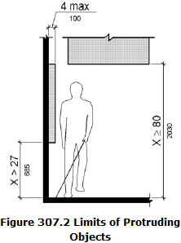

Procedure:
Verify drinking fountains do not create a protruding object. (Two spout heights required for each drinking fountain.)

Location/Notes:
_________________________________________________________________________________________________________________________________________________________________________________________________________________________________________________________________________________________________________________________________
- Yes No Not Applicable
Spout outlet is 36 inches maximum above finish floor or ground for wheelchair accessible spout.
________________________________________________________________________________________________________
- Yes No Not Applicable
Spout outlet for standing persons is 38 inches minimum and 43 inches maximum above finish floor.
________________________________________________________________________________________________________
- Yes No Not Applicable
Drinking fountain is recessed or has exactly 27 inches maximum space from floor to bottom of fountain. (Fountain must meet ABAAS requirements for knee room and requirements for persons with visual disabilities using a cane.)
________________________________________________________________________________________________________

Inspection Results:
_________________________________________________________________________________________________________________________________________________________________________________________________________________________________________________________________________________________________________________________________

Toilet Compartments
Access Board ABA Standards > Chapter 6 Plumbing Elements and Facilities > 604 Water Closets and Toilet Compartments, 605 Urinals, & 609 Grab Bars:
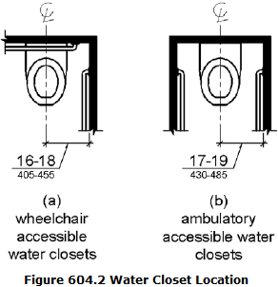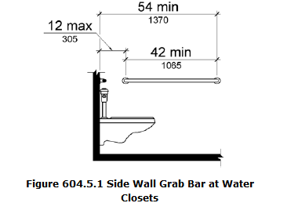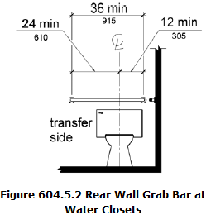
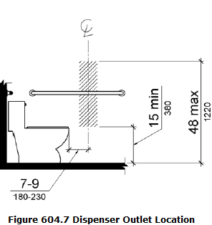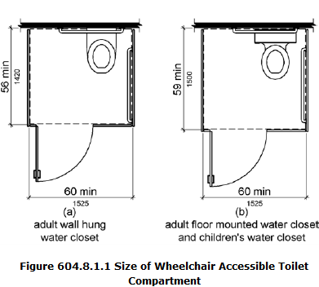
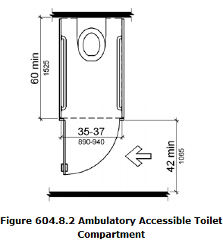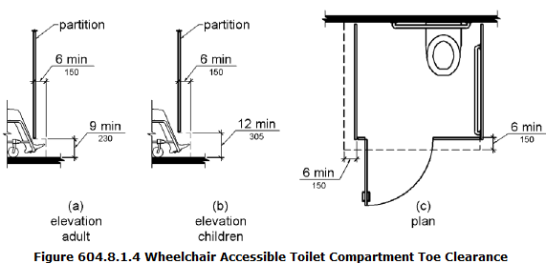
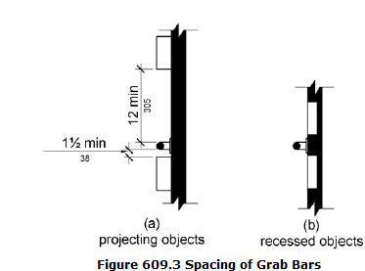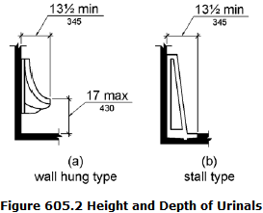

Procedure:
For toilet compartments, attach floor plan and note as-built dimensions on diagrams below. (Use additional sheet for each restroom.)

Location/Notes:
_________________________________________________________________________________________________________________________________________________________________________________________________________________________________________________________________________________________________________________________________
- Yes No Not Applicable
Wheelchair accessible compartment is 60 inches wide minimum and 59 inches deep minimum with wheelchair clear space adjacent to toilet.
________________________________________________________________________________________________________
- Yes No Not Applicable
Ambulatory stall is 60 inches deep minimum, width of 35 inches minimum and 37 inches maximum, and toilet is centered in stall.
________________________________________________________________________________________________________
- Yes No Not Applicable
Accessible compartment has 32 inch wide door opening minimum with door opening outward, or additional wheelchair clear space for door opening inward.
________________________________________________________________________________________________________
- Yes No Not Applicable
Seat height is 17 inches minimum and 19 inches maximum measured to top of seat.
________________________________________________________________________________________________________
- Yes No Not Applicable
Urinal rim is 17 inches maximum above finish floor and 13-1/2 inches deep minimum.
________________________________________________________________________________________________________
- Yes No Not Applicable
Urinal has a clear floor space of 30 inches wide by 48 inches long minimum for forward approach.
________________________________________________________________________________________________________
- Yes No Not Applicable
Side wall grab bar is 42 inches long minimum, located 12 inches maximum from rear wall.
________________________________________________________________________________________________________
- Yes No Not Applicable
Rear wall grab bar is 36 inches long minimum, extends from toilet centerline 12 inches minimum one side towards partition or wall and 24 inches minimum other side.
________________________________________________________________________________________________________
- Yes No Not Applicable
Grab bar height is 33 inches minimum and 36 inches maximum to top of gripping surface.
________________________________________________________________________________________________________
- Yes No Not Applicable
Toilet paper dispensers are 7 inches minimum and 9 inches maximum in front of toilet to centerline of dispenser.
________________________________________________________________________________________________________
- Yes No Not Applicable
Toilet paper dispenser outlet is 15 inches minimum and 48 inches maximum above finish floor.
________________________________________________________________________________________________________
- Yes No Not Applicable
Centerline of wheelchair stall toilet is 16 inches minimum to 18 inches maximum from side wall.
________________________________________________________________________________________________________
- Yes No Not Applicable
Sinks and counters are 34 inches maximum above floor with 27 inches minimum knee space. Drain pipes are insulated or concealed.
________________________________________________________________________________________________________
- Yes No Not Applicable
Space between grab bar and wall/partition and projecting objects below is 1-1/2 inches minimum. Space above is 12 inches minimum.
________________________________________________________________________________________________________
- Yes No Not Applicable
Wheelchair accessible compartment and ambulatory stall have door pulls on both sides of door near latch.
________________________________________________________________________________________________________
- Yes No Not Applicable
Hand dryers, towel and soap dispenser outlets are 15 inches minimum and 48 inches maximum above floor. Bottom edge of reflecting mirror surface above sink or countertops are 40 inches maximum above finished floor.
________________________________________________________________________________________________________

Inspection Results:
_________________________________________________________________________________________________________________________________________________________________________________________________________________________________________________________________________________________________________________________________

Service Counters and Dining and Work Surfaces
Access Board ABA Standards > Chapter 9 Built-In Elements > 904 Check-Out Aisles and Sales and Service Counter & 902 Dining Surfaces and Work Surfaces:

Procedure:
Service counters and dining and work surfaces are parallel or forward approach. NPS treats service counters as possible employee work areas which are required to be 34 inches maximum.

Location/Notes:
_________________________________________________________________________________________________________________________________________________________________________________________________________________________________________________________________________________________________________________________________
- Yes No Not Applicable
Parallel Approach. Counter is 36 inches long minimum and 36 inches high maximum.
________________________________________________________________________________________________________
- Yes No Not Applicable
Forward Approach. Counter surface is 30 inches long minimum and 36 inches high maximum with knee space under counter. See ABAAS 306 for adequate depth and toe clearance.
________________________________________________________________________________________________________
- Yes No Not Applicable
Tops of dining and work surfaces are 28 inches minimum and 34 inches maximum above finished floor with adequate knee and toe clearance.
________________________________________________________________________________________________________

Inspection Results:
_________________________________________________________________________________________________________________________________________________________________________________________________________________________________________________________________________________________________________________________________

Doors
Access Board ABA Standards > Chapter 4 Accessible Routes > 404 Doors, Doorways, and Gates
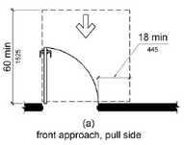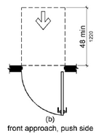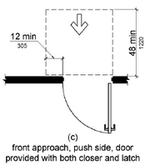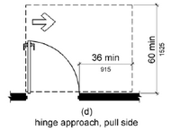
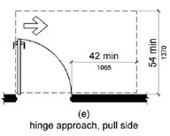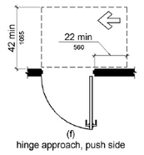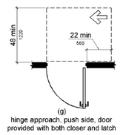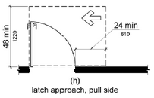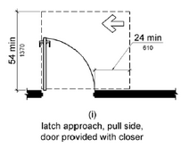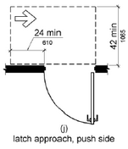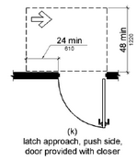
Figure 404.2.4.1 Maneuvering Clearances at Manual Swinging Doors and Gates

Procedure:
Attach accessible route plan with accessible door dimensions and threshold heights.

Location/Notes:
_________________________________________________________________________________________________________________________________________________________________________________________________________________________________________________________________________________________________________________________________
- Yes No Not Applicable
Door openings on accessible routes provide clear width of 32 inches minimum.
________________________________________________________________________________________________________
- Yes No Not Applicable
Door closers move door from open position of 90 degrees to 12 degrees from latch is 5 seconds minimum.
________________________________________________________________________________________________________
- Yes No Not Applicable
Spring hinge doors close from open position of 70 degrees to closed position in 1.5 seconds minimum.
________________________________________________________________________________________________________
- Yes No Not Applicable
Fire doors have minimum opening force allowable by appropriate administrative authority.
________________________________________________________________________________________________________
- Yes No Not Applicable
Interior door and gate hardware located 34 inches minimum and 48 inches maximum above finished floor and operable with hinged doors having opening force of 5 pounds maximum.
________________________________________________________________________________________________________
- Yes No Not Applicable
Thresholds at doors on accessible route are beveled 1/2 inch or less with 1/4 inch maximum vertical change.
________________________________________________________________________________________________________
- Yes No Not Applicable
Clear floor and wall space provide maneuvering clearances required (all doors on accessible route).
________________________________________________________________________________________________________

Inspection Results:
_________________________________________________________________________________________________________________________________________________________________________________________________________________________________________________________________________________________________________________________________

Signs
Access Board ABA Standards > Chapter 7 Communication Elements and Features > 703 Signs:
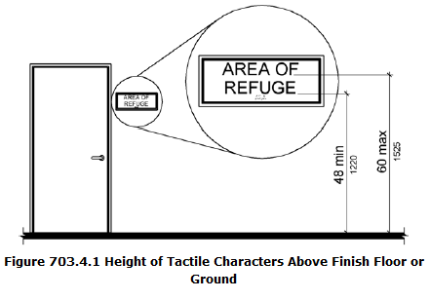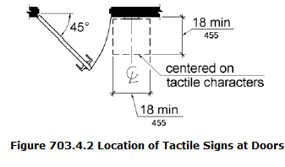

Location/Notes:
_________________________________________________________________________________________________________________________________________________________________________________________________________________________________________________________________________________________________________________________________
- Yes No Not Applicable
Parking space signs are 60 inches minimum above finish ground surface measured to bottom of sign.
________________________________________________________________________________________________________
- Yes No Not Applicable
Van parking space sign includes designation "van accessible."
________________________________________________________________________________________________________
- Yes No Not Applicable
Tactile characters on signs are 48 inches minimum from lowest tactile character and 60 inches maximum above finished floor from baseline of hightest tactile character.
________________________________________________________________________________________________________
- Yes No Not Applicable
Visual characters are 40 inches minimum above finished floor.
________________________________________________________________________________________________________
- Yes No Not Applicable
Sign is located alongside door at latch side.
________________________________________________________________________________________________________
- Yes No Not Applicable
Sign is located with clear floor space of 18 inches by 18 inches minimum.
________________________________________________________________________________________________________

Inspection Results:
_________________________________________________________________________________________________________________________________________________________________________________________________________________________________________________________________________________________________________________________________

Other Accessible Features not Covered by Report

Procedure:
Inspect elevators, lifts, elements for children, etc. Inspect for compliance with ABAAS requirements.

Location/Notes:
_________________________________________________________________________________________________________________________________________________________________________________________________________________________________________________________________________________________________________________________________

Inspection Results:
_________________________________________________________________________________________________________________________________________________________________________________________________________________________________________________________________________________________________________________________________

Punch List Items - Summary of Non-Conforming Inspection Results
Add deficiencies. Correct deficiencies in timely manner.
- Deficiency: _____________________________________________________________________________________________
Corrective Actions Needed/Taken: __________________________________________________________________________
______________________________________________________________________________________________________
- Deficiency: _____________________________________________________________________________________________
Corrective Actions Needed/Taken: __________________________________________________________________________
______________________________________________________________________________________________________
- Deficiency: _____________________________________________________________________________________________
Corrective Actions Needed/Taken: __________________________________________________________________________
______________________________________________________________________________________________________
- Deficiency: _____________________________________________________________________________________________
Corrective Actions Needed/Taken: __________________________________________________________________________
______________________________________________________________________________________________________
- Deficiency: _____________________________________________________________________________________________
Corrective Actions Needed/Taken: __________________________________________________________________________
______________________________________________________________________________________________________
- Deficiency: _____________________________________________________________________________________________
Corrective Actions Needed/Taken: __________________________________________________________________________
______________________________________________________________________________________________________
- Deficiency: _____________________________________________________________________________________________
Corrective Actions Needed/Taken: __________________________________________________________________________
______________________________________________________________________________________________________
- Deficiency: _____________________________________________________________________________________________
Corrective Actions Needed/Taken: __________________________________________________________________________
______________________________________________________________________________________________________
- Deficiency: _____________________________________________________________________________________________
Corrective Actions Needed/Taken: __________________________________________________________________________
______________________________________________________________________________________________________
- Deficiency: _____________________________________________________________________________________________
Corrective Actions Needed/Taken: __________________________________________________________________________
______________________________________________________________________________________________________

Photographs & Sketches
Attach to report as needed. Identify location of photographs and sketches.

Certification
I certify this inspection report is complete and correct and is in compliance with contract documents.

Inspector Name (Print) Inspector Signature Date

