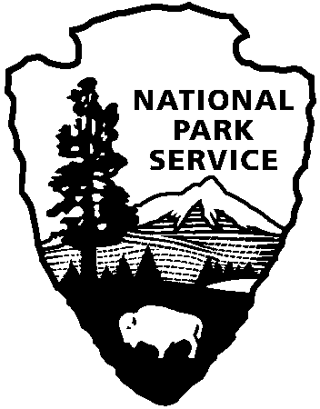 | National Park Service  U.S. Department of the Interior
National Park Service News Release

FOR IMMEDIATE RELEASE – DATE: April 24, 2013
CONTACT: Virginia Fowler, (864) 461-2828

Cowpens National Battlefield to Complete Road Project in May

Park Superintendent John Slaughter announced today that Cowpens National Battlefield has received $243,000 in project money to repair and fog-seal all park roads and parking lots. SoCo Contracting chose Bennett Paving, a local sub-contractor, to complete the majority of the work, thereby keeping the money in the local economy. The project is scheduled to begin on Wednesday May 1, 2013 and will last up to one month. It is scheduled to be completed by early June. During this period, visitors can expect delays with periodic closures of pull-offs and parking areas along park roads.

For visitor safety, the park loop road including the picnic area will be closed to all traffic - pedestrian, bicycle, motor vehicle, and horse - the week of May 13-18. Federal law enforcement officials will do spot checks to make sure everyone is in compliance.

“Fog seal will ruin shoes and clothing, so there will be some inconvenience for our park visitors who may want to drive or walk the three mile park loop road or use the picnic area. We will do everything possible to have the work completed quickly and all facilities reopened as soon as possible,” Slaughter said. He went on to say that park visitors will continue to have access to the park’s Visitor Center and historic battlefield throughout the project.

Visitors can learn about the Battle of Cowpens at the Visitor Center and museum, where an 18-minute movie about the battle shows on the hour between 9:00 and 4:00. A fiber-optic map explains the battlefield strategy and troop movements, and museum exhibits highlight the opposing soldiers who fought here. The one mile interpretive battlefield trail starts at the visitor center.

Cowpens National Battlefield is part of the National Park Service and has a Visitor Center, movie, bookstore, and a one-mile trail on the battlefield. There is also a picnic area, nature trail and three mile auto tour loop. Visitor Center hours are 9:00 a.m. – 5:00 p.m. daily, closed on Thanksgiving, Christmas, and New Year’s Day. For more information, call (864) 461-2828 or visit the park’s webpage at www.nps.gov/cowp.

Find us on Facebook at www.facebook.com/CowpensNationalBattlefield.

About the National Park Service. More than 20,000 National Park Service employees care for America’s 3401 national parks and work with communities across the nation to help preserve local history and create close-to-home recreational opportunities. Learn more at www.nps.gov.

