Fort Pulaski

Pre-visit Background for Fort Pulaski
U.S. Department of the Interior National Park Service


Fort Pulaski National Monument

This is information that you can share with your students prior to your visit to Fort Pulaski. The information is organized thematically. It is designed to be used with the accompanying spider activity as a pre-visit program prior to your field trip to Fort Pulaski.

Location of Fort Pulaski • Built on Cockspur Island.
- Located at the mouth of the Savannah River.
- Built to protect the port of Savannah.
- Fort cannons defended against an enemy approach by water.

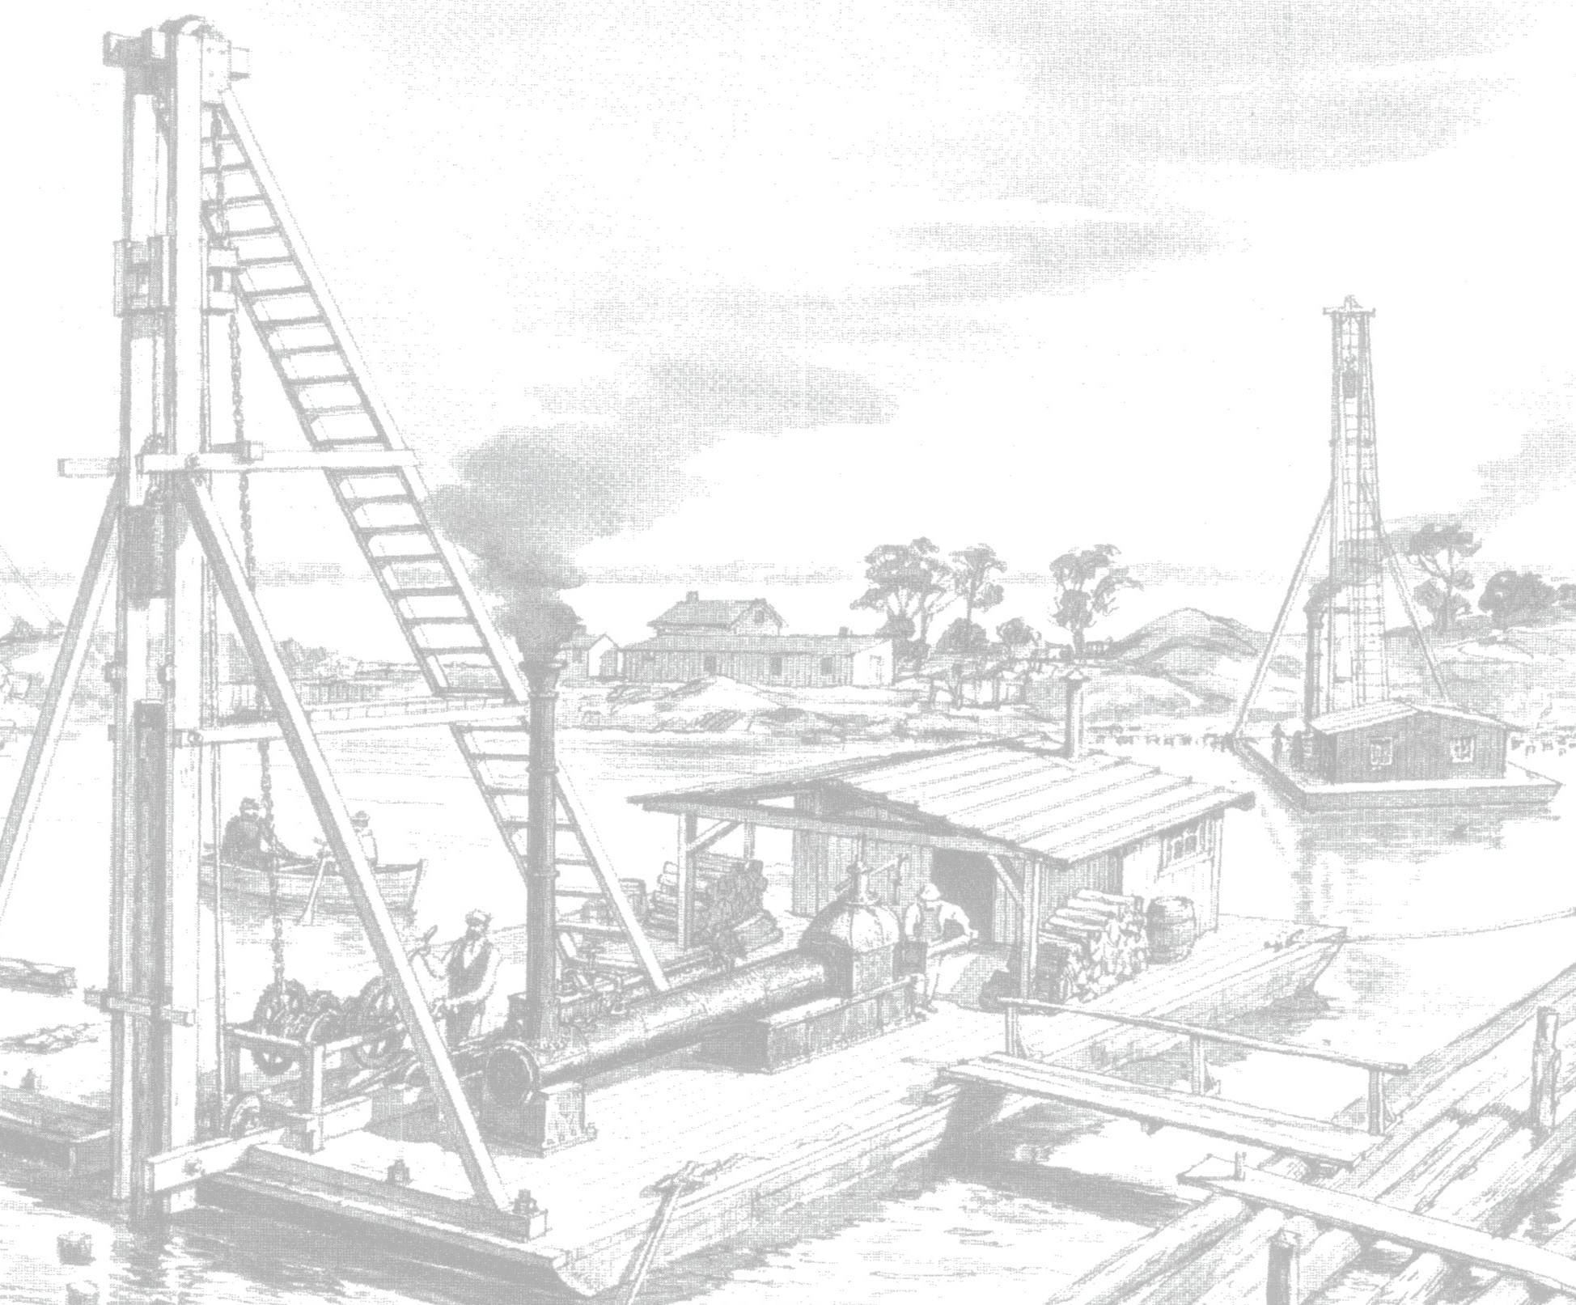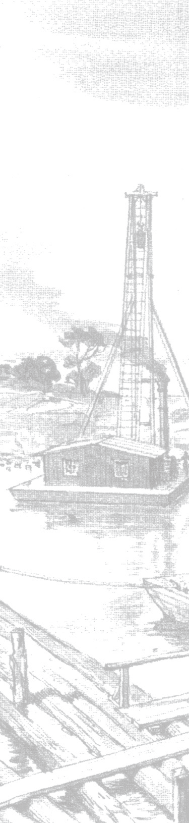Construction of Fort Pulaski

Use of Fort Pulaski
- Planned after War of 1812.
- Built by the U.S. Government.
- Cost to build was $1 million.
- Built with 25 million bricks.

- Georgia state soldiers sieze fort from federal caretakers (January 1861).
- Georgia turns fort over to Confederacy (April 1861).
- Union Army places cannons on Tybee Island preparing to attack fort (February 1862).
- Confederate Colonel Charles Olmstead refuses to surrender fort to Union, so the battle begins (April 10, 1862).
- Construction lasted from 1829-1847.
- It took 18 years to build fort.
- Named for Count Casimir Pulaski, Revolutionary War hero.

- Union General Quincy Gillmore attacks fort with new technology, rifled cannons.
- Corner of fort destroyed by Union cannon fire.
- Battle lasts 30 hours.
- Colonel Olmstead surrenders Fort Pulaski to Union (April 11, 1862).
- Fort Pulaski becomes a National Monument (1924).

Fort Pulaski
U.S. Department of the Interior National Park Service

Fort Pulaski National Monument

Pre-visit Activity Spider Activity

Fill in the circles with the correct information.


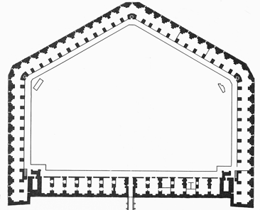
What
Fort Pulaski

Who


U.S. Department of the Interior National Park Service
Fort Pulaski
Fort Pulaski National Monument

Pre-visit Activity Spider Activity Answers

The answers to this activity can be found in the teacher backgrounders that are included on the Fort Pulaski website.

18 years
25 million bricks
$1 million
To defend the port of Savannah and the Savannah River.
- Planned after War of 1812
- Started 1829
- Finished 1847
- Battle in 1862

- Cockspur Island
- Mouth of Savannah River

Brick Fortifiication

What

Fort Pulaski

Who

Military
U.S. Government Laborers
Slaves
Col. Charles Olmstead

