Make Your Own Astrolabe
Early astronomers used a tool called an astrolabe to measure the angle of stars in the night sky. This tool taught the early astronomers many different things about our galaxy including the amount of time it takes for the Earth to revolve around the sun, the hours in a day, and how to track constellations and eclipses.
You Will Need:
- A plastic protractor and/or cardstock or cardboard
- One plastic straw
- A piece of string 7-12 inches long
- A small washer, bolt, or another weight that can be tied to a string
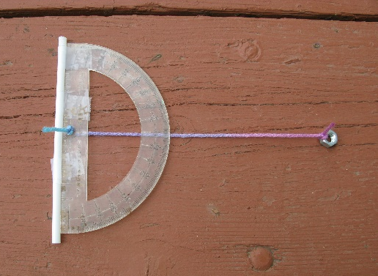
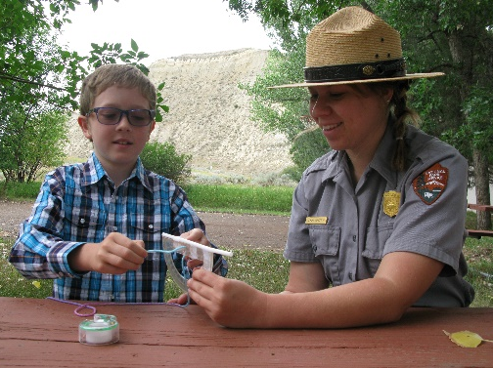
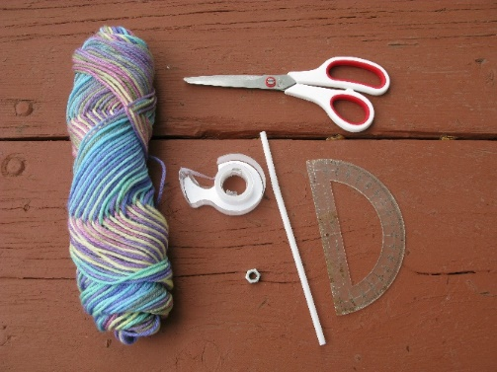
- Tape

What to Do:
- If you are using a protractor, tie one end of the string to the hole in the middle flat-edged side of the protractor. If there is not a hole, carefully drill one.
  - If a protractor is not available to you, make your own using cardstock or cardboard, marking each 10-degrees between 0 and 180. Hole punch or cut a hole in the center of the straight edge and tie one end of the string to the hole.
- Attach the metal weight to the other end of the string.
- Tape the straw to the flat edge of the protractor.
Once your astrolabe is assembled, take it outside! This activity is best done at nighttime to track the stars. Locate a star or planet, using the straw as a viewfinder. Once the star or planet is located, hold the string in place against the protractor and take note of the angle where the star was seen. After about an hour, return to the same position and relocate the same star or planet using the process above. Is it in the same position in the sky as it was previously?

