United States Department of the Interior
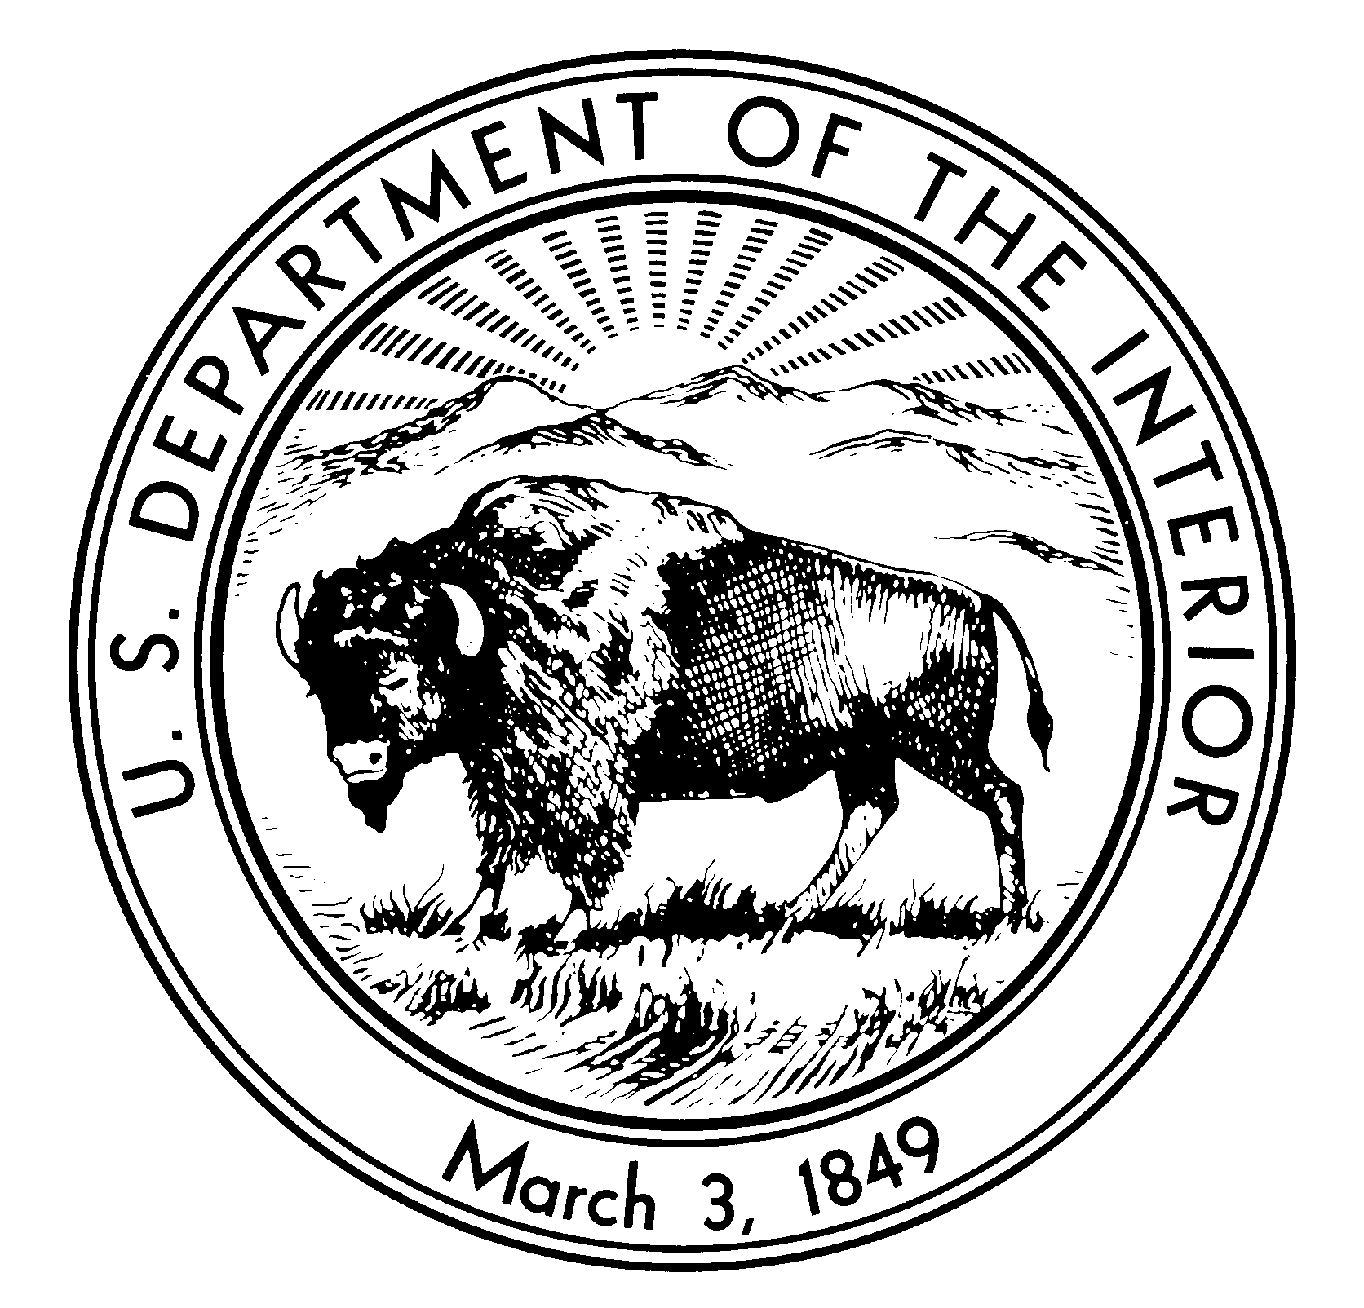

NATIONAL PARK SERVICE
C&O Canal National Historical Park
11710 MacArthur Blvd.
Potomac, Maryland 20854
Revised 3/2010

ACADEMIC FEE WAIVER CRITERIA
and
APPLICATION INSTRUCTIONS

National Park Service (NPS) regulations allow school groups and other bona fide national or international academic institutions to obtain a waiver for park entrance fees, provided that the visit is for educational or scientific purposes, and the resources or facilities the group proposes to use support those purposes.

Academic fee waivers are not granted automatically and applicant groups must show they qualify for the fee waiver. There are three criteria a group must meet to qualify for a fee waiver: eligibility, educational purpose, and relevance of park resources or facilities.

1. Eligibility

Applicant must prove they are a bona fide educational or scientific institution by presenting one of the following types of documentation:

- A statement confirming educational or scientific tax-exemption from the IRS or the applicant’s national, state, or local tax authority; or

- A statement from a bona fide educational institution, confirming that the group is visiting for the purpose of providing transferable educational credit based on a curriculum; or

- A statement of accreditation or recognition as an academic institution, from a qualified national, regional, state, or local authority at the applicant’s location.

2. Educational Purpose of the Visit

- Applicant must provide a written statement confirming that the visit supports a specific curriculum for which academic credit is offered. If the group is on a commercial tour, the applicant must state how the tour supports the curriculum.

3. Relevance of Park Resources or Facilities

- Applicant must provide a written statement identifying the park resources and/or facilities that will be used to support the educational purpose of the visit, and how they are relevant to that purpose.

(1)

To apply for an Academic Fee Waiver, complete the enclosed application and include the following:

1. Educational and scientific groups must submit proof of official recognition as an accredited institution by a federal, state, or local government entity. Private schools or other scientific institutions may submit documentation or tax exempt status granted for educational purposes. Groups or organizations that have been “officially recognized by a school or scientific institution for the purpose of providing education…” must provide evidence of this official recognition. Your fee waiver request cannot be approved without one of these documents.

2. The intended trip must relate directly to the educational or scientific purpose of the visit and to the unique features and resources of the C&O Canal. The visit “shall not be primarily for recreation purposes.” (Course outlines, lesson plans, or a copy of the curriculum may be attached.)

3. Requests from colleges or universities should also include a copy of the course description from the school’s catalog or handbook.

Applications must be received in the Recreation Fee Program Office 2 – 4 weeks in advance of the anticipated visit. If the application is approved, an Academic Fee Waiver will be mailed to you. If your request is denied, you will receive a letter explaining why your group does not qualify.

Each vehicle must present a copy of the Academic Fee Waiver at the park entrance station. FEE WAIVERS WILL NOT BE ISSUED AT THE ENTRANCE STATION and entrance fees will be waived only if each vehicle has a copy of the fee waiver.

Please E-Mail your application package to:

Kyle_lane@nps.gov

Please be aware of the following:

- Academic fee waivers do not include camping, canal boat fees or educational program fees.

- Organizations that are generally considered service, civic or fraternal, such as Scouting, Rotary, and Elks, do not qualify for an academic fee waiver, unless the group meets the criteria above.

- Academic fee waivers cannot be granted for hardship factors.

- “Blanket” academic fee waivers for all national parks are not issued or accepted. Groups must submit separate requests to individual parks for approval. A list of parks and contact addresses is at www.nps.gov.

If you have any questions about academic fee waivers, please contact the Fee Office: 301-767-3703

Additional information about the C&O Canal National Historical Park is available at www.nps.gov/choh.

(2)
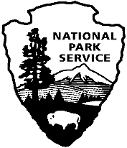
Academic Fee Waiver for Resource Education Study
National Park Service
C&O Canal National Historical Park
(Please print clearly or type)

Name of School:

School Address:

Name of Applicant: Phone:

Date and Time of Park Visit:

Number of Buses: Vans: Autos:

Number of Students 15 or Younger: 16 or Older:

Number of Teachers/Faculty: Chaperones:

Number of Teachers/Faculty/Chaperones Allowed Free Entry:
- 1 Teacher/Faculty/Chaperone per 5 Elementary School Students
- 1 Teacher/Faculty/Chaperone per 8 Middle School Students
- 1 Teacher/Faculty/Chaperone per 12 High School Students
- 1 Teacher/Faculty/Chaperone per 20 College Students
(Additional Teachers/Faculty/Chaperones must pay the park entrance
fee of $10 per person, unless they have a valid park pass.)

Course Title, Catalog Number, and Description or Grade Level and Subject Matter:

What is the Educational Purpose of the Visit and How Does the Visit Relate to Park Resources/Facilities:

I understand that the Code of Federal Regulations allows Academic Fee Waivers only for academic and/or scientific institutions that are using the park for educational purposes. I hereby certify that the above detailed trip meets these requirements and therefore request that entrance fees be waived. Current official documentation of recognition as an educational or scientific institution is attached (e.g. accreditation letter, educational tax-exempt letter).

Applicant Signature Title Date

