
This table is for campers with a reservation.
Picnic areas are available at Bonita Creek, Faraway Ranch, Visitor Center, & Massai Point.
Campers: Welcome to Bonita Canyon Campground!
For your safety, enjoyment, and future generations, please follow all park and campground rules.
   | 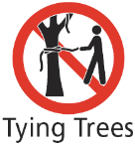   |   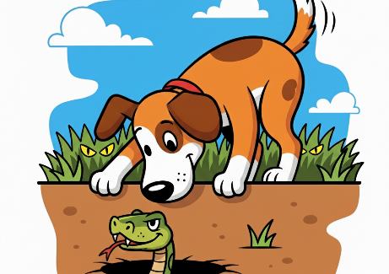
Put Food in Metal Boxes  Store everything – food, trash, coolers – before walking away. | No Tying or Hanging  Dormant trees look dead – ropes injure our trees. | Leash and Watch Pets  Do not unleash, leave pets tied up, or unattended.
  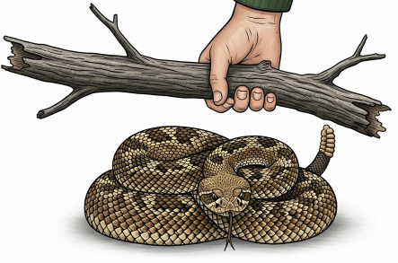 |   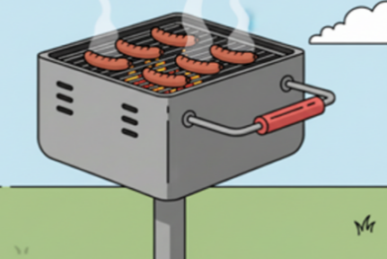 |   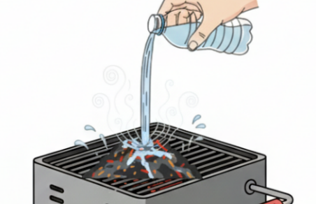
Do Not Collect Firewood  Collecting wood, using liquid accelerants or trash is prohibited. | Use Grills for Fires    Keep fires small and brief to reduce danger. No Ground fires. | Pour Water on Ashes  Leave a cold grill and put ashes in barrels.
  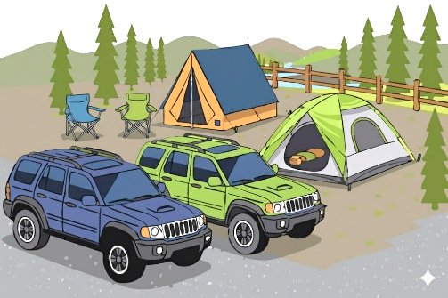 |  |   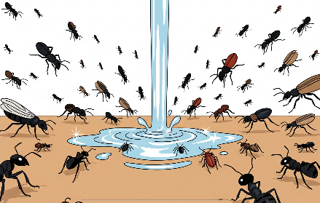
Respect the Limits  Max capacity: 2 vehicles, 2 tents, 8 people. All must fit in boundaries. | No Remote Flying  Flying drones and airplanes are prohibited. | Don’t Pour Liquids Out  Graywater disposals are for soapy water. No draining rigs.
       |    |     AI assisted graphics 9/2025
Check Out by 11 am  Clean up litter & take all you brought. | Respect Quiet Times  Quiet voices only 8 pm to 8 am.  Generator use: 8-10 am & 4-6 pm | No Playing in Road  Watch children. No scooters, skates, or reckless behavior.
Failure to follow rules and regulations may result in fines or expulsion per CFR 36.
Thank you! — Chiricahua National Monument Management, Staff, and Volunteers

