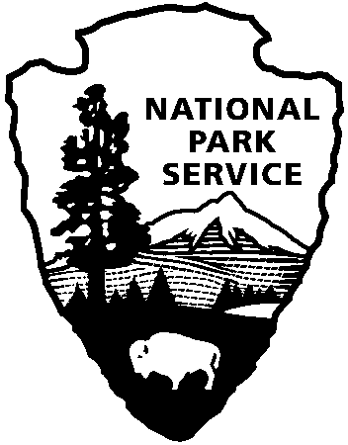

110 Point Park Road

Lookout Mountain, TN 37350

423-821-7786- phone

www.nps.gov/chch

This is a request for a school group to visit Point Park, a part of Chickamauga and Chattanooga National Military Park. Please complete and scan/email this form to [christopher_young@nps.gov](mailto:christopher_young@nps.gov). If you need to make changes after submitting your request, please call the park as soon as possible at 423-821-7786.

Trip Information

Name of Institution: _______________________________________________________________________

Official in charge of group and title: ________________________________________________________

Address: ___________________________________________________________________Zip:___________

Phone Number: _______________________Fax:__________________Email:________________________

Date(s) of Visit: ___________________________Time:___________________________________________

Number of Students: ______________________Age/Grade: ______________________________________

Number of Chaperones:___________________Special Needs Group:____________________________

(Disabilities, accelerated, or learning disabled)

(We recommend school groups have at least one adult for every 8 high school students and one adult for every 4 elementary school students).

A statement of the educational and/or scientific objectives (specific curriculum) to be accomplished through this visit is required and should be attached to the application as a letter of intent on the school’s letterhead.

CERTIFICATION: I hereby certify that the above organization is officially recognizes as a bona fide educational or scientific institution by a Federal, State, or Local government body and that all of the information provided herein are true and accurate the best of my knowledge and are submitted for the explicit purpose of obtaining a waiver of entrance fees. I also certify that the visit by this group is for educational and/or scientific purposes and with the understanding that Title 18 of the United Stated Code, Section 1001, provides penalties for willful falsification in statements of representations to an agency of the United States.

Signature of Applicant: _____________________________________________Date:___________________

If you are planning to eat or picnic at the park, please use the designated picnic area located outside Point Park, next to the park visitor center.

Government Use Only

Waiver of entrance fee Approved Disapproved (circle one)

Signature of Park Official: _________________________________Date:____________________________

Lookout Mountain, TN: To honor those who have served in our armed forces all National Parks are waiving the entrance fee. We invite all visitors to remember our veterans by visiting any National Park site. Point Park, which is part of the Chickamauga and Chattanooga National Military Park, is waiving the entrance fee on Saturday, November 11th and Sunday, November 12th, 2017.

Come enjoy the beautiful views of Chattanooga and its surrounding areas. During the day, ranger-guided history talks are given at 11 am and 2 pm. The talks will start right inside the Point Park entrance gates and will last 30 to 45 minutes. In addition to the ranger-guided history talks, there is special program at the Chickamauga National Military Park at 11am on November 11th, 2017.

For maps and other information, we encourage you to check out our visitor center in person or call the Lookout Mountain Battlefield Visitor Center at (423) 821-7786. Visit the park’s website www.nps.gov/chch for additional information about Point Park, Chickamauga, and Chattanooga National Military Park or call the Chickamauga Battlefield Visitor Center at (706) 866-9241.

[**www.nps.gov**](http://www.nps.gov)

*About the National Park Service. More than 22,000 National Park Service employees care for America’s 417 national parks and work with communities across the nation to help preserve local history and create close-to-home recreational opportunities. Learn more at* [*www.nps.gov*](http://www.nps.gov)*.*

Chickamauga and Chattanooga National Military Park

Application for Waiver of Entrance Fees

National Park Service

U.S. Department of the Interior