Cabrillo Fee Waiver Directions
Step 1 - Fill out the request form attached with this package. Email the form to cabr_education@nps.gov
Note: Your group may be eligible for an educational fee waiver, granting you free entrance to the park. You must meet the following requirements to receive an academic fee waiver.
- Educational Purpose
- Relevance of Park Resources
- Eligibility
Applicants must be prepared to show proof that they are an accredited academic or scientific institution, that they are using the park for educational purposes, and that what they are instructing is relevant to the resources at the park.
Step 2 - Allow a minimum of two weeks for processing. You will receive a confirmation email and a fee waiver once your request has been processed.
Step 3 - Review Group Expectations and FAQs prior to trip.
Step 4 - Check out our Suggested Activities Page for ideas on how to enjoy your visit.
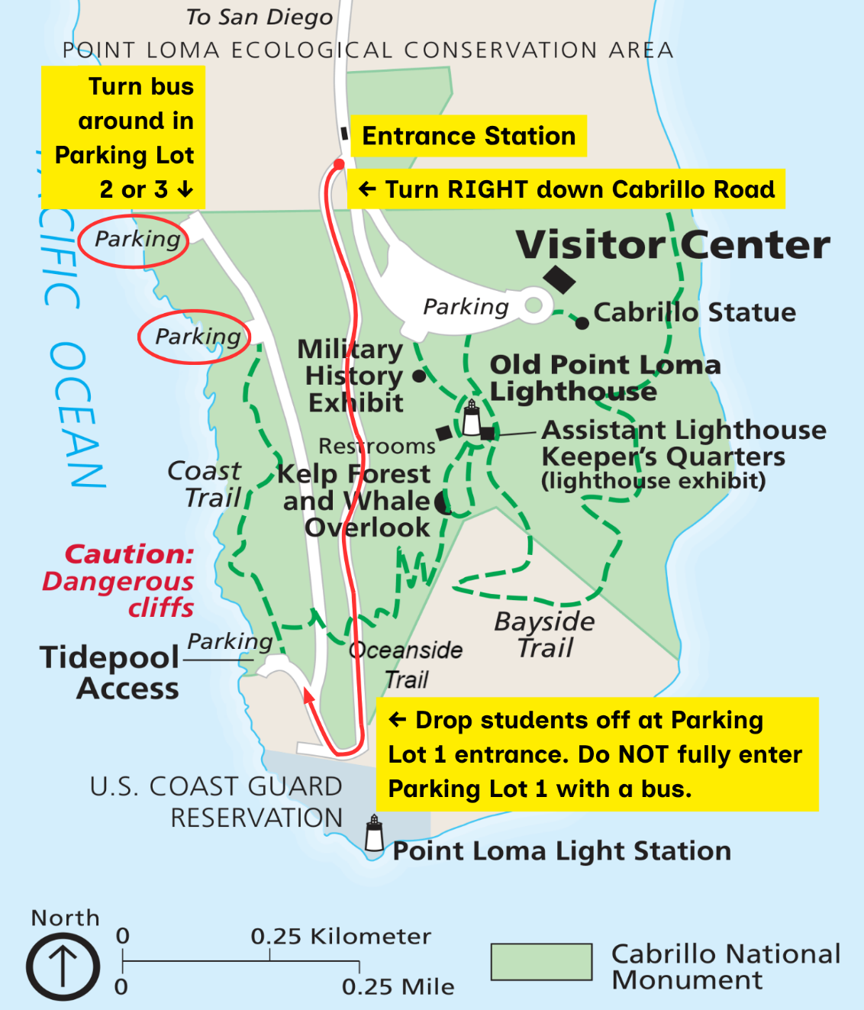
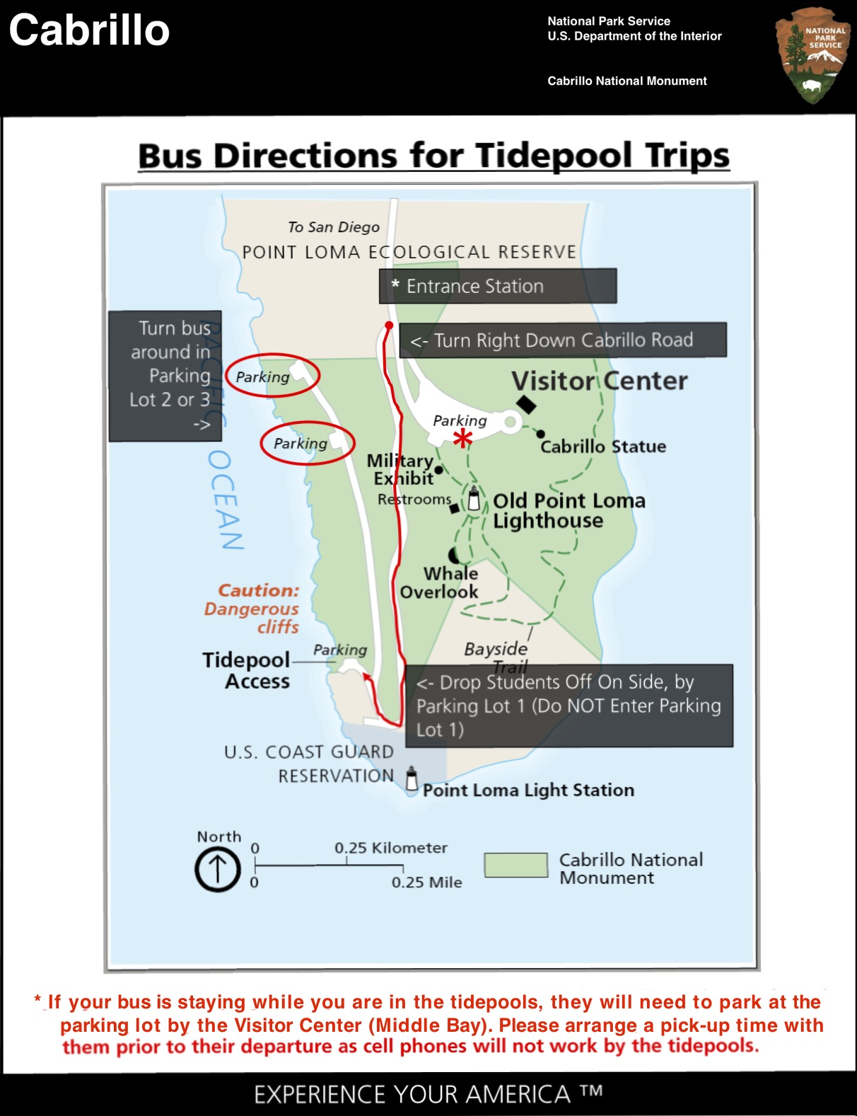
*

Group Name
Grade Level
Group Leader Name
Group Leader Phone Number
Group Leader E-mail Address
(This is where your confirmation will be sent)
Number of Adults
(A ratio of 1 adult per 5 children is REQUIRED)
Number of Students
Mode of Transportation
Date of Visit (MM/DD/YYYY) 1st Choice
Date of Visit (MM/DD/YYYY) 2nd Choice
Date of Visit (MM/DD/YYYY) 3rd Choice
Time of Arrival (HH:MM)
Additional Comments:
Cabrillo Fee Waiver Request Form
(Email form to cabr_education@nps.gov)

