

**Relatively Delicious Rock Dating Worksheet**

Relative dating explains the age of rock in comparison to the rock around it. “Younger” rock is rock that has formed more recently, or closest to the present day. “Older” rock is rock that formed a longer time ago. Geologists use the following laws to help explain the relative age of rock layers:

* Law of Superposition - generally, younger rocks are found above older rocks.
* Law of Cross-cutting Relationships - any rock layer that cuts into another rock layer must be younger (or newer) than the other rock.

Knowing these geologic laws, label the rock layers at Black Canyon in this image from oldest to youngest.

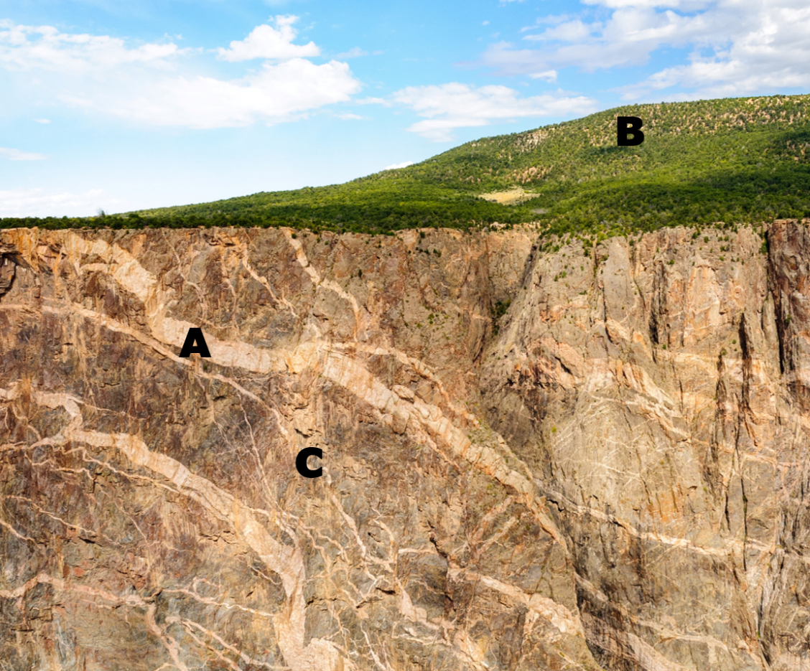

(oldest) ______ _, ____ ____, ______ __ (youngest)

**Explain your answer using the law of superposition and the law of cross-cutting relationships:**

Next, figure out the order these rocks formed, from oldest to youngest.

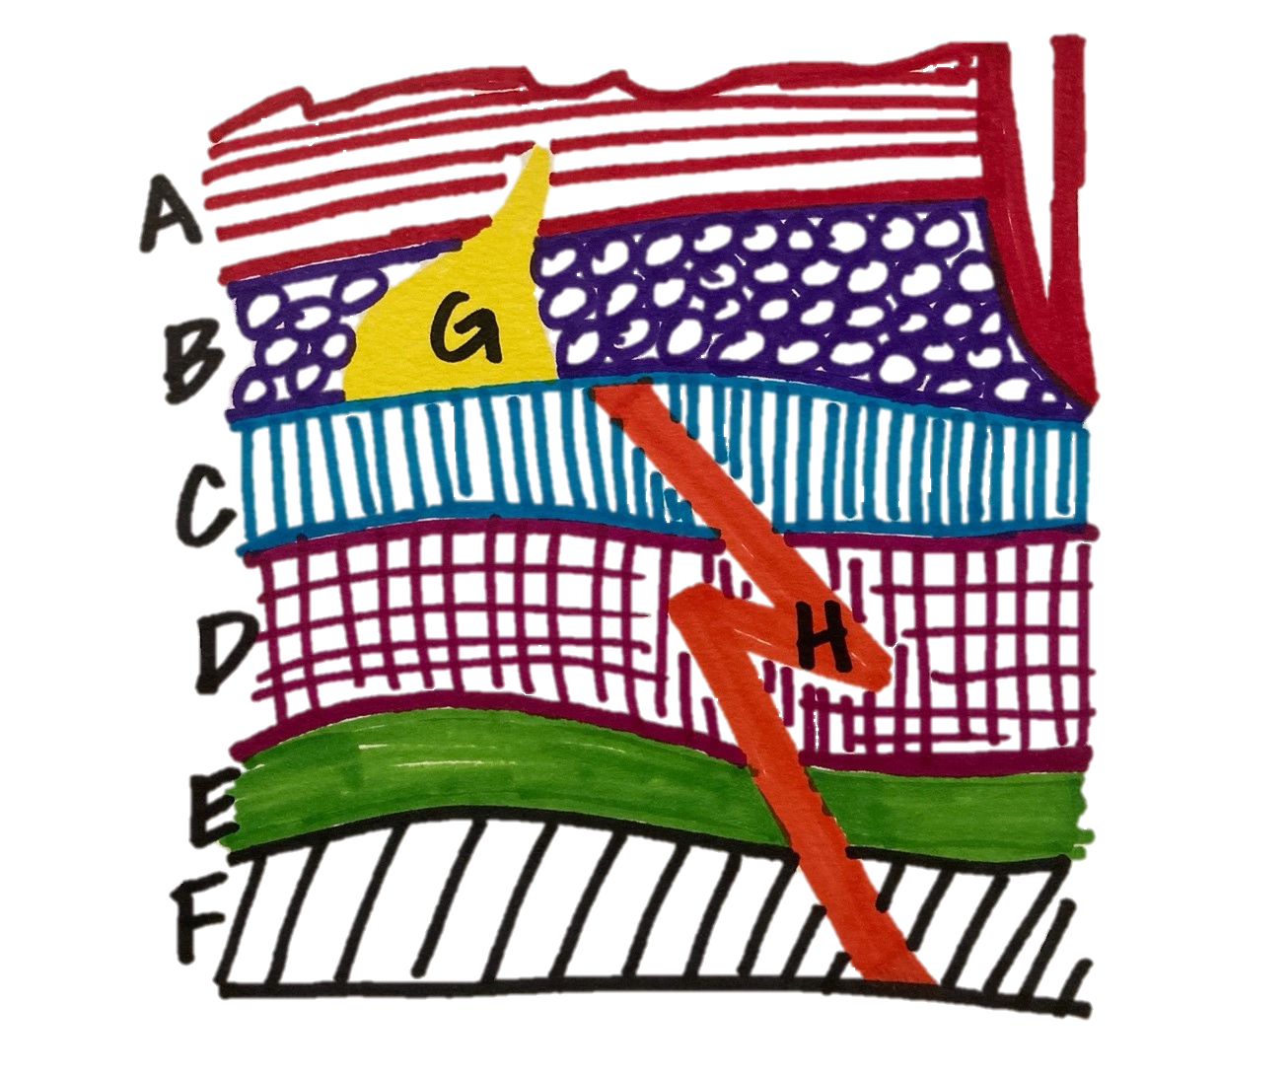

(oldest) _______, ________, _________, ________, _______, _______, _______, _______(youngest)

**Explain how you know H’s age relative to the other layers?**

**Bonus challenge: How old is the canyon (top right of this diagram) in relation to the rock layers?**