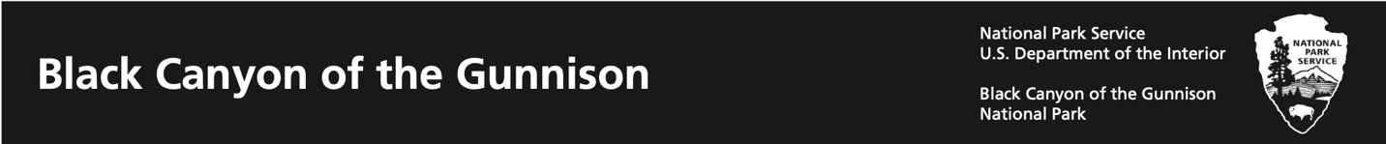

All about National Parks: Make your own Arrowhead

National Parks are special places that protect animals, plants, landscapes, water, and history. You can see all these things in our arrowhead symbol. Now, it’s your turn to draw your own symbol!

1. Use the table to choose things near where you live to draw.
2. Draw your things in the arrowhead shape and answer the question below.

|  |  |  |  |
| --- | --- | --- | --- |
| **Animal** | **Plant** | **Landscape** | **Water** |
|  |  |  |  |

Arrowhead-shaped line drawing. The outline of the National Park Service logo.

Why are National Parks important?