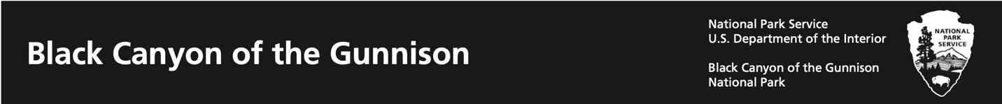

All about National Parks: Build a Park

We learned the National Park Service protects wildlife, plants, landscapes, water, and human history in special places that are called National Park sites. Now, it’s your turn to invent your own national park! Answer the questions below to help you plan your park. Then draw a map of your park on the back of this page.

# Black Canyon Example Description

# Black Canyon National Park protects some of the oldest rocks and steepest cliffs in North America. Over the last two million years, the Gunnison River has slowly cut down through the rocks to create the canyon we see today.

My National Park’s Name:

Write a description of your national park:

What will visitors do for fun in your park?

What animals live in the area?

What will visitors learn when they visit your park?

What historical events have happened at your park?



Make sure to include:

* Land features
* Wildlife habitat
* Hiking trails or other recreational opportunities
* Visitor Center, campgrounds or other services

Map of My Park

Write a Paragraph

My National Park is special because: