SUPERINTENDENT’S COMPENDIUM
Big Bend National Park and
Rio Grande Wild & Scenic River
2023
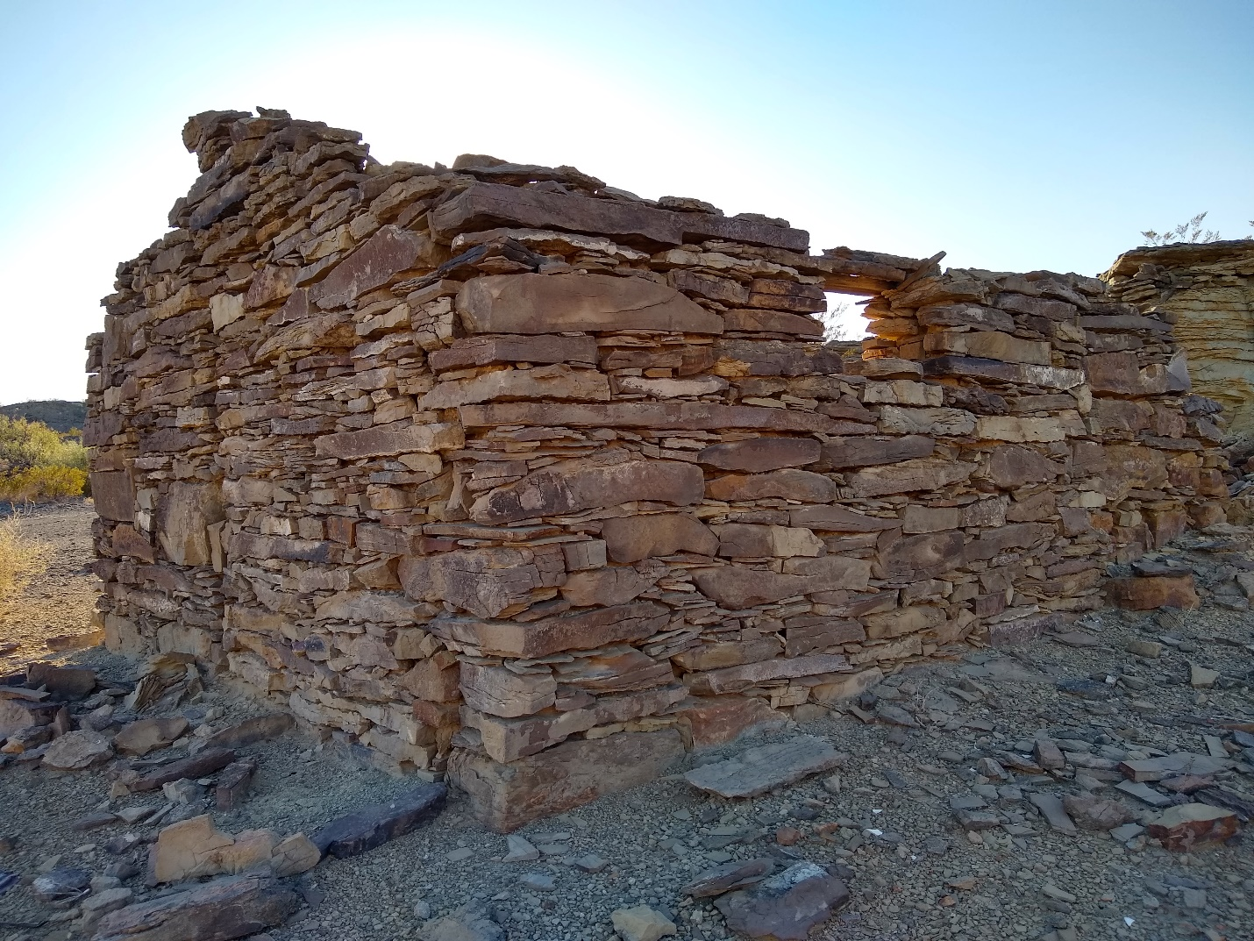

Prepared by:
Scott Taylor, Acting Chief Ranger

Concurred by:
Rick Gupman, Deputy Superintendent

Approved by:
Bob Krumenaker, Superintendent
- INTRODUCTION

- Superintendent’s Compendium Described
The Superintendent’s Compendium is the summary of park specific rules implemented under 36 Code of Federal Regulations (36 CFR). It serves as public notice, identifies areas closed for public use, provides a list of activities requiring either a special use permit or reservation, and elaborates on public use and resource protection regulations pertaining specifically to the administration of the park. The Superintendent’s Compendium does not repeat regulations found in 36 CFR and other United States Code and CFR Titles, which are enforced without further elaboration at the park level.
The regulations contained in 36 CFR, Parts 1-7, are the basic mechanism used by the National Park Service (NPS) to preserve and protect the natural and cultural resources of the park and to protect visitors and property within the park. Parts 1 through 6 are general regulations applicable to all areas of the National Park system, and Part 7 contains special regulations specific to individual parks. Each of these Parts has many sections and subsections articulating specific provisions. Within some of these Part 1-7 sections and subsections, the Superintendent is granted discretionary authority to develop local rules to be responsive to the needs of a specific park resource or activity, park plan, program, and/or special needs of the general public.
As an example, 36 CFR 1.5(a) Closures and Public Use Limits provides the Superintendent certain discretion in allowing or disallowing certain activities. The authority granted by the Section, however, requires the Superintendent to comply with the Administrative Procedures Act (6 USC Section 551), which requires public notice on actions with major impact on visitor use patterns, park resources or those that are highly controversial in nature.
Another example is 36 CFR 1.6 Permits, which allows the Superintendent to require a permit for certain uses and activities in the park. This Section, however, requires that a list of activities needing a permit (and a fee schedule for the various types of permits) be maintained by the park.

A final example is 36 CFR 2.1(c) (1) Preservation of Natural, Cultural and Archeological Resources, which provides the Superintendent the authority to designate certain fruits, nuts, berries or unoccupied seashells which may be gathered by hand for personal use or consumption. This activity can occur, however, only if a written determination shows that the allowed activity does not adversely affect park wildlife, the reproductive potential of a plant species, or otherwise adversely affect park resources.

This Compendium should be used in conjunction with Title 36 CFR, Parts 1-7 to more fully understand the regulations governing the use and enjoyment of all the areas of the national Park System.
A copy of 36 CFR can be purchased at the U.S. Government Printing Office at: www.gpo.gov
OR
Superintendent of Documents
P.O. Box 371954
Pittsburgh, PA 15250-7954
The CFR is also available on the Internet at: www.ecfr.gov.

- Laws and Policies Allowing the Superintendent to Develop This Compendium
The National Park Service (NPS) is granted broad statutory authority under Title 54 United States Code (U.S.C.) §100101(a) (formerly 16 U.S.C. 1a-1, “Organic Act”) to “….regulate the use of the National Park System by means and measures that conform to the fundamental purpose of the System units, which purpose is to conserve the scenery, natural and historic objects, and wild life in the System units and to provide for the enjoyment of the scenery, natural and historic objects, and wild life in such manner and by such means as will leave them unimpaired for the enjoyment of future generations.” In addition, Title 54 U.S.C. §100751(a) allows the NPS, through the Secretary of the Interior, to “prescribe such regulations as the Secretary considers necessary or proper for the use and management of System units.”
In 1970, Congress amended the NPS Organic Act to clarify its intentions as to the overall mission of the NPS. Through the General Authorities Act of 1970, Congress brought all areas administered by the NPS into one National Park System and directed the NPS to manage all areas under its administration consistent with the Organic Act of 1916.
In 1978, Congress amended the General Authorities Act of 1970 and reasserted System-wide the high standard of protection defined in the original Organic Act by stating “Congress further reaffirms, declares, and directs that the promotion and regulation of the various areas of the National Park System, as defined by Section 1 of this Title, shall be consistent with and founded in the purpose established by Section 1 of this Title, to the common benefit of all people of the United States.”
In addition to the above statutory authority, the Superintendent is guided by established NPS policy as found in the NPS Management Policies (2006). The Superintendent is also guided by more specific policies promulgated by the Director, National Park Service, in the form of Director’s Orders. As stated in the Management Policies, the primary responsibility of the NPS is to protect and preserve our national natural and cultural resources while providing for the enjoyment of these resources by visitor and other users, if use does not impair specific park resources or overall visitor experience. The appropriateness of any visitor uses, or recreational experience is resource-based and will vary from park to park; therefore, a use or activity that is appropriate in one park area may not be appropriate in another. The Superintendent is directed to analyze overall park use and determine if any particular use is appropriate. Where conflict arises between use and resource protection, where the Superintendent has a reasonable basis to believe a resource is or would become impaired, then that Superintendent is obliged to place limitations on public use.

- Consistency of This Compendium with Applicable Federal Law and Requirements
The Superintendent’s Compendium is not considered a significant rule requiring review by the Office of Management and Budget under Executive Order 12866. In addition, this Compendium will not have a significant economic effect on a number of small entities nor impose a significant cost on any local, state, or tribal government or private organization, and therefore does not fall under the requirements of either the Regulatory Flexibility Act or the Unfunded Mandates Reform Act.
The actions and requirements described in this Compendium are found to be categorically excluded from further compliance with the procedural requirements of the National Environmental Policy Act (NEPA) in Department of the Interior (DOI) Guidelines 516 DM 6 and as such, an Environmental Assessment will not be prepared.

- Development of the Requirements of the Superintendent’s Compendium
As outlined above, the NPS has broad authority and responsibility to determine what types of uses and activities are appropriate in any particular National Park System area. The requirements of the Superintendent’s Compendium are developed through an analysis and determination process. The decision criteria used during this process are:
- Is there use or activity consistent with the NPS Organic Act and NPS policy?
- Is the use or activity consistent and compatible with the park’s enabling legislation, management objectives, and corresponding management plans?
- Will the use or activity damage the park’s protected natural and cultural resources and other protected values?
- Will the use or activity disturb or be in conflict with wildlife, vegetation, and environmental protection actions and values?
- Will the use or activity conflict with or be incompatible with traditional park uses and activities?
- Will the use or activity compromise employee or public safety?
- Applicability of the Compendium
The rules contained in this Compendium apply to all persons entering, using, visiting or otherwise present on Federally owned lands, including submerged lands, and waters administered by the NPS within the legislative boundaries of the park. This includes all waters subject to the jurisdiction of the United States, including all navigable waters.

- Enforcement of Compendium Requirements

NPS Law Enforcement Park Rangers enforce the requirements of the United State Code, 36
CFR, and this Superintendent’s Compendium.

7. Penalties for Not Adhering to the Compendium Requirements

A person who violates any provision of the regulations found in 36 CFR, Parts 1-7, or provisions of this Compendium, is subject to a fine as provided by law (18 U.S.C. 3571) up to $5,000 for individuals and $10,000 for organizations, or by imprisonment not exceeding six months (18 U.S.C. 3559), or both, and shall be adjudged to pay all court costs associated with any court proceedings. You may receive a list of fines associated with any particular provision by contacting the Chief Ranger at the park address found below.

8. Comments on the Compendium

The Compendium is reviewed annually and revised as necessary. The park welcomes comments
about its program and activities at any time.
Written comments on the Compendium may be submitted to:
Superintendent
Big Bend National Park
P.O. Box 129
Big Bend National Park, Texas 79834

9. Effective Date of the Superintendent Compendium

The Superintendent’s Compendium is effective on the approval date listed on the first page of this document and remains in effect until revised.

10. Additional Information
Some of the terms used in this Compendium may have specific meaning defined in 36 CFR 1.4
Definitions.

11. Availability

Copies of the Compendium are available at Park Headquarters at 1 Panther Junction, Big Bend
National Park, Texas. The Superintendents Compendium may also be found online
at: https://www.nps.gov/bibe/index.htm.

- SUPERINTENDENT’S COMPENDIUM

In accordance with regulations and the delegated authority provided in Title 36, Code of Federal Regulations (36 CFR), Chapter 1, Parts 1-7, authorized by Title 16 United States Code, Section 3, the following provisions apply to all lands and waters administered by the National Park Service, within the boundaries of Big Bend National Park (BIBE) and Rio Grande Wild and Scenic River (RIGR). Unless otherwise stated, these regulatory provisions apply in addition to the requirements contained in 36 CFR, Chapter 1, Parts 1-7. Written determinations, which explain the reasoning behind the Superintendent’s use of discretionary authority, as required by Section 1.5(c), appear in this document identified by italicized print.

Table of Contents:
I. 36 CFR §1.5: VISITING HOURS, PUBLIC USE LIMITS, CLOSURES, AND DESIGNATIONS FOR SPECIFIC USE OR ACTIVITIES 6
II. 36 CFR § 1.6: ACTIVITIES THAT REQUIRE A PERMIT: 9
III. GENERAL REGULATIONS 11
36 CFR § 2.1: PRESERVATION OF NATURAL, CULTURAL, AND ARCHEOLOGICAL RESOURCES.
36 CFR § 2.2: WILDLIFE PROTECTION 12
36 CFR § 2.3: FISHING. 12
36 CFR § 2.4 – WEAPONS, TRAPS, AND NETS 12
36 CFR § 2.10: CAMPING AND FOOD 13
36 CFR § 2.13: FIRES 16
36 CFR § 2.14: SANITATION AND REFUSE. 16
36 CFR § 2.15: PETS. 17
36 CFR § 2.16: HORSE AND PACK ANIMALS. 17
36 CFR § 2.20: SKATING, SKATEBOARDS AND SIMILAR DEVICES. 18
36 CFR § 2.21: SMOKING. 19
36 CFR § 2.22: PROPERTY. 19
36 CFR § 2.35: ALCOHOLIC BEVERAGES AND CONTROLLED SUBSTANCES. 19
36 CFR § 2.51: PUBLIC ASSEMBLIES, MEETINGS. 19
36 CFR § 2.52: SALE OR DISTRIBUTION OF PRINTED MATTER. 20
36 CFR § 3.3: BOATING AND WATER USE ACTIVITIES 20
36 CFR § 3.8: PROHIBITED OPERATIONS. 21
36 CFR § 4.21: SPEED LIMITS. 22
36 CFR § 4.30: BICYCLES. 22
36 CFR § 7.41 SPECIAL REGULATIONS, AREAS OF THE NATIONAL PARK SYSTEM; BIG BEND NATIONAL PARK 23
COMPENDIUM APPENDIX A 24
COMPENDIUM APPENDIX B 27
COMPENDIUM APPENDIX C 30
COMPENDIUM APPENDIX D 34
COMPENDIUM APPENDIX E 36
COMPENDIUM APPENDIX F 37

36 CFR §1.5: VISITING HOURS, PUBLIC USE LIMITS, CLOSURES, AND DESIGNATIONS FOR SPECIFIC USE OR ACTIVITIES
(a)(1) The following visiting hours and public use limits are established for all or for the listed portions of the park, and the following closures are established for all or a portion of the park to all public use or to a certain use or activity:

- Visitor Center 1 Alsate Drive, Big Bend National Park, Texas. This facility is open Monday thru Sunday, from 08:30 A.M. to 5 P.M. throughout the year, except for Federal Holidays.
- Chisos Basin Visitor Center- open seven days a week from 08:00 A.M. to 4:00 P.M. (closed for lunch)
- Rio Grande Village; Castolon; Persimmon Gap Visitor Centers are open November through April as staffing levels allow.

Closures:

- Any area closed by the Superintendent and identified with an official sign is prohibited to public access. This includes all park maintenance compounds, employee housing facilities, partner organizations with facilities in the government housing area, outbuildings, and service roads that are only used for official business

  - Castolon housing area
  - Castolon maintenance area
  - Chisos Basin housing area
  - Chisos Basin water treatment area
  - Panther Junction housing area
  - Panther Junction maintenance compound facilities
  - Panther Junction water treatment area
  - Persimmon Gap housing area
  - Rio Grande Village housing area
  - Rio Grande Village maintenance area
  - Rio Grande Village water treatment area

Determination: Maintenance compounds and other work areas are restricted from public access to protect government property from theft and vandalism and to prevent safety issues related to the operation of heavy machinery and power equipment
- Panther Junction Range

Determination: The Panther Junction Range is designated for administrative purposes, by authorized personnel in performance of their official duties. This range can be used by the residents of Big Bend National Park, only after requesting the date and time through the Chief Rangers Office. Discharge of a firearm or other weapon by park visitors is prohibited to prevent damage and vandalism to government property, and to protect wildlife and visitors from accidents and/or injuries.

- All caves within Big Bend National Park are closed to the public for recreational use. Authorized researchers may be allowed limited entry if they are issued a research permit in advance through the Division of Science and Resource Management.

Determination: BIBE is mandated through its enabling legislation to “preserve” caves and is directed by the Federal Cave Resources Protection Act of 1988 to protect them. Closures are established to protect the fragile ecosystems and resources within the caves and to minimize negative impacts upon any endangered or threatened resource. Cave ecosystems are unique and delicately balanced, with major changes possibly occurring from relatively slight disturbances. Geologic formations in some caves are quite fragile, easily damaged by vandalism or visitor overuse. Caves may contain unsuspected hazards to visitors unfamiliar to such alien environments, and the threat of serious injury or death from falls or drowning is always present. A serious disease of bats called White-Nose Syndrome (WNS) has been killing bats in the United States. On April 19, 2010, Geomyces destructans (the fungus associated with WNS) was confirmed in Texas. Due to WNS, the park is using an abundance of caution in managing activities that impact caves and bats. The Superintendent has determined that WNS is an imminent threat to the bats of BIBE. Every effort should be made to reduce human disturbance to bats and reduce the risk of possible human-borne transmission. The United States Fish and Wildlife Service as the lead federal agency in wildlife conservation has issued protocols that are designed to prevent the spread of the suspected causative agent of the syndrome. The Superintendent has determined the closure of all caves to meet the National Park Service mission to conserve the wildlife in the parks for the enjoyment of future generations.

- The San Vicente Crossing Road is closed to vehicles beyond the intersection with River Road.
- The Santa Elena Crossing Road is closed to vehicles beyond the gate.
- The Langford Hot Springs area, including the parking area, the loop trail, and the area from the mouth of Tornillo Creek to 1/2 mile downstream from the historic Hot Springs bathhouse on the Rio Grande, is closed to the possession of alcoholic beverages, and glass bottles or containers. See alcohol closures page 19.
- The Rio Grande within the boundaries of Big Bend National Park and Rio Grande Wild and Scenic River is closed to motor vehicle traffic, whether self-powered or under tow.
- Lodge Rock- this area is closed to public climbing access and is used for Technical Rescue Training
- Additional trail and/or area closures or use limitations may be implemented.

Public Use Limits:
- Annual Trail Closure:

The following areas will be closed to public entry from February 1 through May 31. These closures are for the protection of the Peregrine falcon, currently classified by the U.S. Fish and Wildlife Service as a Species of Special Concern.

- The East Rim Trail from the Boot Canyon Trail/South Rim Trail junction to a point just north of campsite ER4.
- Campsites East Rim 4-9 are closed during this time.
- All areas within ½ mile of known Peregrine falcon nesting sites, including rock climbing faces, as posted.
- The Boquillas Port of Entry Crossing Road is closed to vehicles and pedestrian traffic beyond the intersection with Boquillas Canyon Road during non-operational hours (winter and summer operational hours are posted at the park visitor centers). The area surrounding the Boquillas Port of Entry facility is closed to the public. This closed area is defined by the road to the Barker house to the east and a line drawn approximately 1800 feet to the west see appendix. The west side of the closed area is marked with posted closed signs. The northern boundary of the closure is delineated by the paved Boquillas Canyon road. The south boundary of the closure follows the Rio Grande. See Appendix D.

- Off Highway Vehicles:

Vehicles operating in the park must have a valid state or government-issued vehicle registration and license plate issued for public highway travel. The Texas OHV (Off Highway Vehicle) license plate does not meet this standard. Unregistered OHVs, including but not limited to ATVs, UTVs, golf carts, dune buggies, sand rails, amphibious vehicles, and any other non-highway vehicles, are prohibited from being operated in the park.

Determination: The State of Texas requires all vehicles operating on public highways to meet state registration, inspection, and insurance requirements. ATVs, dune buggies, sand rails and golf carts are non-highway vehicles and are not manufactured for public roadways. In addition, OHVs have easy access and better capabilities to access areas of the park prohibited to driving. Prohibiting OHVs is consistent with the NPS mission to preserve and protect natural resources.

- River closure to floating under certain conditions:
Sections of the Rio Grande River can be closed to recreational boating by order of the Superintendent when conditions exist that would make river use unsafe for visitors. It is recognized that the NPS does not control river access from the Mexico side, and therefore the river can never be completely closed by the NPS alone. At a level of 11.25 feet or higher on the Boquillas river gauge, the Boquillas Port of Entry (POE) will be closed due to it becoming unsafe for the ferry/rowboat operator to row park visitors safely to and from Boquillas.
- The idling of vehicles and buses while loading, unloading, or waiting for passengers to re-board is prohibited. Drivers must turn the engine off before passengers disembark and turn the engine on only after all passengers have boarded.
- The use of public potable water sources within the park is limited to a total of five gallons per day, per visitor; not subject to RV’s which should only be filling at the designated dump stations.
- Launching, landing, or operating an unmanned aircraft from or on lands and waters administered by the National Park Service within the boundaries of BIBE/RIGR is prohibited except as approved by permit with prior authorization.

Unmanned aircraft - The term “unmanned aircraft” means a device that is used or intended to be used for flight in the air without the possibility of direct human intervention from within or on the device, and the associated operational elements and components that are required for the pilot or system operator in command to operate or control the device (such as cameras, sensors, communication links.) This term includes all types of devices that meet this definition (e.g., model airplanes, quadcopters, drone that are used for any purpose, including for recreation or commerce).

Determination: The usage of unmanned aircraft within the park boundaries poses a substantial threat to visitor safety and wildlife. The visual and sound disturbance caused by the use of an unmanned aircraft also detracts from the natural soundscape and aesthetic setting of the park, preventing visitors from benefiting from its primary purpose. Prohibiting unmanned aircraft will avoid conflict among visitor use activities, while protecting the natural and cultural resources.

36 CFR §1.5 (a)(2): The following areas have been designated for a specific use or activity, under
the conditions and/or restrictions as noted:
- Climbing:
Rock climbing and bouldering are permitted in Big Bend National Park. Minimum impacts to park resources shall be practiced when engaged in rock climbing including:

  - The installation and/or use of any permanent bolt, anchor, or chipped rock hold is prohibited.
  - Removable anchors, natural protection and removable climbing protection are allowed.
  - The use of portable electric drills to set anchors for climbing is prohibited
  - The use of hand operated drills to set anchors for climbing is allowed only with written approval of the Superintendent.
  - Climbing, ascending, descending, or traversing an archeological or cultural resource is prohibited.
  - Technical rock climbing on rock faces within 0.25 mile of known peregrine eyries, as posted, will not be allowed between February 1–May 31.
  - The rock faces of Casa Grande peak are closed to climbing.
  - All trash, including toilet paper, must be packed out.
  - Because colored chalk can permanently stain rock, only white chalk without oil-based additives may be used.
  - All webbing must be removed upon conclusion of climbing activities.

- Consider other users when rock climbing, be courteous to others and help educate non-climbers about your activity to reduce impacts. Inform other climbers about a Leave No Trace ethic and techniques.
- Boats, rafts, tubes, kayaks, paddleboards, and/or canoes

  - Motorized watercraft used within the park is limited to conventional boats with up to 60 horsepower inboard or outboard motors. Jet skis are not allowed in the park (see Title 36 CFR 3.24).
  - Motorized watercraft will be prohibited on the following sections of the Rio Grande:
    - Boquillas Canyon, from the entrance of Boquillas Canyon to the eastern Park boundary.
    - Mariscal Canyon, from Talley to Solis.
    - Santa Elena Canyon, from the western park boundary to the Santa Elena takeout, except for electric motors, which are allowed.
  - Paddleboards, canoes and kayaks are required to have all safety equipment with them

- E-cigarettes

  - The use of e-cigarettes and other Electronic Nicotine Delivery Systems (ENDS) is prohibited in any park owned or leased building, vehicle, vessel, or shared government residences.
  - END- The term Electronic Nicotine Delivery Systems or ENDS encompasses all forms of vaping, the process of inhaling vaporized nicotine, flavorings, and other chemicals with battery-powered device. Electronic or e-cigarettes are a type of ENDS.

Determination: The use of ENDS is prohibited in are where smoking is restricted by Management Policies (2006) and Director’s Order #50D (Smoking Policy). The NPS moving forward with revising the current regulation at 36 CFR 1.4 to include the use of ENDS in the definition of smoking. Once promulgated, section 2.21 will apply to the smoking of tobacco and the use of ENDS.

- Hiking

- Day hiking activities in the front-country and on trails and off-trail in the backcountry are limited to a maximum group size of 30 participants, including guides. Larger groups must split into two smaller groups and use two different trails.
- Parking

- Vehicles and/or support vehicles (trailers) must not park across multiple parking spaces or impede the normal flow of traffic.

II. 36 CFR § 1.6: ACTIVITIES THAT REQUIRE A PERMIT:
(f) The following is a list of activities for which a permit from the Superintendent is required:

§1.5(d) The following activities relate to Public Use Limits:

- Entering a closed area.

The Superintendent may issue a written permit for entering a closed area. Exceptions include but are not limited to applicants engaging in a scientific or educational purpose.

§2.1(b) All organized groups or groups over 30 persons on all trails or in off-trail backcountry areas.

§2.3(a)/(b) Fishing in the Rio Grande Wild and Scenic River downstream of the eastern boundary of Big
Bend National Park (state license required) (Also see §7.41)

§2.5(a) Research Specimen Collections (the taking of plant, fish, wildlife, rocks or minerals)

§2.10(a) Camping (within the boundaries of Big Bend National Park)

§2.16(g) Horse and Pack animals

§2.50(a) Special Event: (Conducting a sports event, pageant, regatta, public spectator attraction,
entertainment, ceremony, wedding, and/or similar events.)

§2.51(a) Public assemblies, meetings, gatherings, demonstrations, parades and other public expressions
of views.

- Written applications for permits must be submitted to the Superintendent within a reasonable time frame prior to the date desired for the event; processing usually requires ten business days. The activity may not conflict with any scheduled NPS function or program. Groups of 25 or fewer people are not required to obtain a permit for 2.51 activities.
- Groups larger than 25 people must obtain a permit but are not required to pay an application fee.
- Groups without permits will be allowed use of the areas on a first come first serve basis. A group with a valid permit will be permitted to displace a group without a permit.
- The following areas have been designated as available for public demonstrations or assemblies: Panther Junction visitor parking area on the concrete sidewalk; Rio Grande Village Visitor Center Western half of the parking lot; Maverick Entrance Station Bathroom paved parking lot (maps attached in Appendix A)

§2.52(b) Sale/distribution of Printed Material
- While not mandatory, it is recommended that the organizer provide reasonable notice of the proposed event to the park superintendent
- Groups larger than 25 people must obtain a permit
- The following areas have been designated as available for sale/distribution of printed material: Rio Grande Village Store beneath ramada between bulletin board and south end of the store building facing parking lot; Chisos Basin Ranger Station between the flagpole and building roof; Panther Junction Visitor Center sidewalk on the eastern side handicap parking space (maps attached in Appendix B)

§2.62(b) Memorialization (scattering of human ashes)

§3.3 River Use
- Note: A permit is not required by the National Park Service for river users embarking and disembarking from Mexico; river users embarking and disembarking from Mexico are advised to be aware of and comply with all rules established by Mexican authorities.

§5.1 Post or distribute commercial notices or advertisements

§5.3 Commercial Use (Engaging in or soliciting any business on Federal property requires a permit,
contract, or other written agreement with the United States, or must be pursuant to a special regulation.

§5.5 Commercial Photography and Filming:
- Commercial filming of motion pictures or television involving the use of professional casts,
settings, or crews; other than bona fide newsreel or news television.
- Still photography of vehicles, or other articles of commerce or models for the purpose of
commercial advertising.
- See also https://www.ecfr.gov/current/title-43/part-5/subpart-A.

§5.6(c) Commercial Vehicle Use: The Superintendent shall issue permits for commercial vehicle used on park public roads when such use is necessary to access private lands situated within or adjacent to the park area, to which access is otherwise not available.
§71.13(d) Waiver of Fees: This is the exceptions, exclusions, and exemptions.

In all cases, the permit or letter of authorization must always be in the permittee’s possession
and must be exhibited to any authorized person upon request.

Determination: The superintendent has determined that the above activities have a high
potential for impacting park resources, safety, and visitor experience. By requiring
permits for these activities, the park can manage these activities and mitigate negative impacts.

Permit Information:

Special regulations, restrictions, and fees may apply when applying for a permit.

Information regarding permits is available at park headquarters during normal business hours at (432)
477-2251, or can be found on the park’s website at www.nps.gov/bibe, under Permits and Reservation.
Written requests can be mailed to the following address:

Superintendent
Big Bend National Park
P.O. Box 129
Big Bend National Park, Texas 79834

Permits may be denied/terminated based on 36 CFR 1.6(a), (d), (e), (g)(1), (g)(2), (h)

Federal Law and agency policy require that certain activities that fall outside the scope of normal visitation
be managed through the issuance of a permit. Permits may only be issued if the activity is in keeping with
the purpose of the park and will not result in damage to the resource or conflict with other park users.

III. GENERAL REGULATIONS

36 CFR § 2.1: PRESERVATION OF NATURAL, CULTURAL, AND ARCHEOLOGICAL RESOURCES.

(a)(4). Dead and down wood may be collected only from the flood plain of the Rio Grande and used for campfires where permitted. Such campfires must be in accordance with Section 2.13(a) (1). A fire pan must be used for ground fires.

(b). A Special Use Permit is required for all day use groups of 30 or more persons more than a quarter mile from any trailhead.

(c)(1). Fruits, nuts, and berries may be collected by hand for immediate personal consumption on site without a collection permit. All collected items must be edible. No more than one handful may be taken per person, per day unless otherwise noted:

- Prickly pear fruits 1quart

Determination: It has been determined that the gathering or consumption of these items in these
quantities will not adversely affect park wildlife, the reproduction potential of any plant species, or
otherwise adversely affect park resources. If future monitoring indicates that such gathering or
consumption is likely to cause adverse effects to park resources, then the authorization of this
consumptive use will be terminated.

36 CFR § 2.2: WILDLIFE PROTECTION

(d) Wildlife lawfully killed outside the park may be transported through the park under the following conditions and procedures:
- People transporting animal carcasses will have a valid state hunting license in their possession.
- Animal carcasses shall display a valid state game tag when required.
- Animal carcasses must be covered and out of sight.
- Animal carcasses shall be subject to inspection at any time by authorized law enforcement personnel.
- Animal carcasses may be transported through the park only on Route 13 (Hwy 118), Route 11 (Hwy 385), Terlingua Ranch Road, Chalk Draw Ranch Road, and the Malek Ranch Road. See Appendix E
- Possession or transportation of live wildlife in the park is prohibited.

(e) All areas of the park are closed to the viewing of wildlife with an artificial light.

- Artificial light is defined as a flashlight, hand-held spotlight, headlights, exterior vehicle lights or other light, which is emitted from a non-natural source.

36 CFR § 2.3: FISHING.

- A State of Texas fishing license is required to fish the Rio Grande Wild and Scenic River downstream of the eastern boundary of Big Bend National Park.
- A free NPS fishing permit, obtainable at any open Visitor Center is required by one person from each party fishing in the park.
- Jug fishing or free-floating line fishing is allowed within Rio Grande Wild and Scenic River consistent with state of Texas fishing regulations downstream of the eastern boundary of Big Bend National Park. Jug lines must be marked daily with the fisherman’s name and that day’s date.
- Trotlines and throw lines must be marked with a gear tag and dated daily.
- If flagging is utilized to mark trotlines or throw lines, it may not be attached to vegetation. Nails or spikes for attaching lines may not be driven into rock walls and must be removed by the fisherman when no longer being used.
- Trotline fishing is allowed within Big Bend National Park, provided each end of the fishing line is anchored to the same riverbank in a fashion that does not interfere with water vessels or swimmers.
- Possessing and using live bait minnows obtained locally from the Rio Grande is allowed for fishing in the Rio Grande. This is the only live bait allowed for fishing in the Rio Grande. (See Big Bend National Park Special Regulations in Title 36 CFR 7.41)
- Possession of the protected Gambusia Minnow is prohibited.

Determination: This prohibition is for resource protection. These conditions are intended to promote
resource protection while accommodating an activity legally conducted outside the park.

36 CFR § 2.4 – WEAPONS, TRAPS, AND NETS

(a)(2)(i) Weapons, traps or nets may only be carried, possessed, or used at the following designated times and locations:
- In accordance with Texas state law, except as otherwise prohibited by applicable federal law and regulation.
- Firearms are prohibited in facilities owned or leased by the federal government where federal employees are regularly present for performing their duties. These facilities are posted with signs informing the public that firearms are prohibited in these buildings.

Justification: This prohibition is for the protection of federal employees, and in accordance with
national law and guidance on possession of firearms inside of federal facilities.

36 CFR § 2.10: CAMPING AND FOOD
Camping is defined into 5 different areas:

- Developed campsites are defined as front-country campgrounds.
- Chisos Mountain Backpacking campsites are defined as hiking/backpacking sites. Group size is limited to 15 participants, including guides.
- Primitive Desert Backpacking campsites are defined as hiking/backpacking sites that are ½ mile from view of any road and 100 yards from any trail, historical structure, archeological site, dry wash, or cliff edge. Group size is limited to 15 participants. Larger groups than 15 must split and camp in separate, non-adjacent zones. These locations are reserved at the visitor centers.
- Primitive Roadside Campsites are defined as drive into location only.
- River camping is designated to over-night river trips. You will be required to have all required equipment with you. Person’s camping along the river are not allowed to camp within ½ mile of put in or take outs or any designated campground or feature ex. (Hot Spring)
- Checkout time for all camping park wide is 12 noon.
- Occupied campsites may not be left unattended for more than 24 hours.
- Quiet hours for all designated camping areas are from 10 p.m. to 6 a.m.
- Parkwide, any food and beverages, food product, cooking utensils, food garbage, used food and
beverage containers, or other aromatic products (including soap, toothpaste, deodorants, etc.,) must
be stored inside a hard-sided vehicle or in a container that will prevent bears or other wildlife from
acquiring the items, when the items are not actually being transported, prepared, consumed, or
closely attended and within the immediate reach of the owner day or night.
- Attaching any of the following to natural features and/or plants is prohibited: supporting hammocks,
slacklines, tarps, or similar devices.
- Campgrounds are designated by appropriate signing and by brochures and maps available to the
public at ranger stations and visitor centers.
- Advance reservations are required for camping in Big Bend National Park developed campgrounds
and group sites. Reservations are arranged through www.recreation.gov.
- Camping within Big Bend National Park in any combination of campsites for more than 28 nights in a
12-month period is prohibited. The 12-month period is measured from January 1st through December
31st.
- From January 1st through April 15th, only 14 nights in any combination of developed; backpacking;
and/or primitive camping is allowed.
- Chisos Mountain Backpacking and Primitive Backpacking/Roadside Campsite permits may not be
issued for more than 14 consecutive nights.
- Camping in any developed campground (Rio Grande Village, Chisos Basin, and Cottonwood) for
more than 14 consecutive nights is prohibited.
- Exceeding two motor vehicles; one vehicle with trailer; one motorhome with tow vehicle; or four
motorcycles per campsite is prohibited. Vehicle(s) must be parked on pavement or designated area.
In no case shall vehicles park on vegetation, or in such a manner that causes a hazard or impede
traffic flow.
- Exceeding a single wheeled camping unit and one tent, or four tents per campsite is prohibited. Some
individual campsites have smaller capacities due to the size of the site. All campsite capacities and
details are indicated on www.recreation.gov
- Exceeding eight persons per campsite overnight, except for designated group sites, is prohibited.
- Exceeding the limit of persons and/or tents in a group site, as listed below, is prohibited.
- A minimum of 9 persons is required to occupy a group campsite.
- Generator use and the use of idling vehicles to generate power are allowed in designated areas
between the hours of 8 a.m. -11a.m. and 5p.m. -8 p.m. in the Chisos Basin Campground and in the
RGV Campground. Operating generators must always be attended by a campsite occupant.
- Use of generators in all other public use areas is prohibited including backcountry sites.
- The following areas are closed to generators and idling vehicles used to generate power:

- Rio Grande Village Campground sites 10, 12-13, 15-50, and 94-100
- Basin Campground sites 19-60.
- Cottonwood Campground.
- All group campsites.

Chisos Basin Campground (Open Year-Round)

- 2/3 of campsites are reservable up to 180 days in advance. 1/3 of campsites reservable up to 14 days in advance.

Basin Campground: Group Site – tents only unless listed below.
Site L- 20 persons/10 tents
Site M- 10 persons/5 tents
Site N- 14 persons/7 tents
Site O- 14 persons/7 tents (This is the only group site to allow for 1 RV to be parked)
Site P- 20 persons/10 tents
Site Q- 20 persons/10 tents
Site R- 20 persons/10 tents

Rio Grande Village Campground (Open year-round, reduced capacity during summer)

- 2/3 of campsites are reservable up to 180 days in advance. 1/3 of campsites are reservable up to 14 days in advance.

Rio Grande Village Campground: Group Site – tents only unless listed below
Site A - 20 persons/10 tents
Site B- 20 persons/10 tents
Site C- 40 persons/20 tents (This is the only group site to allow for 1 RV to be parked)
Site D- 40 persons/20 tents

Cottonwood Campground (Open November 1 through April 30)

- All campsites reservable up to 14 days in advance

Cottonwood Campground: Group Site- tents only unless listed below
25 people maximum capacity/13 tents (1 RV to be parked)

Chisos Mountain Backpacking and Primitive Backpacking/Roadside Camping

Chisos Mountain Backpacking & Primitive Backpacking/Roadside Camping Fee permits are required
prior to overnight stay and most are available online through www.recreation.gov.

Use of generators is prohibited in these locations.

No mechanized device shall be used in the Chisos Mountain Backpacking or Primitive Backpacking
areas to transport gear and supplies.

All overnight camping and river trips require a permit. River permits are available up to 7 days in
advance of the first night.

No single permit will be issued for more than 14 consecutive nights in the backcountry except for
River Use Permits which will not exceed 28 consecutive nights.

Permits are available year-round at Panther Junction and Chisos Basin Visitor Centers. During the
winter season, permits are also available at Persimmon Gap, Rio Grande Village, and Castolon
Visitor Centers.

Permits for primitive backpacking and primitive roadside sites along the Maverick Road, Old Ore Road, and River Road are available in person only at Park Visitor Centers up to 24hours before the first night.

The permit must be in the camper's possession while in the backcountry and must be exhibited upon
the request of any authorized employee.

Within the designated backcountry zone camping areas, the following areas are closed to camping:

- Burro Mesa above 3400 feet elevation (Tule Mountain 7.5-minute USGS quadrangle).
- The Chisos Backcountry Use Area: (Defined in the Big Bend Zone Camping Map Appendix F).
- The High Chisos backcountry use area is restricted to designated sites and closed to zone camping.
- Within 1/2 mile of any development areas and out of view of paved or unpaved roads.
- Within 100 yards of a historic structure, archeological site, trail, or non-river water source, unless camping in a designated site.
- From the upstream end of the Santa Elena Canyon Nature Trail to 3/4 mile downstream from Castolon.
- The river floodplain from 1/2 mile upstream from the mouth of Tornillo Creek to the Boquillas Canyon Trail terminus.
- A 2-mile radius around the refinery ruins of Mariscal Mine.
- A 1/2-mile radius around the San Vicente River crossing.

Food Storage:

The caching of food and water by backcountry users is prohibited unless the food and water are
stored in a bear-resistant container. Bear-resistant container is defined as securable container
constructed of a solid, non-pliable material capable of withstanding a minimum of 300 foot-pounds of
energy.

- “Bear bagging” where items such as food or other perishables are suspended out of reach of a bear is not permitted.
- In camping areas where bear resistant storage boxes are provided, the boxes, or a hard-sided vehicle, must be utilized when the items are not actually being transported, prepared, and consumed. Only the permit holder may utilize the provided bear box at the campsite where the permit is written for and for the duration of the permit.
- Only water may be cached in the Homer Wilson Ranch and Juniper Canyon Trailhead storage containers. Food and other items stored in these boxes is subject to removal by park personnel. Upon retrieval of the cached water, or upon completion of the backcountry trip, all associated water bottles must be removed from the storage container and packed out.

The cached food and water must be labeled with the owner’s name and expected date of removal
that coincides with the expiration of their permit. Water and/or food must be cached at least 100
yards from historic structures, archaeological sites, trails, and non-river water sources. Food and
water caches shall not interfere with any park owned supplies stored in these lockers in the Chisos at
the start of the Emory Peak Trail and near composting toilets.

In the interest of protecting night skies, outdoor lighting will be limited between 10pm and 6am to
handheld lighting designed for wayfinding, and lighting needed for immediate camp chores or
cooking.

Most primitive roadside campsites in Big Bend are inaccessible to RVs and trailers. Small RVs (less
than 30 feet) and trailers (less than 25 feet) may be accommodated at the following sites depending
on availability and road conditions: Croton Springs 1 & 2; Grapevine Hills 1, 2, & 3; Hannold Draw
(only site with a horse corral); K-Bar 1 & 2; Nine Point Draw; Paint Gap 2, & 3. Reservations required
through www.recreation.gov

Justification: Camping is an intensive use of park resources. Limitations on the number of persons per site seek to reduce impacts to individual campsites and reduce negative impacts to adjacent campers while still providing an equitable allocation of camping opportunities. These conditions are intended to reduce the visual impact of camping on other park users as well as impacts on sensitive park resources. Additionally, animals that feed on human food can become reliant on it and be less adapted to the natural conditions of Big Bend National Park. Frequently fed animals can become a nuisance and cause litter to be strewn about campsites and picnic areas.

36 CFR § 2.13: FIRES
(a)(1) Ground fires and wood fires (including starter logs, e.g., Duraflame) are prohibited in the park. The following are exceptions:

- Charcoal fires in above-ground grills or fire pans are allowed in developed campgrounds, picnic areas, and backcountry road campsites.

- Wood and charcoal fires are allowed within the river corridor (on permitted river trips), located at the river’s edge on cobble or sand beaches in areas that are open to camping, and must be contained in fire pans with sides at least 2 inches high. Only dead and down wood, that has been gathered from the river corridor, may be used. Wood purchased locally is also allowed for use on river trips.

- Fires on river trips must be in a fire pan.

- Wood fires are allowed in the residential housing areas provided they are contained within a fire pan with sides at least two inches high, or within a fireplace constructed or authorized by the NPS. Wood may not be gathered in the park, but brush deposited in the Panther Junction, Rio Grande Village and Castolon boneyard(s) can be utilized. No painted or treated wood shall be burned.

- Fire remains must be made cold and out completely (no embers shall remain) and must be disposed of in a trash receptacle or carried out of the park, except that non-floatable wood fire remains (provided no chemical fire starter was used and nothing other than wood was burned) may be placed in the main current of the river. Charcoal fire remains must not be placed in the river.

Justification: The use of ground fires requires aggressive management due to the high probability of
windblown hot coals or ash igniting combustible materials such as tents, awnings, and vehicles.
Allowing open fires only in fire pans, or existing grills provided by the park helps to control human-
caused fires. Restricting fires also serves to inhibit the illegal collection of sparse native vegetation
materials and wood from signs and historic structures. The superintendent has determined that the
areas around the above campgrounds are extremely susceptible to wildland fire due to heavy fuel
concentrations and low fuel moisture. This restriction is intended to ensure visitor safety as well as
resource protection.

36 CFR § 2.14: SANITATION AND REFUSE.
(a)(1)

In campgrounds with service sinks, disposing or dumping dish water and other gray water is
prohibited except in the service sinks.

Food refuse at concessions and residences within the park must be secured to prevent wildlife from
acquiring it.

(a)(6)

On the river, cooking liquids may be strained (including dishwater) for any solids visible to the naked
eye then deposited in the river. Strained solid materials must be carried out and deposited in a solid
waste refuse container.
(b)

In non-developed areas more than a quarter of a mile from restroom facilities, solid human body
waste must be buried six inches deep and at least 100 feet from the river and one quarter mile from
any spring or stream water source and well away from designated campsites and trails. Toilet paper
and all menstruation products must be carried out as trash and removed from the park or deposited in
a park-provided trash receptacle.

Campers on the South Rim (SR) and East Rim (ER) campsites in the Chisos Mountains are required
to pack out human waste using a waste disposal kit, such as PETT, Cleanwaste, WAG bags,
Restop II, or similar commercial products. The contents of the bag are safe for disposal in trash
receptacles and landfills, and the bags provide a lightweight, sanitary way to pack out waste.

All overnight river trips will carry out their solid human waste with a dump station compatible waste
System or NPS approved personal waste system. The approved personal waste systems are
commercially produced dry chemical bag systems.

CUA holders are responsible for the removal of all trash associated with holder’s visit to the park and
is prohibited from depositing commercial waste generated outside the park into park trash
Containers. The holder may deposit accepted recyclables in bins located throughout the park.

Justification: These regulations are for resource protection and visitor safety.

36 CFR § 2.15: PETS.
(a)(1)

Pets (except documented service animals used by persons with disabilities) are prohibited on any
park land, river, or trail except in those locations identified below:

- On and within 30 feet of paved and unpaved park roads open for public vehicular use.
- Parking areas.
- Established picnic areas.
- Front country campgrounds.
- Established residential areas.
- Castolon Historic Compound.
- Within designated backcountry road campsites.

(a) (5): Pet owners are required to immediately remove and properly dispose of fecal matter
deposited by pets in an appropriate refuse container.

Justification: The superintendent has determined that pets pose a danger to wildlife and natural resources. Conditions may exist where the act of leaving a pet in a vehicle during hot weather may pose a significant risk to the health of a pet. Excrement must be removed to prevent health hazards to people and to lessen negative impact on wildlife from potential disease transmission.

e.: Pet(s) may be kept by park residents under the following conditions:

- In accordance with the Park Housing Management Plan and any applicable Superintendent’s Order.

36 CFR § 2.16: HORSE AND PACK ANIMALS.

(a). Only horses, mules, burros, and llamas are defined as riding and/or pack animals.

(b). The park is open to riding and/or pack animals, except for the following closed areas:

- The Chisos Backcountry Use Area as defined in the Chisos Mountain Backpacking Map, Appendix F, The Lost Mine and Window Trails are within this area.
- The High Chisos Use Area: except for the Laguna Meadow to South Rim Trail to Boot Canyon Trail junction, then return the way you came.
- Boquillas Canyon Trail, Rio Grande Village Nature Trail, Hot Springs Nature Trail, Pine Canyon Trail, Grapevine Hills Trail, Oak Springs and Cattail Falls Trails, Sam Nail Ranch Trail, Lower Burro Mesa Pour-off Trail, Tuff Canyon Trail, Santa Elena Canyon Trail, and the Lone Mountain Trail.
- All paved roadways and their shoulders, except for necessary crossings. Stock may be used on backcountry roads.
- Within 1/2 mile of any developed zone, except when using the designated access route from the Basin Amphitheater to the Laguna Meadow trail for access to the South Rim or Blue Creek trails.
- Within any developed or designated backcountry road or trail campsite, except those designated for stock use.
- Crossing the Rio Grande.
- The Boquillas Port of Entry crossing road and parking lot.

(g) Allowing stock to graze or browse in the park or picketing stock to or within reach of any plant subject to grazing is prohibited.

Picketing or hobbling stock within 100 yards of a non-river water source is prohibited.

In backcountry roadside campsites where horses are permitted, and in parking areas where stock is unloaded and loaded, all manure, bedding, and feed remnants shall be removed from the park by the user. These are not to be deposited in park waste receptacles.

Justification: The superintendent has identified these animals as pack animals per authority granted under 36 CFR §1.4. These closures are for resource protection and visitor safety. The recreational use of horses and pack animals is well established in the park. However, restrictions on animal type, watering, numbers, and locations for stock use are necessary to: 1) protect the soil, vegetation, and water quality from unacceptable damage, 2) protect public health concerns, 3) prevent the introduction of exotic species, and 4) avoid conflict among visitor use activities.

36 CFR § 2.20: SKATING, SKATEBOARDS AND SIMILAR DEVICES.

Only park residents and their guests may use these devices, and only in the areas hereby
designated for use of these devices:

- The Rio Grande Village residential road.
- All paved areas in the Panther Junction residential area. Congested parking lots/roads (HQ building, Maintenance building and area, Alsate Drive) around park office/or work buildings are excluded and thus not allowed in these areas.
- The Chisos Basin residential area.
- The Castolon residential area.

Justification: Roller skates, roller skis, and other such devices may create a hazardous condition when used on the same roadways as vehicles, sidewalks traveled by pedestrians, or on trails when other visitors are present. They also cause damage to natural resources when used off pavement or another hard surface. For these reasons, specific areas have been designated for their use where they will conflict minimally with other user groups.

36 CFR § 2.21: SMOKING.
- All government buildings and government vehicles are closed to smoking except those areas
designated open in accordance with existing policy. That policy is hereby adopted and made a part of these orders. Violating the provisions of this policy is prohibited. E-cigarettes/Vaping are included in these prohibitions.

Smoking is prohibited in all concession dining, lobby areas, dining patio area, stores, offices, and
shops. "No Smoking" signs will be posted in these areas.
Disposal of any remains of smoking materials on the ground is strictly prohibited.

No smoking on or off park trails parkwide. Exceptions will be smoking is allowed in paved parking areas and immediately adjacent sidewalks, designated backcountry campsite areas without
vegetation, front country campgrounds, and park roads.

Justification: Certain areas are restricted to protect public health and to protect structures from fire danger or smoke. This prohibition is consistent with federal and state law.

36 CFR § 2.22: PROPERTY.
(a)(2). Leaving property unattended for longer than 24 hours is prohibited except for motor vehicles
with displayed backcountry permit numbers parked at trailheads, along roadside for zone
camping, and river access points. Properly cached water and food, see food storage
requirements in the camping section 2.10 (d), are excluded from this prohibition.

Justification: The superintendent has determined that this is a reasonable condition with negligible negative impacts which also allows for visitor safety and wellbeing. Abandoned vehicles, apparently abandoned vehicles, and inoperable vehicles cause a shortage of parking spaces, create an eyesore, and may interfere with access to a building during an emergency, such as fire.

36 CFR § 2.35: ALCOHOLIC BEVERAGES AND CONTROLLED SUBSTANCES.
(a)(3) The following areas are closed to the possession of any open alcoholic beverage container or
the consumption of any alcoholic beverage:

- All park-operated visitor centers, the Boquillas Port of Entry (POE), and ranger stations to include the areas within the structures and any related developed areas adjacent to the structure which are frequented by the visiting public. This does not include the Headquarters Community Room between the hours of 5 p.m. and 2 a.m. for NPS or authorized partner-sponsored events.
- The areas within all concession buildings open to the public (except for the Chisos Basin Lodge Dining Room and patio), the stores, and parking areas immediately adjacent to the stores at Rio Grande Village, Castolon, the Basin, and Panther Junction.
- Langford Hot Springs area to include the trail and parking lot.

Justification: Park buildings are places of business and use and/or possession of alcoholic beverages is deemed inappropriate. These restrictions are necessary to protect visitors, park resources, to avoid visitor use conflicts and ensure safe and orderly operation of visitor use facilities.

36 CFR § 2.51: PUBLIC ASSEMBLIES, MEETINGS.
(e) The following are designated public meeting or assembly areas. Detailed maps of specific areas are attached, see Appendix A.

- Rio Grande Village Visitor Center parking lot.
- West Entrance Parking Lot.
- Panther Junction Headquarters Parking Lot.
- Other areas so designated by the Superintendent.
- In the event of multiple groups using the same area at the same time the protesting group will have the right to stay in the designated public assembly site or to move to another location if asked by NPS employees as long as the protest is peaceful and does not interfere with vehicular/foot traffic, access to any campsites, or any park facilities.

Justification: A permit is necessary to control public assemblies and meetings in the park that may damage park resources or conflict with the overall safety and enjoyment of the park by most park visitors, while allowing for First Amendment rights. Refer to Section 1.6 Permits for requirements.

36 CFR § 2.52: SALE OR DISTRIBUTION OF PRINTED MATTER.
(e) The following areas are designated as acceptable for the sale or distribution of printed matter. Sale or distribution areas may not interfere with foot traffic or block any public entrance or park signage. Detailed maps of specific areas will be furnished upon request. See Appendix B.

- Beneath the Ramada at the Rio Grande Village Store, facing the parking lot, between the bulletin board and the south end of the store building.
- On the plaza in front of the Chisos Basin Ranger Station, in a six-foot-wide area between the flagpole and the southeast building roof corner, and within four feet of the rock retaining wall closest to the lodge.
- On the sidewalk at the handicapped space outside of the Panther Junction Visitor Center.

Justification: A permit is necessary to control sale or distribution of printed matter since such activities may conflict with the overall safety of visitors and employees, the right of park visitors to have free and unencumbered passage throughout park facilities, the right of park visitors to enjoy park values without non-value related intrusions, and basic operational needs. Refer to Section 1.6 Permits for requirements.

36 CFR § 3.3: BOATING AND WATER USE ACTIVITIES

Am I required to obtain a permit to operate a vessel in the park area?

River permits, can be obtained at all Big Bend National Park visitor centers and are required for the
use of any water vessel within the boundaries administered by Big Bend National Park and the Rio
Grande Wild and Scenic River. One permit per group is required.

River permits are available up to 7 days in advance of the trip.

Exceptions to the permit requirement are day use boaters on the Rio Grande Wild and Scenic River
downstream of the eastern park boundary, and day use floating on the river inside the boundary of
the national park on inner tubes. Inner tubes, pool floats and similar inflatables, are allowed on the river for day use only, except for Santa Elena, Mariscal, and Boquillas Canyons.

Recreational Fee Permits (backcountry permits) are required for overnight stays anywhere on the
Rio Grande both within the park and within the Rio Grande Wild and Scenic River; see SECTION
2.10.

The following are special conditions of all river use permits:

- Each person shall have a type I, II, III or V, U.S. Coast Guard approved personal flotation device (PFD) which is properly fitted, in serviceable condition, and immediately accessible while on the river. If using a type V PFD, it must always be worn during the trip. All PFDs must be worn in Class II or greater difficulty whitewater.
- Children under the age of 13 must wear a PFD when a vessel is underway per Federal and State law.
- Each group shall carry one extra type I, III, or V PFD.
- Each vessel shall carry an extra paddle or oar; kayaks shall have an extra paddle per group. Permittee is required to show the permit writer that these are in their possession before a permit is issued.
- River trips shall have a fire pan with them if they are using wood or charcoal.
- Each group using inflatable vessels, will carry an operable pump and a patch kit capable of making major repairs.
- No watercraft shall exceed the manufacturer’s recommended occupancy limits in weight or number of persons.
- Inner tubes, pool floats, and similar inflatables, as primary watercraft are not allowed in Boquillas, Mariscal, Santa Elena, and Lower Canyons.
  - No group, organization, or commercial operator may start more than 25 persons per day, including guides, on the Rio Grande within the Rio Grande Wild and Scenic River downstream of the eastern boundary of Big Bend National Park.

On the following river sections, group size for private trips is limited to 30 persons. Commercial
Operators may start no more than 35 persons per day, including guides, on any one of the following
sections:

- Western Park boundary to the Santa Elena take-out
- Santa Elena take-out to Cottonwood Campground
- Cottonwood Campground to Talley
- Solis to Boquillas Canyon entrance

On the following river sections, group size for private trips is limited to 20 persons. Commercial
operators may start no more than 25 persons per day, including guides, on any one of the following
sections:

- Talley to Solis
- Boquillas Canyon entrance to the eastern park boundary
- Lower Canyons

Each river trip must travel, camp, and eat lunch separate from other groups.

Justification: A permit is necessary to ensure public safety and resource protection such as the habitat of aquatic species or sensitive species.

36 CFR § 3.8: PROHIBITED OPERATIONS.
(a)(2)

Commercial or private river trips are not allowed to utilize the Boquillas Crossing Port of Entry (POE) as
a point of ingress or egress for river trips.

Justification: Allowing the POE to be a river access point is contrary to the Memorandum of Agreement (MOA) between the U.S. Department of Homeland Security (DHS) and U.S. Customs and Border Protection (CBP.)

Using trailers to launch or recover vessels is prohibited, except at the following designated sites:

- Santa Elena Canyon River Access takeout (not the trail access)
- Tally (October only)
- Solis (October only)
- Rio Grande Village put-in/take-out

There are no NPS restrictions on trailer launches on the Rio Grande Wild and Scenic River (RIGR)
outside of the National Park boundary. Visitors will need to coordinate with the landowners for trailer
launches outside of the National Park into RIGR.

Justification: This condition is for public safety and resource protection.

36 CFR § 4.21: SPEED LIMITS.
- The following areas are designated as 10 miles per hour speed limits:

- Rio Grande Village, Chisos Basin, and Cottonwood Campgrounds.

The following areas are designated as 15 miles per hour speed limits:

- Approaches to Maverick and Persimmon Gap Entrance Stations.
- Throughout the Basin developed area beginning on Route 14 (Basin Road), near milepost 6.0, where posted (Approximately .3 miles east of the main Basin parking lot intersection).
- Throughout the Panther Junction Housing / Administration area, beginning at the intersection of Route 12 (RGV Road) and Alsate Ave.
- San Vicente School Zone.
- Route 14 (Basin Road) near milepost 4.3, where posted, and continuing south, toward the Basin, over Panther Pass to the bottom of the “S” curves below Lost Mine (Westbound) to where the change is posted to 25 mph near milepost 5.5.

The following areas are designated as 25 miles per hour speed limits:

- Daniels Ranch Road.
- Boquillas Canyon Road.
- RGV Campground Road from the RGV store to the campground.
- Santa Elena Canyon Road from Maverick Road junction to Santa Elena Canyon parking area.
- All unpaved (gravel/dirt) roads.

The following areas are designated as 30 miles per hour speed limits:

- Route 12 (RGV Road) and Route 13 (Hwy 118) near the Panther Junction Headquarters.
- Route 12 (RGV Road) from the Tunnel to Rio Grande Village.
- Route 11 (Hwy 385) near Panther Junction.
- Route 15 at Sam Nail Ranch

The following areas are designated as 35 miles per hour speed limits:

- Route 15 from 1/2 mile north of Castolon Residential Area to Route 16 (Santa Elena Canyon Road).
- Route 16
- Route 14 (Basin Road) near milepost 3 to approximately milepost 4.3, where posted.

Justification: This condition is for public safety and resource protection. This is consistent with all
applicable federal and state laws.

36 CFR § 4.30: BICYCLES.

In accordance with Section 4.2(a) adopting Texas Transportation Code Sections 541.201(8) and 551.003,
all regulations applicable to bicycles and will also apply to low-speed electric vehicles.

The term “e-bike” means a two- or three-wheeled cycle with fully operable pedals and an electric
motor of less than 750 watts (1 hp).

E-bikes are allowed in Big Bend National Park where traditional bicycles are allowed. E-bikes are
prohibited where traditional bicycles are prohibited. Except where the use of motor vehicles by the
public is allowed, using the electric motor to move an e-bike without pedaling is prohibited.

A person operating an e-bike is subject to the following sections of 36 CFR part 4 that apply to the
use of traditional bicycles: sections 4.12, 4.13, 4.20, 4.21, 4.22, 4.23, and 4.30(h) (2)-(5).

Guided tours on paved roads can have a maximum group size of 30 participants, including guides.
Guided tours conducted on dirt roads can have a maximum group size of 15 participants, including
guides.

Big Bend National Park does not allow support vehicles to immediately precede or immediately
follow bicyclists. However, one vehicle will be allowed to pull off into designated parking areas and
pullouts to provide water and relief to bicyclists.

Food Storage rules apply while camping and hiking in conjunction with bicycles are left unattended.
Trash must be carried out if receptacles are not available.

As there are no NPS roads or trails in Rio Grande Wild and Scenic River, both bicycle use and e-
bike use are prohibited.

Justification: For purposes of this section, the term ‘low-speed electric bicycle’ means a two- or three-wheeled vehicle with fully operable pedals and an electric motor of less than 750 watts (1 hp), whose maximum speed on a paved level surface, when powered solely by such a motor while ridden by an operator who weighs 170 pounds, is less than 20 mph. These restrictions are in effect for public safety and resource protection.

36 CFR § 7.41 SPECIAL REGULATIONS, AREAS OF THE NATIONAL PARK SYSTEM; BIG BEND NATIONAL PARK
(a) Fishing; closed waters. Special ponds and springs reserved for species of rare fish are closed to fishing and bait collecting. The taking or release of any form of fish life in these ponds or springs is prohibited except by special authorization by the Superintendent. These ponds and springs will be posted as closed to fishing and bait collecting and molestation.
(b) Fishing; method.
(1) Fishing with pole and line, rod and reel, and trot and throw line is permitted all year from the United States side of the Rio Grande.
(2) Use of seine. The use of seines and nets is prohibited except minnow seines no greater than 20 feet in length may be used for taking of minnows for bait.
(c) Fishing; limit of catch. The limit of catch per person per day or in possession shall be 25 fish, except that minnows caught for bait shall not be accountable for the purpose of this section.
Justification: The superintendent has determined that fishing in closed waters has a high potential for impacting park resources, safety, and visitor experience.

COMPENDIUM APPENDIX A
DESIGNATED AREAS FOR PUBLIC ASSEMBLY

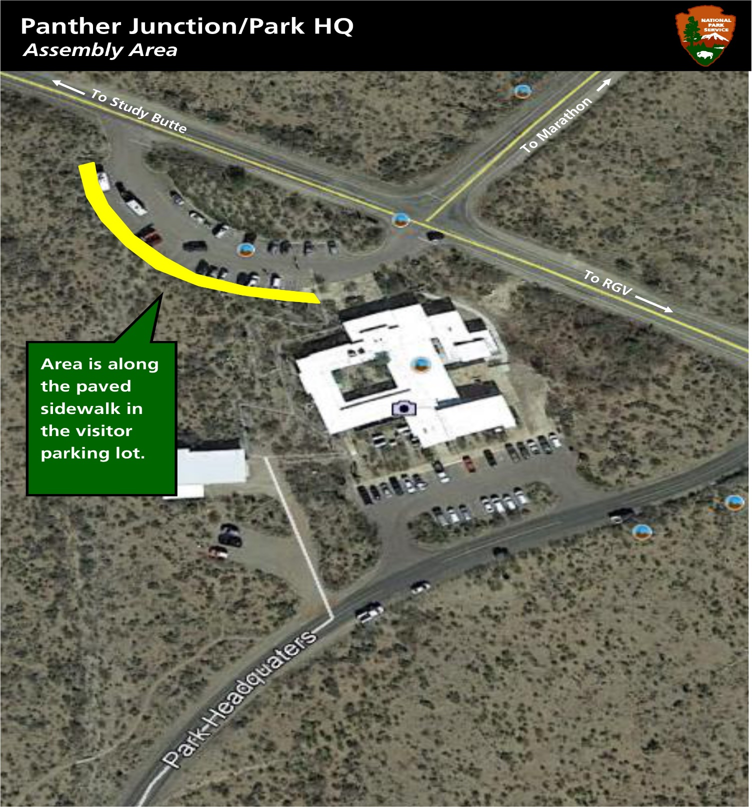

Panther Junction Headquarters Public Assembly Area
COMPENDIUM APPENDIX A

DESIGNATED AREAS FOR PUBLIC ASSEMBLY

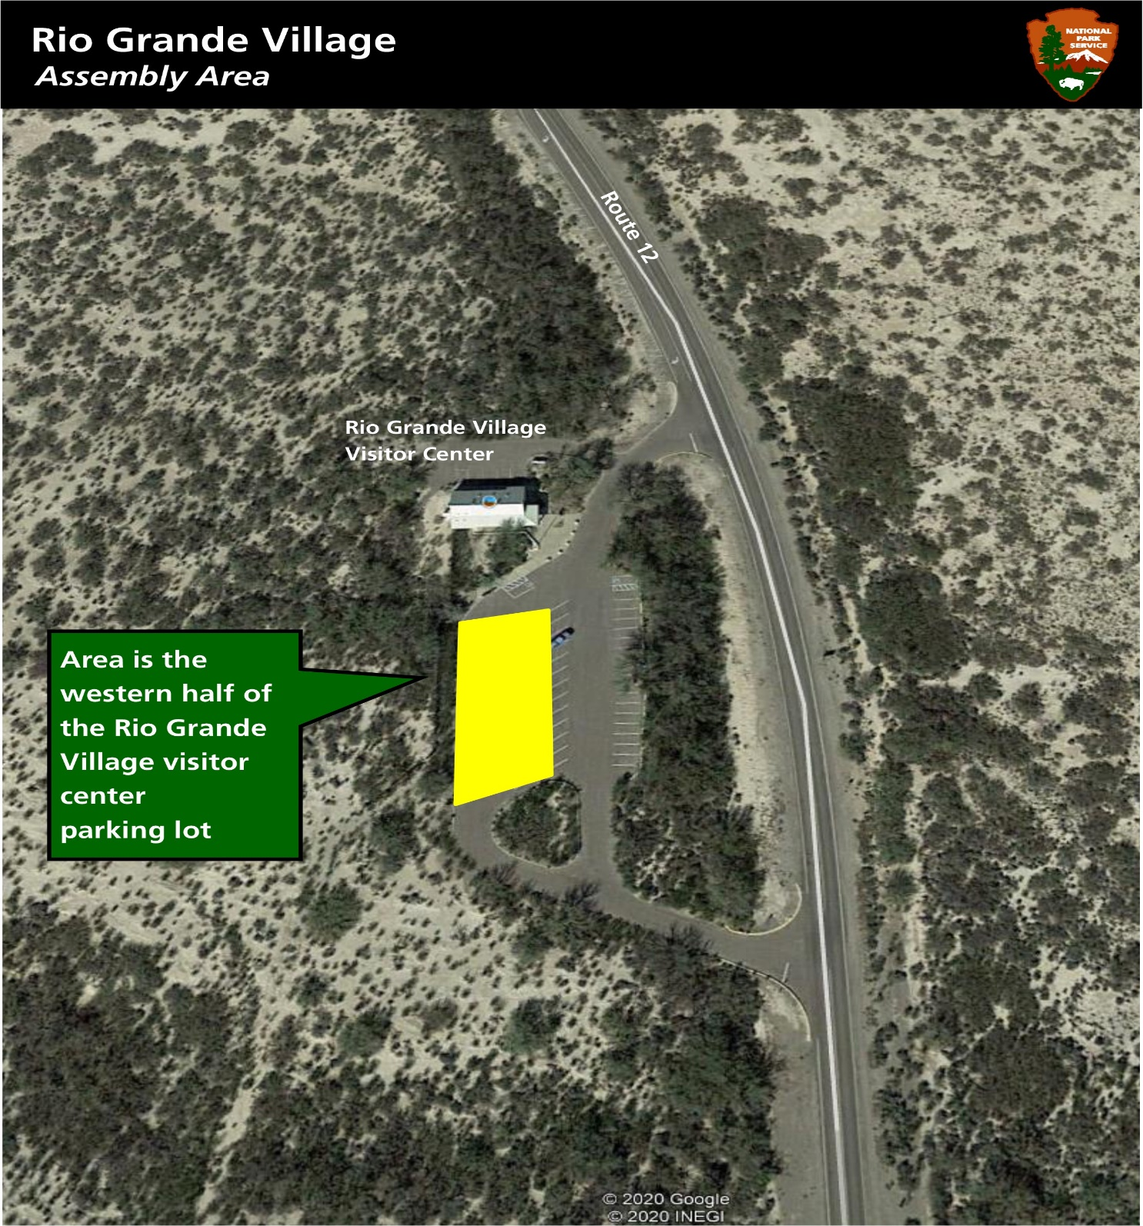

Rio Grande Village Public Assembly Areas
COMPENDIUM APPENDIX A

DESIGNATED AREAS FOR PUBLIC ASSEMBLY

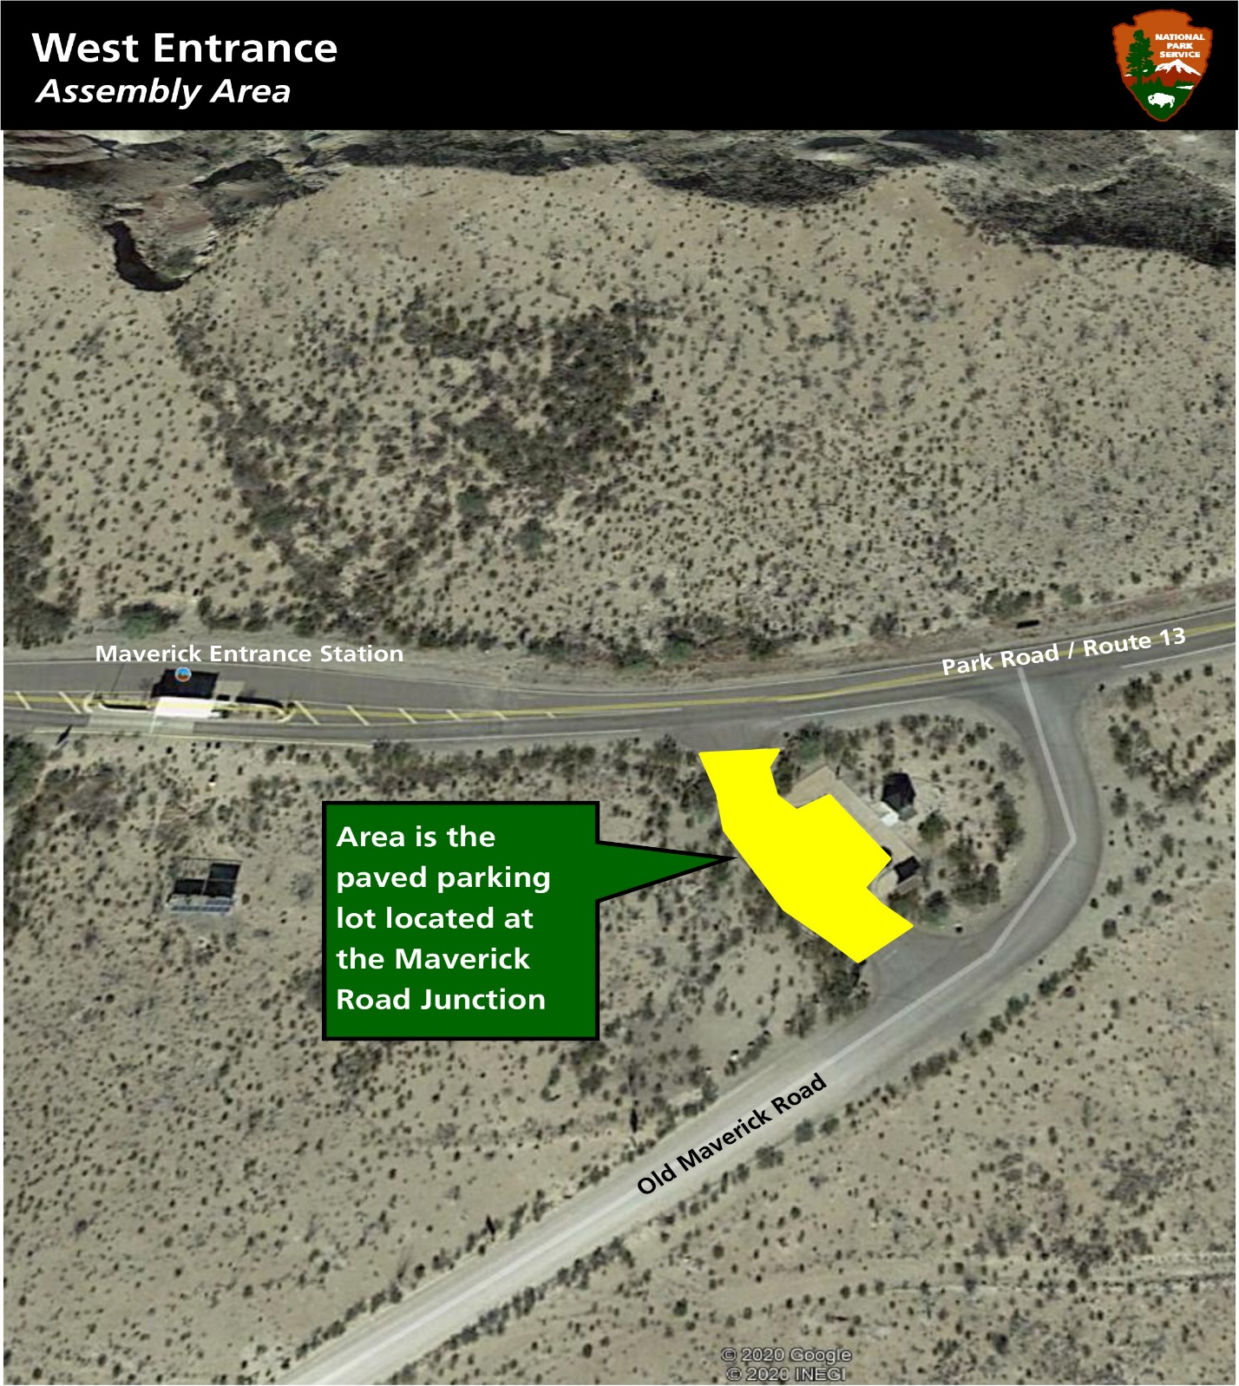

West Entrance Public Assembly Area

COMPENDIUM APPENDIX B
DESIGNATED AREAS FOR SALE OR DISTRIBUTION
OF PRINTED MATERIAL

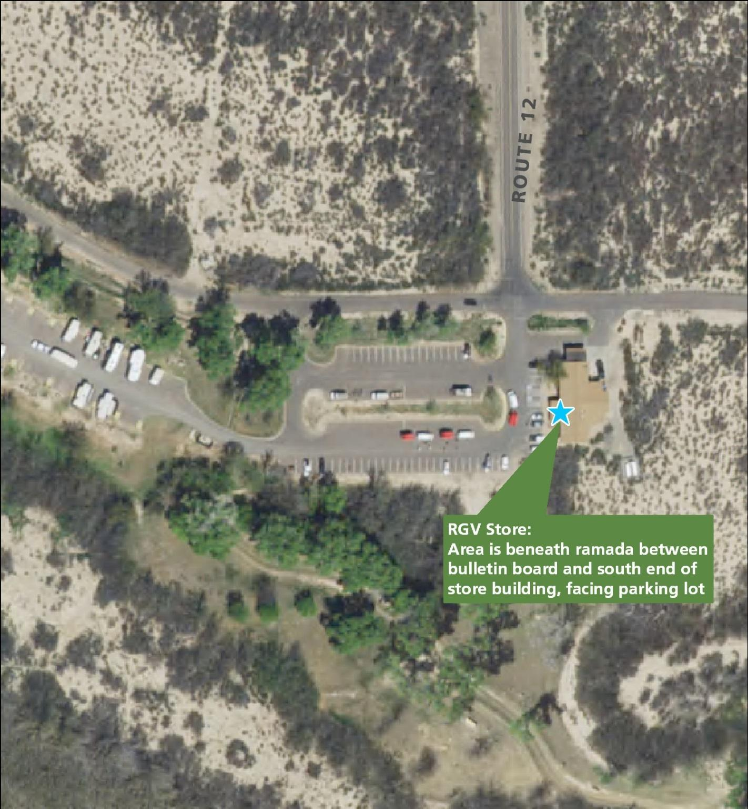
Rio Grande Village Store Center Sale or Distribution of Printed Matter

COMPENDIUM APPENDIX B
DESIGNATED AREAS FOR SALE OR DISTRIBUTION
OF PRINTED MATERIAL

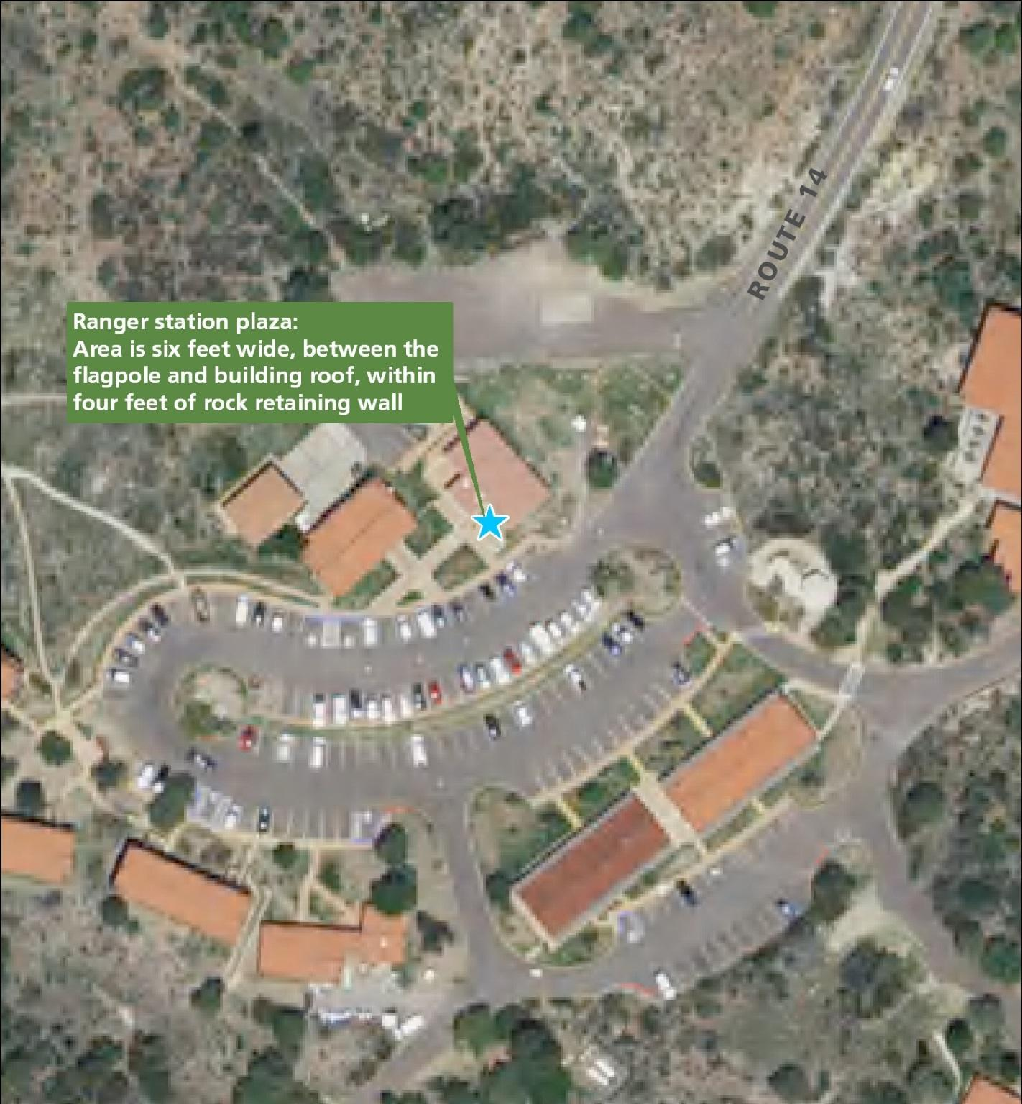

Chisos Basin Ranger Station Sale or Distribution of Printed Matter

COMPENDIUM APPENDIX B

DESIGNATED AREAS FOR SALE OR DISTRIBUTION
OF PRINTED MATERIAL

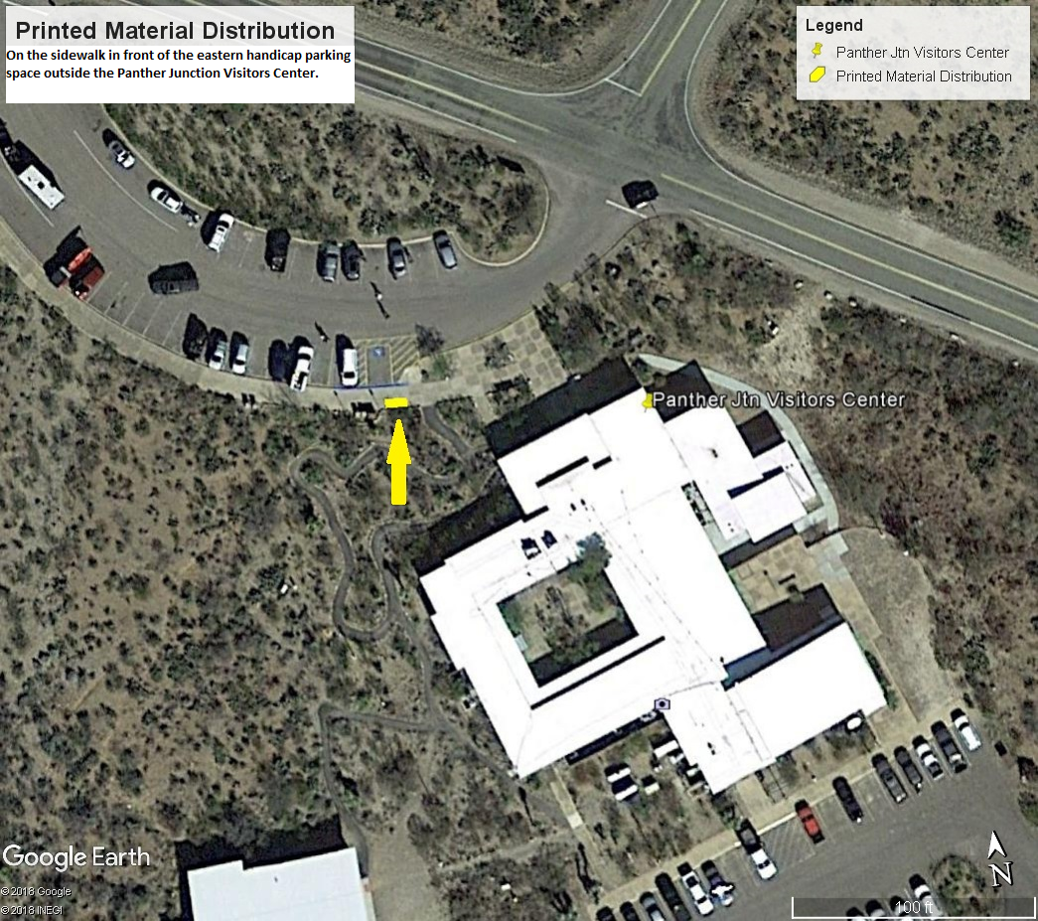

Panther Junction Visitor Center Sale or Distribution of Printed Material

COMPENDIUM APPENDIX C
BACKCOUNTRY CAMPING USE LIMITS

Big Bend National Park
Rio Grande Wild and Scenic River

The attached pages indicate the official areas open or closed to camping; designated sites; use limits for numbers of people, tents, or vehicles; and camping limits for stock.

The official backcountry use area boundary map is kept at the front desk of the Panther Junction Visitor Center. The attached backcountry use area boundary map is an approximation.

Vehicles are not to be parked on vegetation nor can they block access to roads, trails, or other campsites.

PRIMITIVE ROADSIDE BACKCOUNTRY CAMPSITES
CAMPSITE | HORSES | CODE | VEHICLES | PERSONS
Grapevine Hills 1 | 0 | GH1 | 3 | 20
Grapevine Hills 2 | 0 | GH2 | 2 | 6
Grapevine Hills 3 | 0 | GH3 | 2 | 6
Grapevine Hills 4 | 0 | GH4 | 2 | 6
Grapevine Hills 5 | 0 | GH5 | 2 | 6
Paint Gap 1 | 0 | PG1 | 1 | 4
Paint Gap 2 | 0 | PG2 | 2 | 6
Paint Gap 3 | 0 | PG3 | 1 | 4
Paint Gap 4 | 0 | PG4 | 2 | 6
Croton Springs 1 | 0 | CS1* | 2 | 6
Croton Springs 2 | 0 | CS2* | 2 | 6
K-Bar 1 | 0 | KB1 | 2 | 6
K-Bar 2 | 4 (one 4- horse trailer) | KB2 | 2 | 6
Hannold Draw 1 | 8 | HD1 | 3 | 20
Nine-Point Draw 1 | 4 (one 4- horse trailer) | NP1 | 2 | 8
Nugent Mountain 1 | 4 | NM1 | 3 | 20
Pine Canyon 1 | 0 | PC1 | 2 | 6
Pine Canyon 2 | 0 | PC2 | 2 | 6
Pine Canyon 3 | 0 | PC3 | 1 | 4
Pine Canyon 4 | 0 | PC4 | 2 | 6
Pine Canyon 5 | 0 | PC5 | 2 | 6
Rice Tank 1 | 0 | RT1 | 2 | 6
Robbers Roost 1 | 0 | RR1 | 2 | 8
Camp Chilicotal 1 | 0 | CC1 | 2 | 8
Twisted Shoe | 0 | TS1 | 1 | 4
Glenn Springs 1 | 0 | GS1 | 2 | 8
Glenn Springs 2 | 4 | GS2 | 2 | 8
Candelilla 1 | 0 | CA1 | 2 | 8
Ernst Tinaja 1 | 0 | ET1 | 2 | 10
Camp de Leon | 0 | CL1 | 1 | 6
La Noria 1 | 0 | LA1 | 1 | 6
La Noria 2 | 0 | LA2 | 1 | 6
Ernst Basin 1 | 0 | EB1 | 2 | 10
Willow Tank 1 | 0 | WT1 | 1 | 8
Telephone Canyon 1 | 0 | TC1 | 1 | 6
Telephone Canyon 2 | 0 | TC2 | 2 | 12
Roy's Peak 1 | 0 | RP1 | 2 | 6
McKinney Spring 1 | 0 | MS1 | 2 | 6
Dominguez Trailhead1 | 4 | DT1 | 2 | 8
Loop Camp 1 | 4 (4x4 req.) | LP1 | 3 | 12
Loop Camp 2 | 4 (4x4 req.) | LP2 | 2 | 8
Johnson Ranch 1 | 4 (4x4 req.) | JR1 | 2 | 10
Johnson Ranch 2 | 2 (4x4 req.) | JR2 | 2 | 8
Gauging Station 1 | 0 | GA1 | 1 | 6
Black Dike 1 | 0 | BD1 | 2 | 10
Buenos Aires 1 | 4 (4x4 req.) | BA1 | 2 | 10
Terlingua Abajo 1 | 0 | TA1 | 2 | 8
Terlingua Abajo 2 | 0 | TA2 | 2 | 8
Terlingua Abajo 3 | 0 | TA3 | 2 | 8
Ocotillo Grove | 0 | OG1 | 2 | 8
Gravel Pit 1 | 0 | GP1 | 2 | 10
Gravel Pit 2 | 0 | GP2 | 2 | 10
Gravel Pit 3 | 0 | GP3 | 2 | 12
La Clocha 1 | 4 (4-horse trailer, 4x4 required) | LC1 | 2 | 10
La Clocha 2 | 0 | LC2 | 2 | 8
Solis 1 | 0 | SO1 | 2 | 12
Solis 2 | 0 | SO2 | 3 | 15
Fresno 1 | 0 | FR1 | 2 | 8
Elephant Tusk 1 | 0 | EL1 | 1 | 6
Talley 1 | 0 | TY1 | 2 | 8
Talley 2 | 0 | TY2 | 2 | 8
Talley 3 | 0 | TY3 | 3 | 12
Talley 4 | 4 (4x4 required) | TY4 | 2 | 8
Rattlesnake Mt 1 RM1 2 8

* Both sites in these areas may be combined to form one group site with a 3 vehicle/20 person limit. NM #1 and #2 as a group site will accommodate 4 horses 4-trailer pulled by 4x4 vehicles only.

CHISOS MOUNTAINS BACKCOUNTRY CAMPSITES
CAMPSITE | CODE | PERSONS | TENTS
Juniper Flat 1 | JF1 | 4 | 1
Juniper Flat 2 | JF2 | 6 | 3
Juniper Flat 3 | JF3 | 6 | 3
Boulder Meadow 1 | BM1 | 4 | 2
Boulder Meadow 2 | BM2 | 4 | 2
Boulder Meadow 3 | BM3 | 4 | 2
Boulder Meadow 4 | BM4 | 4 | 2
Boulder Meadow 5 | BM5 | 6 | 2
Pinnacles 1 | PI1 | 4 | 1
Pinnacles 2 | PI2 | 6 | 2
Pinnacles 3 | PI3 | 10 | 3
Toll Mountain 1 | TM1 | 4 | 1
Boot Canyon 1 | BC1 | 6 | 2
Boot Canyon 2 | BC2 | 12 | 5
Boot Canyon 3 | BC3 | 4 | 2
Boot Canyon 4 | BC4 | 6 | 2
Colima 1 | CO1 | 15 | 5
Colima 2 | CO2 | 3 | 1
Colima 3 | CO3 | 4 | 2
Juniper Canyon 1 | JC1 | 6 | 2
East Rim 1 | ER1 | 5 | 2
East Rim 2 | ER2 | 6 | 2
East Rim 3 | ER3 | 6 | 2
East Rim 4 | ER4 | 10 | 5
East Rim 5 | ER5 | 6 | 2
East Rim 6 | ER6 | 6 | 2
East Rim 7 | ER7 | 10 | 5
East Rim 8 | ER8 | 6 | 2
East Rim 9 | ER9 | 6 | 2
South Rim 2 | SR2 | 3 | 1
South Rim 3 | SR3 | 10 | 4
South Rim 4 | SR4 | 4 | 1
Blue Creek 1 | BL1 | 4 | 1
Blue Creek 2 | BL2 | 4 | 1
Laguna Meadow 1 | LM1 | 6 | 2
Laguna Meadow 2 | LM2 | 10 | 5
Laguna Meadow 3 | LM3 | 6 | 2
Laguna Meadow 4 | LM4 | 6 | 2
Laguna West 1 | LW1 | 4 | 2
Laguna West 2 | LW2 | 4 | 1
Laguna West 3 | LW3 | 4 | 1
NOTE: No horses or fires are allowed in any Chisos Mountains Backcountry Campsite.

BACKCOUNTRY USE AREA (ZONE) CAMPING
USE AREA | CODE | CAPACITY
Lower Juniper | C03 | 30
Dodson | C04 | 40
Upper Wilson | C05 | 20
Ward Spring | C06 | 10
Ash Spring | C07 | 40
Wright Mountain | C08 | 30
Hayes Ridge | C09 | 30
Mule Ears | S01 | 18
Upper Smoky | S02 | 35
Lower Smoky | S03 | 40
Quemada Sur | S04 | 40
Black Gap | S05 | 40
Pettits | S06 | 25
Mariscal Mountain | S07 | 35
Talley Mountain | S08 | 30
Chilicotal | S09 | 50
Canyon Flag | W01 | 20
Bruja Canyon | W02 | 20
Mariposa | W03 | 20
Canyon Rim | W04 | 20
Terlingua Creek | W05 | 30
Chimneys | W06 | 25
Tule Mountain | W07 | 35
Slickrock | N01 | 60
Croton Vista | N02 | 40
Neville | N03 | 40
North Rosillos | N04 | 35
Nine Point | N05 | 35
Tornillo Creek | E01 | 60
Dagger Mountain | E02 | 40
Sue Peaks | E03 | 50
Telephone Canyon | E04 | 40
Ore Terminal | E05 | 45
Strawhouse | E06 | 45
Arroyo Venado | E07 | 40
Marufo Vega | E08 | 40

COMPENDIUM APPENDIX D
CLOSURE MAPS

Big Bend National Park
Rio Grande Wild and Scenic River

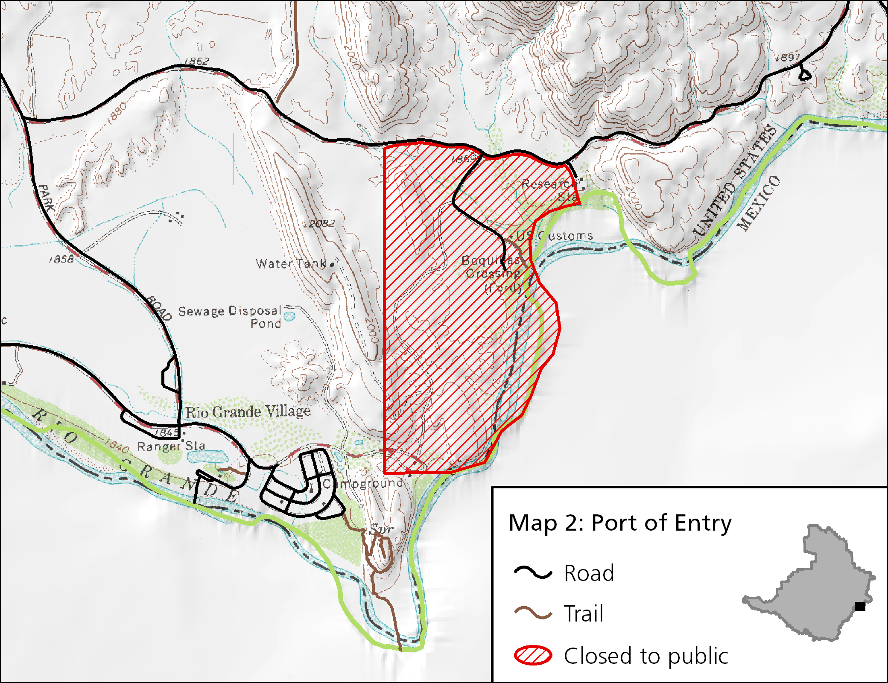Port of Entry Closure

COMPENDIUM APPENDIX D

CLOSURE MAPS

Big Bend National Park
Rio Grande Wild and Scenic River

Peregrine Falcon Closure
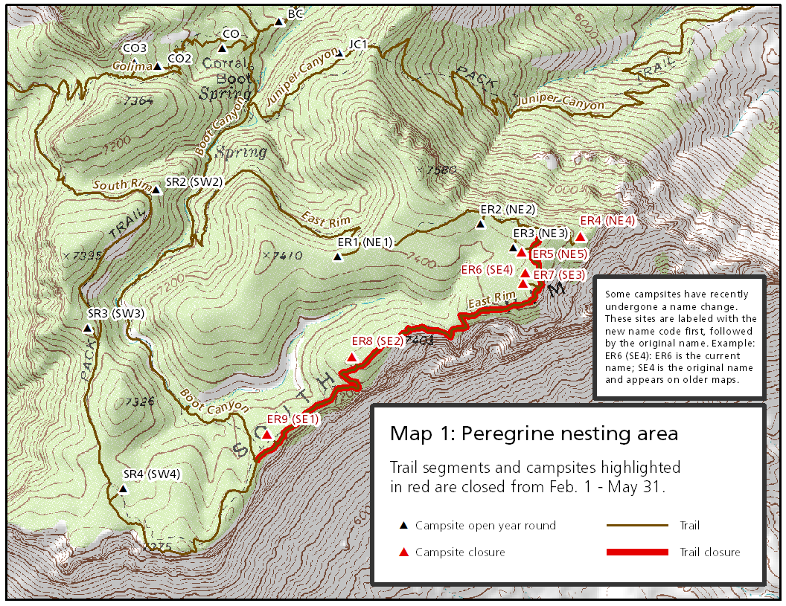

COMPENDIUM APPENDIX E

BIG BEND ROUTE NUMBER MAP

Big Bend National Park
Rio Grande Wild and Scenic River

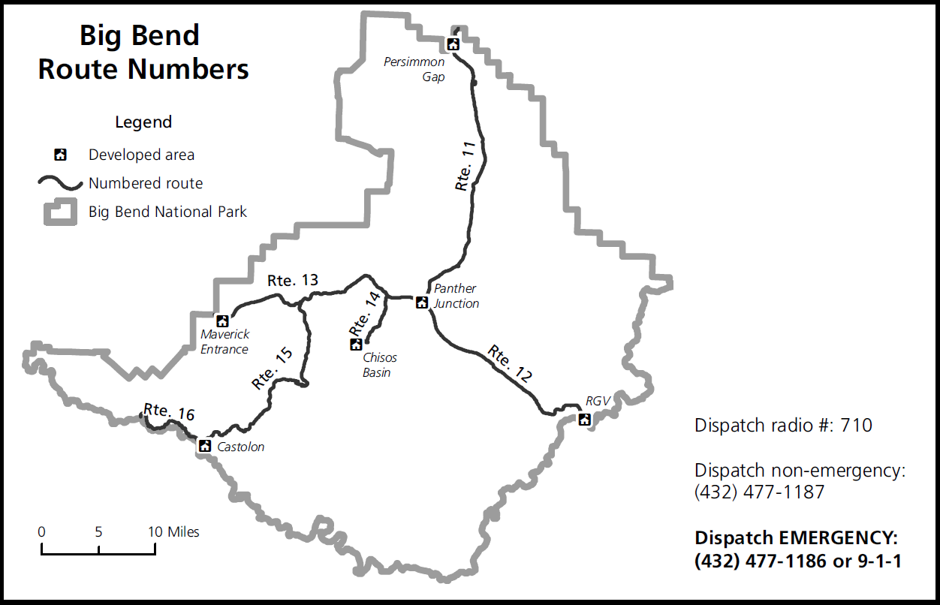

COMPENDIUM APPENDIX F

ZONE CAMPING MAP

