William’s Wheel of Fortune

Decide if William’s choices created an overall positive or negative result. These are your opinions. Place a plus sign next to the positive results and a minus sign next to the negative ones.
- _______Profited from the hunting of buffalo
- _______Traded internationally with England, Italy, Mexico, China, etc.
- _______Provided goods which various Native American nations desired
- _______Traveled in trade caravans through Native American lands
- _______Served as Army scout for Kearney during the U.S./Mexican War
- _______Traded guns to Native American nations
- _______Learned to speak various languages
- _______Extracted a large amount of natural resources
- _______Built the first permanent trading post in Colorado territory
- _______Received buffalo robes from the Cheyenne and Arapaho for trade
- _______Enslaved Charlotte, Dick, and Andrew
- _______Worked toward creating peaceful relations with Native American tribes
- _______Served as government representative for the Treaty of 1865 which limited
Native American lands
- _______Gave Army of the West quarter and supplies as they prepared to invade
Mexico
- _______Warned Cheyenne/Arapaho encampment about smallpox outbreak
- _______Cautioned against revenge with those involved in Charles Bent’s
assassination
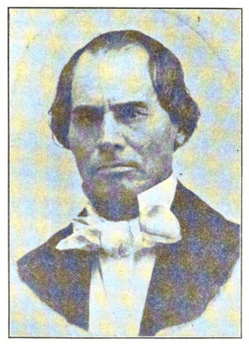

William Bent managed business at Bent’s Fort alongside Mestaahéhe (Owl Woman) during a difficult time in a remote location. He had to weigh his choices carefully.

Point to Ponder

How do you determine whether or not a past decision is a good one?

