Juan’s Draft Pick
Travelers to Bent’s Fort often needed to trade their tired working animals for new ones. Compare these three animal descriptions and circle the one you would choose for a long journey.
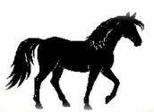
Description: The horse is the fastest of the three, but it needs to stop frequently to rest. It is the most expensive and needs a specific diet to stay healthy.
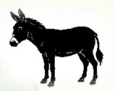
Description: The mule is stronger than the horse and lasts longer on the trail. It is less expensive than the horse but can be stubborn. It needs more than just grass to eat.
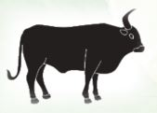
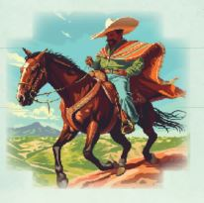
Description: The ox is the slowest of the three. It has the best endurance over long journeys and is the least expensive. It is usually not picky about what it eats.
Point to Ponder
Juan was so skilled taming horses that he could place a Mexican eagle coin in his stirrups without losing one by the time the wild horse was trained. What do you think might be a better nickname for him than “one-eyed Juan”?
“The Bents had cowboys whose business it was to break and ride the wild horses which were brought up from New Mexico… One-eyed Juan was the best of them.” – George Bent

