Cultural Contact
Draw a line to match the artifact with its name. Use the key below to write its trade origin in the blank.

England = E China = C Italy = I Mexico = M American Great Plans = A

Navajo blanket Trade beads Mexican reales Buffalo Robe Chocolate
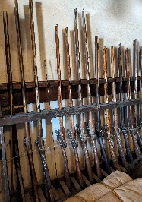
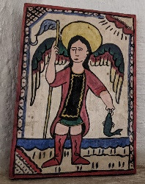
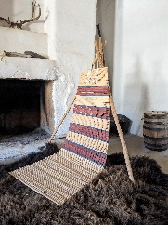
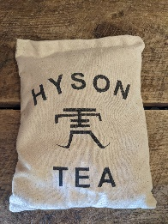
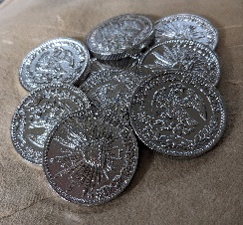
__________ __________ ____________ _________ __________
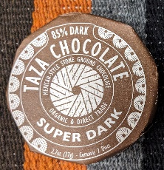
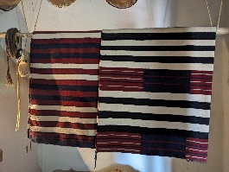
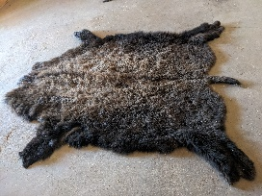
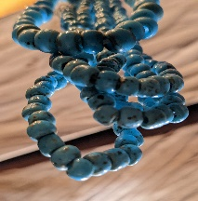

___________ __________ ____________ __________

Northwest trade gun Retablo Cheyenne backrest Tea
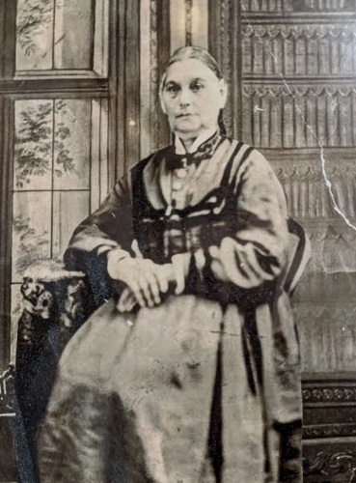
Point to Ponder
Why are some items only available from certain regions?
As the daughter of an influential Mexican merchant, Maria Ignacia would have helped her husband, Charles Bent, understand the language, habits, diet, and cultural objects of Mexico.

