Martin Van Buren
National Park Service
U.S. Department of the Interior

National Historic Site New York

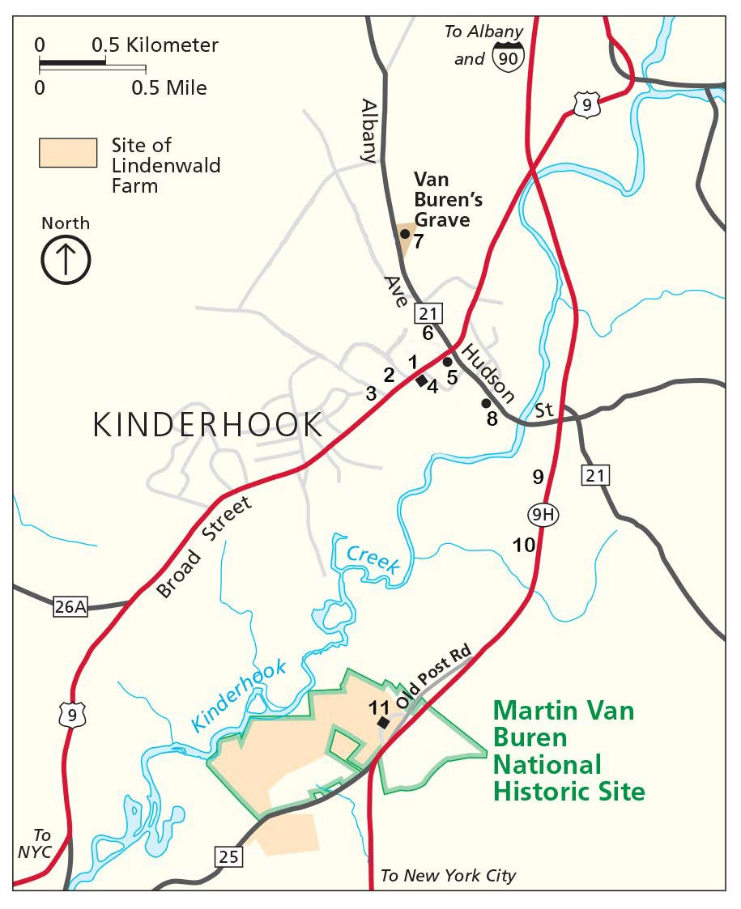
Directions to Van Buren's Grave, Historic Kinderhook & Area Sites

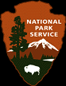
- James Vanderpoel House
- General John Burgoyne House*
- Benedict Arnold House*
- Kinderhook Reformed Dutch Church
- Martin Van Buren Statue
- Columbia County Museum
- Martin Van Buren Grave (Reformed Church Cemetery)
- Martin Van Buren Birthsite*
- Luykas Van Alen Home
- Ichabod Crane Schoolhouse
- Martin Van Buren National Historic Site
* Not open to the public

Directions to...

Village of Kinderhook, Martin Van Buren Birth site and Gravesite:
Take Route 9H North to the exit at the Kinderhook Elks Lodge, take exit. At the bottom of the exit turn right onto Hudson Street (MVB Birth site is 1/4 mile on left after 9H underpass). Continue on Hudson Street to the traffic light in Kinderhook Village. Go straight at the light one-half mile to the Dutch Reformed Cemetery which is on the right. Look for small signs directing you to the MVB grave.

FDR Home and Vanderbilt Mansion:
Take Route 9H South to Bells Pond Intersection (4th traffic light) Take Route 9 South to Hyde Park
Vanderbilt Mansion and FDR Home on right

Eleanor Roosevelt Cottage (Val Kill):
Take Route 9H South to Bells Pond Intersection (4th traffic light) Take Route 9 South to Route 9G
Take Route 9G to Cottage
Directions to Cottage can also be obtained at FDR Home and Vanderbilt Mansion

Saratoga National Historical Park:
Take Route 9H North, Route 9H becomes Route 9 Take Route 9 to I-90
Take I-90 West to I-87 Take I-87 North to Exit 12
Follow brown and white signs to Park Park is approximately 15 miles from Exit 12

Olana State Historic Site:
Take Route 9H South to Bells Pond Intersection (4th traffic light) Take Route 23 to Route 9G
Olana SHS on left opposite Rip Van Winkle Bridge

8/2022

