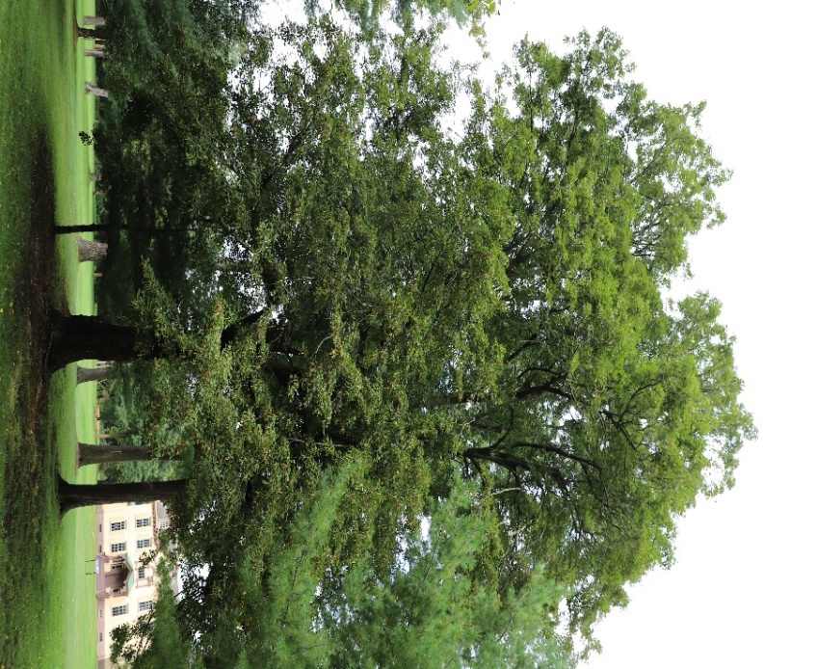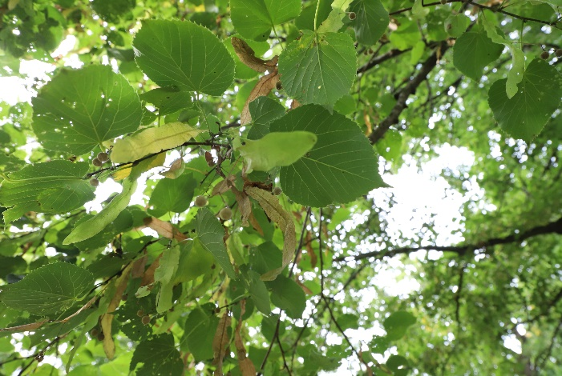
The Linden Tree: The “Tree of Hearts”

President Van Buren named his house and farm ‘Lindenwald.’
The name is a combination of two words; Linden and Wald.
Linden is the name of this tree,there were many on his land at the time.
And, ‘Wald’ is the German word for forest.

During Martin Van Buren’s lifetime the Linden tree was called the “sweetheart tree,” because its leaves are shaped like a heart.

What do you think?
Now, it’s time to make your own heart !

Make Your Own Heart Shaped Ornament!

“Tree of Hearts” Ornament

You will need:

4 cups of All -purpose flour ( 500 grams)
1 cup of table salt (125 grams)
1 ½ cups of warm water (350 ml )

Mixing bowl and large spoon
2 large squares of Parchment
A Rolling pin
A Heart shaped Cookie cutter
or
The heart template and knife for an adult to use to cut a dough heart.
A Straw or a chop stick —or something to poke a hole at the top of the heart to hang it up.
A Baking sheet
A 6 inch piece of Ribbon, String or Yarn —for hanging the heart.

Print it out the paper template of this heart on stiff paper,
or print it out on regular paper and trace it onto cardboard for easier cutting around the dough.

Directions
1. 1. In the mixing bowl add the flour and salt.
2. Mix them together with the large spoon.
- 3. While mixing the flour and salt, slowly add all of the warm water.
- 4. When it gets to thick to mix with the spoon use your hands until it is a soft ball of dough.
- 5. Place one sheet of parchment paper on a hard surface (like a counter top or table), then put the ball of dough in the middle.
- 6. Cut the ball of dough in half and set it aside.
- 7. Place the second sheet of parchment paper on top of the half of dough that is still on the first square of parchment paper – like a paper and dough sandwich.
- 8. Use the rolling pin to flatten out the half-ball of dough between the two sheets of parchment paper.
- * Make sure you roll it out so that the dough is not too thick or too thin.
- 9. Punch out a heart with a cookie cutter or have a grown-up cut it out using the paper template.

“Tree of Hearts” Ornament Directions Continued
1 10. Do not lift the heart but keep it on the parchment paper.
111. Clear away the left over dough around the heart.
1 12. Poke a hole at the top of heart.
113. Slide the parchment paper with the heart on it onto the baking sheet.
114. Bake for one hour at 300 degrees Fahrenheit or 148 degrees Celsius.
115. Let them cool and then you can paint them or just out the ribbon through the hole and hang them up!
1

